Bellringer #16
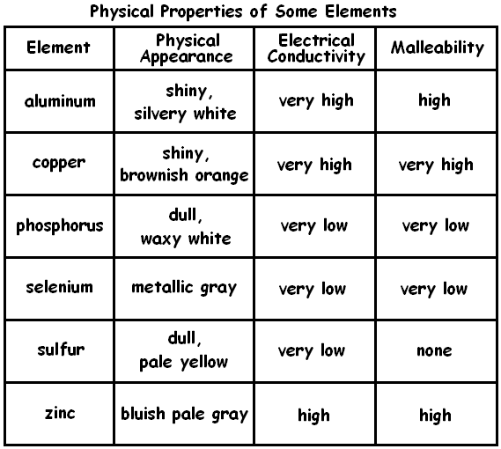

Zachary recorded some physical properties for the six elements shown in the table above. The data in the table imply that Zachary is most likely trying to
--------------------------------------------------------------------------------------------------------------------------------------------------------------------------------
classify the elements as either metallic or nonmetallic.
compare elements with low and high atomic numbers.
observe how malleability changes the color of elements.
predict the melting point of highly conductive elements.

