Bellringer #38
Shelbi learned the definitions of some important terms concerning atomic particles.
1. atomic number → the number of protons in an atom
2. atomic mass → the decimal number on the periodic chart
3. mass number → the number of protons + neutrons; the atomic mass rounded to a whole number

Therefore, Shelbi could complete the following chart.
Element | Symbol | Atomic Number | Atomic Mass | Mass Number | #p⁺ | #e⁻ | #n⁰
boron | B | 5 | 10.811 | 11 | 5 | 5 | 6
chromium | Cr | 24 | 51.9961 | 52 | 24 | 24 | 28
selenium | Se | 34 | 78.96 | 79 | 34 | 34 | 45

--------------------------------------------------------------------------------------------------------------------------------------------------------------------------------
Mason was asked to draw the Bohr model for boron, lithium, nitrogen, sodium. First, Mason had to find out the atomic number and the mass number of each element.

Element | Symbol | Atomic # | Mass # | #p⁺ | #e⁻ | #n⁰ | Bohr Model
boron | B | 5 | 11 | 5 | 5 | 6 | 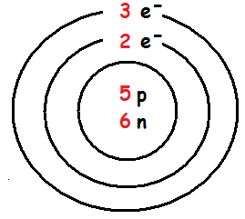
lithium | Li | 3 | 7 | 3 | 3 | 4 | 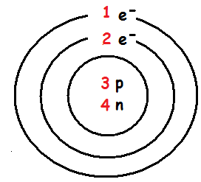
nitrogen | N | 7 | 14 | 7 | 7 | 7 | 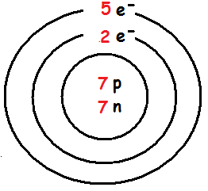
sodium | Na | 11 | 23 | 11 | 11 | 12 | 