An Introduction To the Mechanics of Electric Vehicles
Adapted from http://www.evworks.com.au/index.php for the Science of Alternative Fuels
by Ian Hooper, June 2010
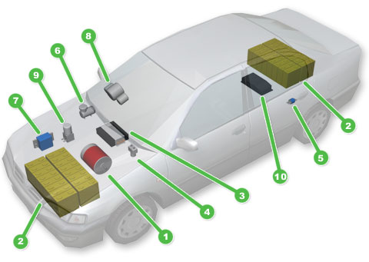 | The Conversion Process:  - Research!  - Select your donor vehicle  - Remove engine and related parts  - Install electric components  - Relicense your vehicle  Electric Vehicle Components:  - Electric Motor  - Battery Pack  - Motor Controller  - Contactor  - Fuse  - Vacuum Pump  - DC/DC Converter  - Instrumentation  - Power Steering Pump  - Battery Charger

Introduction
We love our cars. We can't live without them. Unfortunately our cars are doing a lot of damage – to the environment, our climate, and to our hip pocket every time we fill up with fuel! But you do have a choice. You can own an electric car – today. While there are no electric production cars currently for sale in Australia (as of 2010), you can convert your existing vehicle to zero emission electric. Never pay another cent for petrol, and know that you're doing your bit to minimise air pollution and climate change*.
This article contains some introductory information about the process of converting your car to electric, and an overview of the components involved. Many people with mechanical and electrical experience choose to undertake a conversion themself, and it is a very rewarding project. But if you don't have the time, space or expertise to tackle an EV conversion yourself, there are places that can do it for you.
The Conversion Process


Step 1: Research!
Converting your car to electric is a big decision, and you want to make the right choices. Fortunately there is a wealth of information available on the internet (such as this website!), as well as knowledgeable experts around the country. For Australian residents, AEVA (Australian Electric Vehicle Association - http://www.aeva.asn.au/) is a great resource, and meetings are held regularly in most states. You may also wish to sign up for the EVDL (Electric Vehicle Discussion List - http://www.evdl.org/) mailing list. Do some research to find resources to help with a conversion in the United States. List Resources Below:
______________________________________________________________________________
______________________________________________________________________________


Step 2: Select your donor vehicle
Any vehicle can be converted to electric. Generally small and light vehicles will give you the best performance for your money, but you should always choose a vehicle you like to own and enjoy driving.

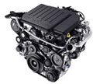
Step 3: Remove engine and related parts
Electric cars are actually much simpler than petrol vehicles, with far fewer moving parts, so a lot comes out. The main components are the engine, fuel tank & lines, radiator and cooling system, exhaust, and sometimes the gearbox.

Step 4: Install electric components
A small, quiet and efficient electric motor goes where the engine was, and batteries are installed in the remaining space – usually half where the fuel tank was, and half under the bonnet – and a variety of other components. The second half of this article describes most of the components you will encounter in an EV. Installation of electric components should be performed in accordance with the National Code of Practice for EVs.

Step 5: Relicense your vehicle
Now that your electric vehicle is complete, you should relicense it as an EV to make the conversion official. You may need engineering signoff if any major modifications were performed (such as chassis changes), or if the weight has changed appreciably. For comprehensive insurance you may need to go to a specialist company.

Electric Vehicle Components
(1) Electric Motor |  | 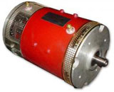
This is what makes the car move, instead of the petrol engine. Electric motors are very efficient, up to around 95% instead of around 25% for a petrol engine! There are various types available, with Series DC being the most popular and cost-effective. We recommend the Kostov 17R or NetGain Impulse 9 for small cars, the NetGain Warp 9 for medium vehicles, or the Warp 11 for larger vehicles. For motorbikes, we recommend the Mars motors.
(2) Battery Pack |  |   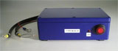
This is what stores the energy for powering the motor. We recommend Lithium Iron Phosphate (LiFePO4) chemistry cells such as those from ThunderSky or Sky Energy. For most cars we recommend 144V battery packs, comprised of 45 cells in series. Motorbikes will usually use 48V-72V battery packs (16-24 cells in series). For small cars we recommend 90-100Ah size cells, for medium cars use the 130-160Ah cells, or large cars 200Ah cells. Typical driving range is 80-160km (50- 100 miles) depending on battery pack size and vehicle efficiency. Our Physics Theory page (http://www.evworks.com.au/tech/index.php?section=theory#5) describes how to predict range based on your vehicle and battery.
Lithium battery packs also require a battery management system, which monitors all the batteries to ensure they remain in a good state of charge and health. We recommend EV Power's solution, which comprises of one cell module per battery and one Master Control Unit (MCU). Visit the following website (http://www.evworks.com.au/tech/EVPowerBMS/) or click here for further information battery management.
(3) Motor Controller |  | 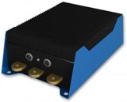
This little box does all the hard work, electrically speaking, controlling the flow of electricity from your battery pack to your motor as you press the accelerator. For the more common Series DC motors, there are a variety of motor controllers available. A good economical option is the ZEVA MC600S (~90kW max), or for higher performance conversions there's the EVnetics Soliton1, handling up to 300kW. For motorbikes and other low voltage conversions, Alltrax provide a range of suitable controllers.
(4) Contactor |  | 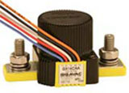
This is like a big ON switch, powering up your drive circuit when you turn the key. TheNanfeng ZJW400A is an economical option, or the Gigavac GX14 is a hermetically sealed and higher powered option.
(5) Fuse or Circuit Breaker |  | 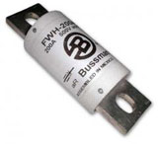
Every EV will have a fuse in its power circuit to ensure that the vehicle will shut down safely in the event of a fault in the traction circuit. The ideal fuse depends on the power rating of your batteries, controller and motor. With ThunderSky batteries we generally recommend a fuse with a rating 4x the capacity of your battery pack, e.g with 100Ah batteries use a 400A fuse. (Circuit breakers for EVs are rare due to their prohibitively high cost.)
(6) Vacuum Pump |  | 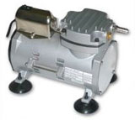
Petroleum vehicles use vacuum pressure from the engine's intake manifold to for vacuum-assisted braking. With no petrol engine, electric vehicles require a small electric vacuum pump to provide this vacuum. We carry several models, listed in the Braking and Steering section.
(7) DC/DC Converter |  | 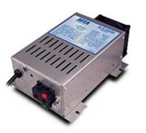
To keep your car's 12V systems running you can retain the vehicle's original alternator, driven off the auxillary shaft of your motor. However alternators are only about 50% efficient, so many people opt to install a DC/DC converter instead, which recharges the 12V battery directly from your traction battery. The Iota DLS-55 is the most common option.
(8) Instrumentation |  | 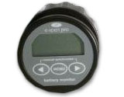
An electric car usually has some specialized instrumentation on the dash to help the driver monitor the state of the battery (the equivalent of your fuel gauge) and the operation of various electrical components. The simplest option for monitoring your battery's charge is the Fuel Gauge Driver, which uses the vehicle's original fuel gauge in the dash. Devices such as the TBS Expert Pro can supply extra information such as pack voltage, power, etc.
(9) Power Steering Pump |  | 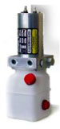
If your vehicle originally featured power steering, you will probably wish to retain this feature. Most petrol-powered vehicles use a hydraulic circuit for power assisted steering, with a hydraulic pump driven off the fan belt. Some people choose to run this original power steering pump off a small dedicated electric motor, but a more elegant option is to use an integrated electric power steering pump. Some more modern vehicles use electric power steering systems already, which will need no modification to work in your electric conversion.
(10) Battery Charger |  | 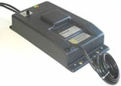
Every EV needs a charger to recharge its battery pack after use. Most run off single phase power (normal 240VAC household sockets), using either a common 10A or a more powerful 15A socket. The Italian-made Zivan NG3 is a very popular option, but the K Series chargers are used as a more economical option.

(11) Other components
Emergency Stop Button: There are two main variants, the larger type break the traction circuit directly, or the smaller type interrupt the power to your contactors. These were once a legal requirement for EVs, but are now just a recommended option.
Inertia Switches: These switches will trip in the event of a vehicle collision, interrupting the power to your contactor(s) to shut down the traction circuit. Check for if these are a legal requirement for EVs: First Inertia Switch
Cabling and Lugs: For most EVs we recommend 50mm² cable for most of the traction circuit with 95mm² cable between the controller and motor. All high voltage wiring in EVs must be double insulated with the outer layer orange. You will also need a range of lugs to suit.
Tools: Working with heavy power cable needs some specialized tools, in particular a large cable cutter and hydraulic crimping tool. AEVA branches in most states have loaner sets of these tools available, or for examples of what you can purchase, see http://www.evworks.com.au/index.php Tools and Equipment section.
Precharger: To avoid excessive inrush currents to the controller when your main contactor closes, you should always run a precharge circuit. This article from our tech library discusses their use and offers one simple solution: Contactor Jewelry
* Electric cars are only as clean as the energy used to recharge them! In Australia it is highly recommend signing up for Green Power,( http://www.greenpower.gov.au/) a federally regulated scheme available throughout Australia which ensures that the electricity you use is generated from renewable sources. Installing solar panels on your roof is another great way to "clean up" your electricity. Research Green Power and use it at a model for the United States.

