BR #28
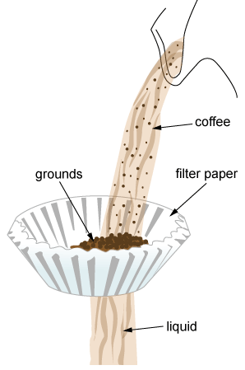
Angel is using the setup illustrated to separate a mixture of coffee
grounds and liquid coffee. Which property of the coffee grounds is
being used to separate them out?

A. color of the grounds

B. polarity of the molecules of coffee grounds

C. size of the particles of coffee grounds

D. size of the molecules of coffee grounds

--------------------------------------------------------------------------------------------------------------------------------------------------------------------------------

Logan is presented with two mixtures:
mixture 1: sand and sugar
mixture 2: sand and iron filings
He is instructed to separate the sand from each mixture.

Part A
Describe a process that will separate the sand in mixture 1.

Logan could add water to the sand and sugar mixture. The sugar will dissolve in the water, but the sand will not. He could then filter the liquid solution. The sand will remain on the filter paper, but the sugar water will go through. He could then separate the sugar from the water by evaporation.

Part B
Describe a process that will separate the sand in mixture 2.

Logan could use a magnet to separate the iron filings from the sand since iron filings are magnetic but sand is not.

