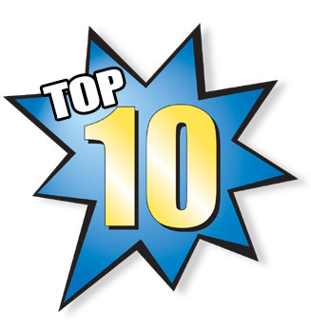
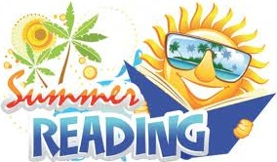
Washington Township Schools
Summer Reading Suggestions
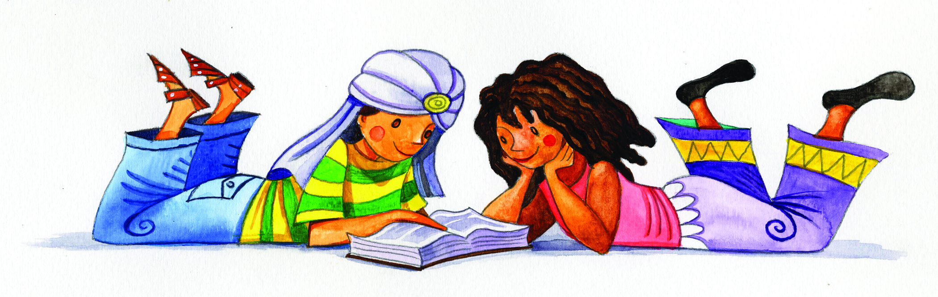
Grades K-5

Preschool / Kindergarten
Duck! Rabbit! by Amy Krouse Rosenthal
How I Became a Pirate by Melinda Long
If You Give A Dog a Donut by Laura Numeroff
More Bears! by Kenn Nesbitt
My Heart is Like a Zoo by Michael Hall
Penny and Her Song by Kevin Henkes
Press Here by Herve Tullet
Too Many Toys by David Shannon
We are in a Book (Elephant and Piggie series) by Mo Willems
Wild About You by Judy Sierra
First Grade

Boot & Shoe by Marla Frazee
Children Make Terrible Pets by Peter Brown
The Eraserheads by Kate Banks
Froggy’s Sleepover (Froggy series) by Jonathan London
Mercy Watson series by Kate DiCamillo
One Cool Friend by Toni Buzzeo
Scaredy Squirrel at the Beach (Scaredy Squirrel series) by Melanie Watt
Splish, Splash, Splat (Splat the Cat series) by Rob Scotton
Those darn squirrels! by Adam Rubin
You Read to Me, I'll Read to You: Very Short Fairy Tales to Read Together by Mary Ann Hoberman
-2-

Second Grade

Amelia Bedelia Goes Camping (Amelia Bedelia series) books by authors Peggy Parish and Herman Parish
A Big Guy Took My Ball! (Elephant and Piggie series) by Mo Willems
Flat Stanley’s Worldwide Adventures series by Jeff Brown and Macky Pamintuan
Freckle Juice by Judy Blume
The Littles series by John Peterson
Mercy Watson series by Kate DiCamillo
My Father’s Dragon by Ruth Stiles Gannett
Orangutans Are Ticklish: Fun Facts From an Animal Photographer by Jill Davis
Secrets of Droon: The Mysterious Island series by Tony Abbott
The Time Warp Trio series by Jon Scieszka
The Watcher: Jane Goodalls Life With the Chimps by Jeanette Winter

Third Grade

2030: A Day in the Life of Tomorrow’s Kids by Amy Zuckerman and James Daly
Big Belching Bog by Phyllis Root
The Boxcar Children series by Gertrude Chandler Warner
Celebritrees: Historic and Famous Trees of the World by Margi Preus
Charlie and the Chocolate Factory by Roald Dahl
Charlotte’s Web by E.B. White
How to Eat Fried Worms by Thomas Rockwell
Jack Plank Tells Tales by Natalie Babbitt
The Kids Summer Games Book by Jane Drake
Misty of Chincoteague by Marguerite Henry

-3-

Fourth Grade

Big Nate in a class by himself Lincoln Peirce
Clementine Robert M. Quackenbush
The maze of bones: 39 Clues, Book 1 Rick Riordan
The one and only Ivan Katherine Applegate
Out of my mind Sharon M. Draper
The Penderwicks : a summer tale of four sisters, two rabbits, and a very interesting boy Jeanne Birdsall
May B.: a novel by Caroline Starr Rose
Meanwhile Jason Shigla
The strange case of Origami Yoda Tom Angleberger
Tuesdays at the castle Jessica Day George
Nonfiction
Knucklehead: tall tales & mostly true stories about growing up Jon Scieszka
Titanic: voices from the disaster Deborah Hopkinson
Kakapo rescue: saving the world’s strangest parrot Sy Montgomery
Ballet for Martha: making Appalachian Spring Jan Greenberg and Sandra Jordan
The day-glo brothers: the true story of Bob and Joe Switzer’s bright ideas and brand-new colors Chris Barton
We Are the Ship: The Story of Negro League Baseball Kadir Nelson

Fifth Grade

Dork diaries: tales from a not-so-fabulous life by Rachel Renée Russell
The invention of Hugo Cabret: a novel in words and pictures by Brian Selznick
Harry Potter series by J. K. Rowling
Liar & spy by Rebecca Stead
The mysterious Benedict Society by Trent Lee Stewart
No talking by Andrew Clements
Savvy by Ingrid Law
Sidekicks by Jack D. Ferraiolo
Three times lucky by Sheila Turnage
Where the mountain meets the moon by Grace Lin
Nonfiction
Drawing from memory by Alan Say
Electric Ben: the amazing life and times of Benjamin Franklin by Robert Byrd
The elephant scientist by Caitlin O'Connell and Donna M. Jackson
Lafayette and the American Revolution by Russell Freedman
Nathan Hale’s hazardous tales: One dead spy by Nathan Hale
100 most dangerous things on the planet by Anna Claybourne

Additional Online Sources for Book Suggestions:

Book Hive
http://www.plcmc.org/bookhive/books/
An award-winning library website offering a good guide to children’s literature and books.

Book Spot
www.bookspot.com/readinglists/
Links to dozens of other sites.

Carol Hurst’s Children’s Literature Site http://www.booksintheclassroom.com/allreviewed.php
Starred reviewed titles for grades K to 6th+.

Ethan’s Bookshelf
http://www.ethansbookshelf.com
Offers book reviews, lists and guides for parents in selections of children’s literature for promoting reading as a lifelong habit.

Inkless Tales
http://www.inklesstales.com
Stories, poems, games, including an animated alphabet and more for Kindergarten and up.

International Digital Children’s Library http://www.childrenslibrary.org/icdl/SimpleSearchCategory
A great website for ages 3-13, that offers a range of choices of both books and languages
Kids Reads
http://kidsreads.com/reviews/index.asp
Lists of book reviews from A-Z and more for kids of all ages
Check your school library’s website for more reading suggestions! 6/2013

