What is going on in this image?
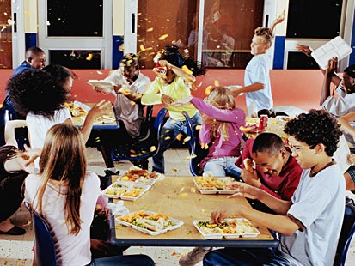

‘Read’ this image as if it were a traditional text using the active reading strategies you just learned about:

Visualize•Clarify•Question•Predict•Connect•Evaluate

