PERSUASIVE TURKEY!

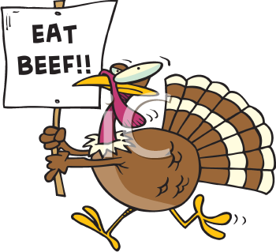

Write a persuasive letter (3/5 essay) convincing the president of the United States, President Obama, to excuse turkeys on Thanksgiving. Here’s the catch: You will be writing through the voice of (from the perspective of) a turkey.

That’s right! Think about how you would feel if every year your entire family (of turkeys) was hunted in an attempt to feed others for Thanksgiving dinner.

It is your job to come up with a plan of action for all of the turkeys that is powerful enough to persuade the president!

Tips for writing:

• Talk about the purpose of Thanksgiving! Is it about eating? Does it really matter what we eat? Why?

• Offer other options! What else could we eat? What does your family eat for Thanksgiving? Tell stories or anecdotes from your experience.

