Metals Lessons
Lesson 1 – Life Before Metal
Objectives SWBAT 1. Conceptualize a world in which metal was not used as a main material.
2. Learn the basic vocabulary of metals.
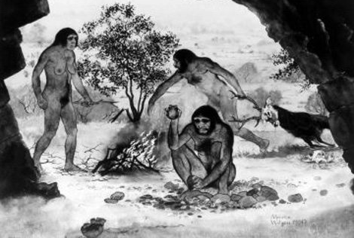
USE “The Inside Story of Metal” Chapter 1 The Discovery of Metal

Vocabulary

Paleolithic Age

Neolithic Age

Melt

Smelt

Ore

Kiln

Reducing Agent

Slag

Alloy

Bronze

Bronze Age

Wrought Iron

Steel

Metallurgy

Extractive Metallurgy

Physical Metallurgy

Questions
- What was the first type of tool that humans had and what were they used for?

- What was the first metal(s) to be found and used and what was it used for?

- Why was the first metal axe not as good as the axe the people had in the Neolithic Age?

- How can scientists tell whether an ancient piece of iron came from outer space or from the Earth?

- Compare and contrast melting and smelting of metals.

