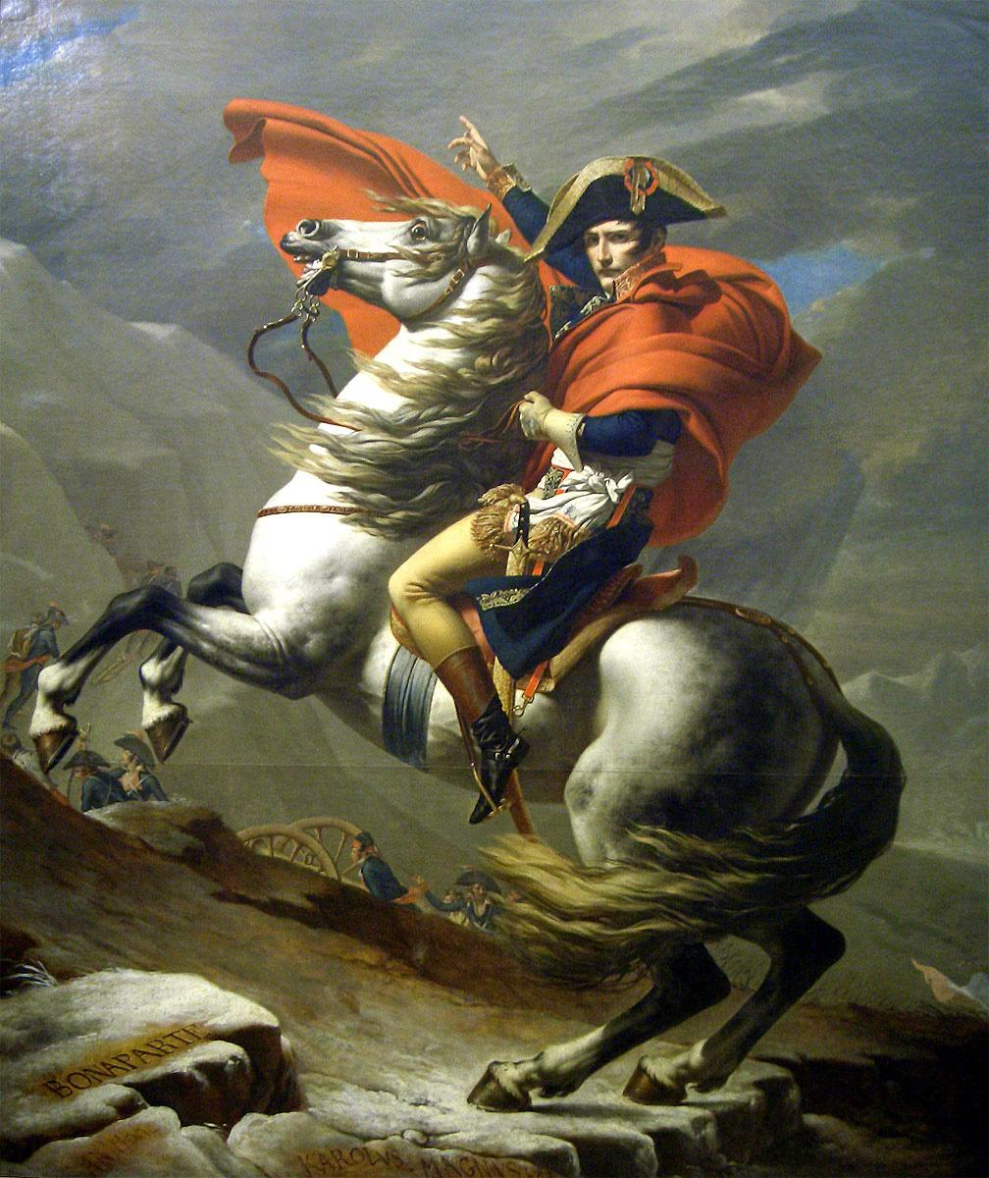

Napoleon Bonaparte

“The study of history enables us to control, not society, but ourselves….It prepares us to live more humanely in the present and to meet rather than to foretell the future”

-Carl Becker, historian
Textbook: A History of Western Society. McKay, Hill, and Buckler, 8th Edition, Houghton Mifflin, 2006

Supplementary Readings: Western Civilization: Sources, Images, and Interpretations: From the Renaissance to the Present. Dennis Sherman, 8th Edition, McGraw-Hill, 2011

Sources of Western Society: From 1300. Amy Caldwell, John Beeler, Charles Clark, Second Edition, Bedford/St. Martin’s, 2011

Course Goals: The study of European history since 1450 introduces students to cultural, economic, political, and social developments that played a fundamental role in shaping the world in which they live. Without this knowledge, we would lack the context for understanding the development of contemporary institutions, the role of continuity and change in present-day society and politics, and the evolution of current forms of artistic expression and intellectual discourse. In addition to providing a basic narrative of events and movements, the goals of AP European History are to develop (a) an understanding of some of the principal themes in modern European history, (b) an ability to analyze historical evidence and historical interpretation, and (c) an ability to express historical understanding effectively in writing.

Course Objectives:
- This course emphasizes relevant factual knowledge about European history from 1450 to the present to highlight intellectual, cultural, political, diplomatic, social, and economic developments.
- This course teaches students to analyze evidence and interpretations presented in historical scholarship.
- This course includes extensive instruction in analysis and interpretation of a wide variety of primary sources, such as documentary material, maps, statistical tables, works of art, and pictorial and graphic materials.
- This course provides students with frequent practice in writing analytical and interpretive essays such as document-based questions (DBQ) and thematic essays.
Themes in Modern European History: (As specified by the College Board)
Intellectual and Cultural History
- Changes in religious thought and institutions
- Secularization of learning and culture
- Scientific and technological developments and their consequences
- Major trends in literature and the arts
- Intellectual and cultural developments and their relationship to social values and political events
- Developments in social, economic, and political thought
- Developments in literacy, education, and communication
- The diffusion of new intellectual concepts among different social groups
- Changes in elite and popular culture, such as the development of new attitudes toward religion, the family, work, and ritual
- Impact of global expansion on European culture
Political and Diplomatic History
- The rise and functioning of the modern state in its various forms
- Relations between Europe and other parts of the world: colonialism, imperialism, decolonization, and global interdependence
- The evolution of political elites and the development of political parties, ideologies, and other forms of mass politics
- The extension and limitation of rights and liberties (personal, civic, economic, and political); majority and minority political persecutions
- The growth and changing forms of nationalism
- Forms of political protest, reform, and revolution
- Relationships between domestic and foreign policies
- Efforts to restrain conflict: treaties, balance-of-power diplomacy, and international organizations
- War and civil conflict: origins, developments, technology, and their consequences
Social and Economic History
- The character of and changes in agricultural production and organization
- The role of urbanization in transforming cultural values and social relationships
- The shift in social structures from hierarchical orders to modern social classes: the changing distribution of wealth and poverty
- The influence of sanitation and health care practices on society; food supply, diet, famine, disease, and their impact
- The development of commercial practices, patterns of mass production and consumption, and their economic and social impact
- Changing definitions of and attitudes toward mainstream groups and groups characterized as the "other"
- The origins, development, and consequences of industrialization
- Changes in the demographic structure and reproductive patterns of Europeans: causes and consequences
- Gender roles and their influence on work, social structure, family structure, and interest group formation
- The growth of competition and interdependence in national and world markets
- Private and state roles in economic activity
- Development and transformation of racial and ethnic group identities

Course Format: This course will be taught as a seminar, which means that each student will play a vital role in the learning process. As in most of my courses, there is a tremendous amount of discussion. In the traditional seminar, students are responsible for completing outside readings so that the interpretation of the literature can be discussed for deeper analysis and understanding in class.
Grading: All grades are computed on a point value system
Tests 50%
- Multiple Choice
- Identification
- FRQ
DBQ 30%
Homework 10%
Blog Submissions 10%

Late Scale:
a) 1 day 25% deduction
b) 2 days 50% deduction
c) 3 or more days no credit

Test Design: Each test will consist of multiple-choice and essay questions. Essay questions will be released at the start of each unit of study in the first semester only. I will provide students with two essay questions to prepare; only one will be on the exam. A number of take-home DBQs and persuasive secondary sources will be issued to offer students more time in examining complex problems.

Tests Make-Up Policy: If you are absent on the day of a test, the make-up is the class period that the class goes over the test (Usually the next day). Other times to take make-up test are (if circumstances warrant) before school, during a free period, or after school. You will still take the test even if you miss the review day.

Class Blog: Incorporating technology is important in a 21st Century classroom. The Blog will give students another opportunity to develop and enhance their analytical skills further on difficult concepts and readings. Details are included on another handout.

Document Based Questions: Each student will be responsible for constructing a series of DBQs throughout the school year. Follow the handouts and class discussion for the proper way to write a DBQ.

Primary and Secondary Sources: A selection of short primary and secondary sources will be utilized for each unit rather than asking students to read entire works like The Prince or Candide. This allows students to have contact with many voices and points-of-view from each era.

Student Preparation: It is expected that all students arrive to class having prepared for that day’s activities, including and especially, reading the assigned pages in the textbook and relevant primary and secondary documents so that all students may participate in class on a regular basis.

Units of Study

First Semester

I. European Society in the Age of the High Renaissance, 1450 - 1550

II. Reform and Renewal in the Christian Church, 1400 - 1555

III. The Age of Religious War & Overseas Expansion, 1550 - 1648

IV. Absolutism in Europe, 1648 - 1715

V. Age of Scientific Revolution & European Enlightenment, 1540 - 1776

VI. The French Revolution & The Napoleonic Wars, 1789 - 1815

VII. The Industrial Revolution, 1770 - 1850

Second Semester

I. 19th Century Ideologies and Upheavals, 1815 - 1850

II. The Age of Nationalism, 1850-1914

III. Europe and the World, 1850 - 1914

IV. World War I, 1870 - 1919

V. The Age of Anxiety, 1919 - 1939

VI. World War II, 1939 - 1945

VII. Cold War Conflicts and Modern Challenges, 1945 - 2000

