BR #26
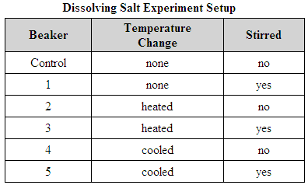
Aaron investigates the time for 10 grams of table
salt to dissolve in 100 milliliters of water. He sets
up six beakers, using the information in the table.
In which beaker will the salt dissolve the fastest?

A. Control Beaker

B. Beaker 1

C. Beaker 2

D. Beaker 3

E. Beaker 4

F. Beaker 5

--------------------------------------------------------------------------------------------------------------------------------------------------------------------------------

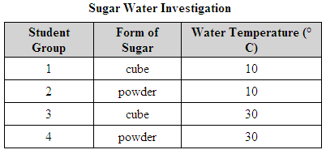
Four student groups pour equal masses of sugar into
equal volumes of water. The table lists the differences
in conditions for each group. Which group should have
the most rapid dissolving rate?

A. Group 1

B. Group 2

C. Group 3

D. Group 4

