From The new york times’ sunday book review:

CHILDREN'S BOOKS // Article written by PAMELA PAUL

Not Just Another Bear Story
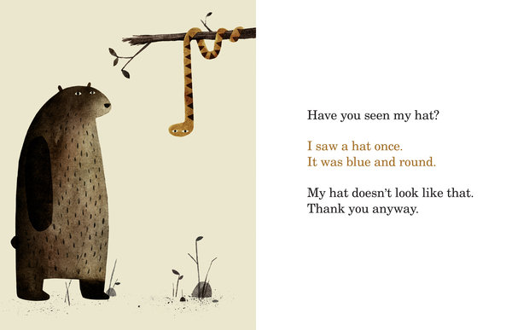
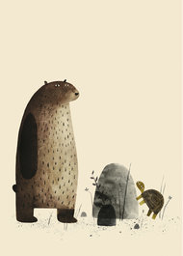
“I didn’t hit her.” “She started it.” “That’s not my mess.” Young children are bad — pathetically, often annoyingly, occasionally heartbreakingly — at making excuses. Most of them are terrible liars. It’s sometimes even funny.

I WANT MY HAT BACK
Written and illustrated by Jon Klassen

So children will recognize, perhaps with a touch of embarrassment, the lies and excuses in “I Want My Hat Back,” the first book written and illustrated by Jon Klassen, a Canadian-born illustrator who previously illustrated “Cats’ Night Out” by Caroline Stutson. And this will make them want the book read aloud again and again, a prospect likely to delight parents much more than listening to their own children’s excuses.
“I Want My Hat Back” is a marvelous book in the true dictionary sense of “marvel”: it is a wonderful and astonishing thing, the kind of book that makes child laugh and adult chuckle, and both smile in appreciation.
The seemingly simple story is told with considerable sophistication. A nameless, nearly expressionless bear is looking for his hat. One by one, he asks the forest creatures he encounters whether they have seen it. “No,” says a frog. “I have not seen any hats around here.” “I saw a hat once,” replies a snake. “It was blue and round.” “What is a hat?” a clueless possum responds. To each, the bear, dejected, is nonetheless unfailingly polite: “Thank you anyway.”
He responds this way as well to a rabbit, even though the rabbit sputters, “I would not steal a hat. Don’t ask me any more questions,” and is drawn with a red, cone-shaped hat on his head (though the bear at first fails to notice). The muted brown palette shifts to an angry red when the bear realizes, “I have seen my hat.”
Revenge is his. The rabbit suffers his due. More lying ensues. None of the behavior is particularly commendable (except for the bear’s good manners), but the actions and attending emotions are all recognizably animal-like and human. It may take younger children a few readings to understand the story in full, but when they do, they will savor it all the more.
Adult readers, for their part, will surely anticipate Klassen’s next picture book in the same way they yearn for a new Mo Willems or relish a William Steig classic. This is a charmingly wicked little book and the debut of a promising writer-illustrator talent. I wish I could say, “I discovered this book first.” But I expect anyone who has already read it — the book was published late last month — would see right through me.

