Bellringer #4
Using a chart of densities, Gracie wants to confirm the metal used in a ring. She measured the volume of the ring and found it to be 1.62 cubic centimeters (cm³). The mass of the ring is as shown. What is the metal composition of the ring?
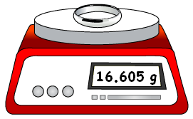
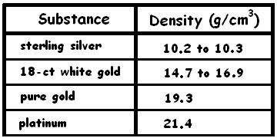

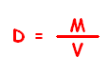
--------------------------------------------------------------------------------------------------------------------------------------------------------------------------------

Recall, density is mass per unit volume and can be represented by the formula:
where, D =
M =
V =
Steps to solve a density word problem.
Step 1: Write variable list with correct units.
Step 2: Write formula.
Step 3: Substitute in formula with correct units.
Step 4: Write answer with correct units
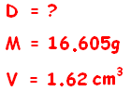
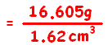
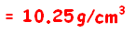

Therefore, the metal in the ring is .

