BR #25
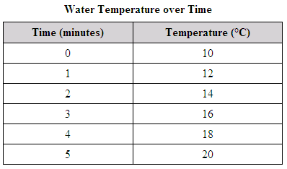
Breana recorded the temperature of a sample
of water in the laboratory every minute for five
minutes, as shown in the table. Which graph
correctly displays this data?

