Bellringer #33
After studying the two types of reactions below, Katelynn was able to classify endothermic and exothermic reactions.
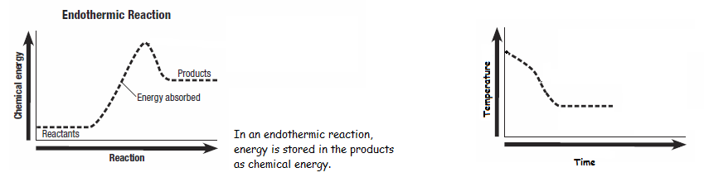

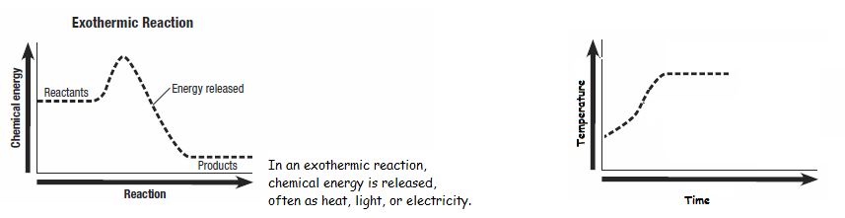

She noticed that during a chemical reaction the temperature decreased. Katelynn decided that the reaction represented an endothermic reaction.
Katelynn also was able to determine which process does not represent an exothermic reaction.
1 – production of electricity
2 – production of light
3 – release of gas
4 – release of heat

