What to Read in Mythology:
Part 1
The Gods: The Titans and the Twelve Great Olympians
How the World and Mankind Were Created

Part 2
Cupid and Psyche
Eight Brief Tales of Lovers:
Pyramus & Thisbe, Orpheus & Eurydice, and Pygmalion & Galatea
The Quest of the Golden Fleece
Four Great Adventures (all)
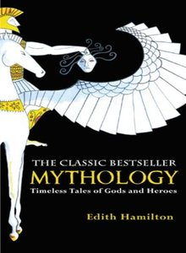

Part 3 (all)

Part 4
The Trojan War
The Fall of Troy
The Adventures of Aeneas

Part 5
The House of Atreus
The Royal House of Thebes

Part 6
Midas

Part 7 (all)

Please note: This is a non-fiction book, and at times it functions as a reference text. There are a number of names, places, conflicts, and such mentioned in text. A reading guide has been provided to help you collect facts and organize the information you find while reading. This reading guide will not be reviewed in class. Instead, we will de enrichment and writing exercises that go deeper into the text. However, you may find it easiest to get ready for your test by completing this study guide.

The reading guide provided covers all of Mythology. However, the following questions refer to sections of the book you will not be tested on.
#1-6
#11-31
#45-51
#60
#62-65
#135-139
#177-185
#188-219

Testing guidelines: The test on Mythology will be given on ____________. There will be ____________ questions. The grade from this test counts as 20% of your grade for the 2nd grading period.

