Current Events Report Sheet
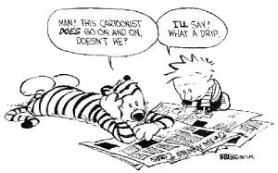

Name:________________________________________

Source:_______________________________________ Date of Source:_____________

Who is the article about? ___________________________________________________

________________________________________________________________________

________________________________________________________________________

What is it about? _________________________________________________________

________________________________________________________________________

________________________________________________________________________

Where did this event happen? _______________________________________________

________________________________________________________________________

________________________________________________________________________

When did this event take place? ______________________________________________

________________________________________________________________________

Why did this event happen? _________________________________________________

________________________________________________________________________

________________________________________________________________________

(Complete back)

Answer each in a well developed paragraph.

How could this event potentially affect you?

________________________________________________________________________

________________________________________________________________________

________________________________________________________________________

________________________________________________________________________

________________________________________________________________________

________________________________________________________________________

________________________________________________________________________

________________________________________________________________________

________________________________________________________________________

________________________________________________________________________

________________________________________________________________________

What is your opinion on this subject and why did you choose this news story?

________________________________________________________________________

________________________________________________________________________

________________________________________________________________________

________________________________________________________________________

________________________________________________________________________

________________________________________________________________________

________________________________________________________________________

________________________________________________________________________

________________________________________________________________________

