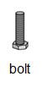
Bellringer #1
How can Damian determine the volume of the bolt pictured at right?

--------------------------------------------------------------------------------------------------------------------------------------------------------------------------------
To determine the volume of an irregularly shaped solid,
you can use water displacement.

1. Fill a graduated cylinder about half full of water.
2. Read the volume of water in the graduated cylinder.
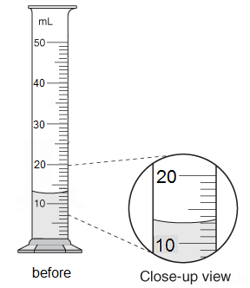

RECORD THE VOLUME READ: 13.0 mL (read the bottom of the meniscus)

3. Place the object into the graduated cylinder of water.
4. Read the new volume of water with the object in the graduated cylinder.
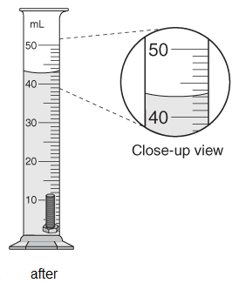

RECORD THE VOLUME READ: 43.0 mL

5. The volume of the object is calculated by subtracting
the old volume from the new volume.

Volume of Bolt = New Volume – Old Volume (show calculations)

V = 43.0mL - 13.0mL = 30mL

RECORD THE CALCULATED VOLUME: 30.0 mL

