Bellringer #17
Ashlyn wants to see how well different glassware can measure volume. She measures the volume of exactly 50 grams of water in several different sizes of graduated cylinders and beakers. She records each result with the correct number of significant digits. What is the independent variable in this investigation?

instrument precision
volume of the glassware
water mass
water volume

--------------------------------------------------------------------------------------------------------------------------------------------------------------------------------

Garrett is finding the volume of a metal object by displacing water in a graduated cylinder. The total volume of metal is approximately 10 cubic centimeters. Which cylinder will provide the most precise volume for the object? [HINT: The smaller the increments of the equipment used, the more precise the instrument.]

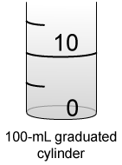
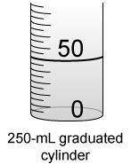
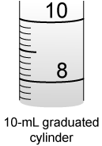
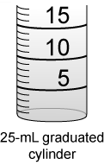

NOTE: The 10-mL graduate is the most precise tool listed. However, it does not fit this example because the metal is about 10cc (10cc = 10mL). Therefore, finding the volume by water displacement would cause the water to overflow the 10mL graduate. Thus, the next increment size is most precise for this example.

