Bellringer #7
Jayla recorded measurements for three objects to compare their densities. Create a table that most easily compares the densities of these three objects
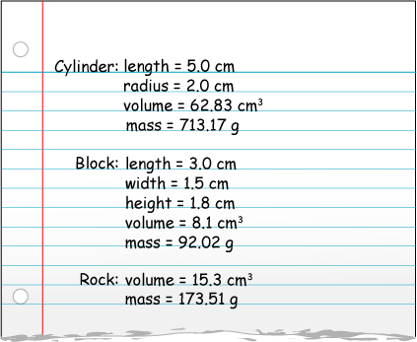

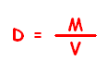
--------------------------------------------------------------------------------------------------------------------------------------------------------------------------------
Step 1. Recall the formula for density:
Step 2. Decide on what is necessary to include in table, number of columns and rows and labels of each.
Step 3. Fill in table with values from notes.
Step 4. Remember to give the table a title.
