Bellringer #34
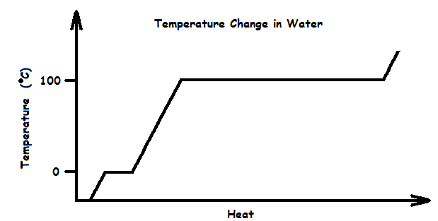
Camrin has become an expert on the Kinetic Theory of Matter. After studying the graph below, he is able to determine what happens to the heat added to water in the time periods where the graph has no slope.

1 - It breaks weak bonds between water molecules.
2 – It causes the molecules to move faster.
3 - It is radiated as light in all directions.
4 – It is stored in chemical bonds within the water molecules.
--------------------------------------------------------------------------------------------------------------------------------------------------------------------------------
Kennedi shows Camrin that she’s also an expert in the Kinetic Theory of Matter. She conducts an experiment in which a metal vaporizes at a temperature of 3000ºC. Which statement below correctly describes the changes that occur at the atomic level when this sample of metal reaches that temperature?

1 – Covalent chemical bonds between the metal atoms break, releasing heat.
2 – The distances between the metal atoms increase dramatically as the atoms break free of one another.
3 – The metal atoms start losing electrons.
4 – Rigid lattices holding the metal atoms in place break apart & the atoms start moving much more rapidly.
--------------------------------------------------------------------------------------------------------------------------------------------------------------------------------
Ainsley, not to be outdone by Camrin and Kennedi, has also become an expert in the Kinetic Theory of Matter. She knows that temperature is a measure of the average kinetic energy of the particles in a substance. She picks out which model below best shows how kinetic energy in a liquid changes with temperature.

1 – A computer simulation that shows how particle speed changes with temperature.
2 – A graph that shows how the speed of an object changes as it falls to the ground.
3 – Three diagrams of particles that show how particles spread out at higher temperatures.
4 – Three glasses of liquid water at 10ºC, 25ºC, and 50ºC.

