Name ___________________________________________________ Period ________ Date _______________
Objectives of this worksheet:
- Practice map reading skills.
- Identify the nations who are members of OPEC.
- Realize that other nations who are not in OPEC also produce petroleum.
- Recall the top nations who supply oil to the US.
- What does OPEC stand for? ________________________________________________________

- How many nations are members of OPEC? __________

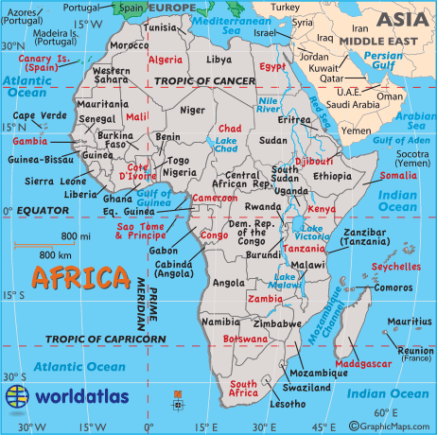
- On the map below, identify and name the members of OPEC.
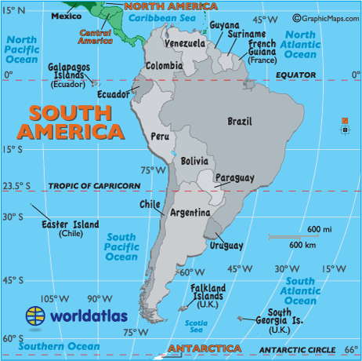

- List the members of OPEC. ______________________________________________________

_____________________________________________________________________________

- Who are the top 10 nonOPEC oil producing nations? 1. ______________________________

2.__________________________ 3. _____________________________ 4. ____________________

5_________________________ 6-_______________________________7.-_____________________

8_________________________ 9_______________________________ 10______________________

- Put the following world regions in order of greatest to least petroleum producer.
- North America
- Middle East and North Africa
- Russia
- Central and South America

LOCATE THESE REGIONS ON THE WORLD MAP
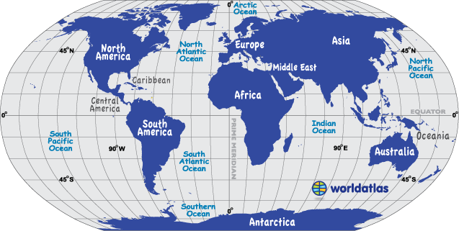

- Match the following countries with what their next commodity would be after oil. (as reported by fellow students in their presentations.)

Angola
Algeria
Lybia
Kuwait
Ecuador
Relies on petroleum only.
Tourism, beaches
Farming, fishing, tourism
Minerals
Diamonds

