Bellringer #39
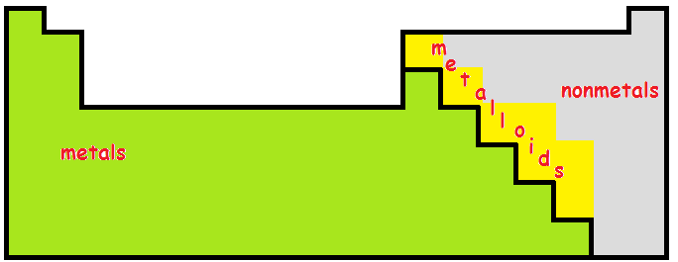
Madison was tutoring Gavin in Physical Science. She explained how the Periodic Chart is arranged.

--------------------------------------------------------------------------------------------------------------------------------------------------------------------------------
Kristy and Timothy were trying to determine what kind of bonds are made with what kind of elements. Kristy concluded that ionic bonds are formed between metals and nonmetals , while Timothy decided that covalent bonds occur between two nonmetals .
--------------------------------------------------------------------------------------------------------------------------------------------------------------------------------
Bennett reminds Madison, Gavin, Kristy, and Timothy that they should be careful not to include the very top left element as a metal because it’s really the element hydrogen , which is definitely a nonmetal. It is placed in column 1 because of its one electron .
--------------------------------------------------------------------------------------------------------------------------------------------------------------------------------
Michael also reminds them that while those elements in the last column to the right are nonmetals, they are the noble gases or the inert gases , which means that they do NOT form bonds for the most part.

