Bellringer #36
Justin learned how to use his periodic chart to determine the kinds of ions that will form when atoms gain or lose electrons. He knows that the outer shells want to have 8 e⁻ (an octet) in order to be stable. So if an atom has 1 e⁻ in its outer shell, it will tend to lose that 1e⁻ to become stable, and thus, become positively 1 charged. If an atom has 7 e⁻ in its outer shell, it will tend to gain 1 e⁻ to become stable, and thus, become negatively 1 charged. So Justin determined the following trend.
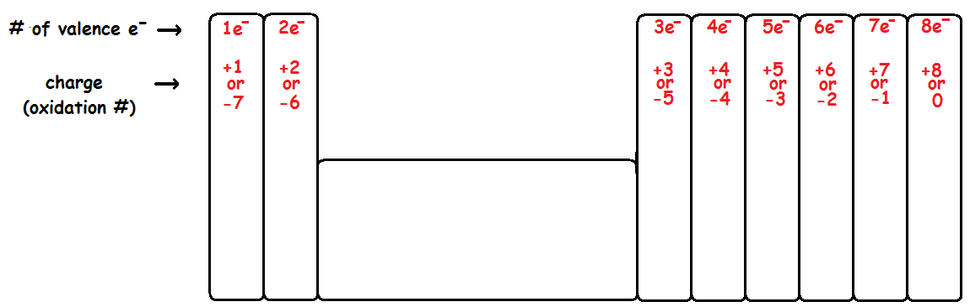

--------------------------------------------------------------------------------------------------------------------------------------------------------------------------------
Hogan figures that it is easier to gain or lose fewer electrons than it is to gain or lose a lot of electrons. So he uses Justin’s chart to help determine the ions formed by each of the following.

calcium – Ca⁺²
chloride – Cl⁻
fluoride – F⁻
magnesium – Mg⁺²
sodium - Na⁺

--------------------------------------------------------------------------------------------------------------------------------------------------------------------------------
Amber also uses Justin’s chart to determine number of valence electrons in the following atoms.

aluminum - 3
beryllium - 2
calcium - 2
chlorine - 7
fluorine - 7
helium - 2 (He only has 2e- total. Its outer shell (1s) is complete with 2e⁻.)
magnesium - 2
sodium - 1

