MR. Wray’s Reconstruction Webquest

I. Policies Regarding Reconstruction
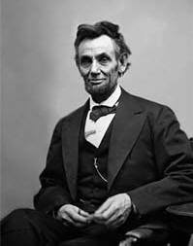A. Describe Lincoln’s plan for reconstruction of the
South.
B. What opposition did he face?
C. What happened to Lincoln?

http://www.infoplease.com/ce6/history/A0860645.html

D. In what way was Johnson’s plan for
reconstruction different from Lincoln’s?

http://www.infoplease.com/ce6/history/A0860646.html

E. How did the Radical Republicans respond to Johnson’s policies?
F. Did congress have a legitimate reason for impeaching Johnson?

http://www.ohiohistorycentral.org/entry.php?rec=509

II. Struggles of the Freedmen
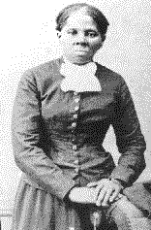A. Once the slaves were free, what were some of the problems would they be forced to face (read "Condition of the Former Slaves.")?

http://www.civilwarhome.com/freedmen.htm

B. What were the Black Codes?

http://www.spartacus.schoolnet.co.uk/USASblackcodes.htm

C. What were the Jim Crow Laws?
D. Give some examples.

http://www.nps.gov/malu/forteachers/jim_crow_laws.htm

E. Why was the first Ku Klux Klan formed?
F. In what ways did the members frighten and abuse African Americans?

http://www.infoplease.com/ce6/history/A0859144.html

III. Amendments 13, 14, & 15
A. Why was the first Ku Klux Klan formed?
B. In what ways did the members frighten and abuse African Americans?

http://www.usconstitution.net/const.html#Am13

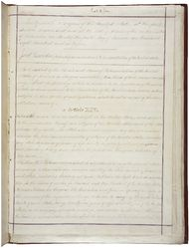 C. Using geography and political affiliations tell who
was most in favor of the 13th Amendment.
Explain.

http://www.u-s-history.com/pages/h127.html

D. Describe one of the earliest attempts to abolish slavery
and explain why it was unsuccessful.

http://memory.loc.gov/ammem/today/jan31.html

E. How did the 14th Amendment attempt to guarantee the freedoms of African
^{Americans?}
F. Why was the 14th Amendment unsuccessful in guaranteeing equal rights to
African Americans born in the United States?

http://en.wikipedia.org/wiki/Black_codes_in_the_USA

Everyone answer the following:
A. What Supreme Court decision put an end to
^{Segregation?}
B. What reasons did the court state for its decision?

http://www.nationalcenter.org/brown.html

