Bellringer #23
Bethany has some foreign coins in her collection. The penny is composed of pure lead, and the shilling is composed of sterling silver, an alloy of silver and copper. Which statement correctly identifies the type of matter for both coins?
------------------------------------
A. Both coins are compounds because they are both made of metal.
B. Both coins are mixtures because they are both made of metal.
C. The penny is made of an element because it is pure lead, and the shilling is a compound because it is made of more than one metal.
d. The penny is made of an element because it is pure lead, and the shilling is a mixture because it is an alloy.

--------------------------------------------------------------------------------------------------------------------------------------------------------------------------------
One of the first laboratory activities in Physical Science class is to observe a burning candle. Which two safety practices are most important for this activity?
A. Have a beaker of water to put out fires and use safety tongs.
B. Tie back long hair and fasten loose clothing.
C. Use paper towels to catch wax drips and use a gas lighter to ignite candles.
D. Wear closed-toe shoes and use an insulated glove.
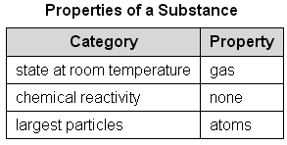
--------------------------------------------------------------------------------------------------------------------------------------------------------------------------------
Norman produces this table of known properties of a
substance. Based on this information, Norman should
classify the substance as

A. a homogeneous mixture.

B. a heterogeneous mixture.

C. a compound.

D. an element.

