Name ____________________________________________________________ Date _____________
Homework

1. At a fancy vegetable stand, Jim bought purple tomatoes for $ 5 each and Aubrey bought organic giant cabbages for $14 each. In total, they paid $132 for 12 vegetables. How many cabbages did Aubrey buy?

a. 5 b. 6 c. 7 d. 8 e.9

Method, show why:

2. If w is a positive integer and (3^{w})^{w} = 3¹⁸*3¹⁸, then what is the value of w?

a. 5 b. 6 c. 7 d. 8 e.9

Method, show why:

3. Nine cups of flour are required to make a batch of cookies. How many cups of flour are requires to make enough cookies to fill 16 cookie jars, if each cookie jar holds 1.5 batches?
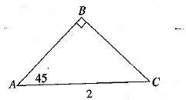

4. In triangle ABC, if AC = 2, what is the length of segment AB?

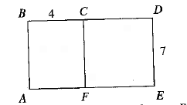

5. In the figure, the perimeter of square FCDE is how much smaller than
the perimeter of rectangle ABDE?

6. If f(g(x)) = 3, f(x) = $\frac{x}{2}$ + 2 and g(x) = x³ – 10 which of the following is a possible value of x?

a. 0 b. 1 c. 2 d. 3 e.4
Method, show why:

7. The length of a certain rectangle is three times the width. If the area of the rectangle is 192, what is the length of the rectangle?

a. 5 b. 8 c. 11 d. 14 e.17
Method, show why:

8. If 4^{n−2} + 4² = 32, then what is the value of n ?

a. 2 b.4 c. 6 d. 8 e. 10

