Bellringer #40
Dre, Daisy, Caleb, and Brennan argued about Rutherford’s motive for doing experiments concerning the model of the atom when Thomson had already explained it. Who is right?

Dre said that Rutherford wanted to find an explanation for an incident not explained by Thomson’s model.
Daisy believed that Rutherford wanted to get famous for discovering something new that would put Thomson to shame.
Caleb stressed that Rutherford wanted to join in with other scientists who felt a new atomic model was needed.
Brennan pointed out that Rutherford wanted to save the incorrect information from Thomson’s experiments to make a model to compete with Thomson’s model.

--------------------------------------------------------------------------------------------------------------------------------------------------------------------------------
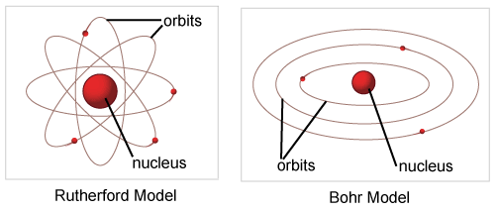
A comparison of Rutherford’s and Bohr’s atomic models illustrates that both models show electrons orbiting a central nucleus. Four students are trying to decide what caused Bohr to change Rutherford’s theory of atomic structure. Who found the evidence that caused Bohr to change how atomic structure is pictured?

Darius found that the formation of ionic compounds indicates that electrons may transfer from one atom to another.
Draik learned that light emissions indicate that atoms have multiple energy levels.
Kaylee uncovered measurements indicate that different atoms have different masses.
Taylor read that radioactive decay indicates that atoms are not the smallest particle of matter.

--------------------------------------------------------------------------------------------------------------------------------------------------------------------------------
Scientists have described elements as being made up protons, electrons, and neutrons that could not be broken into smaller parts. However, new experimental results reject this explanation. Daniel knows why. Daniel share with the class what you know about this subject.
Daniel knows that in the big cyclotrons like the one found in central Europe atoms are allowed to spin around at very great speeds. The high energy collisions between the nuclei of these atoms results in the creation of new particles.

