Name _____________________________________ Per ______ Date __________

In 1996, the EV1, was among the fastest, most efficient production cars ever built. It ran on electricity, produced no emissions and catapulted American technology to the forefront of the automotive industry. The lucky few who drove it never wanted to give it up. So why did General Motors, in 2002, crush its fleet of EV1 electric vehicles in the Arizona desert when so many people were willing to buy them?

Who Killed the Electric Car?
Facts:
- EV1 was made by Saturn a division of GM
- 100 years ago there were more electric cars on the road than gas engine cars
- Nickel metal hydride batteries can take the car 60 – 100 miles on a full charge
- It only took 1 hour for the car to charge up to 85%
- The equivalent amount of electricity to one gallon of gas costs just $.60, not $2.50/gal
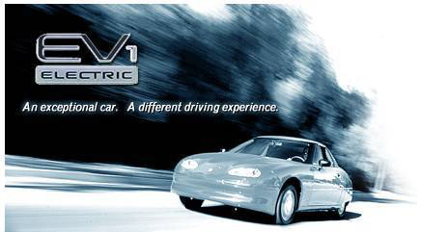

Other Electric Vehicles:

- ______________________________

- ______________________________

- ______________________________

- ______________________________

- ______________________________

- ______________________________
Substitutions for the Gas Engine
- Hybrids (Toyota Prius) uses batteries at low speeds and gasoline at high speeds.

- Plug-In Hybrids have a more powerful battery and can go 100 miles on one gallon of gas.

- Ethanol or “Flex Fuel” is used by GMC and Chevrolet. It is derived from sugar or corn.

- Biodiesel comes from plants or animals sources. Vegetable oil or animal fats are mixed with alcohol.

- Lithium-ion (Li-ion) batteries are more powerful than Nickel hydride batteries used in some hybrids already.

- Hydrogen fuel cells need more energy to isolate the hydrogen than it saves. This technology is still far away.

Suspects in the Murder of the EV1

- Car Companies Guilty or Not Guilty
WHY?

- Oil Companies Guilty or Not Guilty
WHY?

- Batteries Guilty or Not Guilty
WHY?

- C.A.R. B. California Air Research Board Guilty or Not Guilty
WHY?

- Consumers Guilty or Not Guilty
WHY?

- Government Guilty or Not Guilty
WHY?

- Hydrogen Fuel Cells Guilty or Not Guilty
WHY?

What do the following phrases mean? CIRCLE the correct meaning below.

US dependence on foreign oil a) The US controls foreign countries through giving them oil, or
b) The US needs foreign countries to provide oil to run many of our machines.

Air Pollution causes Global Warming a) Emissions from factories and cars dump greenhouse gases into the atmosphere, or b) A lie that people who are in favor of EV cars have made up.

Zero Emissions a) Cars are not allowed to produce any exhaust from their tailpipes, or b) when car companies admit that EV cars are worth zero dollars.

PROS of the EV CONS of the EV

