Jersey City Public Schools
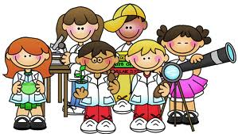

Science Fair packet

Science Project and its Purpose

Scientists all over the world make new discoveries by using the scientific method. Now, you too can be a scientist! A science project is your chance to choose a subject of interest to you and study it in the exact same way that a professional scientific researcher would.
The purpose of the science fair is to give you a chance to explore on your own. Exploration can be a lot of fun. Instead of reading about topics such as composting in a book, you can do experiments comparing store-bought fertilizer to compost that you have made. You may try to figure out what weather patterns would be like if the Earth were square. Or, you can discover what types of plants attract butterflies. Maybe you would like to build a machine to sort your lego pieces by color. The science project presents your creative solution to a question or problem.
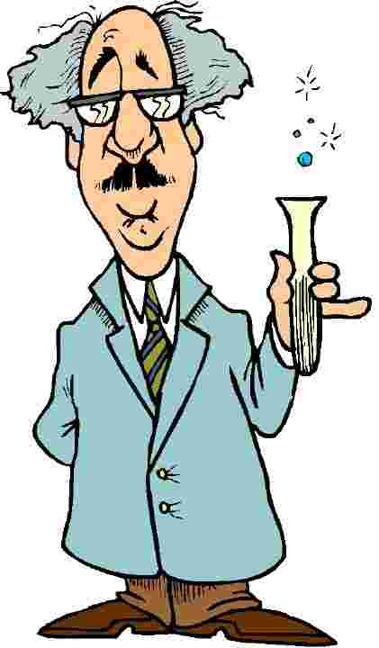
The Scientific method
The scientific method is a way to ask and answer scientific questions by making observations and doing experiments. The steps of the scientific method are:
Find a Problem
Ask a “How does” question
Research the Problem
Find out all you can

Conduct the experiment
Find out if you were right
Make a Hypothesis
Predict what might happen based on what you know

Compile proof by recording data
Do your experiment several times
Organizing your data in tables and graphs
View the results
Form a conclusion
Check your hypothesis against the results… were you right?

Write about what you learned and how it applies to the real world
Come up with another problem for future research
Step 1: Coming up with a good question…

Now that you have picked out a topic that you like and that you are interested in, it’s time to write a question or identify a problem within that topic. To guide you, you can fill in the blanks with the following list of words:

The Effect Question:
What is the effect of _______________ on ______________?
Sunlight the growth of plants
Oil a ramp

The How Does Affect Question:
How does the __________________ affect _______________?
Color of light the growth of plants
Humidity the growth of mold

The Which/What and Verb Question:
Which/What ___________________ (verb) ______________?
Paper towel is most absorbent
Foods do mealworm prefer

Now it’s Your Turn:
Create your science fair question using either the “Effect Question”, the “How does Affect Question” or the Which/What and Verb Question”:
____________________________________________________________________________________________________________________________________________________________

Choosing a category that interests you…
All great projects start with great questions. But before you get started on a great question, you need to pick a subject or topic that you like. There are three different categories in the science fair. They are:
Life Science: This category deals with all animal, plant and human body questions that you might have and want to do an experiment about. Remember that it is against Science Fair Rules to intentionally hurt an animal during an experiment. Life science also includes studying behaviors. You could perform taste tests, opinion surveys, training a pet or teaching your baby brother or sister how to do something.
Physical Science: If you like trying to figure out how things work, then this is the category for you. It includes topics about matter and structure, electricity, magnetism, sound, light or anything else that you might question, “How does it work and what if I do this to it, will it still work?” It also includes the experiments that bubble and ooze. It is the perfect category to try to mix things together to see what will happen. Caution: Always perform these experiments in a presence of an adult.

Earth and Space Science: This category is also awesome because it covers all sorts of topics that deal with the Earth or objects in space. This includes studying weather and astronomy. Astronomy is the study of all that is in space, including the stars, our sun and our planets.

Now it’s Your Turn:
Write down your favorite Science Fair Category and what it is you want to learn more about:
My favorite category is _________________________
(Life Science, Physical Science, Earth & Space Science)

I want to do an experiment involving:
________________________________________________________________________________________________________________________________________________________________________________________

Step 2: doing the research and forming a hypothesis
At this point, you have picked your category and you have chosen a topic. You also wrote a question using the fill in the blank template. Now it is time to research your problem as much as possible. Becoming an expert at your topic is what real scientists do. To become an expert, you need to do the following:
Read!!!
Read about your topic. Read encyclopedias, magazine articles and books from the library. You may read articles from the internet. Take note of any new Science words you learn and use them. Keep track of all the books and articles you read. You will need the list for bibliography and references.
Discuss!!!
Talk about your topic with your parents. Talk about it with your teachers. Talk about it with experts like doctors, weathermen or others who work in the area/subject you are studying. Use the internet to find an e-mail address for an expert who can answer your questions. When you think that you can’t possibly learn anymore, then you are ready to...

Write a Hypothesis
At this time PREDICT what you think will happen if you test the problem. This type of “Educated or Smart Guess” or PREDICTION is what real scientists call A HYPOTHESIS. In order to form a hypothesis, just answer the following question:
What do you think will happen, (even before you start an experiment)?
Example of Problem: Which Paper towel is more absorbent?
Example Hypothesis: I think Brand X will be more absorbent
because it is thicker and most people I
interviewed liked the brand.
Note: Scientist research to form a prediction.

Now it’s Your Turn:
Write down the problem and create a Hypothesis based on what you have researched.

Problem: ____________________________________________________________________________________________________________________________________________________________

Research: My problem is about this subject: ________________________________________________________________________________________________________
Books I found in the library on my topic are:
Title: Author:
____________________________________________________________________________________________________________________________________________________________
____________________________________________________

Internet sites that I found on my topic are:
________________________________________________________________________________________________________________________________________________________________________________________________________________

People I talked to about my topic are:
____________________________________________________________________________________________________________________________________________________________
Some important points that I learned about my topic are
- ________________________________________________
- ________________________________________________
- ________________________________________________
- ________________________________________________
- ________________________________________________
Hypothesis: I think that _______________________________ (will happen) because (my research shows…) ____________________________________________________________________________________________________________________________________________________________

Step 3: testing your hypothesis by doing an experiment
Now, you are ready to experiment. Designing an experiment is really cool because you get to use your imagination to come up with a test for your problem, and most of all, you get to prove (or disprove) your hypothesis. The following steps will guide you through your experiment:
- Gather up your materials: What materials would you need to perform your experiment? Make sure you draw or take pictures of materials used in your experiment.

- Write a procedure: A procedure is a list of steps that you did to perform an experiment. This will help others who want to try the experiment and determine if the steps are true. Think of it as a recipe to your favorite food.

- Identify your variable: The variables are any factors that can change in an experiment. Remember that when you are testing your experiment, you should only test one variable at a time in order to get accurate results. For example, if you want to test the affect that water has on plant growth, then all the plants you test should be in the same, these are called controlled variables: same type of dirt, same type of plant, same type of location, same amount of sunlight. The independent variable is the factor you are testing. The results of the test that you do are called the dependent responding variables. The responding variable is what happens as a result of your test. Knowing what your variables are is very important because if you do not know them, then you would not be able to collect your data or read your results.

- Test, Test, Test: Remember that the judges expect your results to be consistent in order for your experiment to be considered a good experiment. You need to do the experiment more than once in order to test it properly. It is recommended that you perform the experiment at least 3 times.

- Collect your Data: Write down or record the results of the experiment every time you test it. Be sure to organize it in a way that it is easy to read the results. Most scientists use tables, graphs and other organizers to display their results. Organizing makes the results easy to read and much easier to recognize patterns that might be occurring in results. Make sure results make sense.

- Write a Conclusion: Tell the judge what happened. Was your hypothesis right, wrong or neither? Were you successful, did it turn out okay? Would you change anything about the experiment or are you curious about something else now that you have completed your experiment? Most of all, tell what you learned from doing this experiment.

- Understand its Application: Write about how this experiment can be used in a real life situation. Why was it important to know about it?

Now it’s Your Turn:
Materials: (Take Pictures)
List the materials that you will need for your science experiment here:
______________________ ____________________
______________________ ____________________
______________________ ____________________
______________________ ____________________
______________________ ____________________
______________________ ____________________

Variables:
List the variables that you will control, the variables that you will change and the variables that will be the result of your experiment:

My controlled variables are (the stuff that will always stay the same): ___________________________________________________________________________________________________________________________________________________________

My independent variable is (this is the thing that changes from one experiment to the next, it is what you are testing): ________________________________________________________________________________________________________

My responding variables might be ( in other words, the results of the experiment) ____________________________________________________________________________________________________________________________________________________________
Procedure: List the steps that you have to follow in order to perform the experiment here: (write step by step instructions for someone else to follow)
- _______________________________________________
- _______________________________________________
- _______________________________________________
- _______________________________________________
- ________________________________________________
- ________________________________________________
- ________________________________________________
- ________________________________________________
- ________________________________________________
- ________________________________________________
- ________________________________________________
- ________________________________________________
- ________________________________________________
- ________________________________________________
- ________________________________________________
- ________________________________________________
- ________________________________________________
- ________________________________________________
- ________________________________________________
- ________________________________________________
- ________________________________________________
- ________________________________________________

Design a table or chart here to collect your information: Create a table or use graph paper to make a graph of your results. Whatever you are doing, be sure to take pictures or a video.

Conclusion: Tell us what you learned from this experiment and if you were able to prove your hypothesis. Did it work? Why did it work or why didn’t it work? What did the results tell you? What did you prove through this experiment?
____________________________________________________________________________________________________________________________________________________________________________________________________________________________________________________________________________________________________________________________________________________________________________________________________________________________________________________________________________________

Application: (How does this apply to real life?) It is important to know about this experiment because….
____________________________________________________________________________________________________________________________________________________________________________________________________________________________________________________________________________________________________________________________________________________________________________

Suggested Setup for Science Fair Display Board
Title
Purpose
Hypothesis
Research Report
Materials
Picture
Picture
Procedure
Results
Picture
Variables
Conclusion
Application
Resources
Picture

