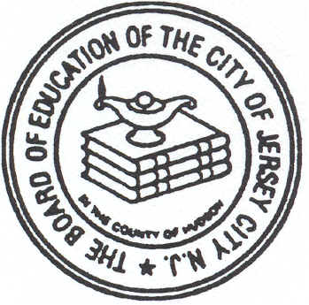
182 MERSELES STREET JERSEY CITY, NJ 07302
THE JERSEY CITY PUBLIC SCHOOLS
PUBLIC SCHOOL #5
DR. MICHAEL CONTI SCHOOL
201-714-4300

OFFICE OF THE PRINCIPAL
MR. JOHN J. RIVERO

September 5, 2013

Dear Parent/Legal Guardian:

Welcome to the Dr. Michael Conti school! I am very proud and honored to have been named Principal of P.S. # 5 this past June and I look forward to working collaboratively with all of you to continue our school’s record of success. Every day our students recite our school pledge, “At Conti, we believe we can achieve!” and with this goal in mind we strive for excellence every day. We are committed to promoting student achievement while at the same time making our school a safe and exciting place where children love to come and learn. We are counting on your support and trust that you will become a contributing member of our school family so that we can all share and work towards a common vision for our children’s success.

I am attaching a Parent Guide to the most recent New Jersey School Performance Report which covers the 2011-2012 school year. I am very pleased to announce that in the area of academic achievement, our performance was rated “very high” and outperformed 83% of our “peer schools” with whom we share similar demographic characteristics such as similar grade levels, percentage of English language learners, special education students, and percentage of students qualifying for free or reduced lunch. With respect to Student Growth, P.S. # 5 outperformed 80% of our peer schools and 59% of schools statewide. Student Growth measures the performance of students from one year to the next in the Language Arts and Math portions of the NJ-ASK. The entire report formerly known as the School Report Card can be accessed online at http://education.state.nj.us/pr/ .

We are very proud of our achievements but realize that we have “bigger mountains to climb.” Our goal at the Dr. Michael Conti school is to strive each day to make it better than the day before in order to achieve greater school success. This year, in addition to fully implementing our instructional programs, the Dr. Michael Conti school will be focusing on re-introducing Project Based Learning (PBL) into the Kindergarten through Grade 8 curriculum. PBL integration will be systemic but gradual and we are confident that it will result in greater gains in content understanding (driven by the Common Core State Standards -CCSS), higher order/ critical thinking skills, real world/life application and technoloy utilization.

Finally, I am excited to announce that we will be inaugurating your very own Parent Resource Room this coming Fall. As Principal, my goal is to strengthen our home-school partnership and believe firmly that working productively and collaboratively will result in our students’ positive academic, social, and emotional development. I look forward to seeing you at the school and especially on Open House next Tuesday, September 10, 2013 at 6:30 pm.

Yours truly,

