SWSD Media Center Curriculum Unit 3
#41 Reduce-Renew-Reuse (& Recycling Assembly with Bill Kerwood)
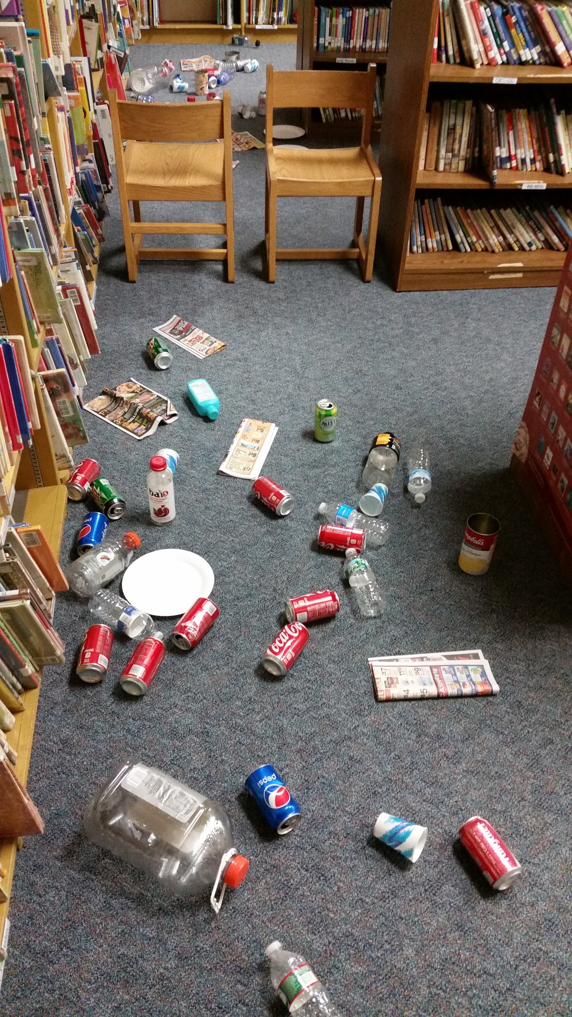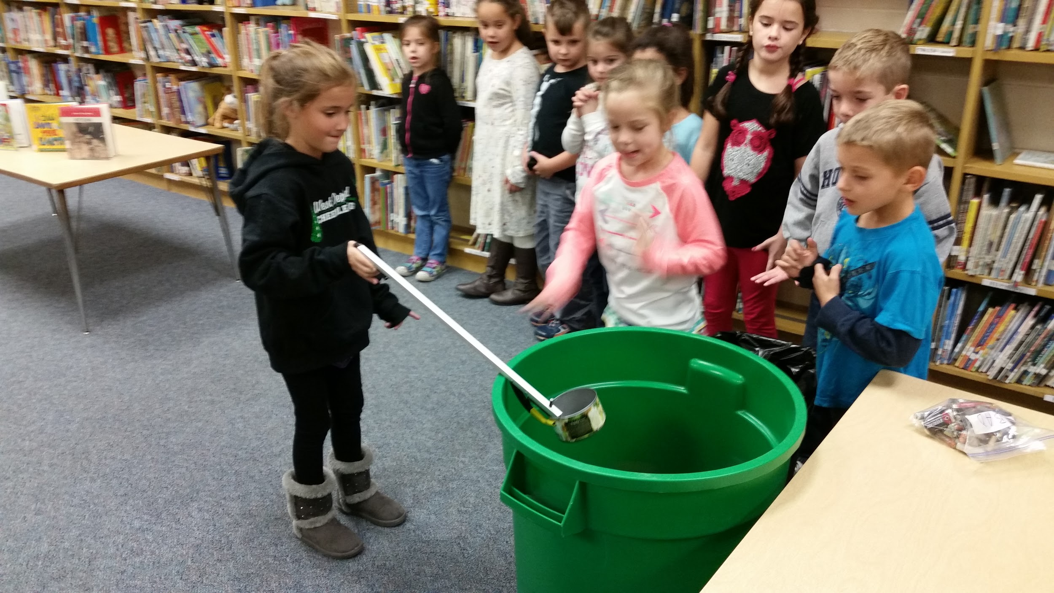
(Lower elementary)

Targets

Students will…
- understand the recycling process.
- define the terms reduce, reuse, renew.
- Learn new recycling habits.

Procedure

Gather cleaned recycled containers such as plastic bottles, aluminum cans, paper, etc., as well as a few items that cannot be recycled like telephone books, clothing, and such. Spread these items on a plastic tablecloth hidden on the other side of the room from your story time and place a recycling trashcan on the opposite side. Read the students a book on recycling, like, Where Do Garbage Trucks Go?: And Other Questions About Trash and Recycling (Good Question!) by Ben Richmond. Show the students the video of Mr. Cool Can at https://www.youtube.com/watch?v=629clJ5VZFc . Split students into two teams and have them stand in a line one behind each other. Hand the first student in each line a long-handled trash grabber. Instruct them to pick up a recyclable item with the grabbers, walk it to the trashcan and place it in. Once every student has placed a recycled item in the trashcan and returned to the line, the race is complete. Say “We are all winners when we recycle!” Have the students choose a book and when they check out have them sign a flyer to take home to their parents that includes a family pledge to recycle and provides the correct recycling information for your town.
*You can arrange a recycling Earth Day assembly for your school with Bill Kerwood. He is informative, but also very funny. You can also inform whoever sets up your assemblies to contact the head of your township’s Public Works department and they may have money to pay for the assembly through their recycling program. Check out his website at: http://www.billkerwood.com/the-magic-of-recycling/
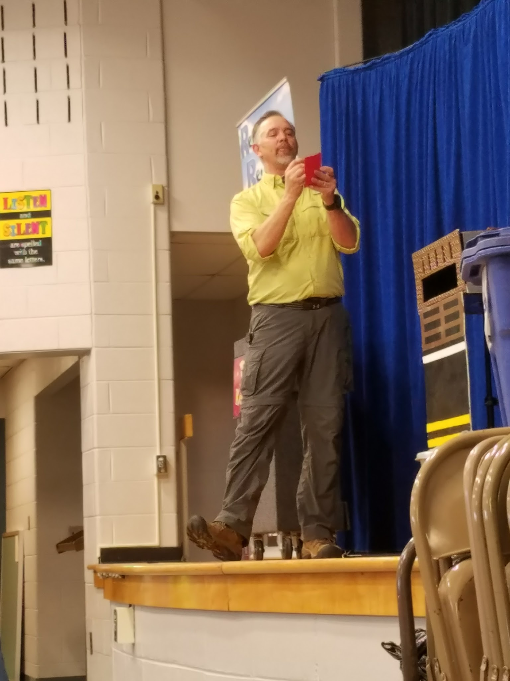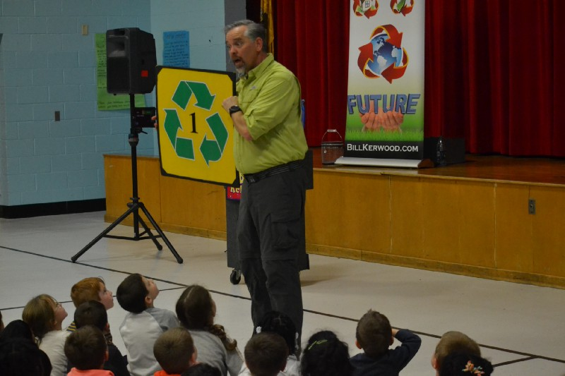
Learning Standards

Resources

Richmond, B. (2016, March 1). Where Do Garbage Trucks Go?: And Other Questions About Trash and Recycling (Good Question!) Sterling Children’s Books.
wastemanagement. (2009, July 6). Recycling for Kids with Waste Management's Mr. Cool Can [Video file]. Retrieved from https://www.youtube.com/watch?v=629clJ5VZFc

#42 Cool Recycling Projects (2-weeks)
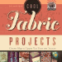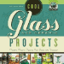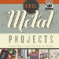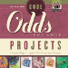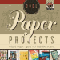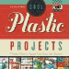
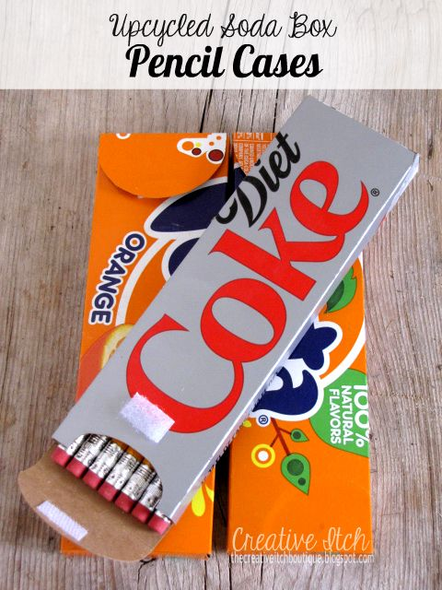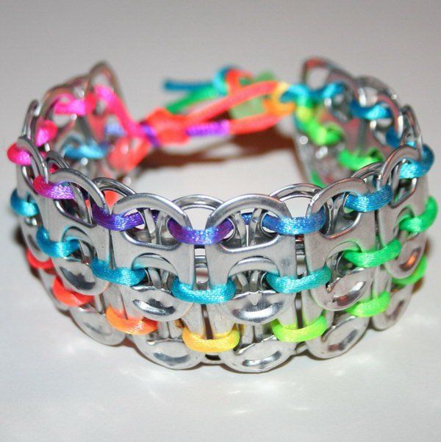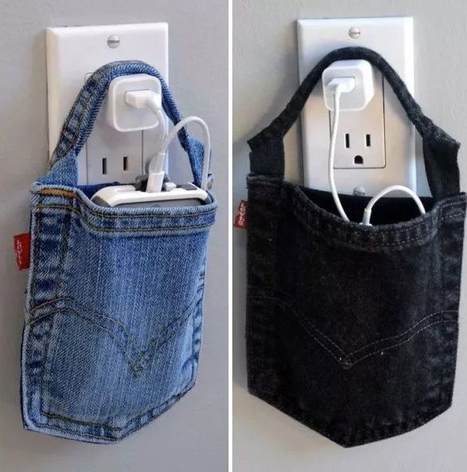

(Upper elementary)

Targets

Students will…
- understand the recycling process.
- define the terms reduce, reuse, renew.
- create a “cool project” out of recycled items.

Procedure
Purchase the Cool Projects book series by Pam Scheunemann. Show the students a video of upcycling. Have students read through the books and allow them to access appropriate websites and images to plan their cool project. Have them work on it at home and bring it in the following week for display outside each classroom as a walking tour. During the library class next week have students take turns sharing what project they made, then take the students on a tour of the cool projects throughout the school.

Learning Standards

Resources
https://www.youtube.com/watch?v=RZu3WcWrCI0

#43 Trash-to-Treasure (2-week, if necessary)

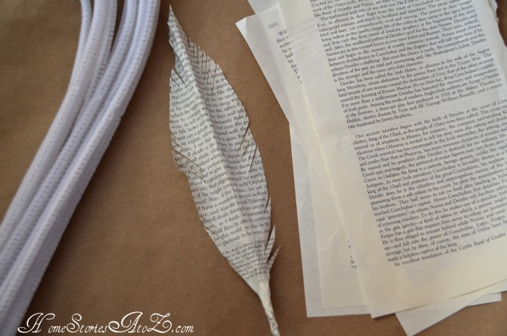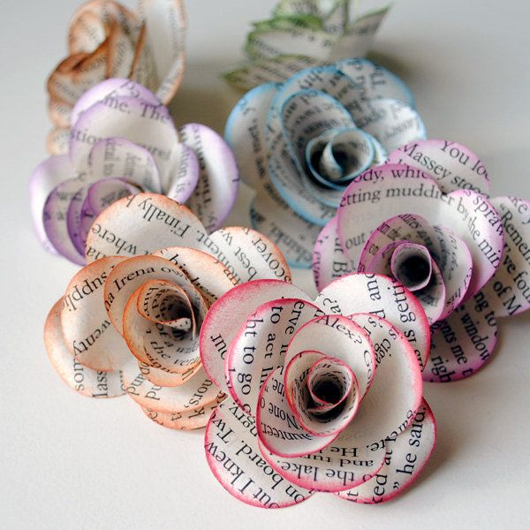
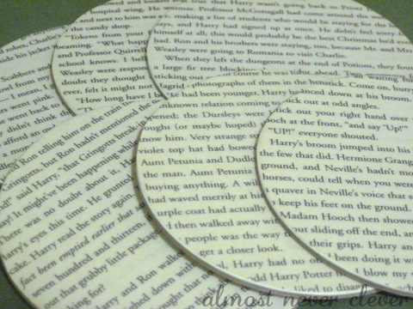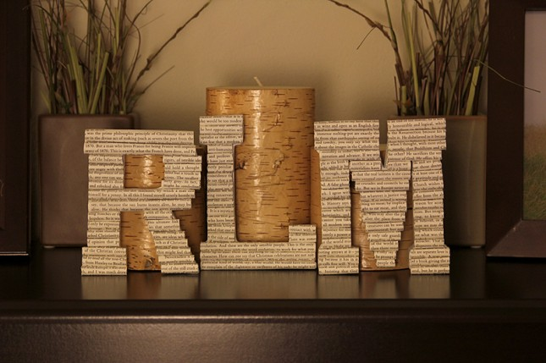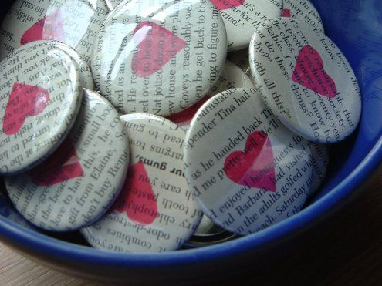
(Lower & Upper elementary)
Targets
Students will…
- learning the importance of weeding materials in the library, recycling and upcycling.
- discover and create new items that can be made from old books and materials.

Procedures
Pull Earth Day, recycling, upcycling and various craft books for display and possible student check out. Around Earth Day, promote reusing resources, even in the library. Collect damaged books and old newspaper throughout the year for this lesson. Print out various images of creations students can make with pages from old books and newspaper. Also search links to websites for old students to follow how-to instruction with their projects, if they wish.
Discuss important and fun facts about Earth Day and recycling. Inform the students that they will be creating a “weeding” project. Show them books that have been removed or “weeded” for the library collection due to age, accuracy, damage, etc. Review the importance of taking care of library resources. Have the students take some pages from the collected books or newspaper and create something new. Give each student an index card to give their project a name/title and write a brief description. At the end of the class, have students display their items on the tables throughout the library and host a walking tour.
Materials
- Old books and newspapers
- Pictures of sample creations
- Worksheet with directions and additional helpful links
- Tape
- Glue
- Index cards
- Pencils
Learning Standards

#44 Cultural Diversity & Kindness Days
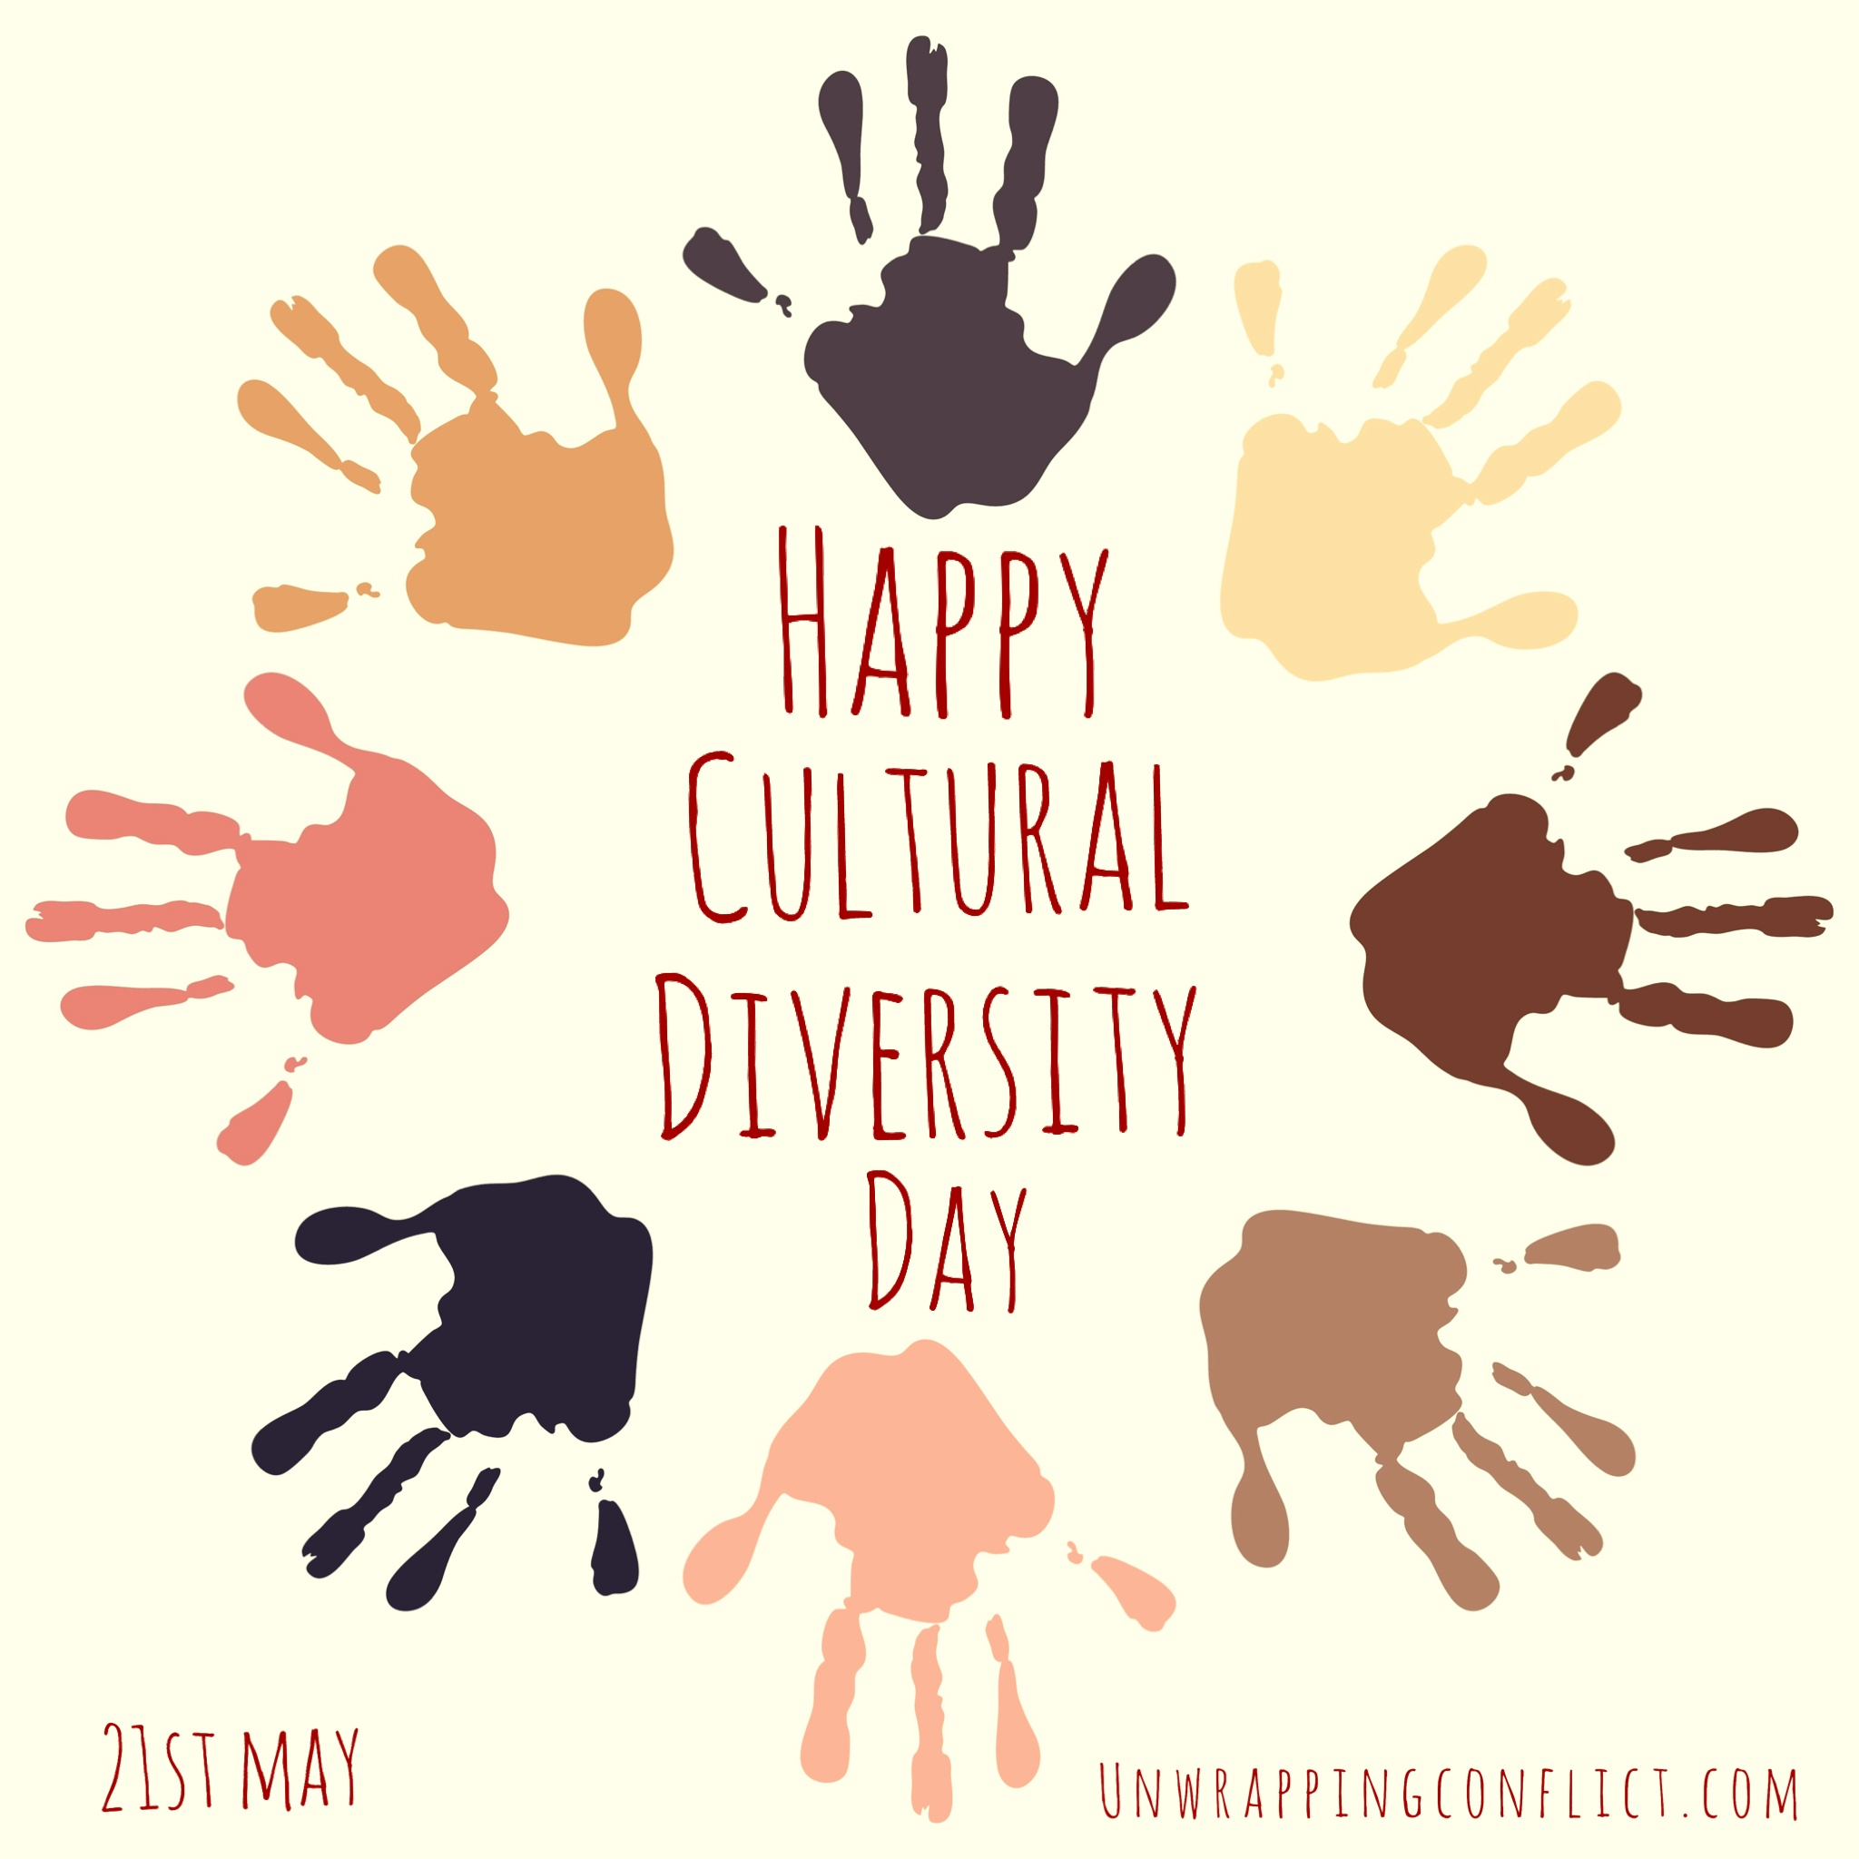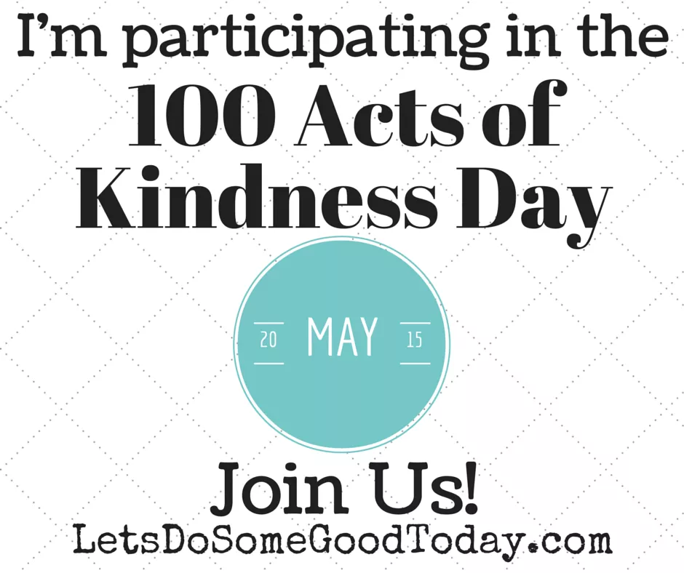
(Lower elementary)
Students will...
- learn about 100 Random Acts of Kindness Day and Cultural Diversity Day (both in May).
- acknowledge the greatness in being different and importance of random acts of kindness.
Pull cultural, diversity and being kind books for display and possible student check out. Wear and display various ethnic clothes and items. Have a globe and map of the world available during discussions. Discuss the importance of being different and yourself. Share the dates and information about World Day for Cultural Diversity and for Dialogue and Development and 100 Acts of Kindness Day.
Play the reading of It’s Okay to be Different-Read by Sherry on the smartboard. Allow time for student discussion afterward about kindness and being different. Give each student a penny and a pre-printed “random act of kindness” note. Allow students to write a short, kind message for the random recipient (tell them to NOT write their name on it). Instruct them to tape their penny on it and discuss places they could leave their penny note out in the community. Allow the students to take the note home to leave in a random spot to brighten someone’s day.
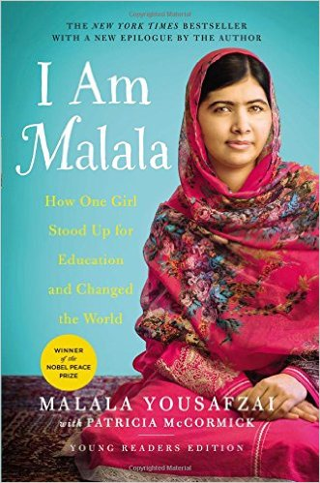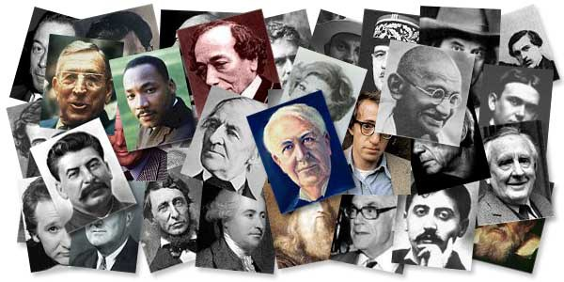
(Upper elementary)
Pull cultural, diversity and being kind books for display and possible student check out. Wear and display various ethnic clothes and items. Have a globe and map of the world available during discussions. Play the video, USA for Africa-We are the World as students enter. Afterward discuss the importance of being different and yourself. Share the dates and information about World Day for Cultural Diversity and for Dialogue and Development and 100 Acts of Kindness Day. Play the video World Day for Cultural Diversity and for Dialogue and Development.
At this time, discuss various people that have made a difference to humanity with the students. Then choose one specific person to share part of their biography and life story. I would use Malala Yousafzai. Read from the book jacket, then show a brief video about her at https://www.youtube.com/watch?v=NIqOhxQ0-H8 . Then play the video 20 Random Acts of Kindness. Give each student a same piece of paper to write a note of kindness that will be placed in various books throughout the library to be found by random students. During book check out play the second version, We are the World 25 for Haiti.
- Videos
- Books about people who changed the world
- Random Acts of Kindness notes
- Pennies

Learning Standards
AASL - Standards for the 21st-Century Learner-AASL 1.1.6 Read, view, and listen for information presented in any format (e.g., textual, visual, media, digital) in order to make inferences and gather meaning.
AASL - Standards for the 21st-Century Learner-AASL 2.1.6 Use the writing process, media and visual literacy, and technology skills to create products that express new understandings.
AASL - Standards for the 21st-Century Learner-AASL 2.2.4 Demonstrate personal productivity by completing products to express learning.
AASL - Standards for the 21st-Century Learner-AASL 2.3.1 Connect understanding to the real world.
AASL - Standards for the 21st-Century Learner-AASL 3.3.1 Solicit and respect diverse perspectives while searching for information, collaborating with others, and participating as a member of the community.
AASL - Standards for the 21st-Century Learner-AASL 3.3.2 Respect the differing interests and experiences of others, and seek a variety of viewpoints.
AASL - Standards for the 21st-Century Learner-AASL 3.3.3 Use knowledge and information skills and dispositions to engage in public conversation and debate around issues of common concern.
AASL - Standards for the 21st-Century Learner-AASL 3.3.4 Create products that apply to authentic, real-world contexts.
Resources
CNN. (2013, July 12). The story of Malala Yousafzai [Video file]. Retrieved from https://www.youtube.com/watch?v=NIqOhxQ0-H8

kamikatze07. USA for Africa-We are the World. Retrieved from https://www.youtube.com/watch?v=M9BNoNFKCBI

La Fira, S. (2014, August 23). It’s Okay to be Different-Read by Sherry. Retrieved from https://www.youtube.com/watch?v=shYf3prwXJU

United Nations. (2014, May 20). World Day for Cultural Diversity and for Dialogue and Development. Retrieved from https://www.youtube.com/watch?v=-gr8OyR1Btg

We are the World 25 for Haiti. (2010, February 12). We are the World 25 for Haiti-Official Video. Retrieved from https://www.youtube.com/watch?v=Glny4jSciVI

Yasmin, J. (2014, September 14). 20 Random Acts of Kindness. Retrieved from https://www.youtube.com/watch?v=AFTBBKIX760

#45 “Mom, Come have some tea & read with me!”
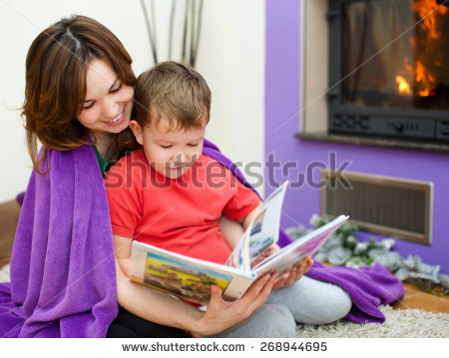
(Upper elementary)
Targets
Students will…
- learn the importance of showing Moms (or female family members) appreciation.
- create a thank you note or poem.
- inform their guests about our library, select a book to read with them.
- understand importance of helping and serving others.

Procedures
This is a great lesson to design with interdisciplinary elements. You may want to connect with grade level teachers, as well as art, music and various teachers as a joint effort to host a special Mother’s Day event. It can be hosted in the library or you can request the use of the cafeteria to be permitted to provide snacks for everyone to enjoy. *If you hold the event in the library treats can be set up outside in the hallway for the guests to take when they leave. Allow students to invite their mom or special lady in their life to their designated time. Provide the information in a flyer containing details and how to sign up. A week or two prior to this event, (during poetry month) have students cut out a tea cup and write a thank you note/poem inside for their mom or special lady to share at on that day.
Decorate the tables with artwork (possibly connect with art teacher for these pieces). Plan appropriate songs to play as moms come in set to a slideshow, which can include pictures of students and their special ladies. Welcome your guests. Possibly connect with the music teacher to teach students a song to sing. Then have a student recite a short story or poem to begin the celebration. Show a short video dedicated to moms. Allow students and their guests about 15 minutes to read together. Next have a fun hands-on activities or game planned, there are plenty of examples online, such as https://www.thespruce.com/mothers-day-games-and-activities-2104574 .

Materials
- Mother’s Day Tea event flyer/sign-up
- Tea cup card
- Tea bags
- Videos
- Artwork
- Songs
- Books
- Activity supplies
- Treats

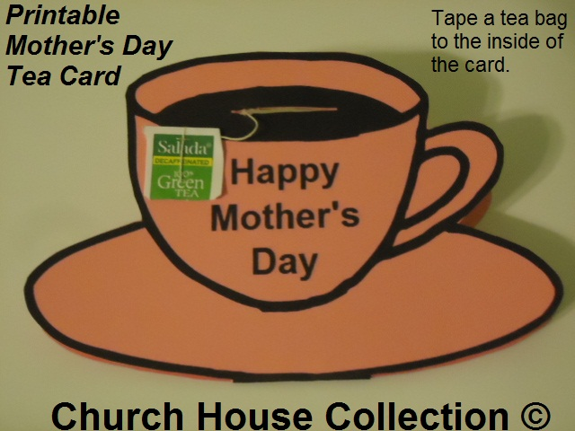
Learning Standards
Resources
SoulPancake. (2013, May 9). An Open Letter To Moms from Kid President [Video file]. Retrieved from https://www.youtube.com/watch?v=pQ4Rnba85o8

#46 “My Dad, My Hero!”
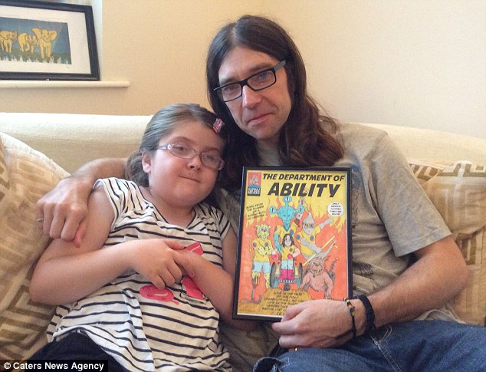
Targets
Students will…
- learn the importance of showing Dads (or male family members) appreciation.
- create a thank you note/poem.
- inform their guests about our library, select a book to read with them.
- understand importance of helping and serving others.
Procedures
(Lower elementary)
During poetry month, have students create a poem for their dads. Connect with grade level teachers, as well as art, music and other teachers as needed to create a great Father’s Day event. It can be hosted in the library or you can request the use of the cafeteria to be permitted to provide snacks for everyone to enjoy. *If you hold the event in the library treats can be set up outside in the hallway for the guests to take when they leave. Allow students to invite their dad or special man in their life to their designated time. Provide the information in a flyer containing details and how to sign up.
Decorate and dress up with a superhero theme. Plan appropriate songs to play as dads come in set to a slideshow, which can include pictures of students and their special men. Welcome your guests. Possibly connect with the music teacher to teach students a song to sing. Then have a student recite a short story or poem. Show a short video dedicated to dads. Allow students and their guests about 15 minutes to read together. There are multiple books you can have available for them to read, such as My Dad is a Superhero (Volume 1)by Lily Lexington, My Dad Is a Superhero by Rudy Brown, Superhero Dad by Timothy Knapman. Next have a fun hands-on activities or game planned, there are plenty of examples online, such as https://www.thespruce.com/fathers-day-games-2104442

Materials
- Father’s Day flyer/sign-up
- Superhero cape card
- Superhero decor and attire
- Lollipops
- Videos
- Songs
- Books (Ex. My Dad is a Superhero (Volume 1)by Lily Lexington, My Dad Is a Superhero by Rudy Brown, Superhero Dad by Timothy Knapman)
- Activity supplies
- Treats
Learning Standards

Resources

Rock My ABCs - Channing Banks. (2013, January 12). Father's Day song for children-My daddy is a superhero - Rock My ABCs [Video file]. Retrieved from https://www.youtube.com/watch?v=-0W4g6tExM0

#47 Author Study-Megan McDonald (Grade 3) 2-week lesson
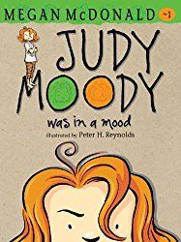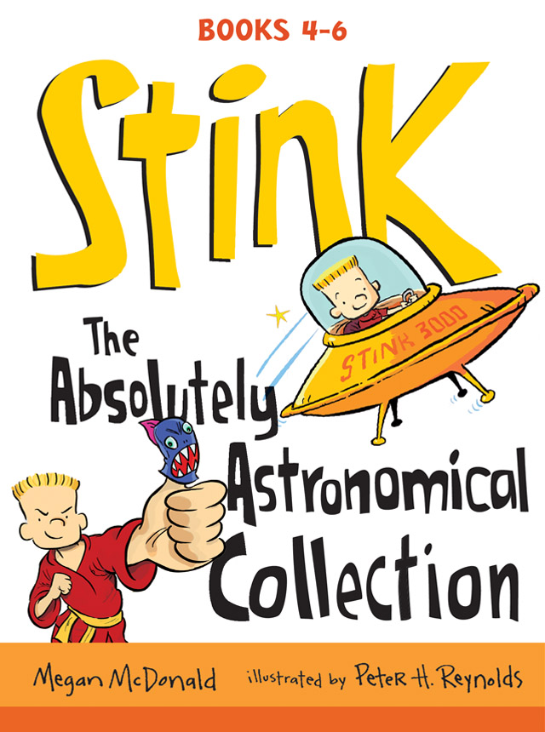
Targets
Students will…
- recall and learn facts about author, Megan McDonald.
- learn what book trailers are.
Procedure
Week 1: Author studies are educational but, can be also be fun and influential in student book choices. Pull books by any author you wish to study. I chose Megan McDonald, and focused on her Judy Moody and Stink book series. Print out an author study worksheet for students to fill out during the group discussions, videos and partner reading. This lesson will take two weeks.
Have students sit at the tables and distribute a worksheets and pencils to them. Discuss the lesson topic, objectives and expectations for everyone to actively participate in an author study. Show an interview about Megan McDonald https://www.youtube.com/watch?v=wKkjZGomFAQ and state that it is from several years ago (if applicable). Then ask a student to explain what a book trailer is. Afterward show a book trailer for Judy Moody https://www.youtube.com/watch?v=nWkgjnk1bAM and one for Stink https://www.youtube.com/watch?v=Y-qX8NYRXa8 . Afterward read from a few book jackets or covers to stir interest.
Students can work in pairs (allow students to work individually or with a group of three, as needed). Ask them to select one of Megan McDonald’s books and read together for 15 minutes. Collect their author study worksheet when the time is up, so you can redistribute them the following week.
Week 2: Place all of the worksheets on the tables and have students find their own. Hold a group discussion to recall what they have learned and the information they have written to this point. Show the book trailer for Megan McDonald’s American Girl, Julie series https://www.youtube.com/watch?v=JkfFXLpLbBM. Then play a few minutes of a Judy Moody https://www.youtube.com/watch?v=c-6NIfTbFk0 and Stink https://www.youtube.com/watch?v=zDXfT9oFV1Q audiobook, sharing that as another book resource.
Instruct students to regroup for additional 15 minutes of reading time. They can continue reading the same book or another one by Megan McDonald. When time is up, have students finish filling out their author study worksheet. Once the students have completed their assignment, have them turn it in and select books to check out.
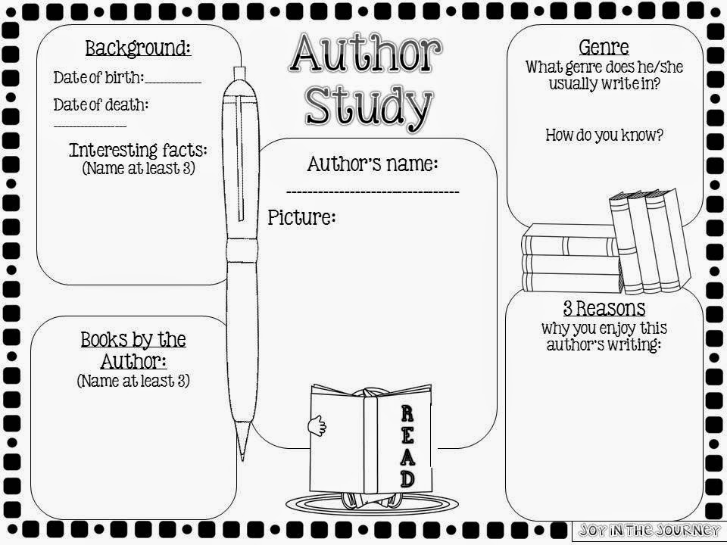

Learning Standards
AASL - Standards for the 21st-Century Learner AASL - 1.1.2 Use prior and background knowledge as context for new learning.
AASL - Standards for the 21st-Century Learner AASL - 1.1.4 Find, evaluate, and select appropriate sources to answer questions.
AASL - Standards for the 21st-Century Learner AASL - 1.1.6 Read, view, and listen for information presented in any format (e.g., textual, visual, media, digital) in order to make inferences and gather meaning.
English Language Arts (2016) RI.3.1. Ask and answer questions to demonstrate understanding of a text, referring explicitly to the text as the basis for the answers.
English Language Arts (2016) RI.3.2. Determine the main idea of a text; recount the key details and explain how they support the main idea.
English Language Arts (2016) RI.3.7. Use information gained from illustrations (e.g., maps, photographs) and the words in a text to demonstrate understanding of the text (e.g., where, when, why, and how key events occur).
English Language Arts (2016) SL.3.1. Engage effectively in a range of collaborative discussions (one-on-one, in groups, and teacher-led) with diverse partners on grade 3 topics and texts, building on others’ ideas and expressing their own clearly.
English Language Arts (2016) SL.3.2. Determine the main ideas and supporting details of a text read aloud or information presented in diverse media and formats, including visually, quantitatively, and orally.
English Language Arts (2016) SL.3.6. Speak in complete sentences when appropriate to task and situation in order to provide requested detail or clarification.
Resources
BNStudio. (2011, June 6). Meet the writers - Megan McDonald [Video file]. Retrieved from
https://www.youtube.com/watch?v=wKkjZGomFAQ

Hayball, A. (2015, May 29). Judy Moody book trailer [Video file]. Retrieved from
https://www.youtube.com/watch?v=nWkgjnk1bAM

Book Buzzes by C-FB ISD. (2015, August 7). Stink: The Incredible Shrinking Kid [Video file]. Retrieved from https://www.youtube.com/watch?v=Y-qX8NYRXa8
Rosenblat, B. (2015, February 11). Audiobook Narrator Barbara Rosenblat Judy Moody (Book 1) [Video file]. Retrieved from
https://www.youtube.com/watch?v=c-6NIfTbFk0

Rosenblat, B. (2014, April 7). Audiobook Narrator Barbara Rosenblat Stink Shark Sleepover [Video file]. Retrieved from
https://www.youtube.com/watch?v=zDXfT9oFV1Q

2BrownNancy. (2014, April 7). Julie-American Girl [Video file]. Retrieved from
https://www.youtube.com/watch?v=JkfFXLpLbBM

#48 Author Study-Gordon Korman (Grade 4) 2-week lesson
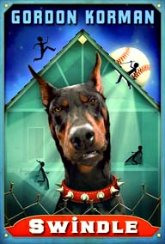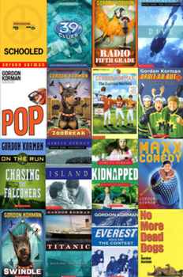
Targets
Students will…
- recall and learn facts about author, Gordon Korman.
- learn what book trailers are.
Procedure
Week 1: Author studies are a good lesson choice for any grade level. It may be beneficial to create an author study for 4th grade at the same time 3rd grade is performing one. Pull books by any author you wish to study. I chose Gordon Korman and discussed several books of the over 85 books he has written. Print out an author study worksheet for students to fill out during the group discussions, videos and partner reading. This lesson will take two weeks.
Have students sit at the tables and distribute a worksheets and pencils to them. Discuss the lesson topic, objectives and expectations for everyone to actively participate in an author study. Show an interview about Gordon Korman https://www.youtube.com/watch?v=u65rfDZ-rIE and state that it is from several years ago (if applicable). Afterward read from a few book jackets or covers to stir interest. Then ask a student to explain what a book trailer is. Afterward present three book trailers (save some others for week 2). Below are some possible options:
Hypnotists https://www.youtube.com/watch?v=wEYd_P4fmjw
Ungifted https://www.youtube.com/watch?v=4A5ZB1a5vxE
39 Clues (wrote 3) https://www.youtube.com/watch?v=q5-Mf8K6tyA

Masterminds https://www.youtube.com/watch?v=8aljgBApiwM&t=17s

No More Dead Dogs (1:16) https://www.youtube.com/watch?v=tIurEJ9pJ2s

Slacker https://www.youtube.com/watch?v=wyjZeWZR1Lw

Island https://www.youtube.com/watch?v=Po6KgKdpwR8

Students can work in pairs (allow students to work individually or with a group of three, as needed). Ask them to select one of Gordon Korman’s books and read together for 15 minutes. Collect their author study worksheet when the time is up, so you can redistribute them the following week.
Week 2: Place all of the worksheets on the tables and have students find their own. Hold a group discussion to recall what they have learned and the information they have written to this point. Show three more book trailers and any audiobook you choose by the Gordon Korman.
Instruct students to regroup for additional 15 minutes of reading time. They can continue reading the same book or another one by Gordon Korman. When time is up, have students finish filling out their author study worksheet. Once the students have completed their assignment, have them turn it in and select books to check out.
Learning Standards
AASL - Standards for the 21st-Century Learner AASL - 1.1.2 Use prior and background knowledge as context for new learning.
AASL - Standards for the 21st-Century Learner AASL - 1.1.4 Find, evaluate, and select appropriate sources to answer questions.
AASL - Standards for the 21st-Century Learner AASL - 1.1.6 Read, view, and listen for information presented in any format (e.g., textual, visual, media, digital) in order to make inferences and gather meaning.
English Language Arts (2016) RL.4.1. Refer to details and examples in a text when explaining what the text says explicitly and when drawing inferences from the text.
English Language Arts (2016) RL.4.2. Determine a theme of a story, drama, or poem from details in the text; summarize the text.
English Language Arts (2016) RL.4.3. Describe in depth a character, setting, or event in a story or drama, drawing on specific details in the text (e.g., a character’s thoughts, words, or actions).
English Language Arts (2016) SL.4.1. Engage effectively in a range of collaborative discussions (one-on-one, in groups, and teacher-led) with diverse partners on grade 4 topics and texts, building on others’ ideas and expressing their own clearly.
English Language Arts (2016) SL.4.4. Report on a topic or text, tell a story, or recount an experience in an organized manner, using appropriate facts and relevant, descriptive details to support main ideas or themes; speak clearly at an understandable pace.
Resources
SmartShoot films. (2008, April 9). Gordon Korman: Swindle [Video file]. Retrieved from
https://www.youtube.com/watch?v=u65rfDZ-rIE

Harclerode, B. ( 2015, July 15). Hypnotists by Gordan Korman book trailer [Video file]. Retrieved from https://www.youtube.com/watch?v=wEYd_P4fmjw

BAchman, E. (2015, December 1). Ungifted by Gordan Korman [Video file]. Retrieved from
https://www.youtube.com/watch?v=4A5ZB1a5vxE

Nu Vybe Dance Crew. (2011, March 27). 39 Clues Book trailer [Video file]. Retrieved from
https://www.youtube.com/watch?v=q5-Mf8K6tyA

Edgewater books. (2015, May 23). Masterminds by Gordan Korman [Video file]. Retrieved from
https://www.youtube.com/watch?v=8aljgBApiwM&t=17s

J, E. (2013, December 11). No More Dead Dogs [Video file]. Retrieved from
https://www.youtube.com/watch?v=tIurEJ9pJ2s

BPLibraryKids. (2016, December 15) Slacker [Video file]. Retrieved from
https://www.youtube.com/watch?v=wyjZeWZR1Lw

Island [Video file]. Retrieved from
https://www.youtube.com/watch?v=Po6KgKdpwR8

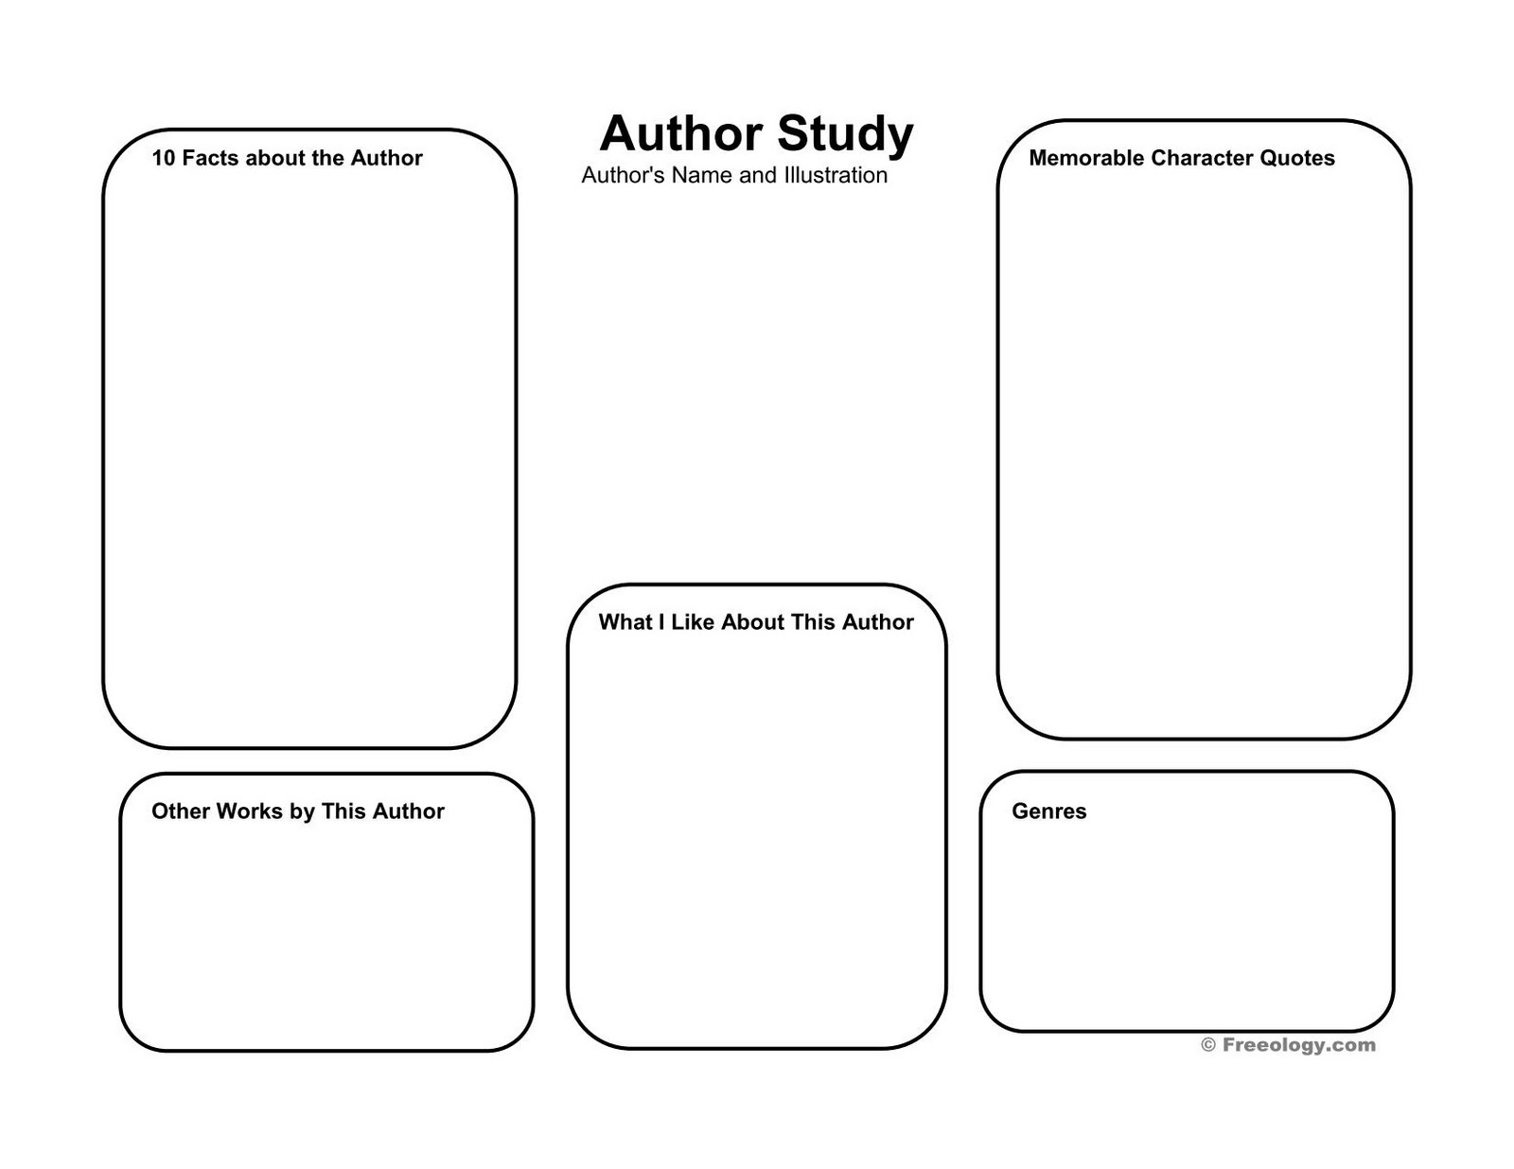

#49 Maga-scene Story
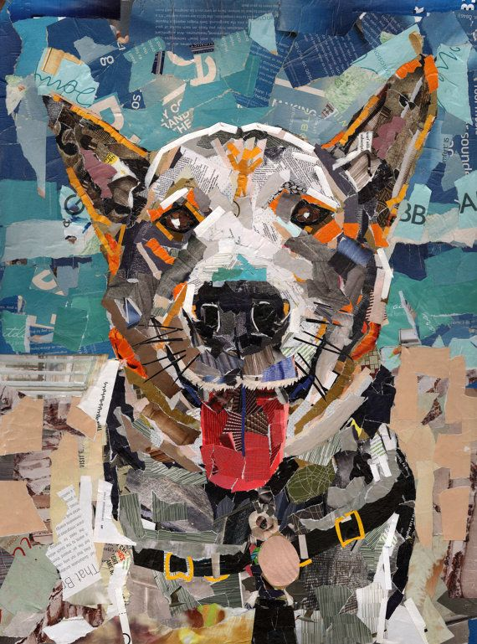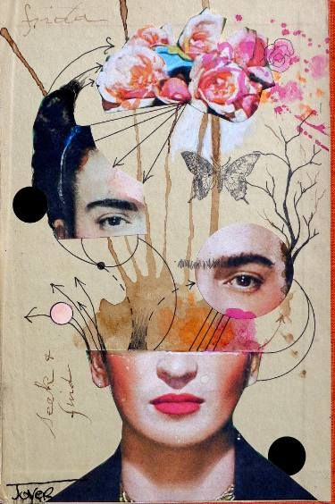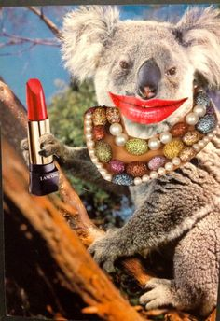

Targets
Students will…
- follow instructions to complete a graphic design product.
- use appropriate writing skills.
- utilize speaking and listening skills.

Procedure
Prior to class gather old magazines, glue sticks, scissors and tape. Use a piece of blank paper (regular or cardstock) as the background to glue magazine pictures together to make a scene or image. Write a short story that goes with the scene you created. It can be any type of story: serious, fun, scary or humorous or you can require a specific type. Use the scene you created as an example for your students. Also copy some online examples to be display around the room.
Instruct your students that they will be creating “maga-scenes” from magazines. Show a show a short slide presentation on the smartboard or an online website with examples to stir their imaginations.
They must find pictures and possibly some words, to create their own unique picture. Once they have cut out pictures and glued or taped them to their background, they must write a short story about their scene. At the end of the class (or during the following class depending on timing), have each student share their final product. Then have each student use a rubric to assess themselves on their final product and presentation.
Materials:
- Magazines
- Paper/Card stock
- Glue sticks
- Tape
- Scissors
- Lined paper (for writing a story)
- Rubric

Learning Standards
AASL 2.1.6 Use the writing process, media and visual literacy, and technology skills to create products that express new understandings.
AASL 2.2.4 Demonstrate personal productivity by completing products to express learning.
AASL 3.1.3 Use writing and speaking skills to communicate new understandings effectively.
AASL 3.4.2 Assess the quality and effectiveness of the learning product.
AASL 4.4.5 Develop personal criteria for gauging how effectively own ideas are expressed.

Resources
Evans, J. (2016, October 24). Format Magazine. Retrieved from https://www.format.com/magazine/galleries/art/ben-giles-collage-art-portfolio?utm_source=Format+Magazine&utm_campaign=7ef03dbf93-formatmag_newsletter_2016_10_25&utm_medium=email&utm_term=0_aebd9a4403-7ef03dbf93-101559637

#50 If You Give A Mouse a Cookie or an iPhone!
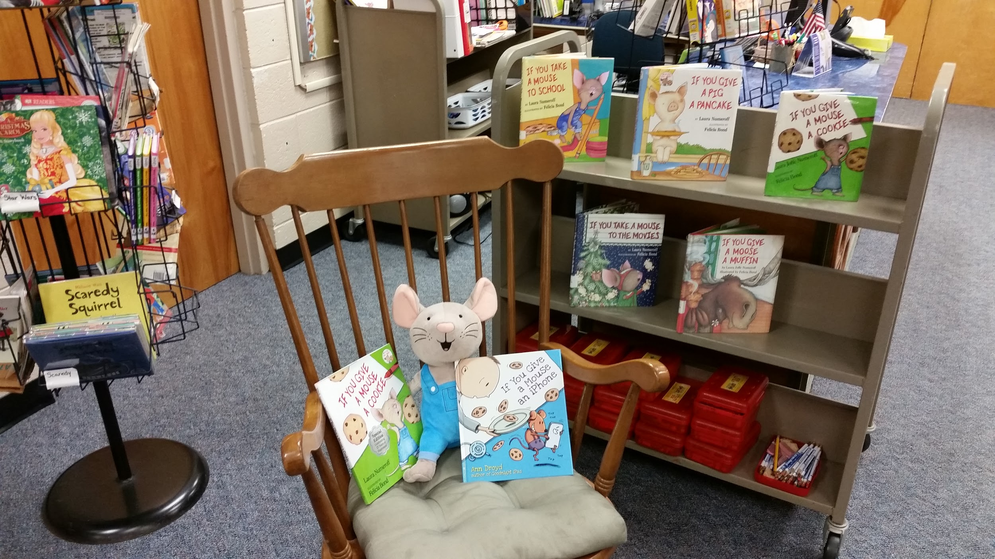
*You can also do this lesson with the books, Goodnight Moon by Margaret Wise Brown and Goodnight iPad by David Milgrim.

(Lower elementary)
Objectives
Students will…
- compare and contrast similar storylines.
- Understand cause and effect elements.

Targets
Purchase the books, If You Give a Mouse a Cookie by Laura Numeroff and If You Give a Mouse an Iphone by David Milgrim. If you can purchase the matching mouse stuffed animal you can use it for students to pass each time you say “mouse” while reading both books or having a group discussion.
Read the original story, If You Give a Mouse a Cookie, then read the new version If You Give a Mouse an Iphone. Depending on the grade level doing this lesson, you can either hold a group discussion about the differences between the two stories or have them complete a Venn diagram (either individually or in pairs). It is also a great story to discuss cause and effect.

Materials
- Books, If You Give a Mouse a Cookie by Laura Numeroff and If You Give a Mouse an Iphone by David Milgrim
- Mouse stuffed animal
- Venn diagram
Learning Standards
AASL 1.1.6 Read, view, and listen for information presented in any format (e.g., textual, visual, media, digital) in order to make inferences and gather meaning.
AASL 4.1.1 Read, view, and listen for pleasure and personal growth.

Resources

*This lesson is a great precursor to the next lesson, Fractured Fairy tales because they both discuss two versions of a story.

#51 Fractured Fairytales- “2 sides to every story”
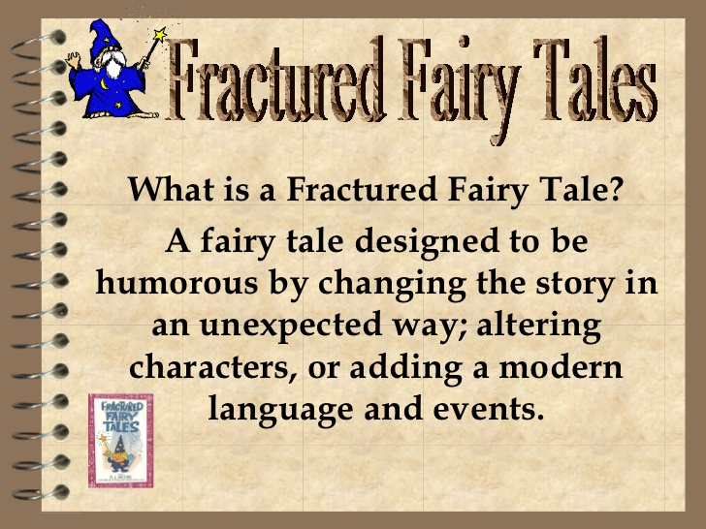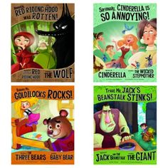
(Lower elementary)
Targets
Students will...
- understand story point of views.
- making a connection to real world views.
- use appropriate writing and speaking skills to accomplish goals.

Procedures
Purchase the fairytale book series pictured above by Trisha Speed Shaskan, then pull samples of the original versions of each fairytale from the library shelves. Handout a worksheet with definitions literature terms, such as: folklore, fables, tall tales, legends, and fairy tales. Discuss the differences between each term (folklore, fables, tall tales, legends, and fairy tales) and provide examples.
Next give each group one of the original fairy tales and the new version of matching fairy tale told from another point of view. Instruct the students to turn over their worksheet to see either a Venn diagram or Fractured Fairy tale worksheet (your choice) to illustrate what is the same in each story and what is different on the other side. Also have them write at the bottom which version of the fairy tale they enjoyed more and why. At the end, have the groups share their stories and answers with the class during a group discussion.

Materials
- Fairy tale books
- Venn diagram or Fractured Fairy tale worksheet
- Pencils

Learning Standards
AASL 1.1.6 Read, view, and listen for information presented in any format (e.g., textual, visual, media, digital) in order to make inferences and gather meaning.
AASL 1.1.7 Make sense of information gathered from diverse sources by identifying misconceptions, main and supporting ideas, conflicting information, and point of view or bias.
AASL 2.1.2 Organize knowledge so that it is useful.
AASL 2.1.5 Collaborate with others to exchange ideas, develop new understandings, make decisions, and solve problems.
AASL 3.1.2 Participate and collaborate as members of a social and intellectual network of learners.
AASL 3.1.3 Use writing and speaking skills to communicate new understandings effectively.
AASL 3.2.2 Show social responsibility by participating actively with others in learning situations and by contributing questions and ideas during group discussions.
AASL 3.2.3 Demonstrate teamwork by working productively with others.
AASL 4.1.3 Respond to literature and creative expressions of ideas in various formats and genres.

Resources (examples)
Fractured Fairy tale worksheet
https://s-media-cache-ak0.pinimg.com/736x/a9/92/80/a9928026649ea16903e21405b8587ea7.jpg
Literature types worksheet
https://s-media-cache-ak0.pinimg.com/736x/e3/f9/73/e3f9737063e2454cc55906fe46a28033.jpg

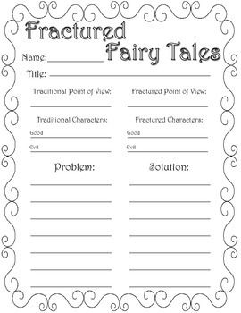
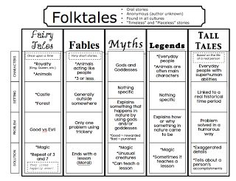

#52 Stars Wars
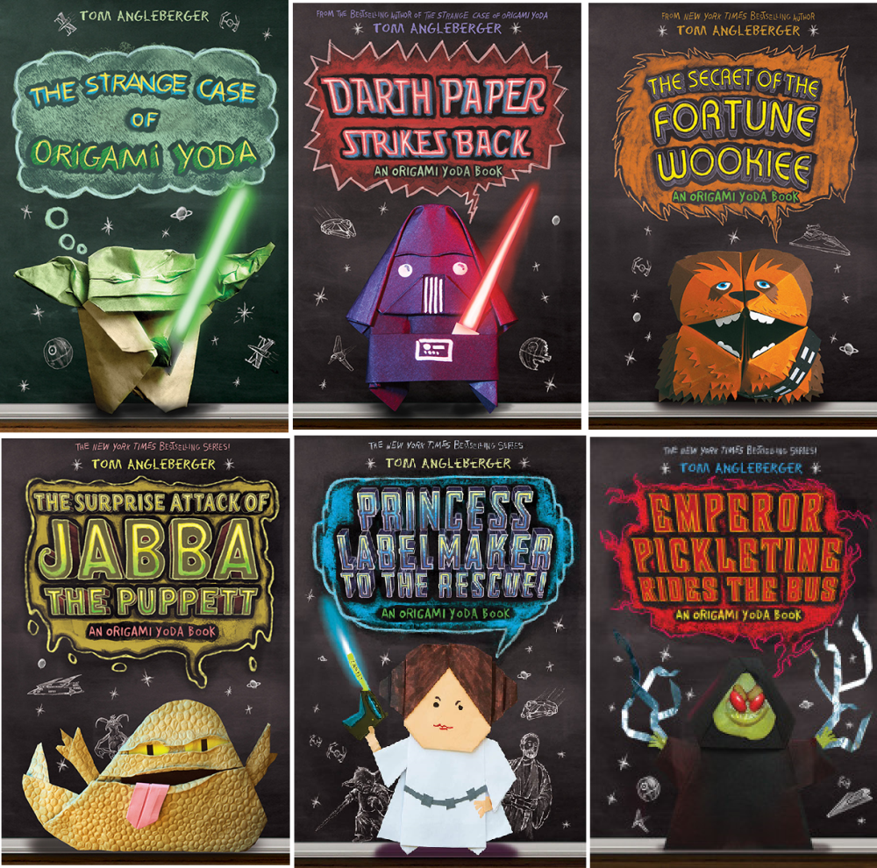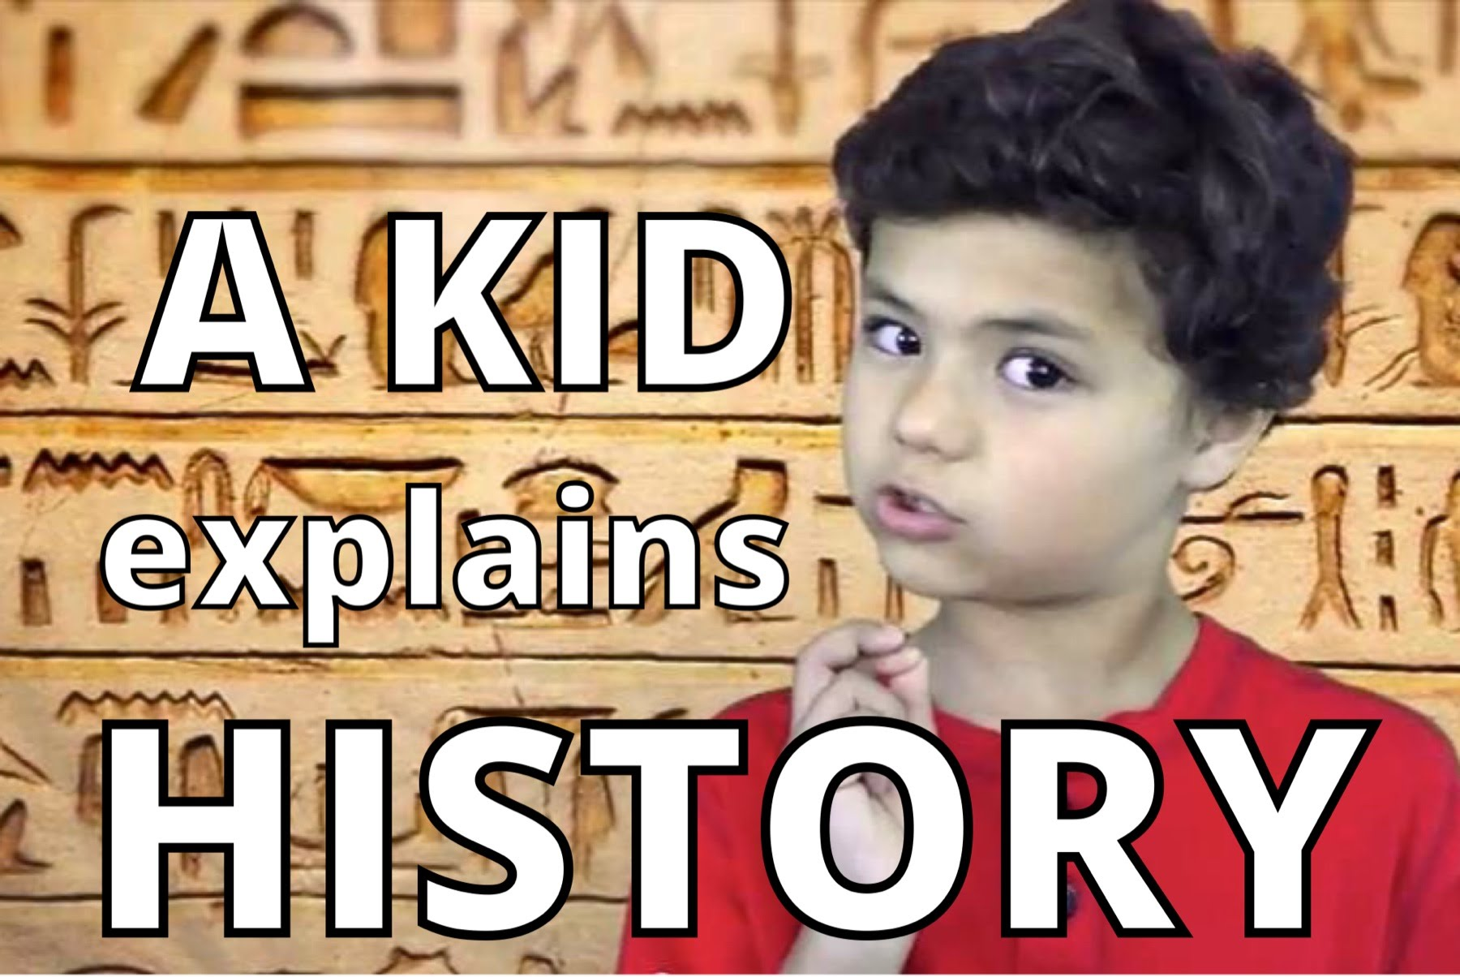
Targets
Students will…
- understand the history of Star Wars.
- learn facts from the A Kid Explains History series
- create origami and discover the book series The Yoda Origami Files.

Procedures
“May the fourth be with you” (May 4th is a great week to have a Star Wars lesson!) Pull Stars Wars and origami books for display and possible student check out. Have the star shower light shining on the ceiling and play the Star Wars music theme as students enter. Ask some Star Wars related questions and then show the students the A Kid Explains History-Star Wars episode https://www.youtube.com/watch?v=qyga44I-rkI for additional information.
Next introduce Tom Angleberger’s book series, The Origami Yoga Files and show its book trailer https://www.youtube.com/watch?v=OKyMI9AK4KE . Read the book jacket or a page from each book to excite students about the series. Then direct the students attention to the origami books and copies of star wars origami instructions and blank paper on their tables and instruct them to pick a origami project to try to fold. (Upper elementary may search some origami how-to videos on the computers). After book check out, allow students to share their origami creations with each other.

Materials
- Star Wars decor and costume
- Star shower light
- Video
- Star Wars Origami Files book series
- Origami books
- Paper, scissors

Learning Standards
AASL 1.1.6 Read, view, and listen for information presented in any format (e.g., textual, visual, media, digital) in order to make inferences and gather meaning.
AASL 2.2.4 Demonstrate personal productivity by completing products to express learning.
AASL 3.2.2 Show social responsibility by participating actively with others in learning situations and by contributing questions and ideas during group discussions.

Resources
A Kid Explains History. ( ). Origins of Stars Wars - A Kid Explains History, Episode 11 [Video file]. Retrieved from https://www.youtube.com/watch?v=qyga44I-rkI
EdTechJenn. (2016, April 25). The Strange Case of Origami Yoda Book Trailer [Video file]. https://www.youtube.com/watch?v=OKyMI9AK4KE
HabraH3. (2009, March 25). Star Wars music theme [Video file]. Retrieved from https://www.youtube.com/watch?v=fl7MI8ZlczE

#53 Helen Keller-The Miracle Worker
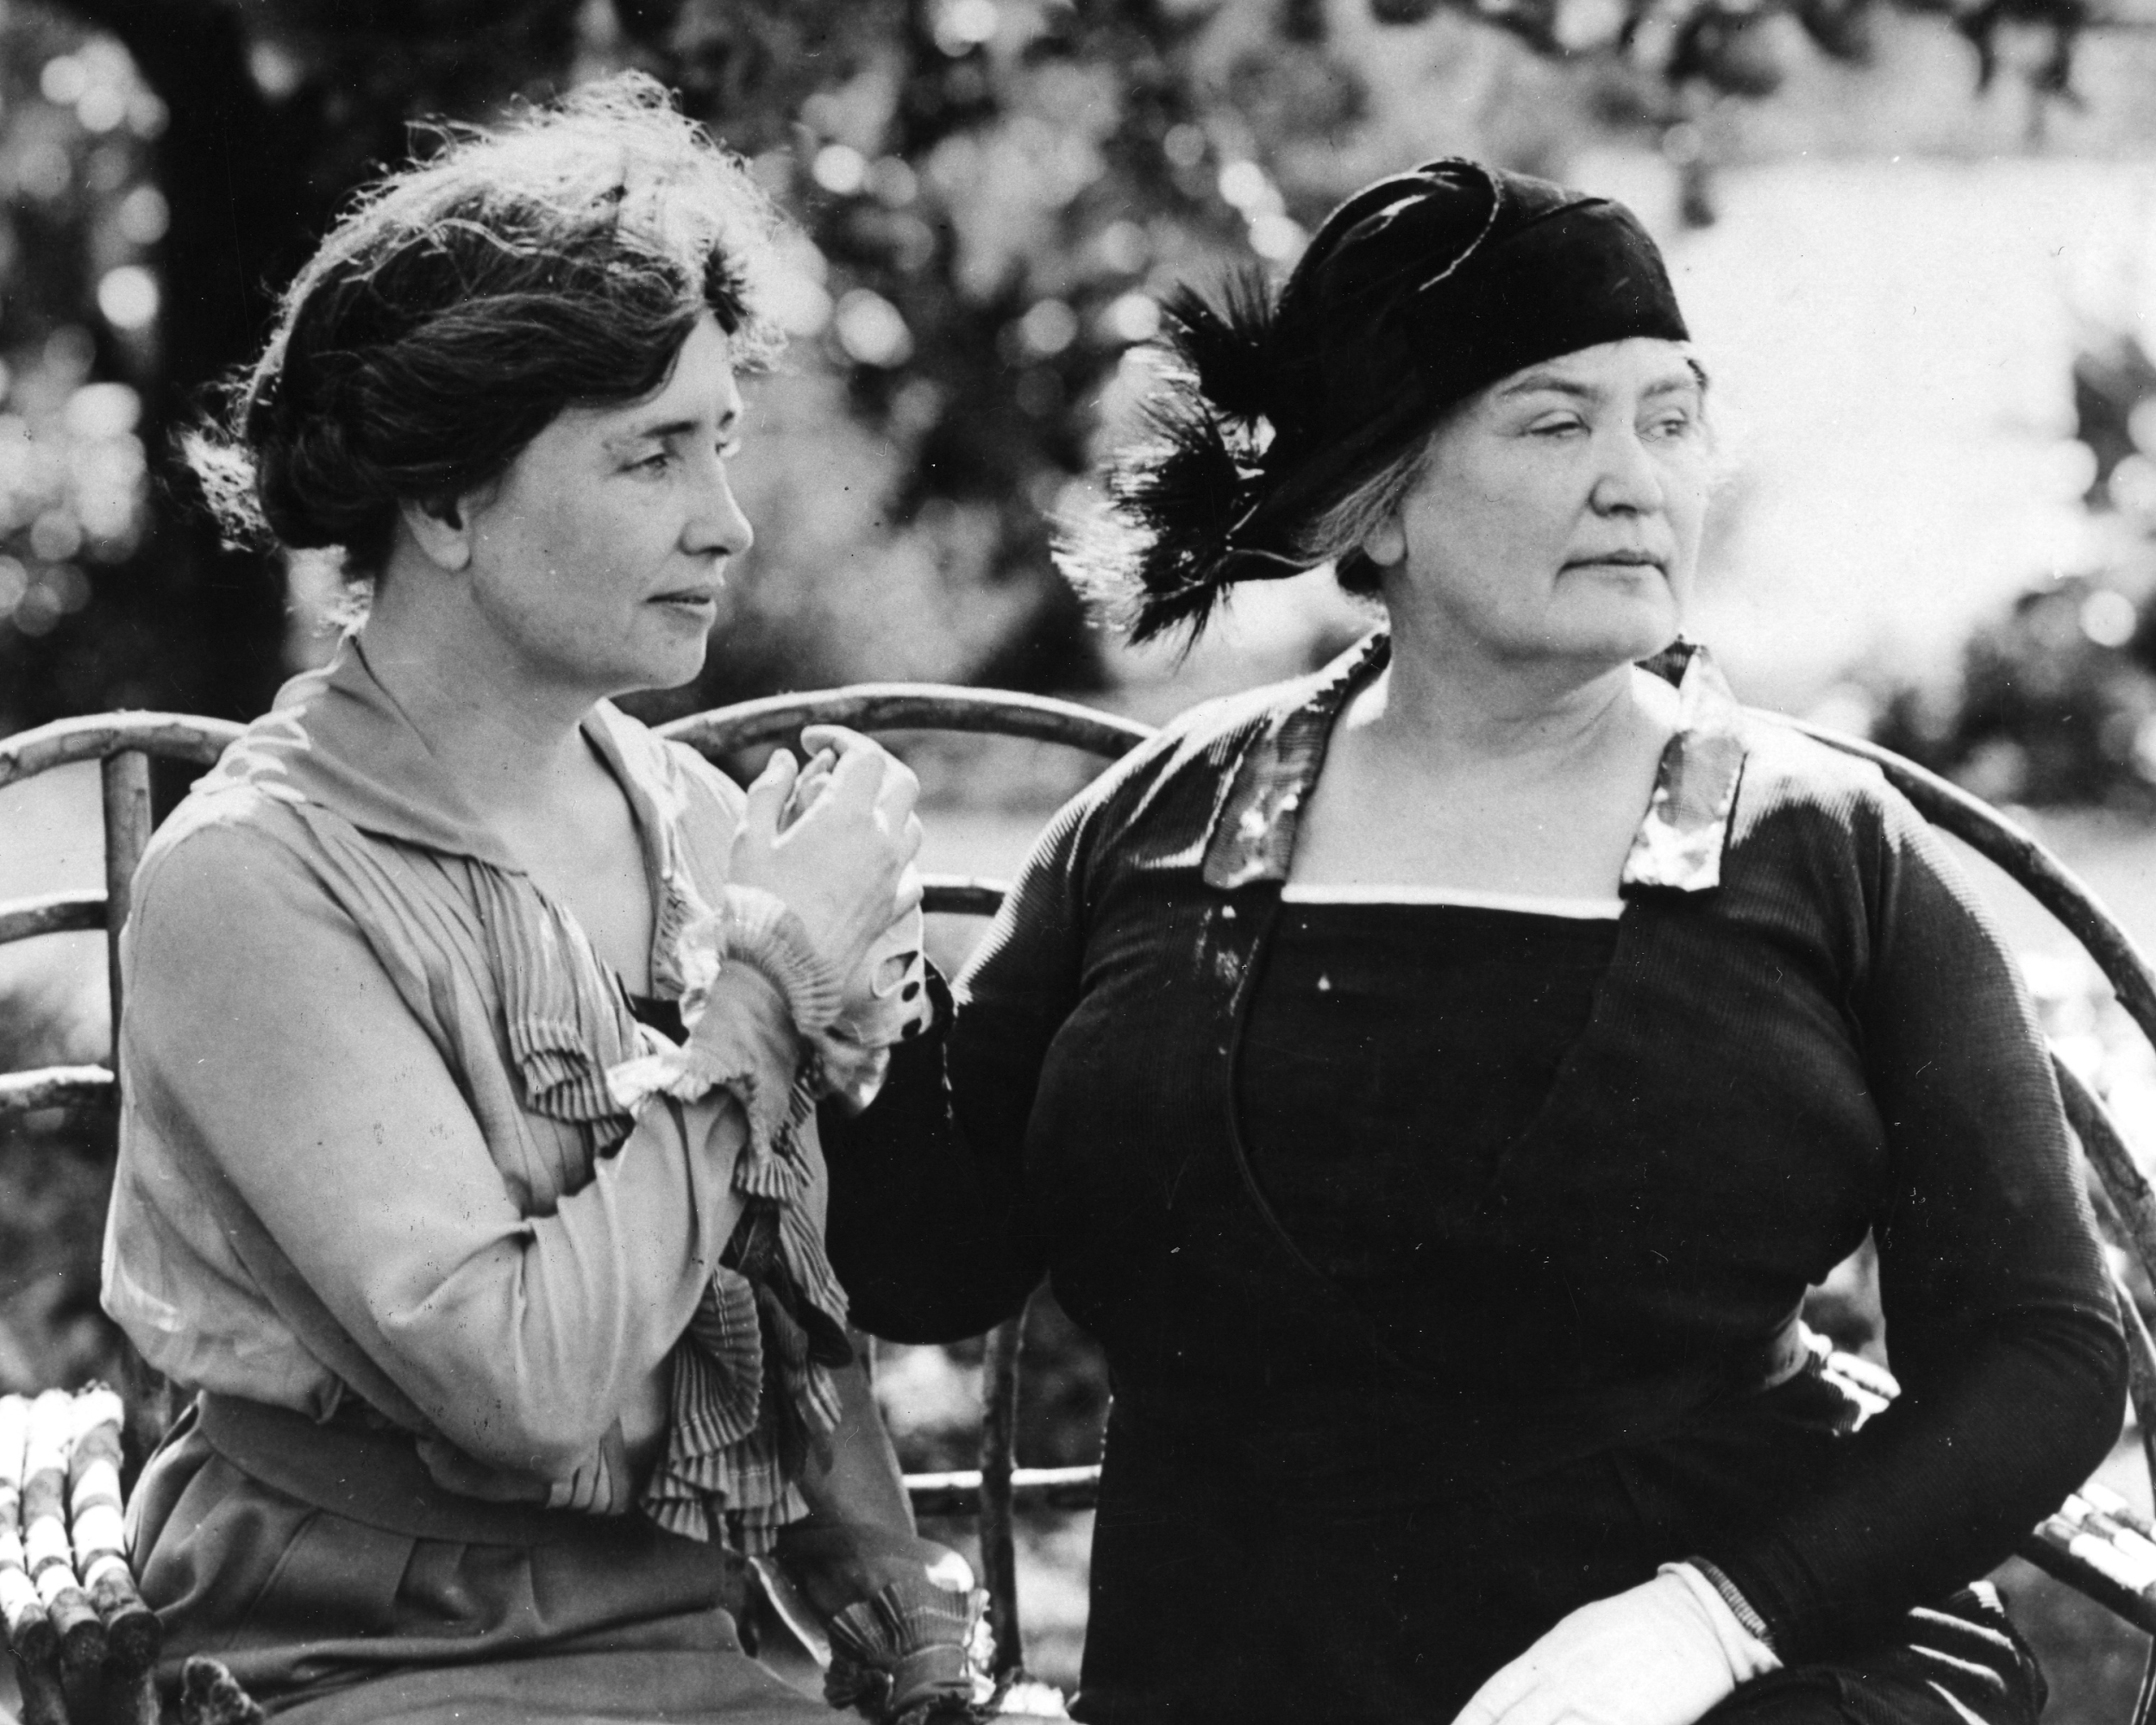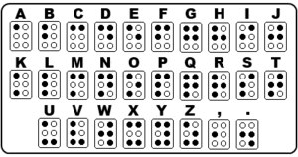
This would be a great lesson prior to teacher appreciation week, highlighting Helen’s teacher, Anne Sullivan or in June because Helen was born and died in that month.
(Lower elementary)
Targets
Students will…
- discover important facts about Helen Keller and Anne Sullivan through multiple formats.
- be introduced to and practice braille.
- participate in a group discussion the about the value of accepting others, never giving up and empathy.

Procedure:
Ask the class what they know about Helen Keller. Instruct them to close their eyes and place one hand over top to reinforce the darkness. Place various items in a paper bags for each student to feel and try to guess what there are, while their eyes are still closed. After a minute, have everyone open their eyes and see if they were correct.
Next freeze the smartboard with a black screen and play various sounds and ask what they hear. Then have them place their fingers in the ears and ask what a few additional sounds again. Have them sit quietly with their eyes closed and ears covered for one minute. Then discuss how it may feel to live every minute of every day without seeing or hearing anything or anyone. Discuss the importance of empathy for others and why Helen Keller’s life and accomplished are so amazing.
Read I am Helen Keller by Brad Meltzer. Then show a couple videos about her, like Mini Bio: Helen Keller https://youtu.be/oxiJ02-hpZY and Helen Keller speaks out https://youtu.be/8ch_H8pt9M8. Share any additional fun facts and life accomplishments with the students. Pass around a book in braille for students to explore. Show them a braille alphabet chart and ask the students to draw their names in braille dots.
If you do this lesson before or during Teacher Appreciation Week, have students create teacher thank you notes for their teachers after book check out.
*If you want to do a similar lesson with older students you may also create a blindfold activity or use a braille board, punch and index card to punch out a sentence with their full name.
Learning Standards
AASL 1.1.6 Read, view, and listen for information presented in any format (e.g., textual, visual, media, digital) in order to make inferences and gather meaning.
AASL 2.3.1 Connect understanding to the real world.
AASL 2.3.2 Consider diverse and global perspectives in drawing conclusions.
AASL 3.2.2 Show social responsibility by participating actively with others in learning situations and by contributing questions and ideas during group discussions.
AASL 3.3.2 Respect the differing interests and experiences of others, and seek a variety of viewpoints.
AASL 4.2.3 Maintain openness to new ideas by considering divergent opinions, changing opinions or conclusions when evidence supports the change, and seeking information about new ideas encountered through academic or personal experiences.

Resources
Helen Keller. (2011, April 11). Helen Keller speaks out [video file]. Retrieved from https://youtu.be/8ch_H8pt9M8
Biography. (2015, May 25). Mini Bio: Helen Keller [video file]. Retrieved from https://youtu.be/oxiJ02-hpZY
Transforming Art. (2009, June 27). Rare footage of Helen Keller [video file]. Retrieved from https://youtu.be/Gv1uLfF35Uw

#54 Lessons 4U by U!
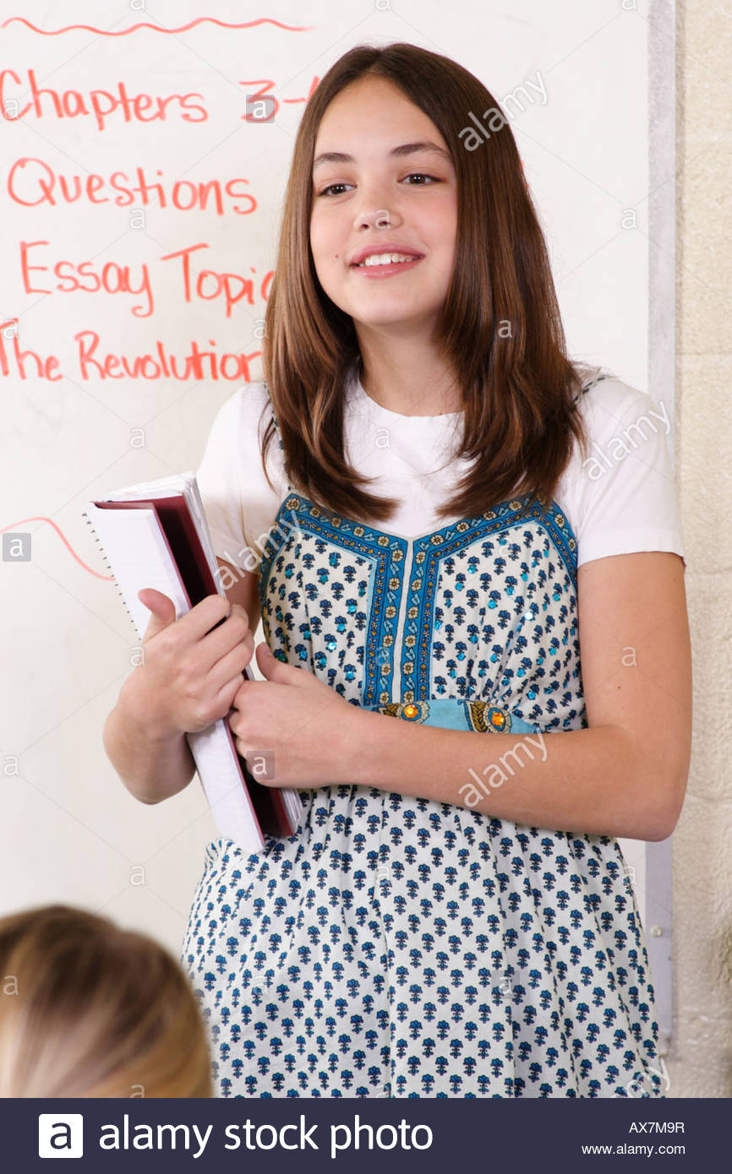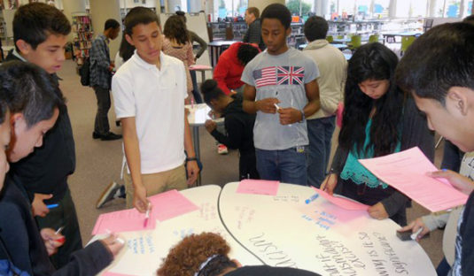
(Upper elementary)
Targets:
Students will…
- understand the process of creating lesson plans.
- research, write and create a library lesson.
- utilize speaking and listening skills during group share.
Procedure:
After teacher appreciation week, it could be fun to have a Student Appreciation Week. Tell your students that you want to celebrate all they like and do. Inform students that they will work in small teams to create, outline and develop a library lesson on any (appropriate) topic they choose. It will allow students to understand the process a teacher goes through on a weekly basis and the time it takes to complete a lesson. In addition, it will allow them the opportunity to possibly have their lesson turned into an actual lesson in the near future. Provide each group with a worksheet that contains all of the requirements for this project, such as the to research a desired topic, determine the learning goals and objectives, find images, videos, books, additional resources, and learning activities. They must also decide how the library should be set up and decorated.
Students will have 2 weeks to fully develop the lesson. During the second week, each group will be have up to five minutes to share their lesson concept, purpose and research findings. At the end of each class, all students can vote on which topic they liked best. A copy of the winning lesson worksheet will go into a ballot box from each class. After all classes have submitted their favorite lesson plan, randomly pick one out of the ballot box and create a lesson from for your students. Create a video that showcases the winning group and allows them to
discuss their project to share during your lesson. While creating the the video, also host a brainstorming session with the group and get their opinions on the lesson you are finalizing.
Materials
- Student lesson worksheet
- Laptops
- Ballot box/ballots

Learning Standards
AASL 1.1.2 Use prior and background knowledge as context for new learning.
AASL 1.1.8 Demonstrate mastery of technology tools for accessing information and pursuing inquiry.
AASL 1.2.3 Demonstrate creativity by using multiple resources and formats.
AASL 1.2.5 Demonstrate adaptability by changing the inquiry focus, questions, resources, or strategies when necessary to achieve success.
AASL 1.3.3 Follow ethical and legal guidelines in gathering and using information.
AASL 1.3.4 Contribute to the exchange of ideas within the learning community.
AASL 2.1.2 Organize knowledge so that it is useful.
AASL 3.1.3 Use writing and speaking skills to communicate new understandings effectively.
AASL 3.1.4 Use technology and other information tools to organize and display knowledge and understanding in ways that others can view, use, and assess.
AASL 3.2.1 Demonstrate leadership and confidence by presenting ideas to others in both formal and informal situations.
AASL 3.2.2 Show social responsibility by participating actively with others in learning situations and by contributing questions and ideas during group discussions.
AASL 3.2.3 Demonstrate teamwork by working productively with others.
AASL 3.3.4 Create products that apply to authentic, real-world contexts.

Resources

#55 Random Storytellers
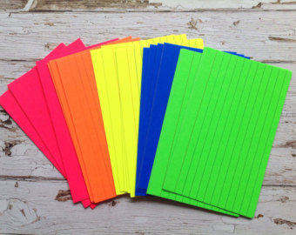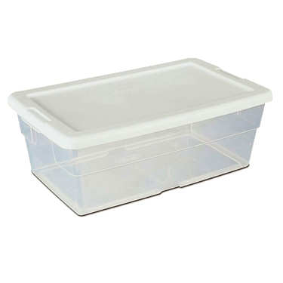
Targets:
Students will…
- utilize creative thinking and writing skills.
- demonstrate understanding of assignment requirements through partner assessments.
Procedure:
Set up a long table with several plastic shoe boxes lined across it. Label each box with a different color index card with a word written on it such as, type of fiction, subject, setting, protagonist, antagonist, animal and any other category you desire. Hand students a worksheet with an outline of a story writing project, including what each color index card represents. For example, pink=type of fiction, blue=subject, yellow=setting, green=protagonist, white=antagonist and neon colors=animal. Have students pick an index card from each container (without looking) and sit in a quiet area to work. Instruct them to use the cards they randomly selected to construct a story outline, then write a short story from all of the elements collected. At the end of class (or the following week depending on time) have students pair and share their stories. Then assess their partner’s work from a rubric that is distributed. Then leave all of the stories out on the tables for students to walk around and enjoy reading after they check out books.
Materials
- Assorted color index cards
- Plastic shoe boxes
- Worksheet/instructions/outline
- Rubric

Learning Standards
AASL 1.1.4 Find, evaluate, and select appropriate sources to answer questions.
AASL 1.1.6 Read, view, and listen for information presented in any format (e.g., textual, visual, media, digital) in order to make inferences and gather meaning.
AASL 1.2.2 Demonstrate confidence and self-direction by making independent choices in the selection of resources and information.
AASL 1.3.5 Use information technology responsibly.
AASL 1.4.1 Monitor own information-seeking processes for effectiveness and progress, and adapt as necessary.
AASL 2.2.4 Demonstrate personal productivity by completing products to express learning.
AASL 3.4.2 Assess the quality and effectiveness of the learning product.
AASL 4.1.8 Use creative and artistic formats to express personal learning.

Resources

#56 Book Speed Dating
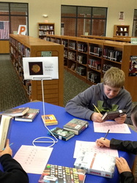
(Upper elementary)
Targets
Students will…
- be open to different genres and books.
- identify books they would read.

Procedure
Set up at least 6 tables with various genres of books. Create signs for each “type” of books students will be dating and print out a Book Dating Worksheet for each student (print the chart on both sides to provide up to 12 books to rate). Inform the students they will be “dating” some books today to find the perfect one to check-out and take home.
Have students pick a table to start at. They will have 3 minutes to look over each book. When a bell is rung, students must move to another seat at the same table. Each student will be able to date 2 books at each table, until the time runs out. Encourage students to check-out a book they meet today.
Materials
- Tablecloths
- Centerpieces (cloth napkin, candlestick, flower)
- Various books
- Signs for each category
- Book Dating Worksheet (copy below)
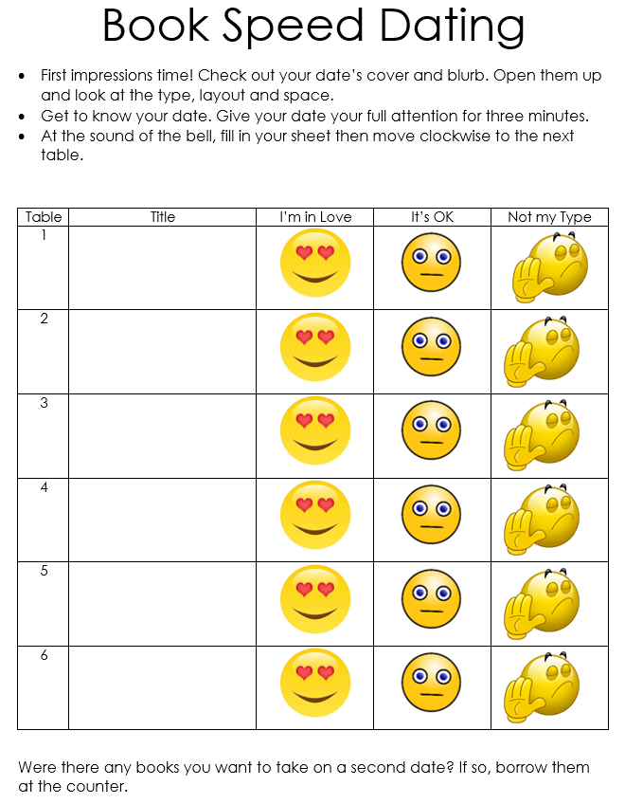

Learning Standards
AASL 3.3.2 Respect the differing interests and experiences of others, and seek a variety of viewpoints.
AASL 4.2.4 Show an appreciation for literature by electing to read for pleasure and expressing an interest in various literary genres.
AASL 4.3.2 Recognize that resources are created for a variety of purposes.
AASL 4.4.1 Identify own areas of interest.
AASL 4.4.6 Evaluate own ability to select resources that are engaging and appropriate for personal interests and needs.

Resources
Book Dating worksheet
https://thebooklight.edublogs.org/files/2015/10/book-speed-dating-19weepx.png

*You can also create similar reading activities such as Book Tastings or Mystery Books.
https://s-media-cache-ak0.pinimg.com/736x/a8/ca/15/a8ca157a64d9c33b235f088b60503c29.jpg
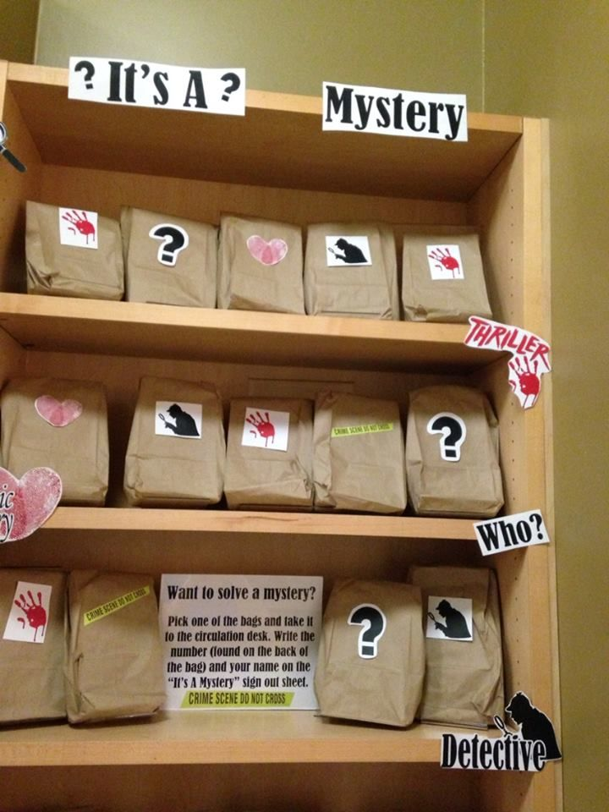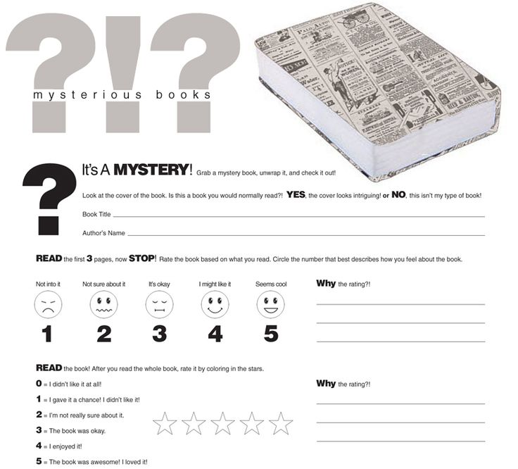

#57 The Magic Owl
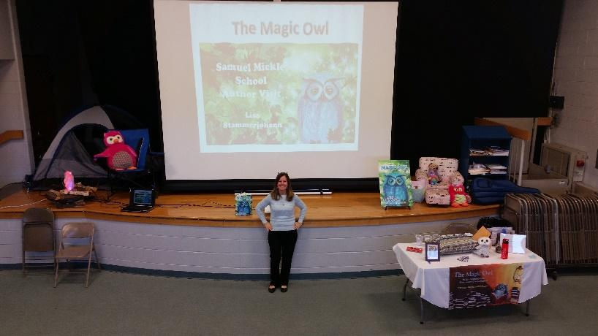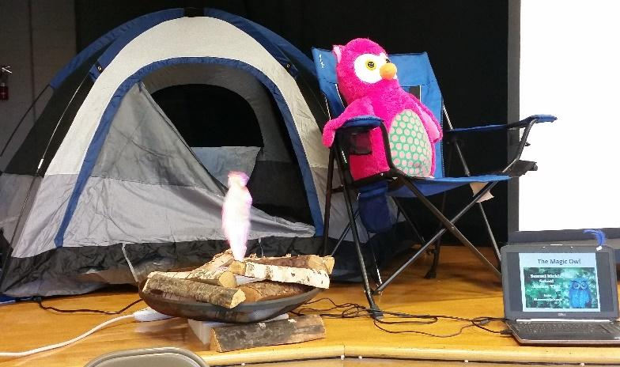
Targets
Student will…
- understand they have the ability to write and illustrate their own stories.
- actively discuss their favorite books/authors
- create a question for a local author.

Procedure
Set up the library with a small tent, sleeping bag, firepit, stuffed owls and have the image of The Magic Owl book on the smartboard. Have the students walk in a single file line and follow you around the library taking a few brief stops to look about various books. Discuss how our very library houses thousands of books that started as an idea and that an author followed through to a finished. published book. Once students are seated at their tables or story ask questions about what an author, illustrator, publisher, etc is or does. Discuss the fact that a local East Greenwich parent, Lisa Stammerjohann, wrote the book, The Magic Owl (add that you will be having her for an author visit assembly soon, if you are able to schedule it). Read the book to the class, then discuss the author’s purpose. Inform the students, just like the Magic Owl, they can collect and bring in new and gently used books to be used in our library, as rewards for students and to be donated to those in need. Have students each write a question they would like to ask Mrs. Stammerjohann when she visits. Distribute order forms to any student that would like to purchase a signed copy of the book (whether she visits or not, this is possible).
Materials
- The Magic Owl book by Lisa Stammerjohann
- Small tent (or any fun, related decor)
- Stuffed owls
- Firepit
- Sleeping bag
- Flyer donating books
- Magic Owl Order Form
- Slip of paper for author questions

Learning Standards
AASL - Standards for the 21st-Century Learner-AASL 1.1.3 Develop and refine a range of questions to frame the search for new understanding.
AASL 1.1.6 Read, view, and listen for information presented in any format (e.g., textual, visual, media, digital) in order to make inferences and gather meaning.
AASL 2.1.6 Use the writing process, media and visual literacy, and technology skills to create products that express new understandings.
AASL 2.3.1 Connect understanding to the real world.
AASL 3.1.3 Use writing and speaking skills to communicate new understandings effectively.
AASL 3.2.2 Show social responsibility by participating actively with others in learning situations and by contributing questions and ideas during group discussions.
AASL 4.3.2 Recognize that resources are created for a variety of purposes.
AASL 4.4.1 Identify own areas of interest.

Resources

Magic Owl order form and information below:
Dear Parents/Guardians,

We are so excited to tell you about an upcoming event! On ??? author Lisa Stammerjohann will visit our school to speak to all students in grades 3-6. She will share her children’s picture book and be available for Q & A after a brief presentation. Mrs. Stammerjohann is a Samuel Mickle parent and a licensed counselor who has over 20 years working with children and adults. She is an enthusiastic speaker who excites students about reading with personal stories and shares tips she’s developed during her career as a working writer and storyteller. Her belief is that every child has a story to tell and a passion worth sharing!

Please check out the website, www.themagicowlbook.com for more details about her book. If you would like your child to have a book signed by the author or to order books for gifts, please complete and return this form with payment to your child’s teacher or to me by ??? Mrs. Stammerjohann will sign and personalize each book. Thank you in advance for your interest and support!
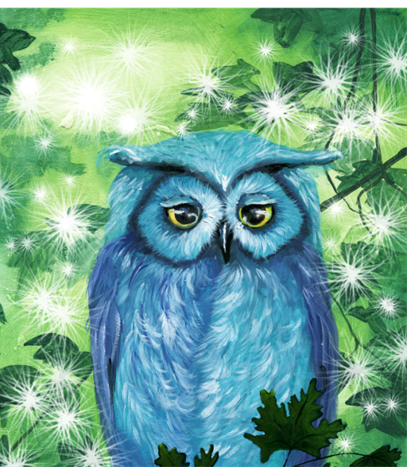
Sincerely,
Your Librarian???

The Magic Owl
Spreading the love of reading, one book at a time.

“This book is so enjoyable to read with my kids. The story and the characters are adorable. I've even started leaving books under my little one's pillow (like the magic owl does) and it is getting my son even more excited about reading!”
– Maggie Pajak, author Jellybeans Morning, Noon, and Night

- - - - - - - - - - - - - - - - - - - - - - - - - - - - - - - - - - - - - - - - - - - - - - - - - - - - - - - - - - - - - - - - - - - - - - -
**Please return this form to your Homeroom Teacher or the Librarian, ???**
Book Order & Autograph Form
Child’s Name (please print) ____________________________________________________________________
Child’s Teacher ________________________________________________________ Grade _______________
The Magic Owl
______ books @ $25 each = $________ PAYMENTS CAN BE IN THE FORM OF CASH OR CHECKS

*Please make any checks payable to Lisa Stammerjohann & return them to school by ???

#58 Read to Red Carpet Event
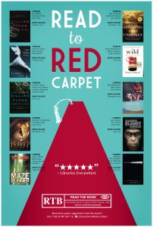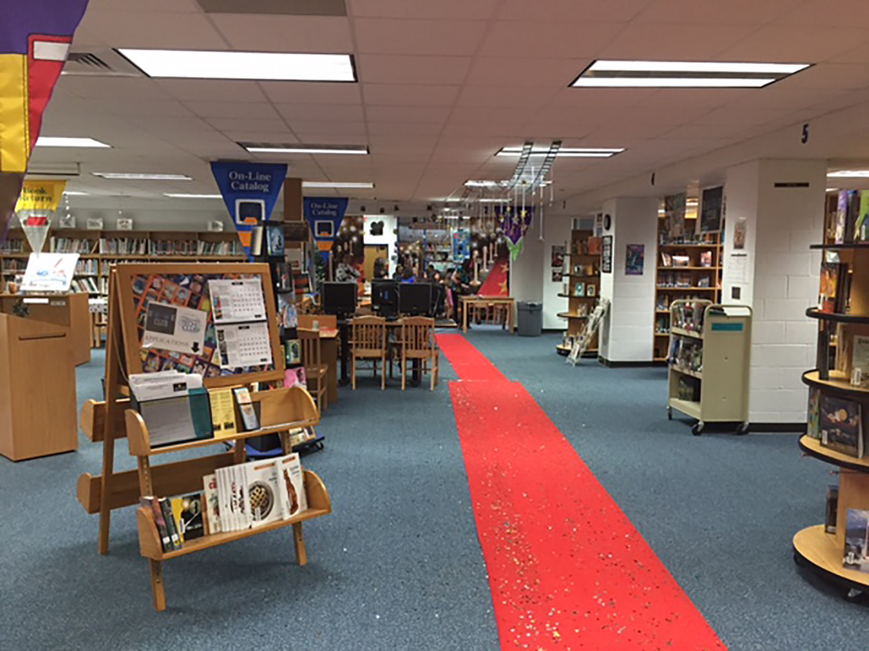
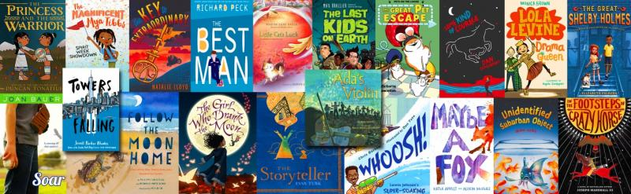

Targets
Students will…
- learn about book awards and annual book winners.
- use appropriate research skills.
- utilize acceptable speaking and listening skills.

Procedure
Decorate the library as for a Red Carpet Event. Roll out a red carpet, hang stars, set up a camera, spotlight and paparozzi cut-outs. Dress in a fancy outfit and hold a microphone. Announce we will be meeting some great award winning books today and will all be doing brief “book interview” to get to know each book better. First, show the students a Google presentation about what book awards there are and some past winners in each category. Here is a link to a sample presentation https://docs.google.com/presentation/d/1--BPuBRSUshb1pR-NIJe-06erbNvTGf-zILHoA3fnKc/edit#slide=id.gc3ae9d16c_1_16
After the slide presentation, walk one award-winning book up the red carpet at a time, announcing its title and the book award it won. Then hand the book to a student and instruct them to find a partner. Together they will have approximately 10 minutes to read the book jacket, then research a summary and review on the book online. They will fill out a Book Award Winner worksheet (which would include space to fill in the title, author, illustrator, publisher, award it won, book summary, book review, additional fun facts, etc.) to share with the class. When time is up, one team at a time will walk the red carpet to the front of the class and have 2 minutes to share information about their book. (You can have fun taking pictures of each team and posting them around the room throughout the week).
Encourage students to write reviews on books they like reading now and throughout the year. You can laminate the student reviews or put them into plastic frames around the library to excited other students about reading these books.
Learning Standards
AASL 1.1.4 Find, evaluate, and select appropriate sources to answer questions.
AASL 1.1.6 Read, view, and listen for information presented in any format (e.g., textual, visual, media, digital) in order to make inferences and gather meaning.
AASL 2.1.2 Organize knowledge so that it is useful.
ASL 2.1.1 Continue an inquiry-based research process by applying critical thinking skills (analysis, synthesis, evaluation, organization) to information and knowledge in order to construct new understandings, draw conclusions, and create new knowledge.
AASL 3.1.1 Conclude an inquiry-based research process by sharing new understandings and reflecting on the learning.
AASL 3.1.3 Use writing and speaking skills to communicate new understandings effectively.

Resources

#59 Reading at the Beach
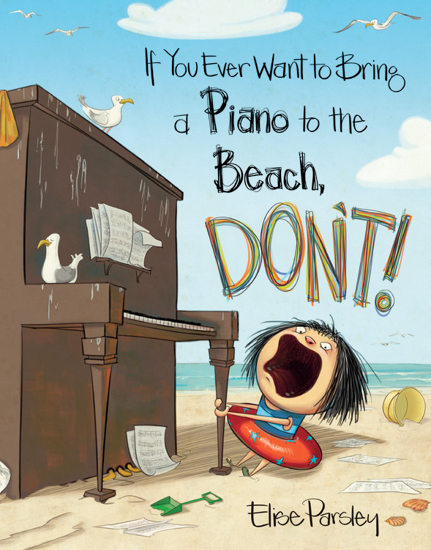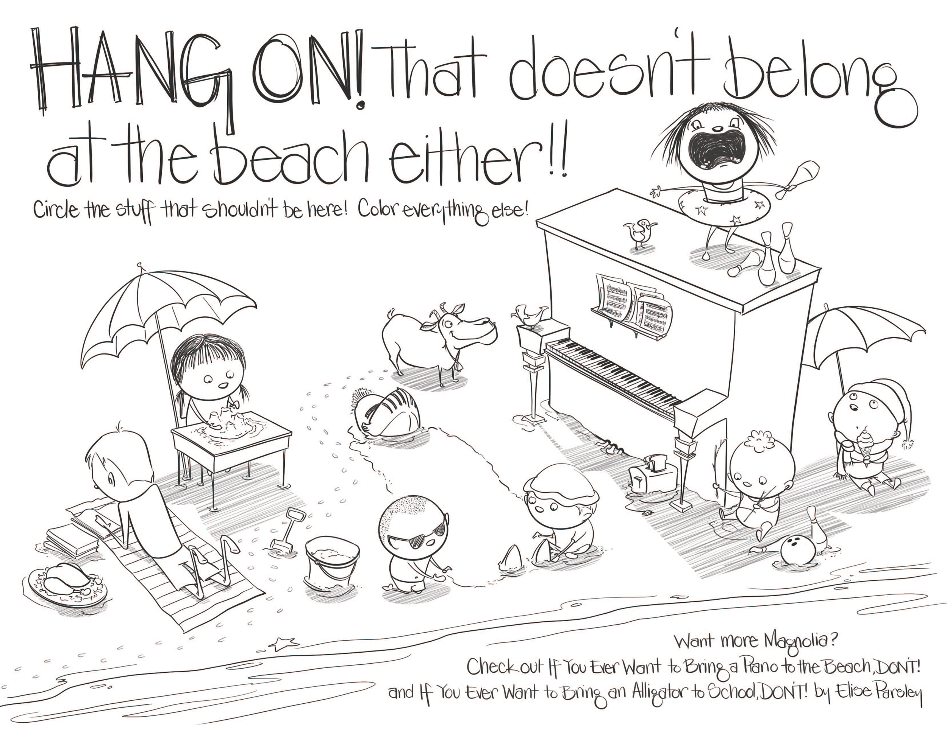
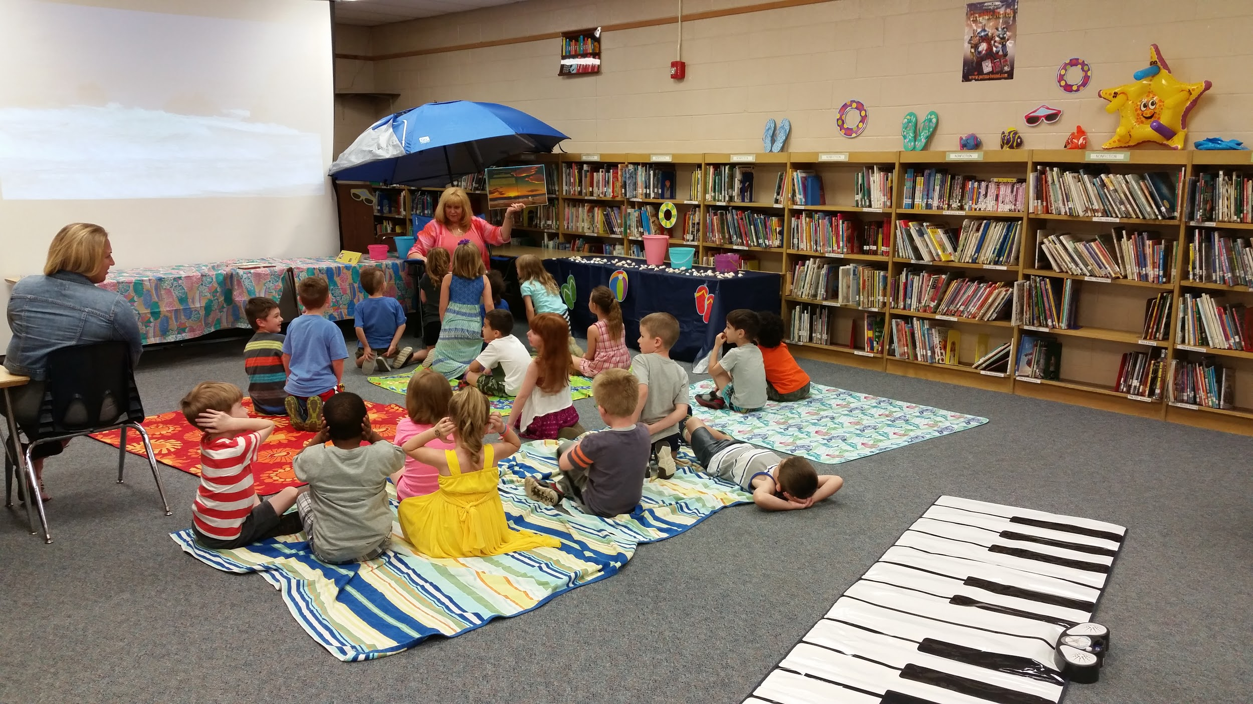
Targets
Students will…
- recall previous knowledge.
- determine appropriate choices and related outcomes.
- acknowledge diverse viewpoints.

Procedure
Set up the library like a beach. You could include things, such as towels, beach blankets, buckets, umbrella, beach wagon, and wear a beachy outfit with sunglasses. Put the video of the waves crashing on the beaches from the first library “welcome” class. Then invite students to your beach and to sit down on a towel on the floor. Discuss the fun of reading on the beach, but the importance of good book care. It is the perfect time to see what good book care students remember from past lessons. Remind students NOT to bring books into the water, keep them out of the direct sun and sand, wash hands before handling the book, etc. while they are reading this summer.
Discuss what are good things to bring to the beach and what is not. Read the book, If You Ever Want to Bring a Piano to the Beach, Don’t!, pausing to ask story-related questions throughout the story. At the end, allow the students time to share their favorite beach-related memories and plans for the summer. Once the lesson is complete, have the students line up and take turns walking and playing on the floor piano mat (I would use a timer and allow each student about 15 seconds). As they finish, send the students to go find a book to check out. Quietly play the Peanuts piano music video https://www.youtube.com/watch?v=OQybajU2GNk in a loop while students can complete and color the story-related worksheet from http://littlebrownlibrary.com/wp-content/uploads/2016/07/311643307-If-You-Ever-Want-to-Bring-a-Piano-to-the-Beach-Don-t-by-Elize-Parsley-Coloring-Pages-1.png .
Materials
- Beach attire and decor
- Beach towels/blankets
- Videos
- Book, If You Ever Want to Bring a Piano to the Beach, Don’t!
- Piano floor mat
- If You Ever Want to Bring a Piano to the Beach, Don’t! coloring page
Learning Standards
AASL - Standards for the 21st-Century Learner-AASL 1.1.2 Use prior and background knowledge as context for new learning.
AASL - Standards for the 21st-Century Learner-AASL 1.1.6 Read, view, and listen for information presented in any format (e.g., textual, visual, media, digital) in order to make inferences and gather meaning.
AASL 3.2.2 Show social responsibility by participating actively with others in learning situations and by contributing questions and ideas during group discussions.
AASL 3.3.2 Respect the differing interests and experiences of others, and seek a variety of viewpoints.

Resources
Outstanding videos. (2012, October 25). Relaxing 3 Hour Video of A Tropical Beach with Blue Sky White Sand and Palm Tree [Video file]. Retrieved from https://www.youtube.com/watch?v=qREKP9oijWI
Squintan. (2009, July 8). Peanuts theme piano cover [Video file]. Retrieved from https://www.youtube.com/watch?v=OQybajU2GNk

#60 Year-in-Review Summer Book Swap
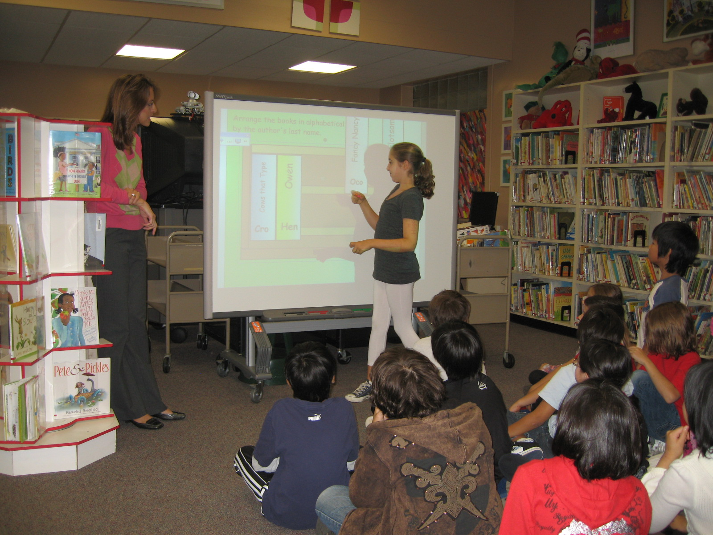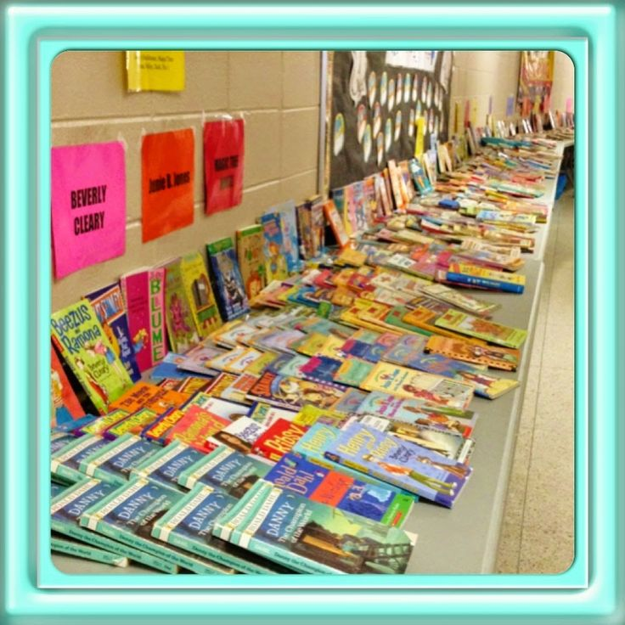
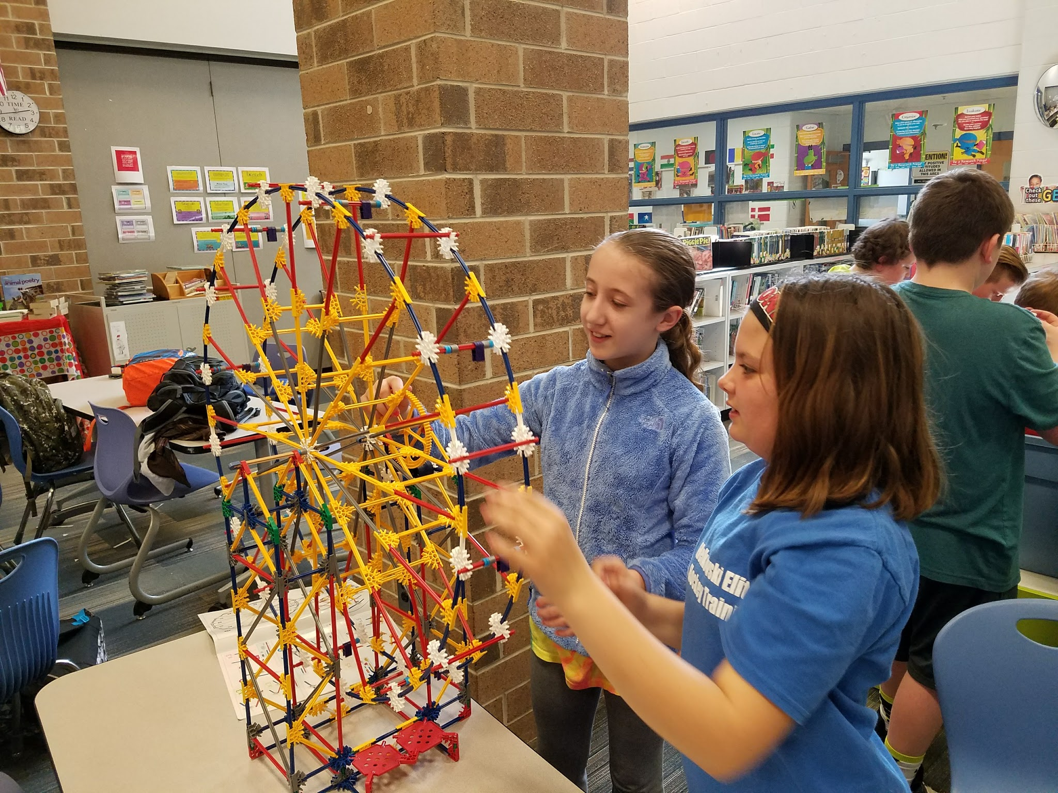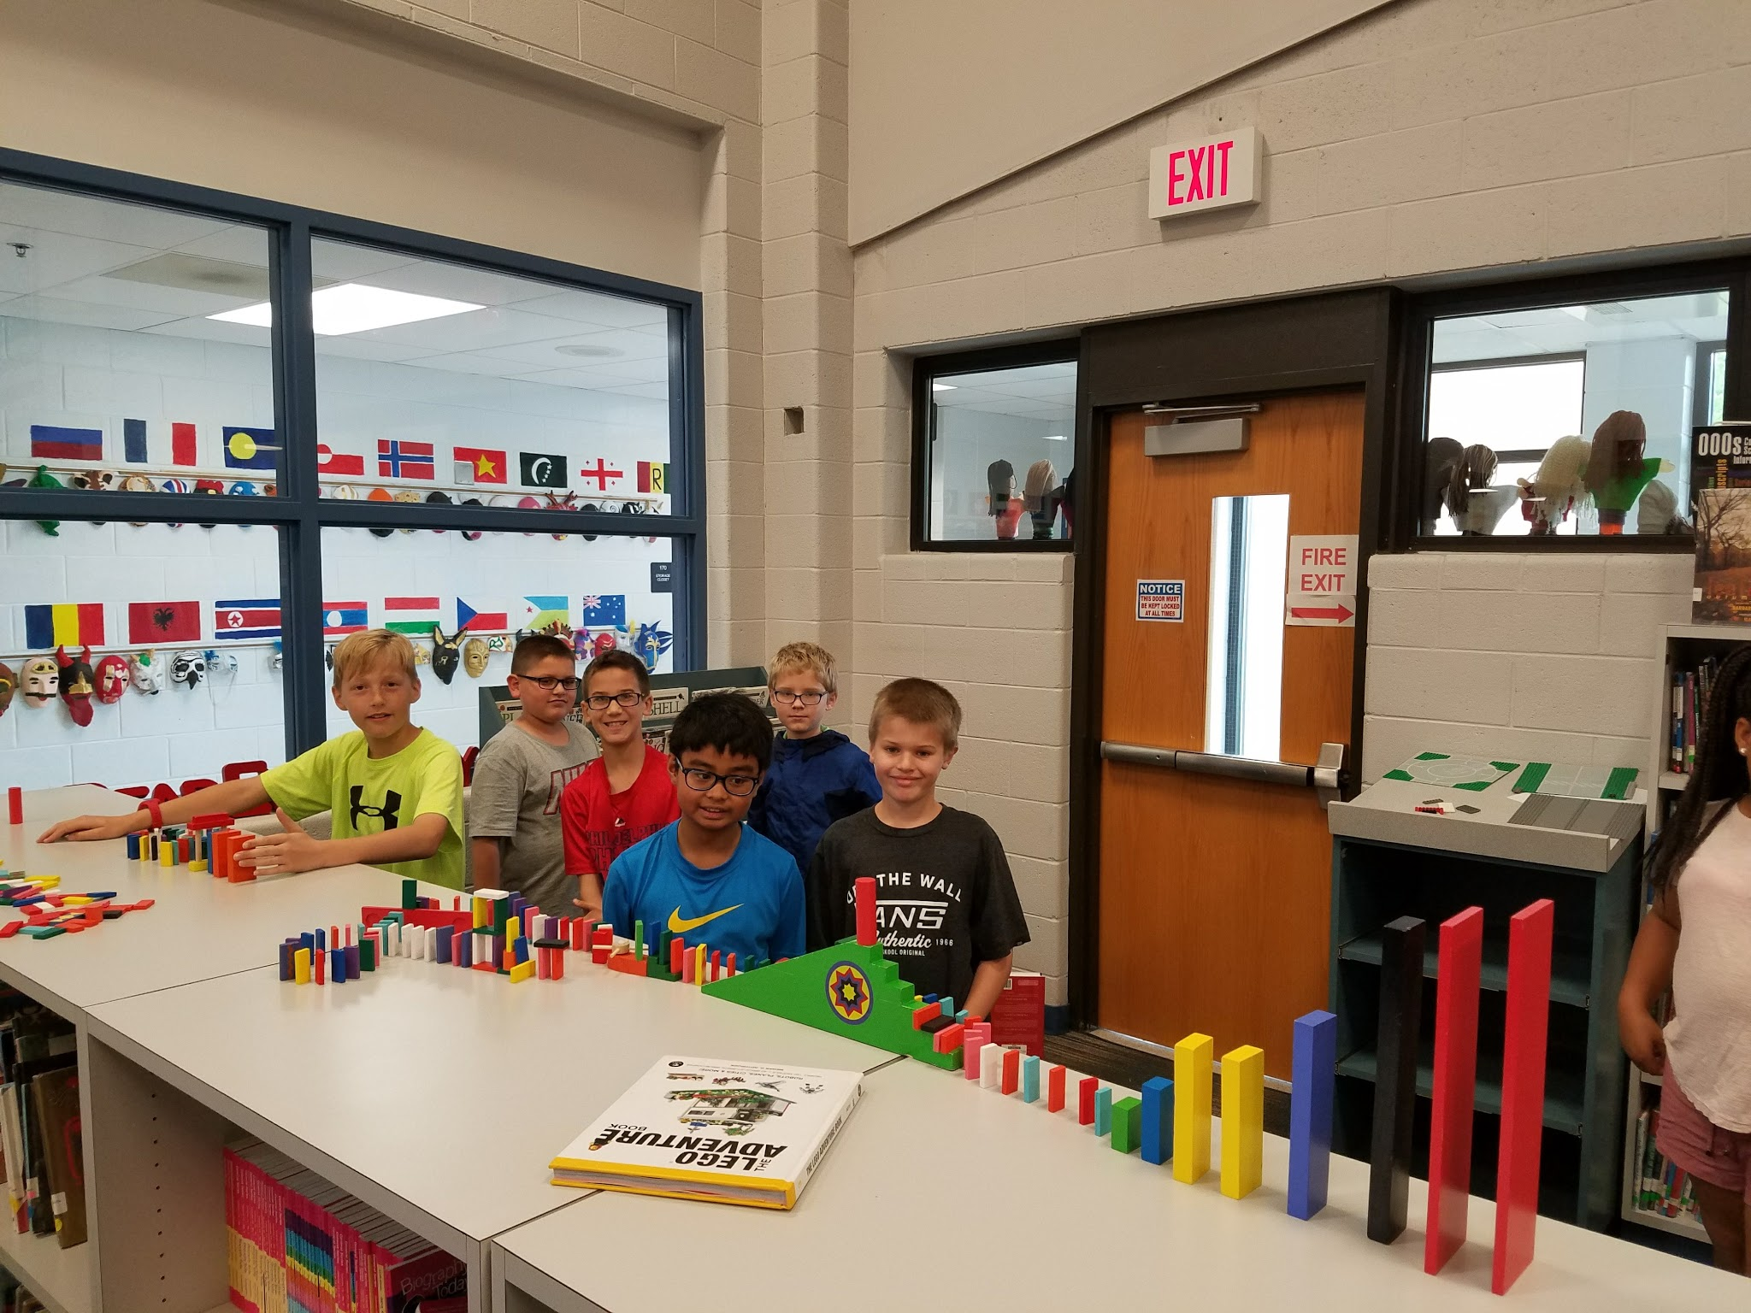

Students will…
- review topics discussed throughout the year.
- actively discuss their favorite lessons and activities.
- view a slideshow of the lessons and activities throughout the year.
- write topics or activities they would like to experience in library next year.
- select a book to take home for summer reading.

Procedure
During your last library class of the year, celebrate the great, memorable, fun-filled year in summer style. Decorate for the summer and wear summer clothes or a Hawaiian shirt and any related accessories. Put pictures that you take throughout the year during library class into a slide presentation to show students. (You may even want to invite parents to join the students for this end-of-the-year event). After the presentation, have students fill out a questionnaire with a list of the lessons you taught and ask them to rate them or pick the top 3 favorites. You can provide additional multiple choice questions to gather their opinions about various aspects of library. For example, questions about the library: rules, lessons, organization, furniture, arrangement, and their favorite activities, as well as books, activities and lessons they would like to have next year.
Next inform the students they will all select one book they can have to take home and read over the summer. Direct them to the tables in the back covered with a variety of donated and weeded books. After a student has selected a book, allow them to read or participate in a fun activity until the class is over. Send the students home with a summer reading challenge that they can return when they come back to school for a prize.
Materials
- Summer decor and attire
- Year-in-review picture slide presentation
- Library questionnaire
- Donated/weeded books
- Games/activities
- Summer challenge flyer

