SWSD Media Center Curriculum Unit 2
#21 Super Bowl...Score with Books
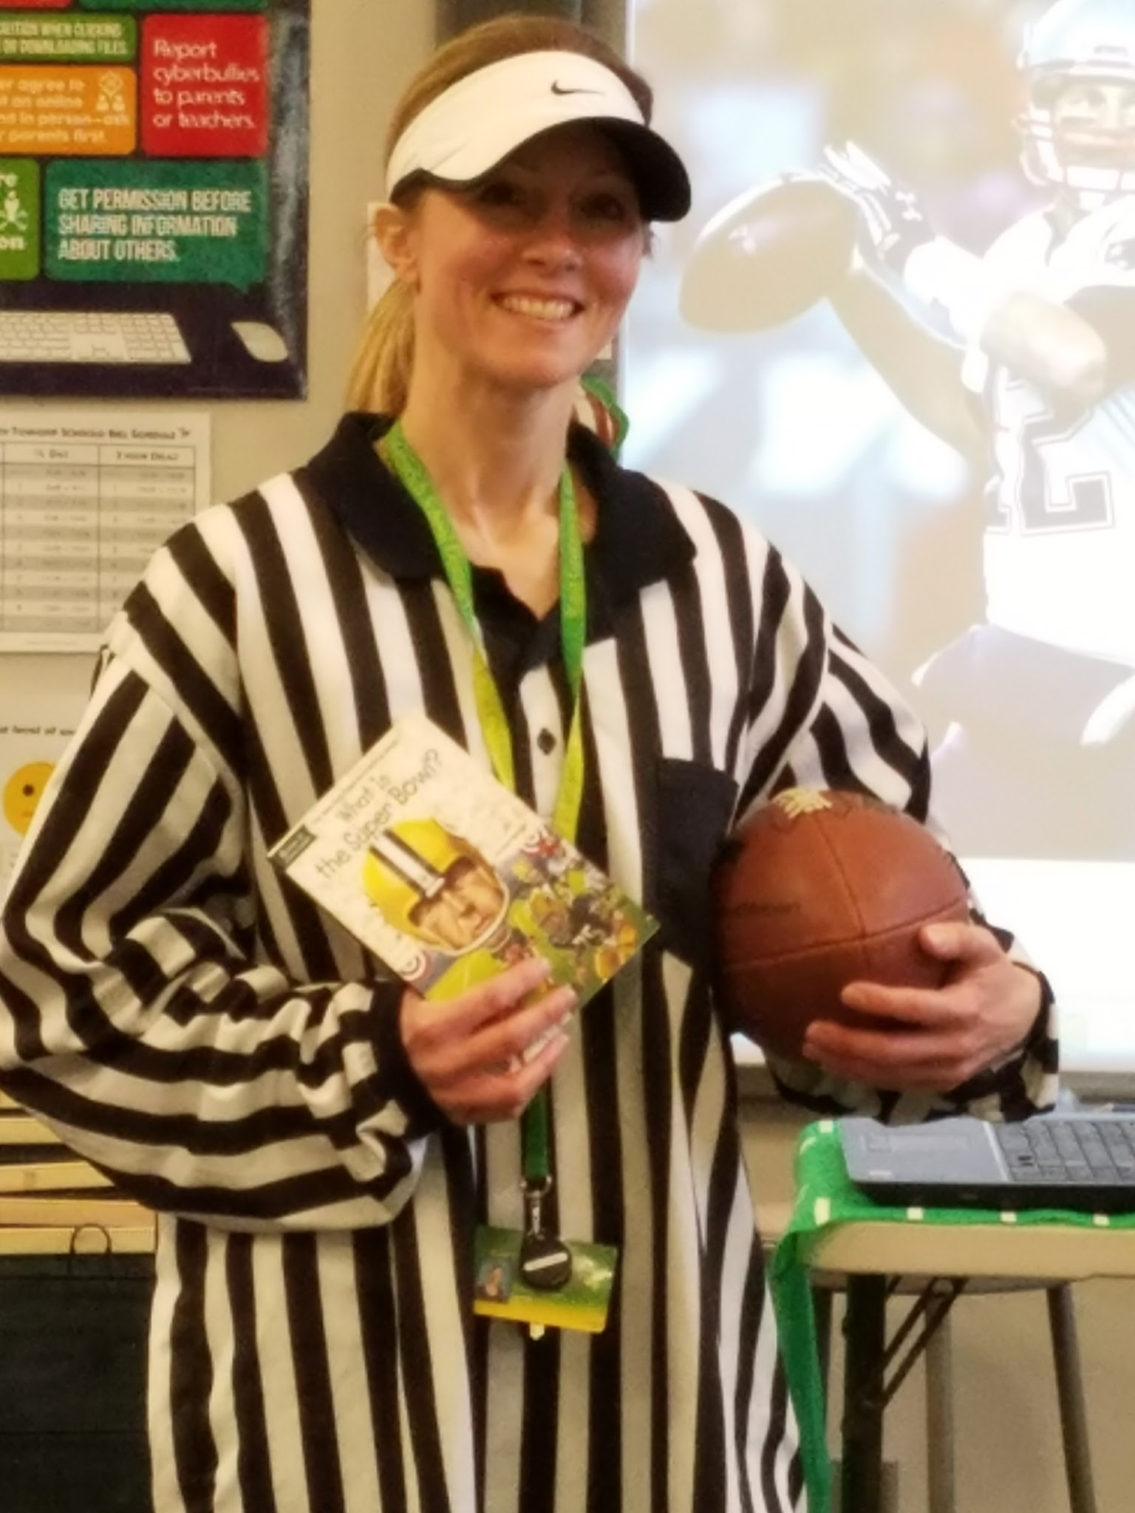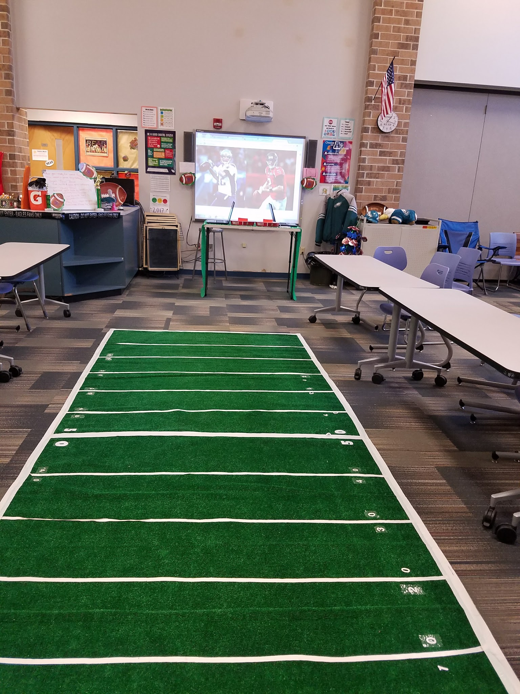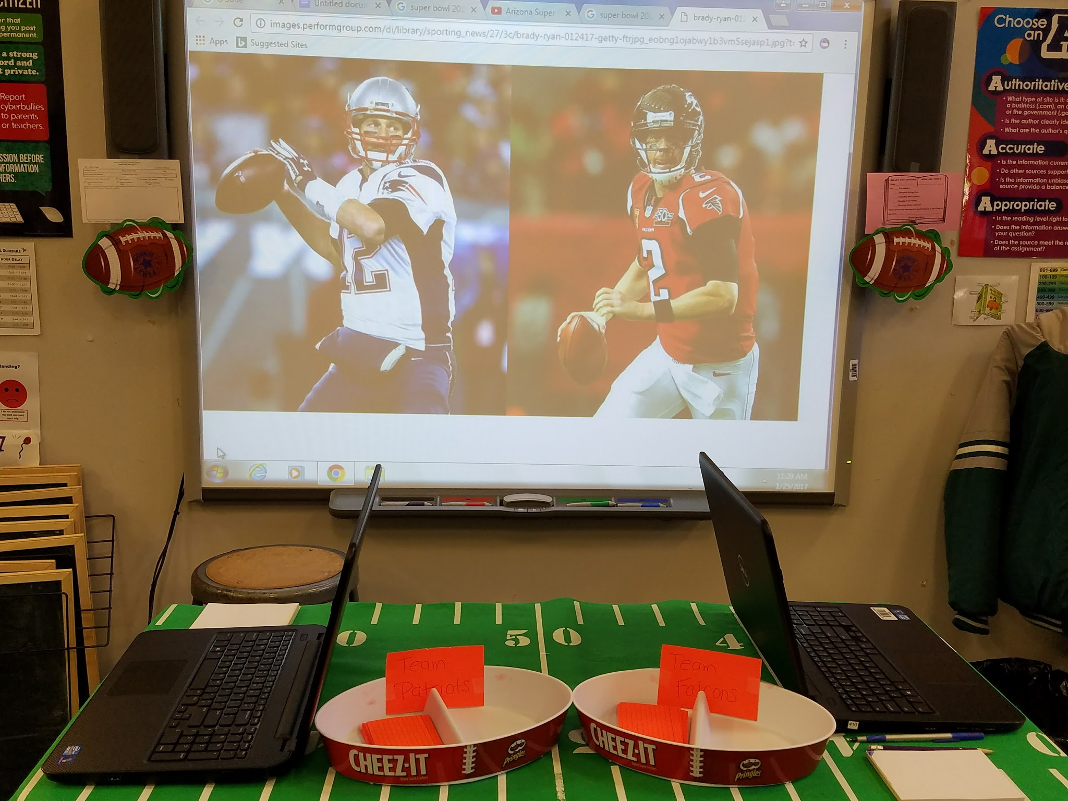
Targets
(Lower elementary)
Students will:
- make a connection to the upcoming Super Bowl, the story that is read and the activity that is played.
- listen to directions and following the directions.
- practice locating books in the library.
- ask for help when necessary, not giving up and ultimately succeeding.
- experience teamwork and the importance is not winning or losing, but having fun while learning.

Procedure

(Lower elementary)
Dress up like football referees or a football player. Put a football video on the smartboard as the students enter, while calling “Are you ready for some football?” Welcome in the students and have them sit around the football field. (The field was created from indoor/outdoor carpet and lined with white tape, and numbers were added.) Leave the video paused on the screen as the background. Read the book, Football with Dad by Frank Berrios (for grades K-1) or What is the Super Bowl? by (for grades 2-3).

(Upper Elementary)
Students will play the Super “Trivia” Bowl game. Divide the class into two teams. One from each team goes head-to-head in a question and answer game. Ask a Super Bowl related question and the first person to Goggle it or that already knows and writes it on the notepad (or dry erase board) and shows you advances their football down the field. First team to score a touchdown wins.
Afterward I will explain the rules of the game (all ages can play):
- Reinforce the following rules: being kind, sometimes you win and sometimes you lose, etc. prior to starting the activity.
- Hand each student an index card with a call number and word or image on it.
- Announce you are the referee and what you say goes. (If you have an aide or parent volunteer, they can be out in the “field” meaning they can help direct the players who are searching for books.)
- One player from each team must WALK to locate and retrieve a book that correlates to their card.
- They must WALK it back and hand it off to the referee, for a call.
- If the book matches, the player can advance their ball 10 yards, for a first down.
- If it is not correct, a flag is thrown on the play and the player must return the book and get the correct book.
- Only the player retrieving the book is standing up, all other team members must remain seated and quietly cheer their teammate on.
- After the allotted time (approximately 10-15 minutes) the team that has scored the most touchdowns or advanced the farthest is the winner.
- When time is up, announce “Everyone is a winner with books!”
Have each students put away one book in the correct place, and find a book to check out.

Materials
- Referee or football attire
- Footballs, flags, whistle
- Youtube videos
- Football with Dad by Frank Berrios or What is the Super Bowl by Dina Anastasio
- Football field-indoor/outdoor carpet, white tape, white number stickers, letter stickers
- Index cards with call numbers and/or images on them

Resources

*Use any videos or images for the current upcoming Super Bowl
Materials
- Referee or football attire
- Footballs, flags, whistle
- Youtube videos
- Football field-indoor/outdoor carpet, white tape, white number stickers, letter stickers
- Laptops
- Mini notepads
- Pens/pencils
- Index cards with call numbers and/or images on them
Learning Standards
AASL - 1.2.6 Display emotional resilience by persisting in information searching despite challenges.
AASL - 4.4.3 Recognize how to focus efforts in personal learning.
AASL - 1.1.6 Read, view, and listen for information presented in any format (e.g., textual, visual, media, digital) in order to make inferences and gather meaning.
AASL - 3.2.2 Show social responsibility by participating actively with others in learning situations and by contributing questions and ideas during group discussions.
AASL - 4.3.2 Recognize that resources are created for a variety of purposes.
AASL - 2.2.3 Employ a critical stance in drawing conclusions by demonstrating that the pattern of evidence leads to a decision or conclusion.
AASL - 1.1.2 Use prior and background knowledge as context for new learning.
AASL - 1.2.2 Demonstrate confidence and self-direction by making independent choices in the selection of resources and information.

#22 Black History Month-John Glenn and his “Hidden Figures”
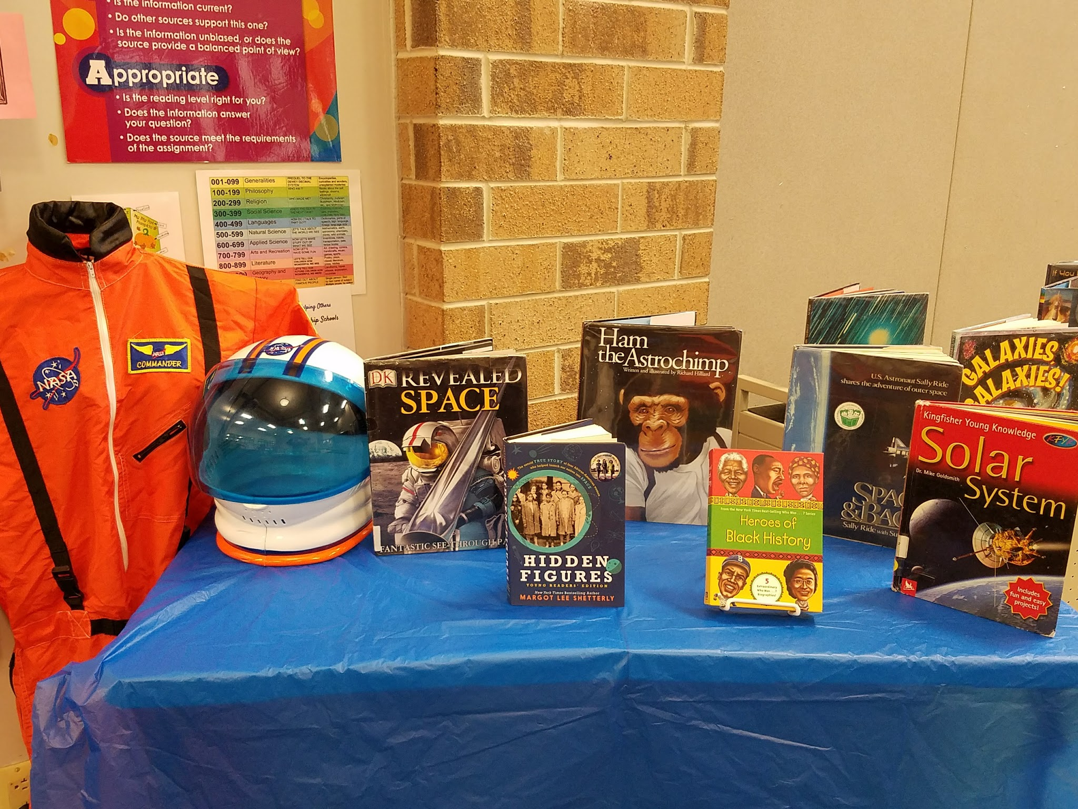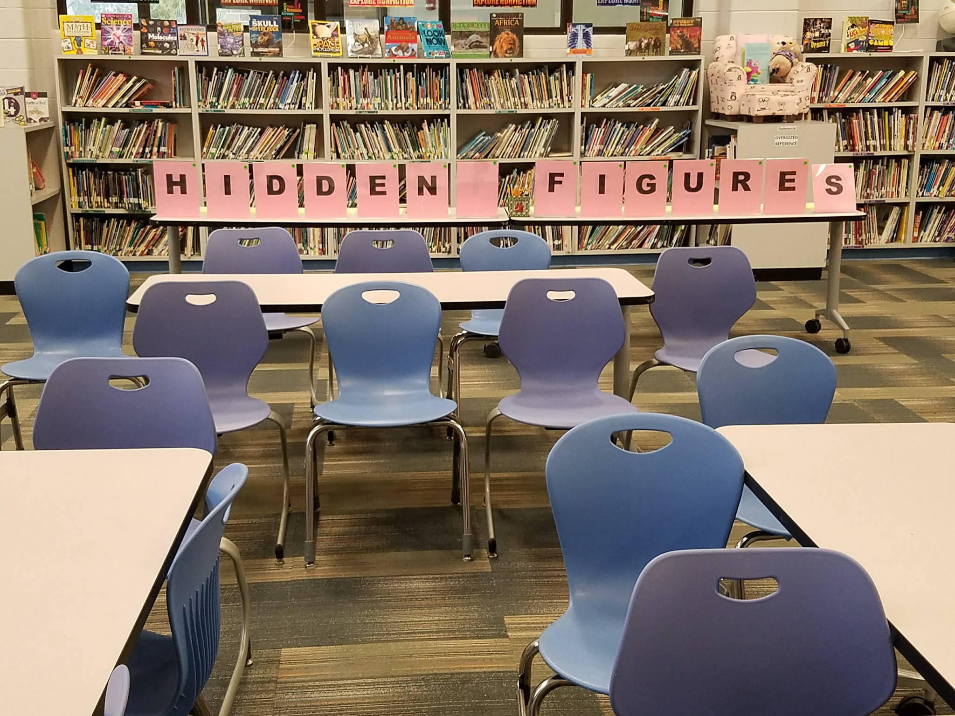
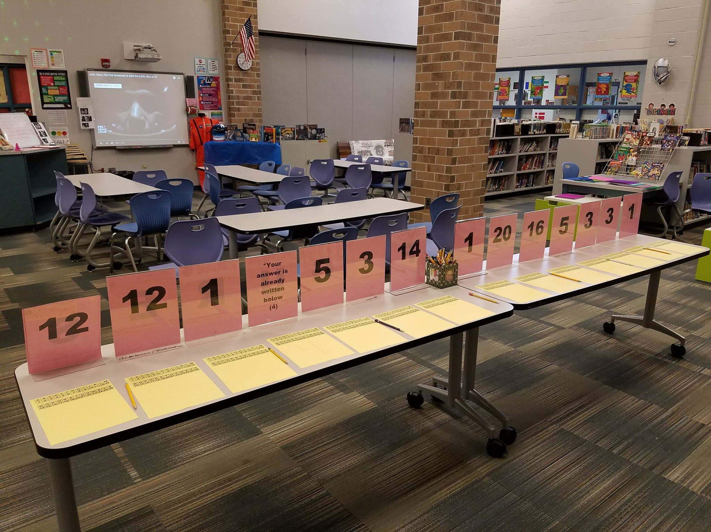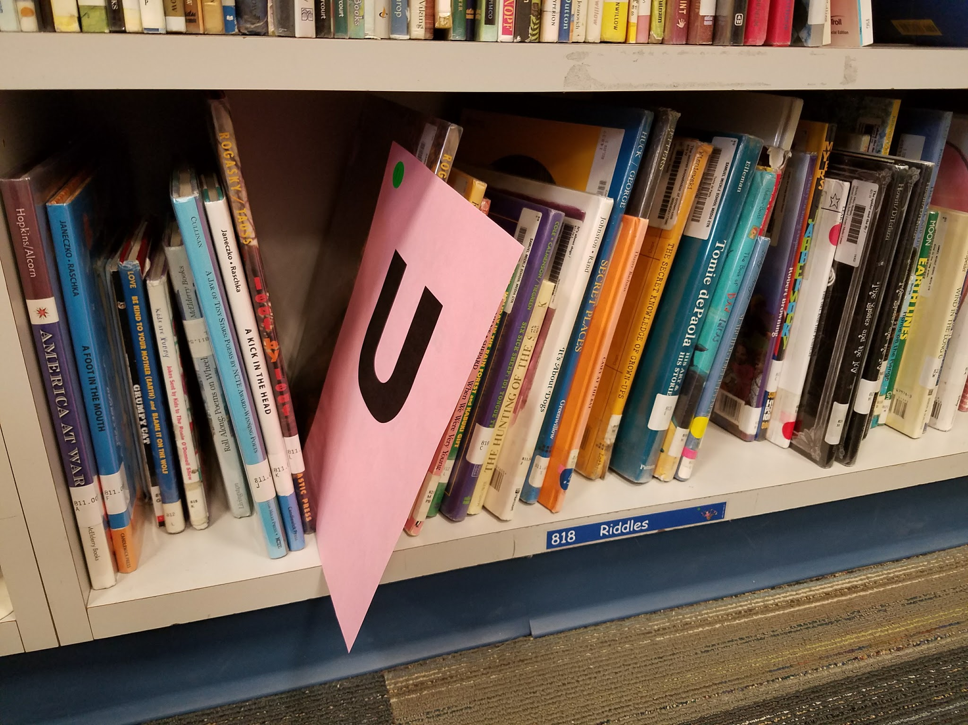
Targets
Students will…
- understand it is Black History Month.
- view and learn about NASA’s three secret weapons.
- decode an important message.

Procedure
(Lower & Upper Elementary)
Decorate the room with NASA/astronaut decor. Print an image of Nasa’s symbol and tape it to the back of a clipboard. Use the clipboard to hold any paperwork required for the lesson. Ask if anyone can tell you what is special about the month of February. (Desired answer: It’s Black History Month). Ask students if they can share some black men and women that have are or should be celebrated for accomplishments in their lifetime. Discuss John Glenn’s legacy, including three of NASA’s best kept secret weapons: Katherine Johnson, Mary Jackson and Dorothy Vaughan. They were black women, nicknamed “computers in skirts,” that performed meticulous calculations to help the United States to catch up in the space race and send John Glenn into orbit around the Earth. Show the movie trailer for the film, Hidden Figures, that was shown in the theaters. Discuss how these women were segregated in West Area of NASA, but were the ones to change their policies and way of thinking. These strong, intelligent, brave ladies paved the way for women, especially black women, to be an accepted part of NASA. Share brief biographies on all three women. Additionally share that Mary Jackson, Dorothy Vaughan and John Glenn (recently) have all died, but Katherine Johnson is 98 and still very humble.
(Optional-Upper Elementary)
Discuss computer programing and coding. Show the students a video on coding in Scratch. Have students work in pairs to create a Scratch game/activity. It would be helpful to have the computer teacher pop in for instructions and questions or prior to the lesson videotape a tutorial. This lesson would continue throughout 2 library classes. Allow students to share their creations at the end of the period.
Materials
- NASA decor and outfit
- Google image (NASA symbol)
- Clipboard
- John Glenn video
- 14 plastic sign holders
- Paper with letters and numbers on it to spell out “Hidden Figures” and decode the message, “Acceptance 4 All”
- Papers with number/letter code printed on them
- Pencils
- How-to Code instructional video and books
- Laptops/Computer
- Scratch (free online coding game)

Learning Standards
AASL - 1.2.6 Display emotional resilience by persisting in information searching despite challenges.
AASL - 2.2.2 Use both divergent and convergent thinking to formulate alternative conclusions and test them against the evidence.
AASL - 1.1.6 Read, view, and listen for information presented in any format (e.g., textual, visual, media, digital) in order to make inferences and gather meaning.
AASL - 3.2.2 Show social responsibility by participating actively with others in learning situations and by contributing questions and ideas during group discussions.
AASL - 2.1.5 Collaborate with others to exchange ideas, develop new understandings, make decisions, and solve problems.
AASL - 2.1.3 Use strategies to draw conclusions from information and apply knowledge to curricular areas, real world situations, and further investigations.
AASL - 4.1.1 Read, view, and listen for pleasure and personal growth.
AASL - 3.3.1 Solicit and respect diverse perspectives while searching for information, collaborating with others, and participating as a member of the community.
AASL - 4.1.4 Seek information for personal learning in a variety of formats and genres.
AASL - 1.1.2 Use prior and background knowledge as context for new learning.

Resources
CBS News. (2017, January, 17). The story behind “Hidden Figures.” Retrieved from http://www.cbsnews.com/videos/the-story-behind-hidden-figures/
MIT education lab. (2017). Scratch. Retrieved from https://scratch.mit.edu/
PBS NewsHour. (2016, December 8). John Glenn, the first American to orbit the Earth, dies at 95. Retrieved from https://www.youtube.com/watch?v=0FwDvGwQd4g

#23 We LOVE the Library!
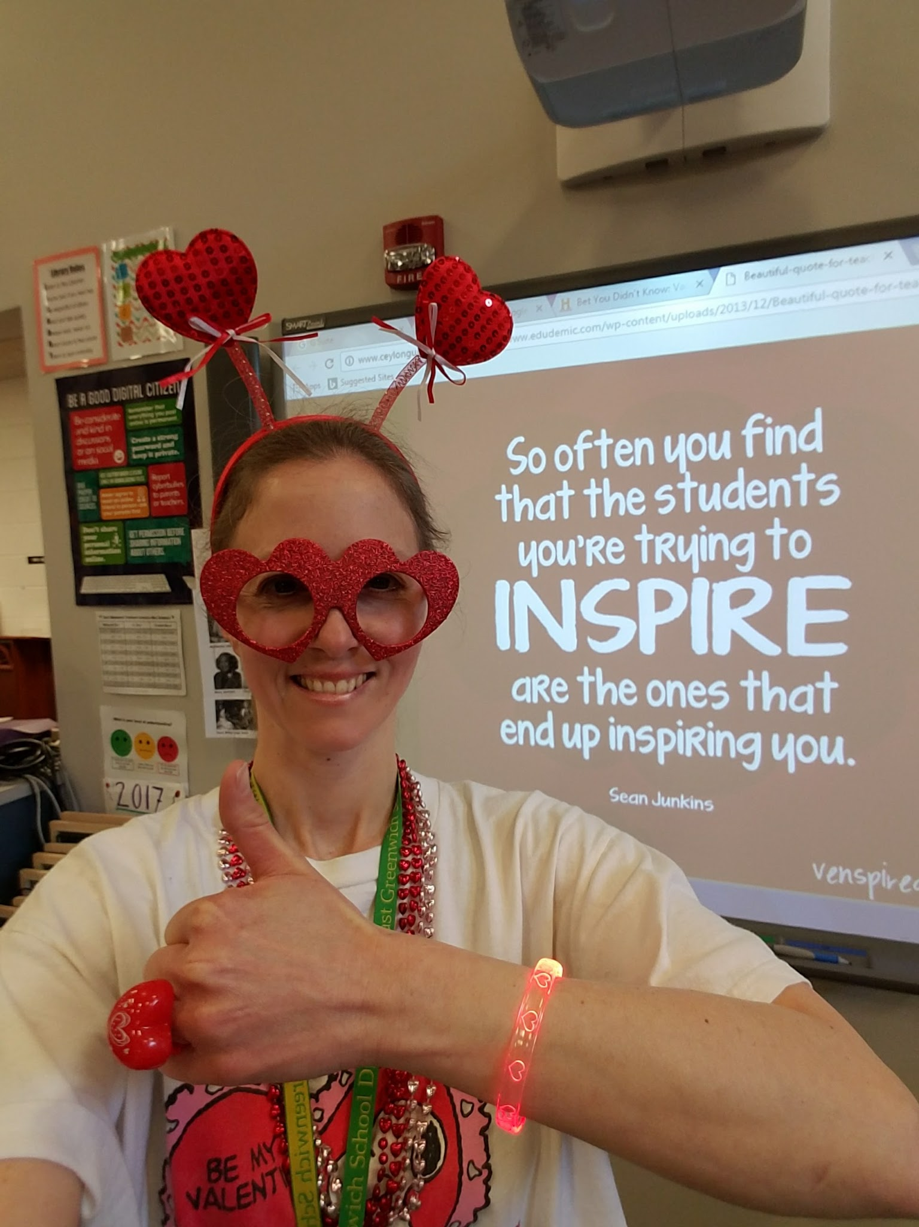
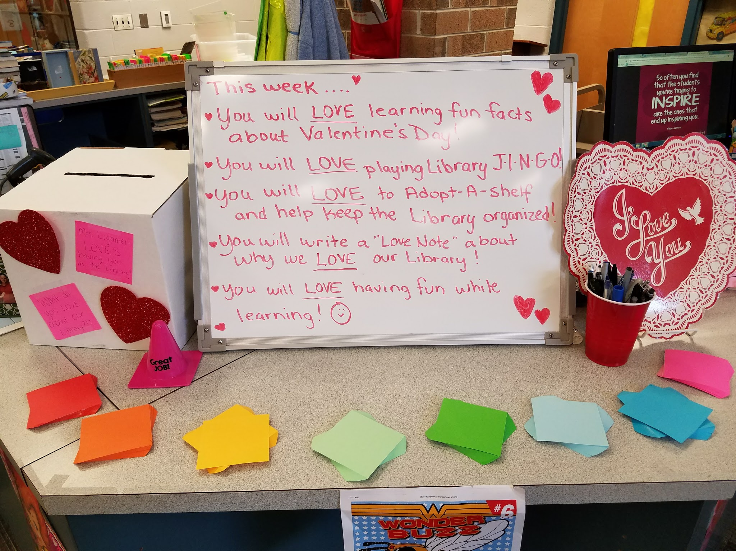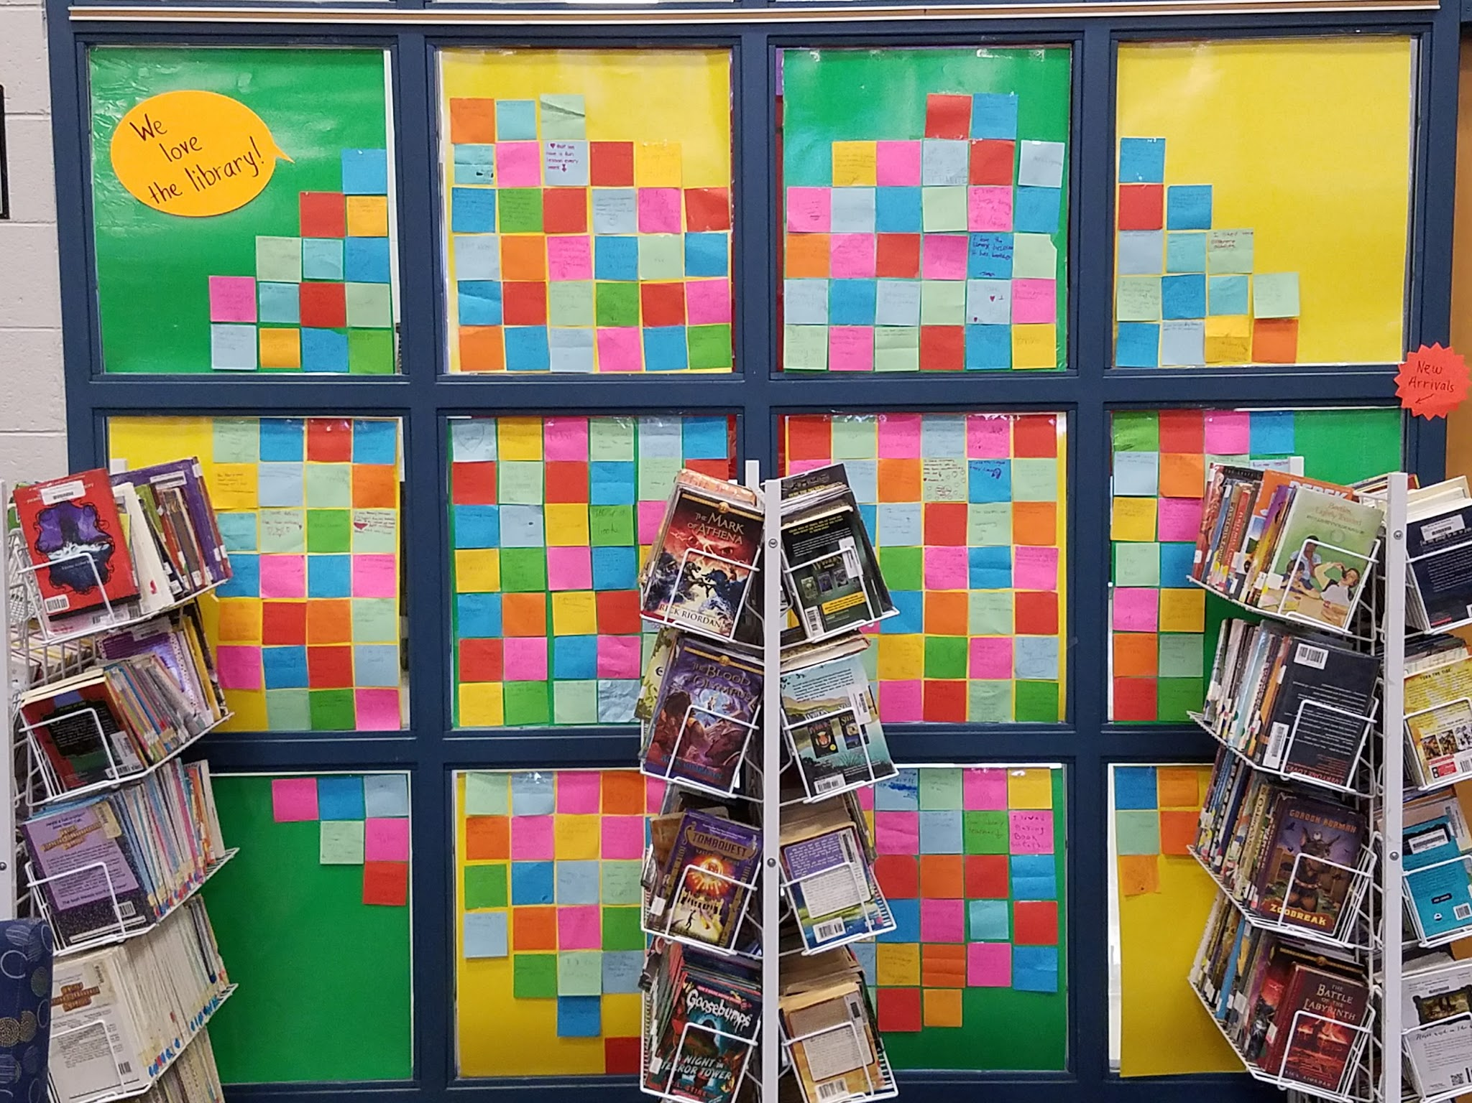
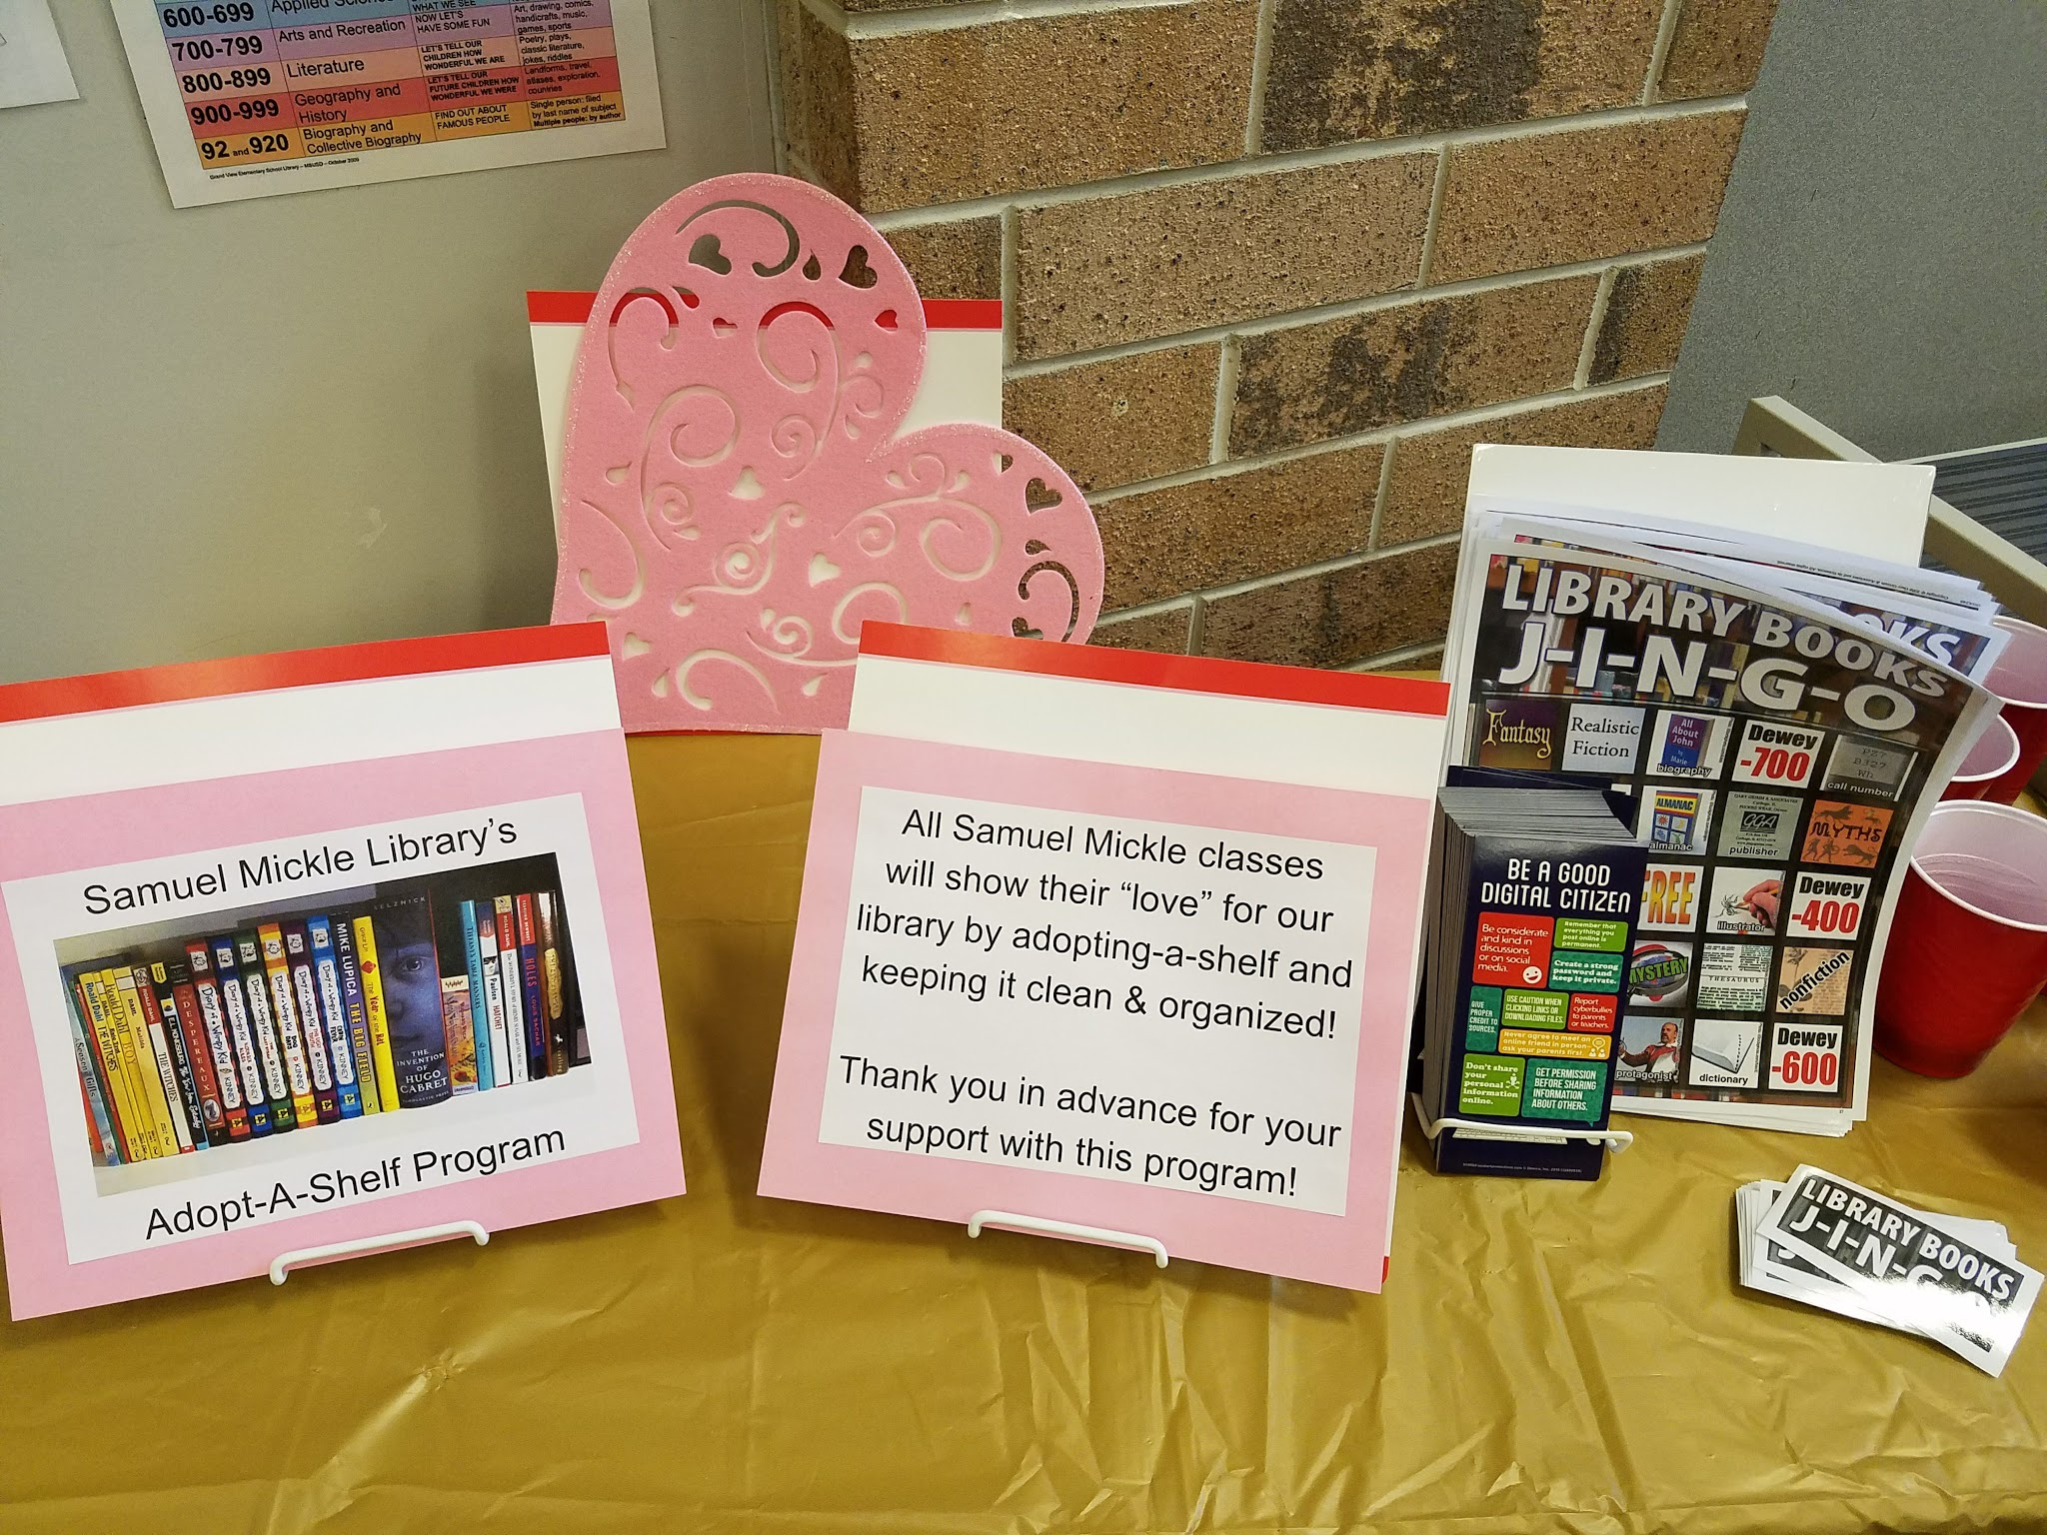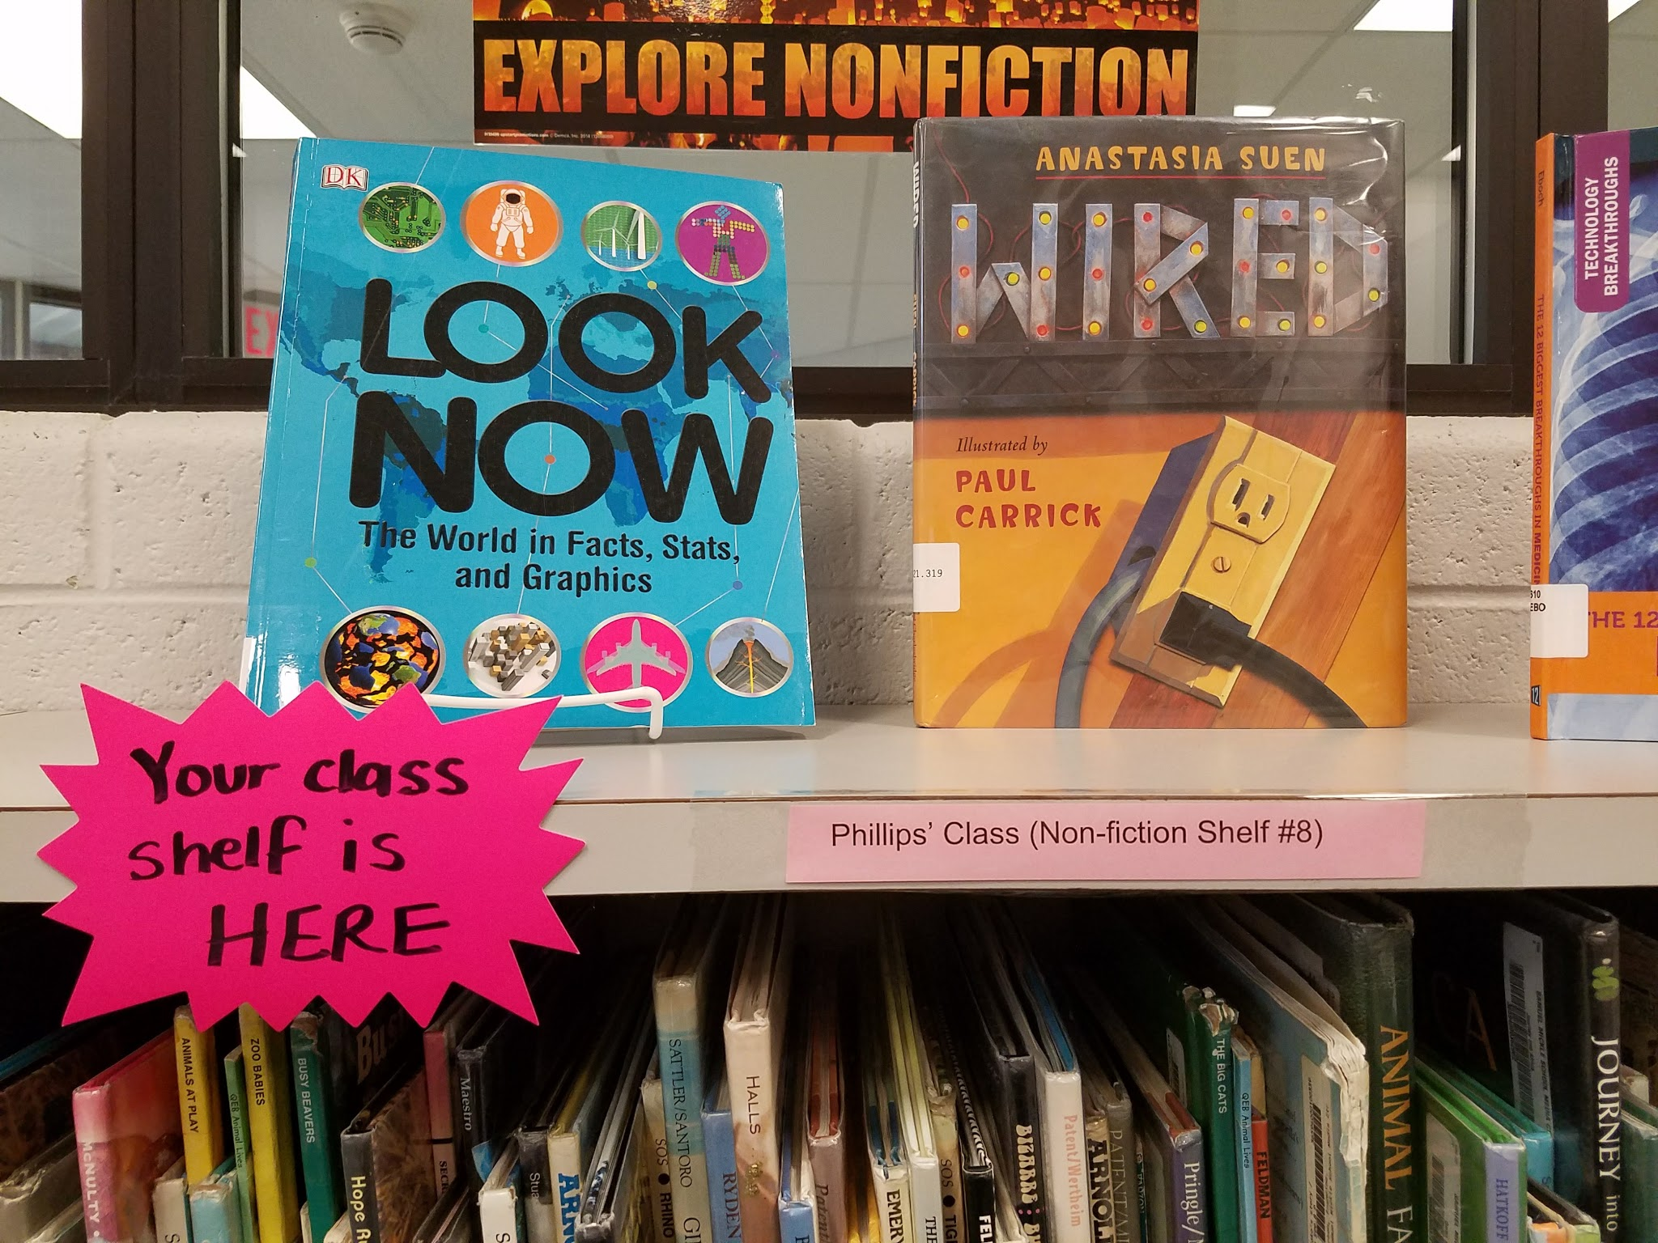
(Lower & Upper elementary)
Student will…
- learn fun facts about Valentine’s Day.
- recall library terms and resources (during a game of Library Bingo).
- learn about responsibility (during Adopt-a-shelf program).
Procedure
Dress up in Valentine’s attire. Share fun facts about Valentine’s Day (You can show a short Valentine’s video if it will enhance the lesson). Play a bingo game that uses terms associated with the library (I purchase a BINGO game called J-I-N-G-O). As students win they get a bookmark. Once everyone has won, hand each student a post-it note to write down what they like about the library. Post them on the wall or in windows in a heart shape. Have the students post their note after you view it or simply place their post-it in a container to sort later. Then walk the students over to the shelf that their class has been assigned to in your “adopt-a-shelf” program. Allow students to pick books to check-out. Direct the first students to check-out to organize their class shelf. Each week students should show the library some LOVE by taking turns cleaning up their shelves.
Materials
- Valentine’s decor and attire
- J-I-N-G-O (or other Library BINGO) game
- BINGO chips
- Bookmarks
- Post-it notes
- Adopt-a-shelf sign/poster
- Class names on colored paper

Learning Standards
AASL - 2.4.1 Determine how to act on information (accept, reject, modify).
AASL - 3.2.3 Demonstrate teamwork by working productively with others.
AASL - 1.4.4 Seek appropriate help when it is needed.
AASL - 1.4.3 Monitor gathered information, and assess for gaps or weaknesses.
AASL - 3.2.2 Show social responsibility by participating actively with others in learning situations and by contributing questions and ideas during group discussions.
AASL - 3.1.2 Participate and collaborate as members of a social and intellectual network of learners.
AASL - 1.1.9 Collaborate with others to broaden and deepen understanding.
AASL - 4.2.2 Demonstrate motivation by seeking information to answer personal questions and interests, trying a variety of formats and genres, and displaying a willingness to go beyond academic requirements.
AASL - 4.1.1 Read, view, and listen for pleasure and personal growth.
AASL - 1.1.2 Use prior and background knowledge as context for new learning.
#24 Lincoln’s Log Cabin & Life
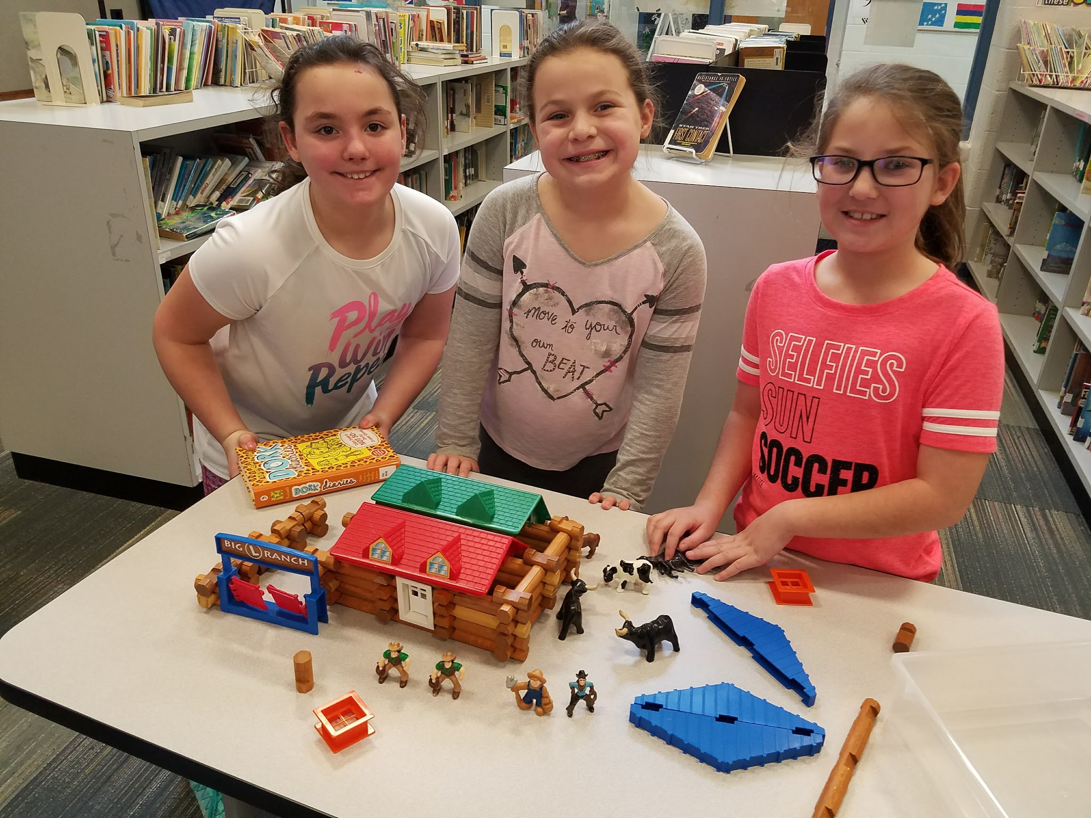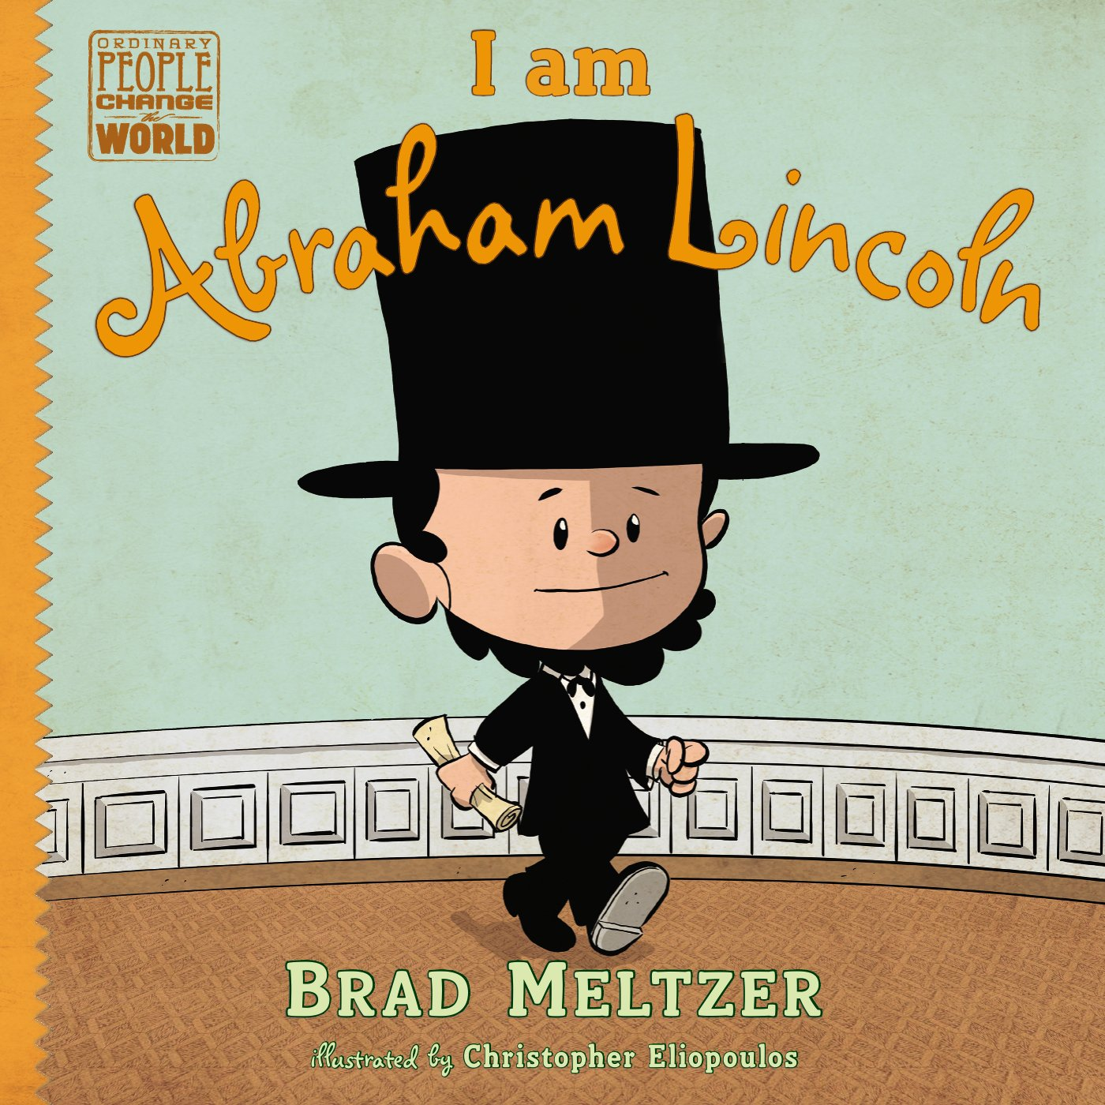
(Lower & Upper elementary)
Targets
Students will…
- learn information about Abraham Lincoln’s life and achievements.
- work as a team to construct a log cabin.
Procedure
(Lower elementary)
Dress up like Abraham Lincoln or just wear a similar hat. After welcoming the students, take of your hat and pull out papers with facts about Lincoln. Discuss that is where he stored his important papers too. Have a Lincoln Log box on display and put a picture of Abraham Lincoln and his log cabin on the smartboard. Discuss Abraham Lincoln’s birthday and ask what president he was. Read the book, I am Abraham Lincoln by Brad Meltzer. Share some additional fun facts about Lincoln. Then have students work together in teams to construct their own log cabins out of Lincoln Logs. Allow for time to share their creations and to check out books.
Materials
- Google images (Abraham Lincoln and his log cabin)
- Book, I am Abraham Lincoln by Brad Meltzer
- Lincoln Logs

Learning Standards
AASL - 4.1.8 Use creative and artistic formats to express personal learning.
AASL - 3.2.3 Demonstrate teamwork by working productively with others.
AASL - 1.1.6 Read, view, and listen for information presented in any format (e.g., textual, visual, media, digital) in order to make inferences and gather meaning.
AASL - 2.1.5 Collaborate with others to exchange ideas, develop new understandings, make decisions, and solve problems.
AASL - 3.2.1 Demonstrate leadership and confidence by presenting ideas to others in both formal and informal situations.
AASL - 1.1.2 Use prior and background knowledge as context for new learning.
*Social Studies

#25 Presidential Pets & Other Fun Facts
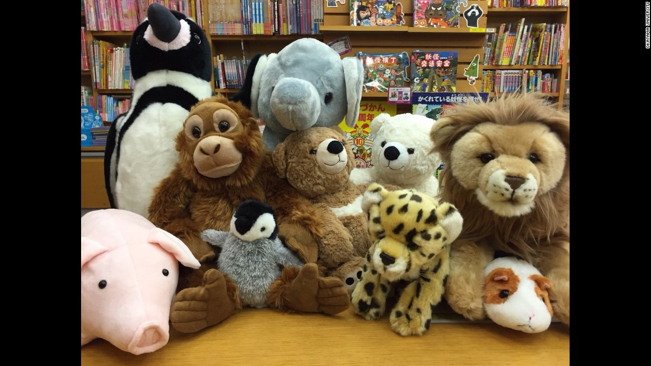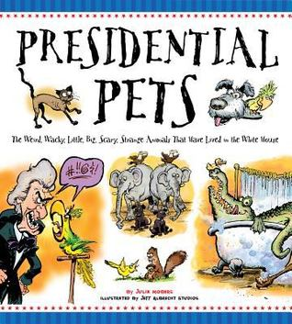
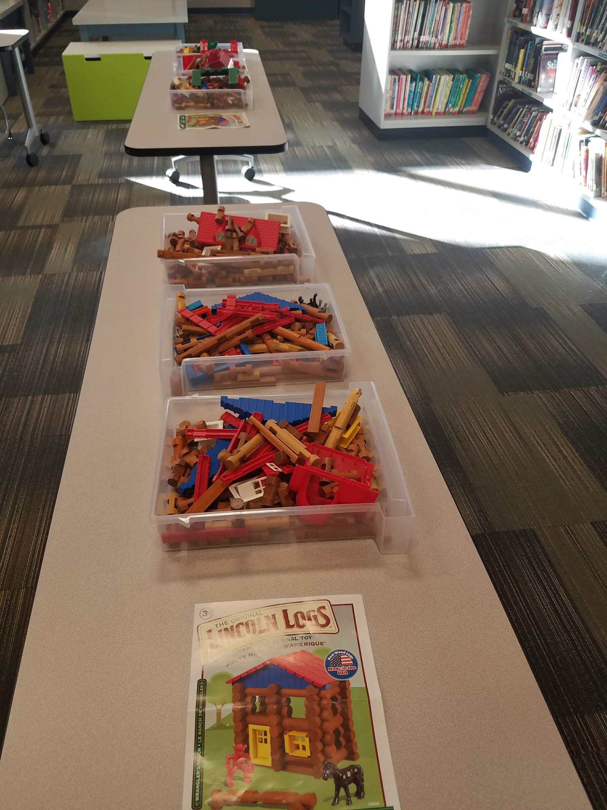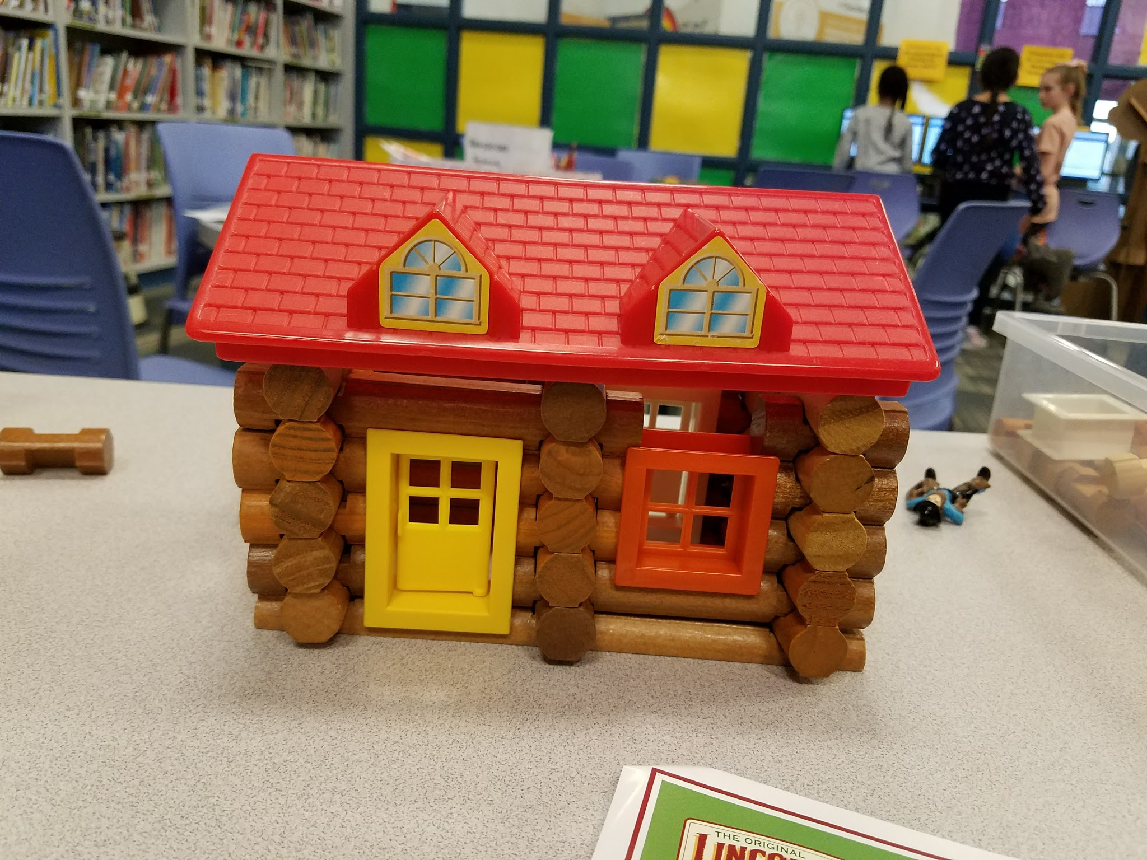
Students will…
- learn fun facts about Presidents.
- take turns sharing fun facts about all of the President’s pets.
- work as a team to create a new version of Lincoln’s log cabin
Procedure
(Lower elementary)
Welcome students to pick a stuffed animal to hold and sit by the smartboard to watch two videos. The first is filled with fun facts about presidents https://www.youtube.com/watch?v=B_8yQ2plaAE . The second is when Kid President meets President Obama https://www.youtube.com/watch?v=TssZ9Uma1-w . After discuss additional fun facts about various Presidents, including their unique pets from Presidential Pets book and ask each student what pet they would have in the White House if they were president. Have students get into teams to create their own Lincoln log cabins, then allow time for them to show and share before checking out books.
Materials
- Americana decorations
- Assorted stuffed animals
- Presidential videos
- President’s pets handouts
- Lincoln Log sets

Learning Standards
Cool School. (2015, February 12). Presidents- Fun Facts! - Wiki for Kids at Cool School [Video file].. Retrieved from www.youtube.com/watch?v=B_8yQ2plaAE .
SoulPancake. (2013, February 12). Kid President meets the President of the United States of America [Video file]. Retrieved from https://www.youtube.com/watch?v=TssZ9Uma1-w
Resources
AASL - 4.1.8 Use creative and artistic formats to express personal learning.
AASL - 3.2.3 Demonstrate teamwork by working productively with others.
AASL - 1.1.6 Read, view, and listen for information presented in any format (e.g., textual, visual, media, digital) in order to make inferences and gather meaning.
AASL - 2.1.5 Collaborate with others to exchange ideas, develop new understandings, make decisions, and solve problems.
AASL - 3.2.1 Demonstrate leadership and confidence by presenting ideas to others in both formal and informal situations.
AASL - 1.1.2 Use prior and background knowledge as context for new learning.

#26 The Presidential Challenge
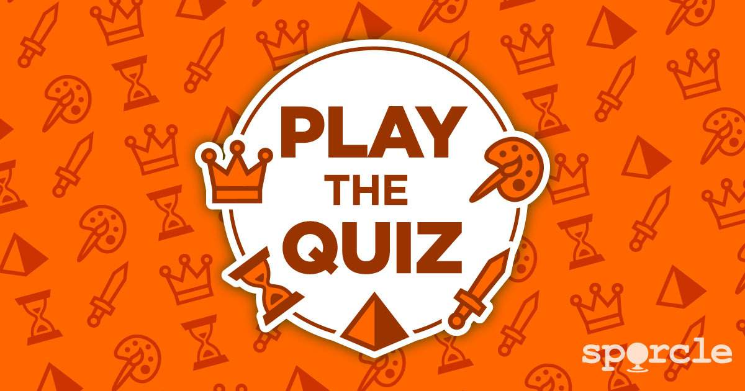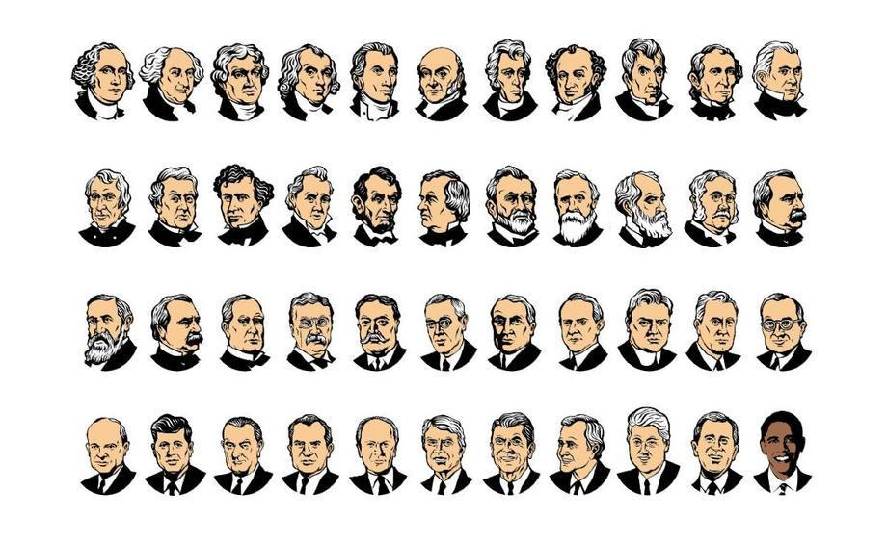
Targets
Students will…
- Recall all the presidents.
- utilize encyclopedias for unknown presidential information.
- Learn to work as a team to create a new version of Lincoln's log cabin.
Procedure
(Upper elementary)
Put the sporcle online quiz "Can you name all the presidents?" on the smartboard. Have the chairs in front of the smartboard for students to sit and see clearly. Instruct them that together, they have 10 minutes to recall all the presidents names they can. If at any point they can no longer name them, the time will be recorded and they can use an encyclopedia to look up “Presidents” and figure out which presidents they forgot. When they have completed the task or the time is up write down their class time, score and how many presidents their class typed in on a record sheet.
Share some fun facts or videos about various presidents and their pets, as time allows. Then have the students team up and create their own Lincoln log creations.
Materials
- Americana decor
- Online quiz
- World Book encyclopedia set
- Presidential video
- Lincoln Log sets

Learning Standards
AASL - 4.1.8 Use creative and artistic formats to express personal learning.
AASL - 3.2.3 Demonstrate teamwork by working productively with others.
AASL - 1.1.6 Read, view, and listen for information presented in any format (e.g., textual, visual, media, digital) in order to make inferences and gather meaning.
AASL - 2.1.5 Collaborate with others to exchange ideas, develop new understandings, make decisions, and solve problems.
AASL - 3.2.1 Demonstrate leadership and confidence by presenting ideas to others in both formal and informal situations.
AASL - 1.1.2 Use prior and background knowledge as context for new learning.
Resources
Sporcle. (2017). Can you name all the presidents? Retrieved from
https://www.sporcle.com/games/g/presidents

#27 George Washington’s Teeth
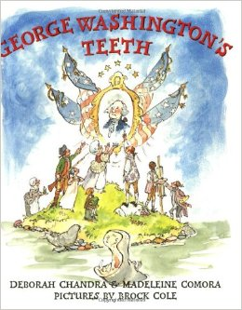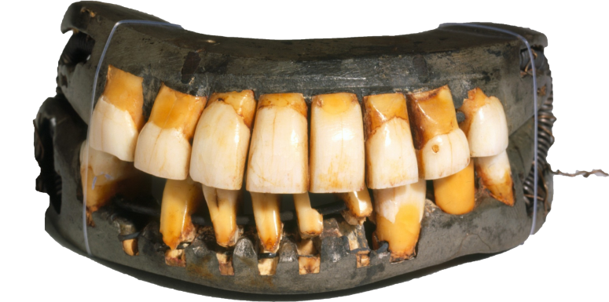
Targets
Students will…
- learn February is National Children’s Dentistry Health Month.
- understand the importance of caring for your teeth.
- understand it is George Washington’s birthday.

Procedure
(Lower elementary)
See if a local dentist can provide you with toothbrushes to give your students during library. Dress in a dental/doctor scrub uniform with a medical mask over your mouth. Have a toothbrush sticking out of your shirt pocket and a name tag with “Dentist (Your name)” on it. Welcome students and inform them that February is National Children’s Dentistry Health Month. Joke about everyone having a dental cleaning today, then discuss Washington’s birthday and how he probably wished he went to the dentist when he was younger. Share some fun facts about the dentist and teeth. Read the book, George Washington’s teeth by Deborah Chandra & Madeleine Comora. Pause reading the story to allow students to take turns pulling out one of “Washington’s teeth” from a clay mold of a mouth, as he loses them throughout the story. Before the students leave, take a close-up picture of the class with big smiles to post on your bulletin board for example “There’s plenty to Smile about in Our Library!” Add assorted emoji images to the wall or window where they are posted.
*Another option is to include Dr. Seuss’s The Tooth Book, as a precursor to Read Across America the first week of March.
Materials
- Scrub uniform, mask and name tag
- Information (video or paperwork) about National Children’s Dentistry Month, dentists and teeth
- Toothbrushes
- George Washington’s teeth book by Deborah Chandra & Madeleine Comora
- Fake teeth
- Playdoh
- Camera
- Emoji pictures

Learning Standards
AASL1.1.2 Use prior and background knowledge as context for new learning.
AASL 1.1.6 Read, view, and listen for information presented in any format (e.g., textual, visual, media, digital) in order to make inferences and gather meaning.
AASL 3.2.2 Show social responsibility by participating actively with others in learning situations and by contributing questions and ideas during group discussions.
AASL 4.2.3 Maintain openness to new ideas by considering divergent opinions, changing opinions or conclusions when evidence supports the change, and seeking information about new ideas encountered through academic or personal experiences.

#28 Happy Birthday, Dr. Seuss!!!
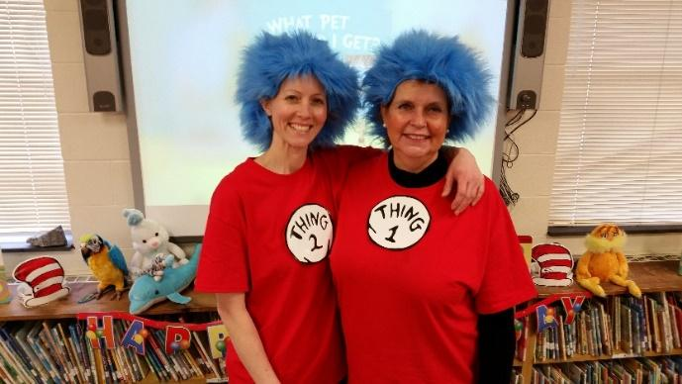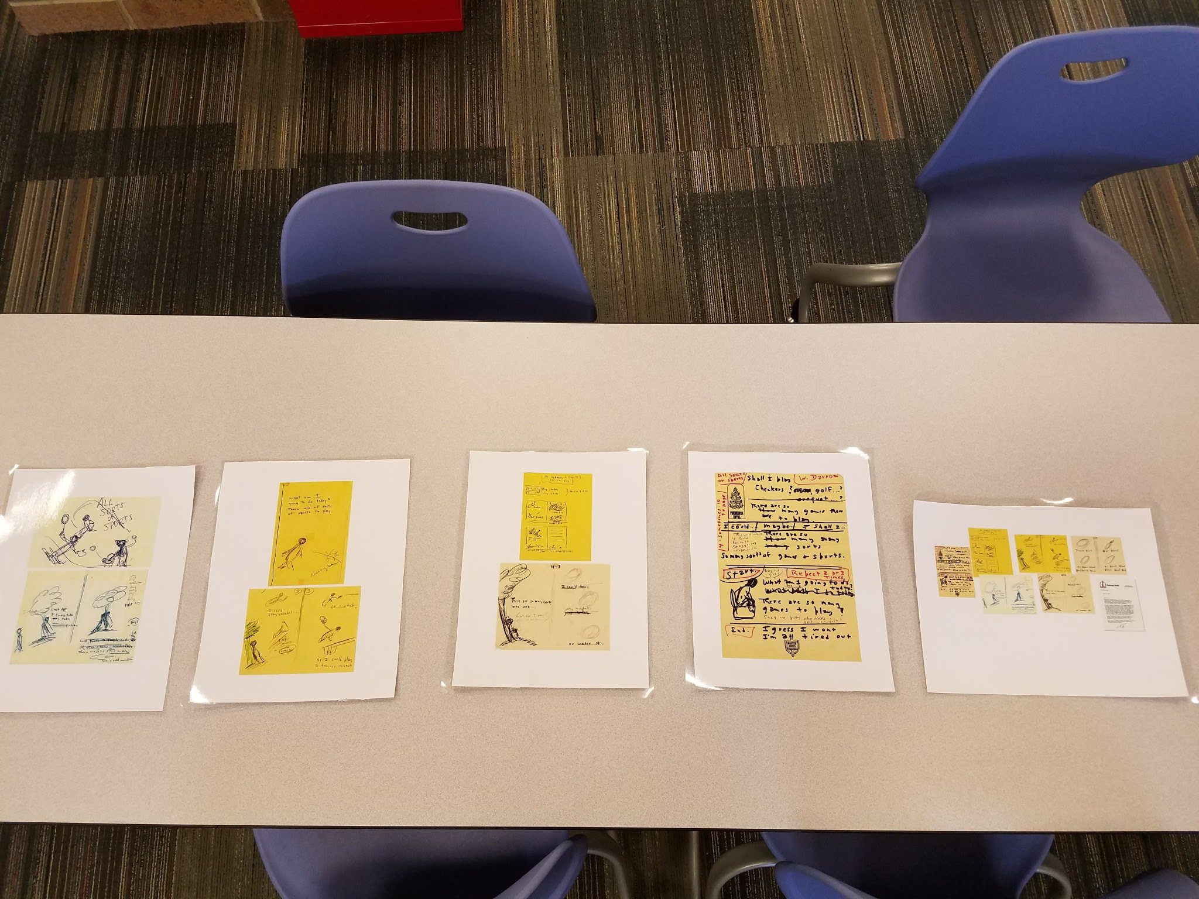
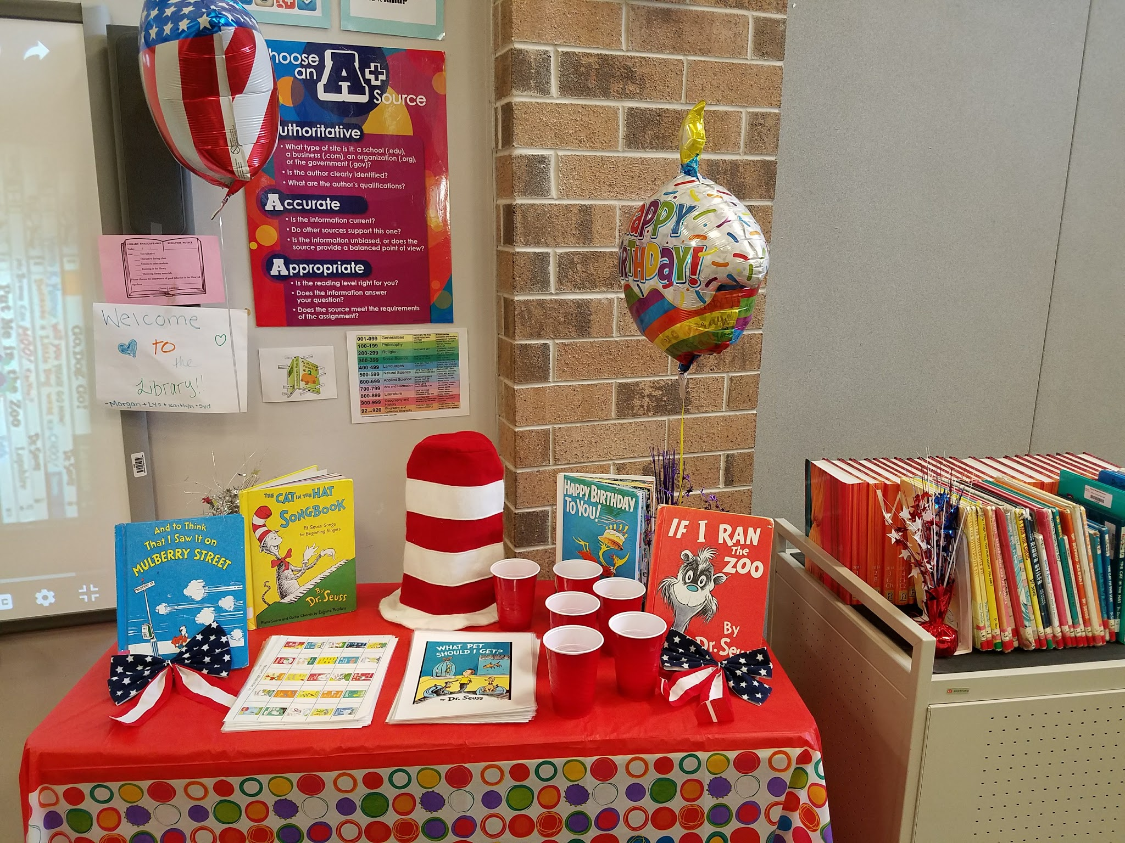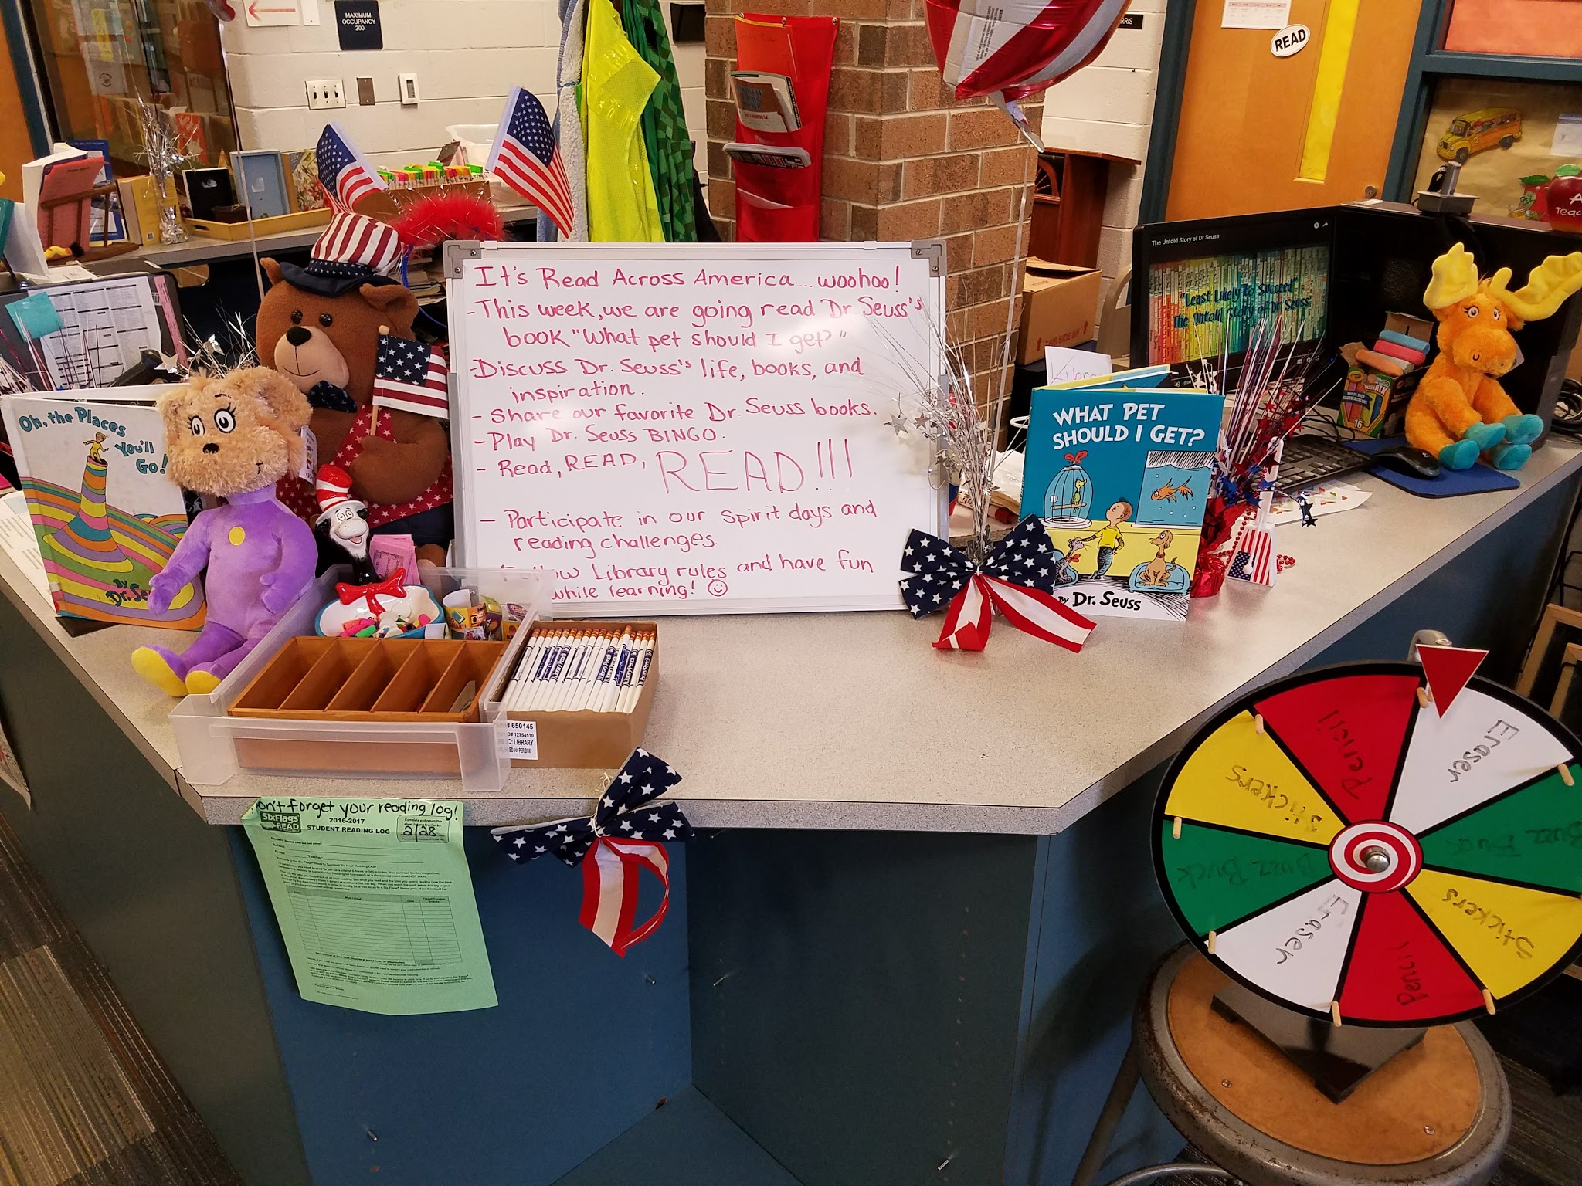
Targets
Students will…
- understand it is Read Across America.
- vote which pet they would get.
- learn and recognize various Dr. Seuss books while playing Book Bingo.
Procedure
(Lower elementary)
Decorate the library with red, white and blue and place Dr. Seuss books everywhere. Dress up like a Seuss character (Cat in the Hat, Thing 1, etc). Share the importance of being about to read, share facts about literacy. Discuss Dr. Seuss’ life and accomplishments and show the video, 5 FUN-tastic Facts About Dr. Seuss. You can read your favorite Seuss book aloud to the class. A good suggestion is his latest book, published posthumously, What Pet Should I get? Also share the unfinished, unpublished manuscript, All Sorts of Sports, that Dr. Seuss wrote in the 1960’s and was auctioned in 2010. Then distribute a Dr. Seuss BINGO cards (or any relatable type) to each student and chips. Play Bingo until each student fills his or her card, and give them a bookmark or any small item, as their reward. If you have a prize wheel for them to spin, they will love that! At the conclusion of the lesson, encourage students to participate in your school’s reading challenge. As students check out books, have them put a tally mark on a poster you create of different pets the characters got in the book, What Pet Should I get?
(Upper elementary)
You can show the students a video about Dr. Seuss. (After an intensive search on an appropriate video, I found…*I just muted it for 8 seconds that discussed him getting caught drinking in college). Share additional information as stated above and play BINGO. Then you can allow a student or multiple students to read What Pet Should I get? aloud, during or after book check to any interested students.
Materials
- Red, white & blue decorations and balloons for Dr. Seuss a party
- Dr. Seuss character costume
- Variety of Dr. Seuss books, including What Pet Should I get?
- A poster of various pets from the book for students to put a tally mark on
- BINGO cards and chips
- Bookmarks

Learning Standards
AASL - 1.1.6 Read, view, and listen for information presented in any format (e.g., textual, visual, media, digital) in order to make inferences and gather meaning.
AASL - 3.2.2 Show social responsibility by participating actively with others in learning situations and by contributing questions and ideas during group discussions.
AASL - 4.4.1 Identify own areas of interest.
AASL - 4.1.1 Read, view, and listen for pleasure and personal growth.
AASL - 4.1.4 Seek information for personal learning in a variety of formats and genres.
AASL - 3.3.2 Respect the differing interests and experiences of others, and seek a variety of viewpoints.
AASL - 1.1.2 Use prior and background knowledge as context for new learning.
Resources
live4silverlake. (2009, May 1). The Untold Story of Dr. Seuss [Video file].
https://www.youtube.com/watch?v=xXTxfHBspJ4

Writer’s Relief. (2016, March 1). Five FUN-tastic facts about Dr. Seuss [Video file]. Retrieved from https://www.youtube.com/watch?v=iQH_lz7s_7E

#29 Einstein: A Creative Genius
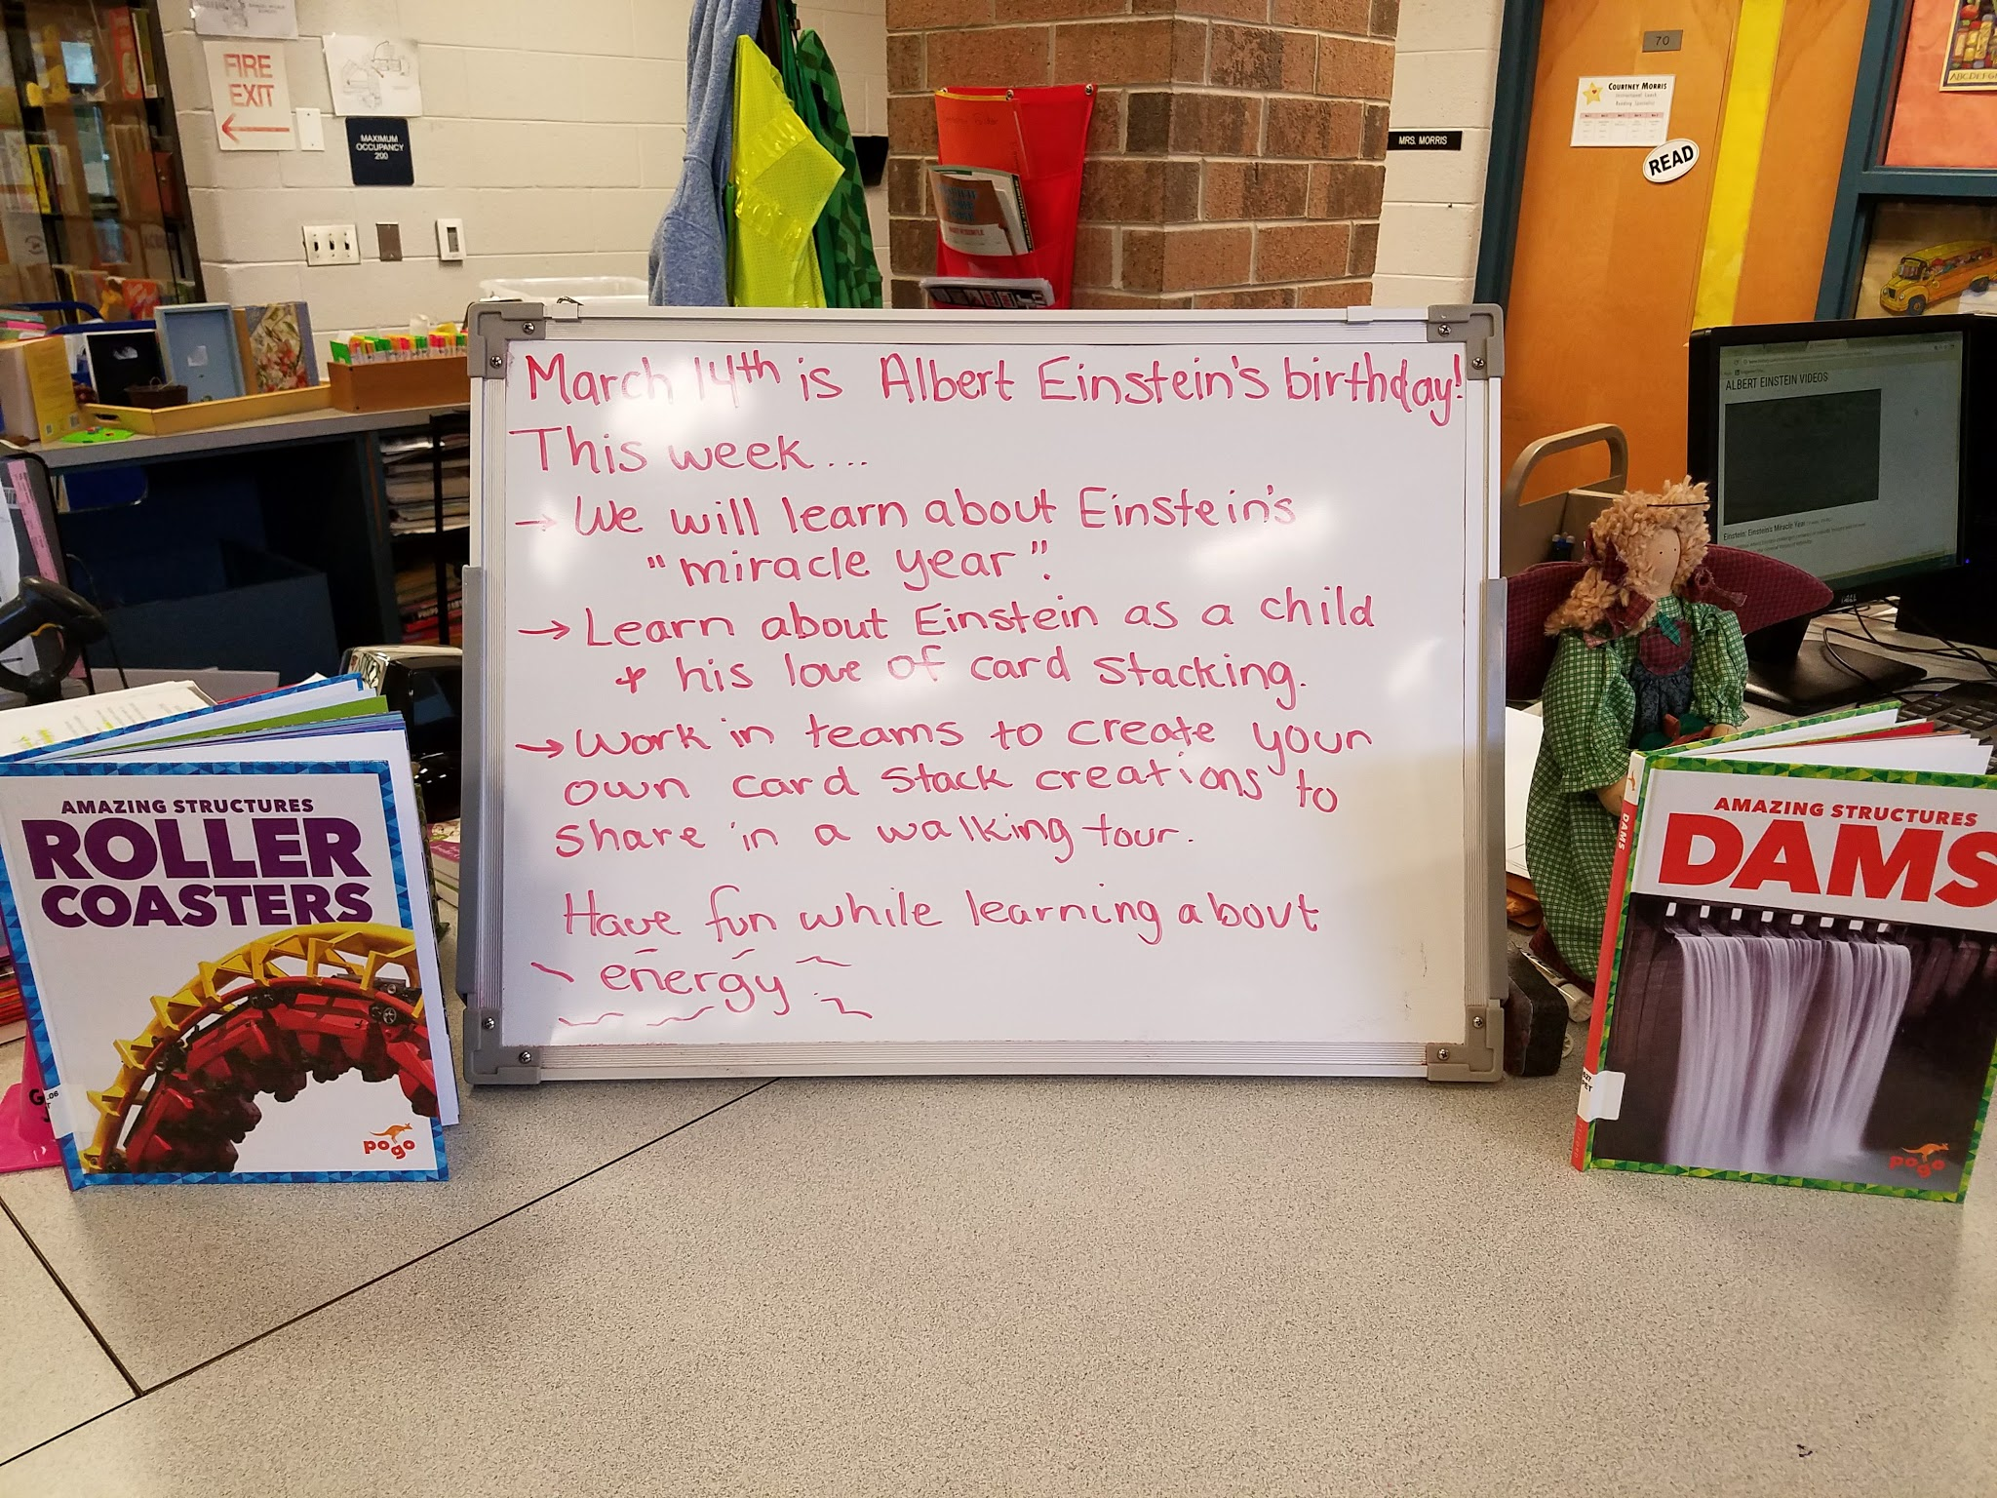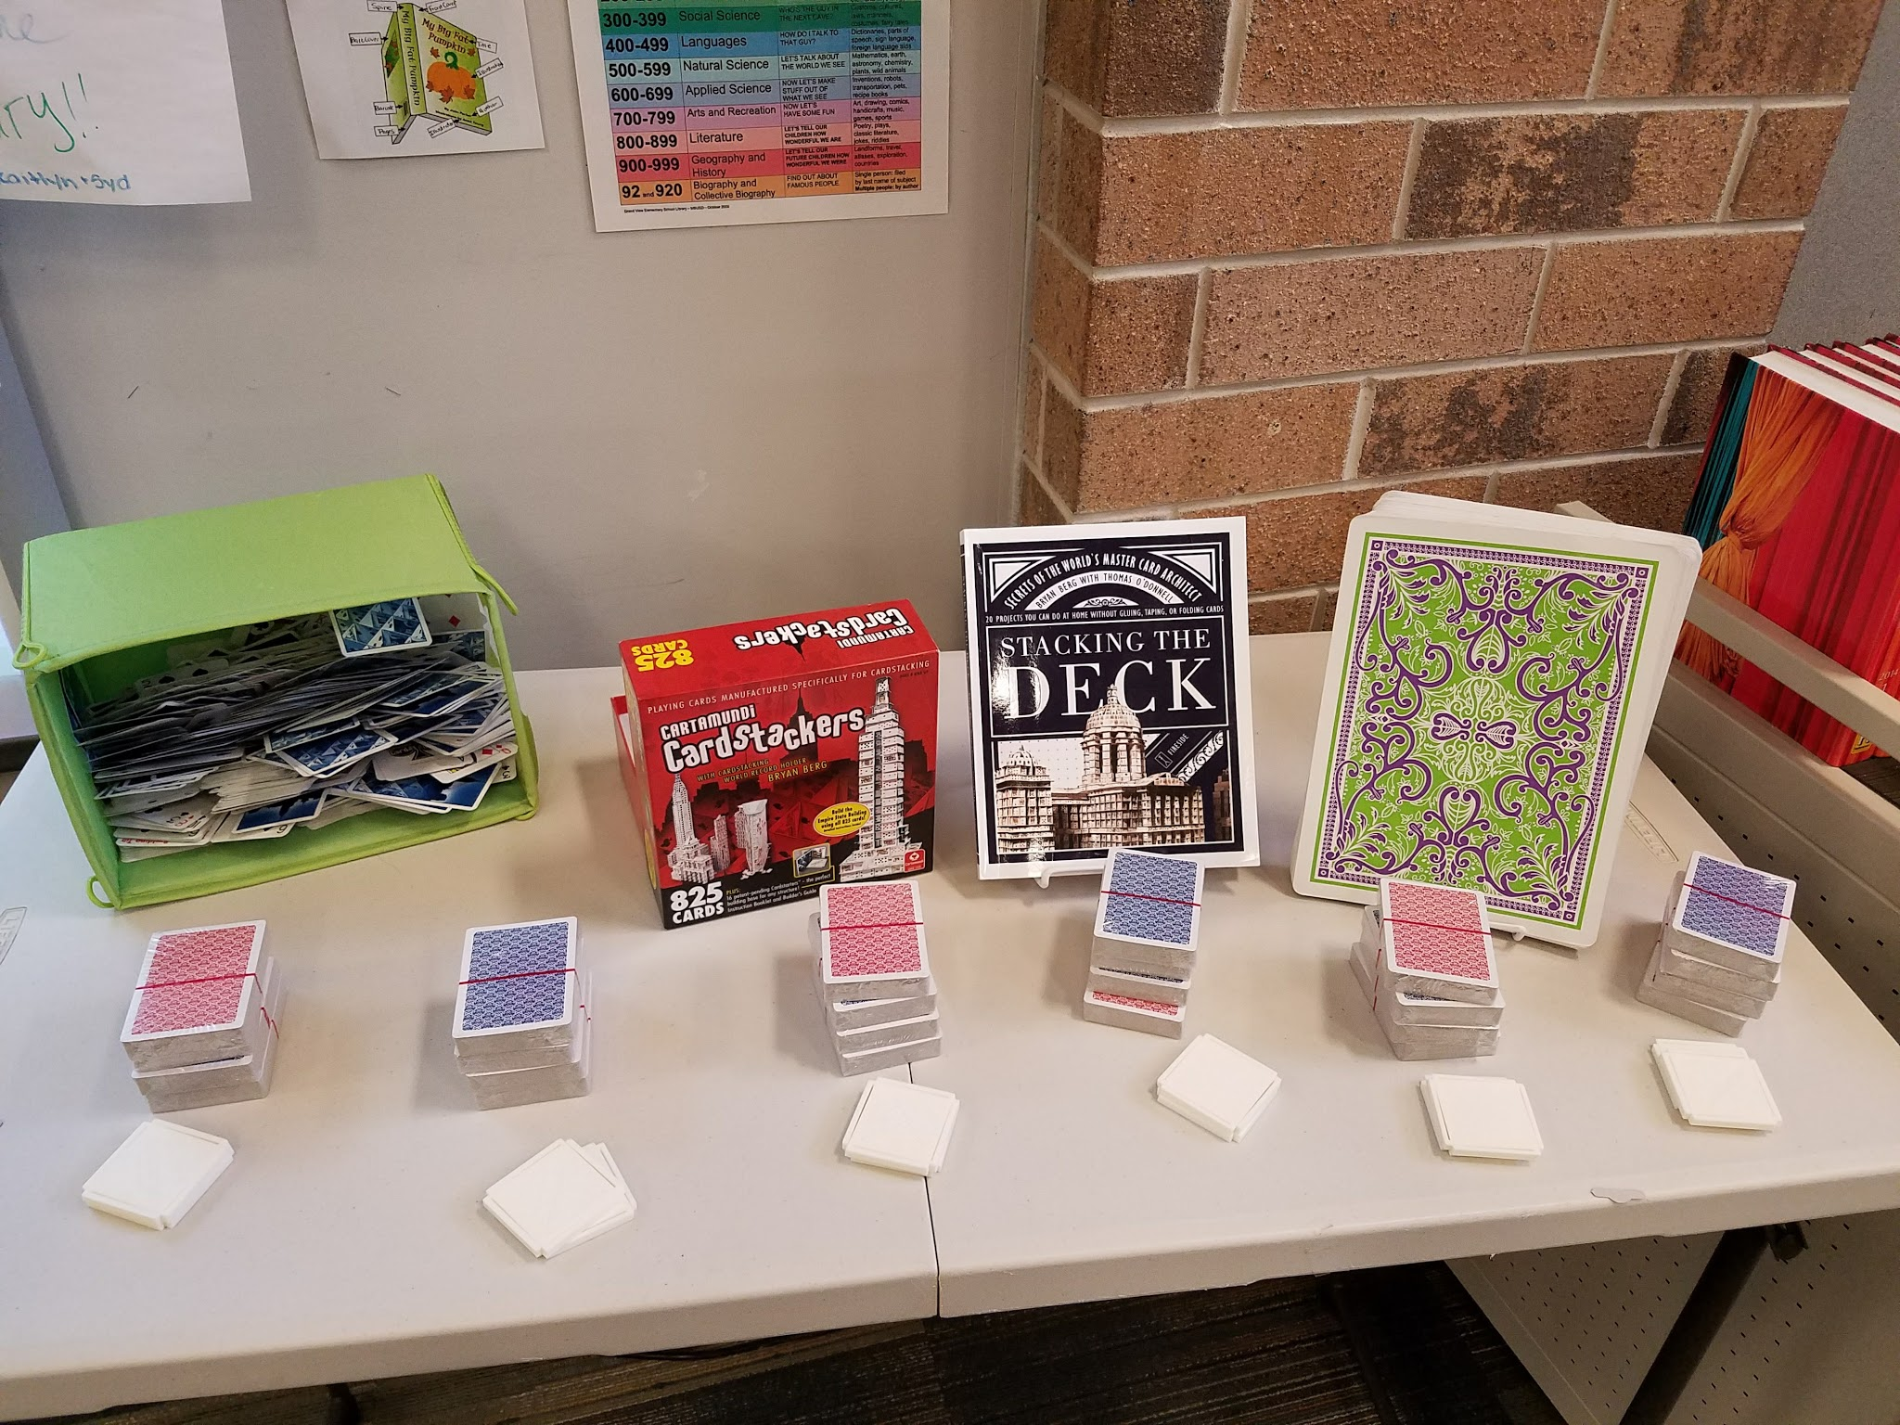
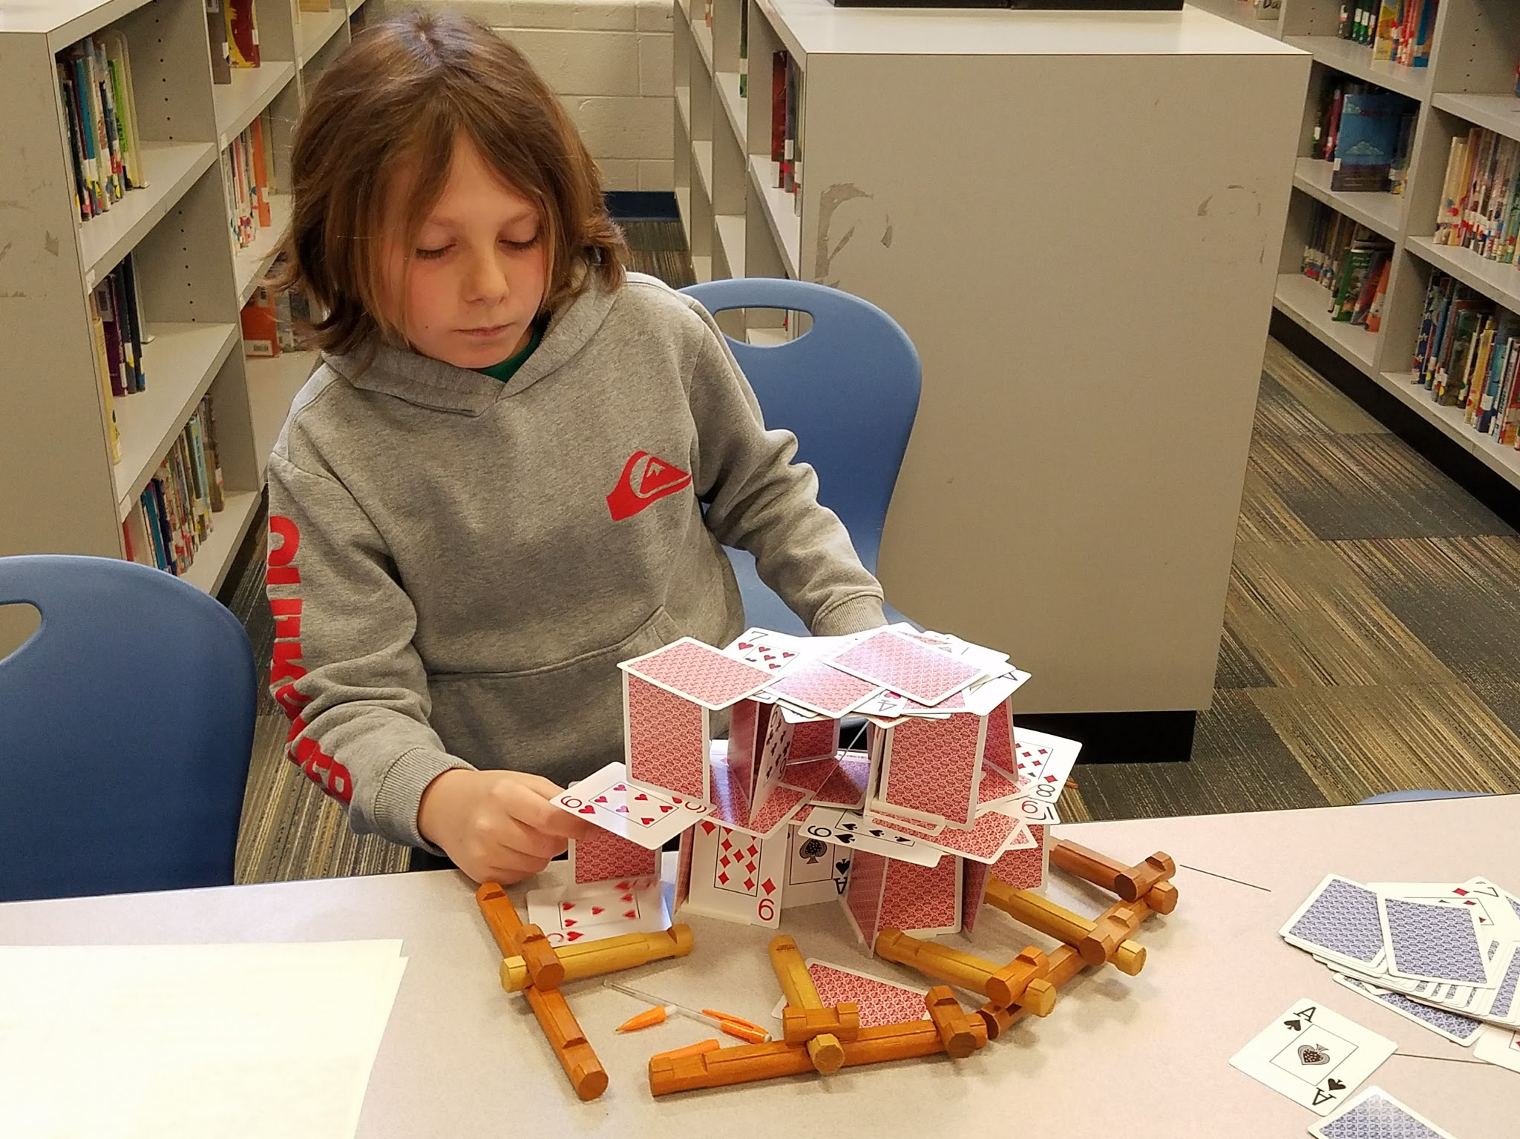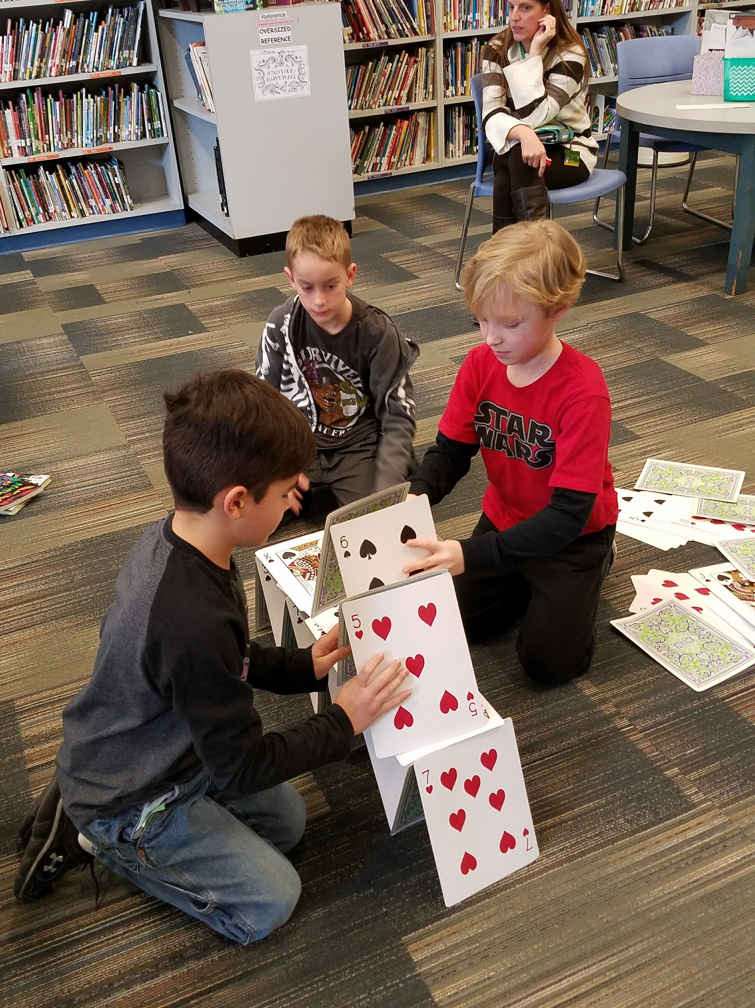
Targets
Students will...
- acknowledge it is Albert Einstein's birthday on March 14th.
- learn about his "Miracle Year."
- share information about various forms of energy.
- understand the characteristics of Einstein's childhood and life.

Procedure
(Lower elementary)
Dress up like Einstein (crazy hair, lab coat, etc.). Put a famous quote and image of Einstein on the smartboard. My favorite is:
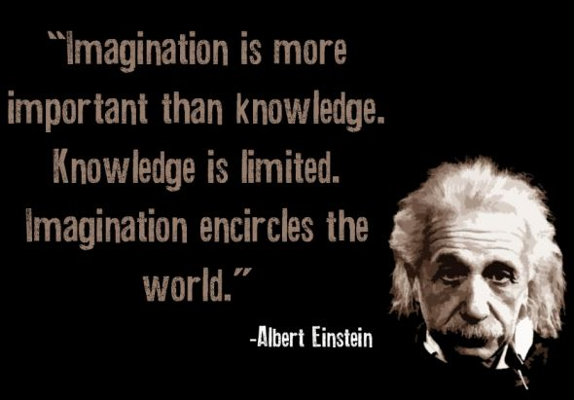
Have a birthday balloon to illustrate the exciting of celebrating Albert Einstein's birthday and remembering his great accomplishments. Show three videos over the class period.
- Einstein’s childhood video http://www.history.com/topics/albert-einstein/videos/einstein-childhood
- Renewable energy display in lego car and creations video http://burnanenergyjournal.com/forms-of-energy-motion-heat-light-sound-2/
- One of his favorite childhood hobbies, card stacking world record video https://www.youtube.com/watch?v=MlnHkKKCEBs.
After the videos, allows students to work in pairs or individually to construct their own unique card stacks.

(Optional-Upper elementary)
Feel free to include this video and show it second in the order above.
http://www.history.com/topics/albert-einstein/videos/einstein-einsteins-miracle-year If time allows, have students sit in pairs and share various forms of energy for a page copied from the Scholastic True Book book series, Energy. Then they can work in pairs or individually to construct card stacks for display in a walking tour at the end of class.

Materials
- Birthday decor
- Einstein wig, mustache and coat
- Videos
- Energy book by Matt Mullins
- Playing cards

Learning Standards
AASL - 1.1.6 Read, view, and listen for information presented in any format (e.g., textual, visual, media, digital) in order to make inferences and gather meaning.
AASL - 3.2.2 Show social responsibility by participating actively with others in learning situations and by contributing questions and ideas during group discussions.
AASL - 1.1.9 Collaborate with others to broaden and deepen understanding.
AASL - 4.1.1 Read, view, and listen for pleasure and personal growth.
AASL - 4.1.4 Seek information for personal learning in a variety of formats and genres.
AASL - 1.3.4 Contribute to the exchange of ideas within the learning community.
AASL - 1.1.2 Use prior and background knowledge as context for new learning.
AASL - 4.1.8 Use creative and artistic formats to express personal learning.
Science (2009) 5.2.04.C.1 Compare various forms of energy as observed in everyday life and describe their applications.
Resources
Alchetron. (n.d.). Brian Berg card stacker [Online image]. Retrieved from
https://s-media-cache-ak0.pinimg.com/564x/04/bf/91/04bf9140b950bec8e955bf8162d9744c.jpg

Burn: An energy journal. (2012). Forms of energy: motion, heat, light, sound [Video file].
http://burnanenergyjournal.com/forms-of-energy-motion-heat-light-sound-2/

Diagonal View. (2010, March 29). World’s biggest card stack [Online image]. Retrieved from https://www.youtube.com/watch?v=MlnHkKKCEBs

History.com 2016). Einstein: childhood. [Video file]. Retrieved from
http://www.history.com/topics/albert-einstein/videos/einstein-childhood

History.com (2016). Einstein: Einstein’s Miracle Year [Video file]. Retrieved from
http://www.history.com/topics/albert-einstein/videos/einstein-einsteins-miracle-year

Quotesta. (n.d.). Einstein Imagination quote [Online image]. Retrieved from
http://www.azquotes.com/picture-quotes/quote-imagination-is-more-important-than-knowledge-knowledge-is-limited-imagination-encircles-albert-einstein-52-21-90.jpg

#30 How to Catch a Leprechaun by Adam Wallace

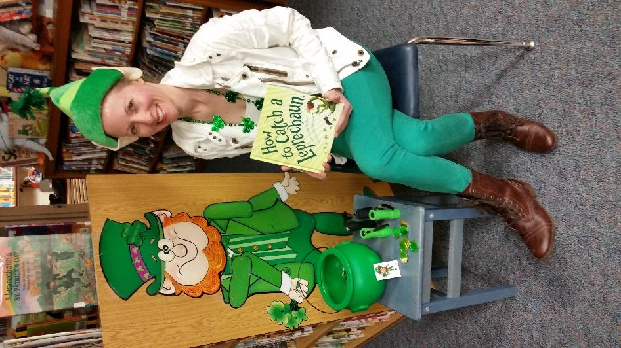
Targets
Students will…
- learn about St. Patrick’s Day, leprechauns and gold.
Procedures
(Lower elementary)
Decorate the library for St. Patrick’s Day and wear Leprechaun attire. Before the class arrives hide laminated pictures of leprechauns in the bookshelves. Turn down the lights and welcome the students in. Have them sit around you on the floor by a lantern. First share some facts about St. Patrick’s Day and watch History.com’s video Bet You Didn’t Know St. Patrick’s Day. Then read the book, How to Catch a Leprechaun. After each page, pause and send two students out to the bookshelves with flashlights to each find a leprechaun. Once they return, read another page and continue sending out students after each until the end of the book. Then have students trade in their leprechaun for a gold coin they can take home. Briefly tell them some facts about gold, such as the value of an ounce of gold, most valuable coin and biggest gold nugget ever found. Allow the students to check out books.
Materials
- St. Patrick’s Day decor
- Leprechaun costume
- Laminated leprechaun pictures
- How to Catch a Leprechaun book by Adam Wallace
- Mini flashlights
- Gold coins
- Video
Learning Standards
AASL - 1.1.6 Read, view, and listen for information presented in any format (e.g., textual, visual, media, digital) in order to make inferences and gather meaning.
AASL - 3.2.2 Show social responsibility by participating actively with others in learning situations and by contributing questions and ideas during group discussions.

Resources
History.com (2013, March). Bet you didn’t know St. Patrick’s Day. Retrieved from http://www.history.com/topics/st-patricks-day/history-of-st-patricks-day/videos/bet-you-didnt-know-st-patricks-day

#31 Lucky Charms Memory Game
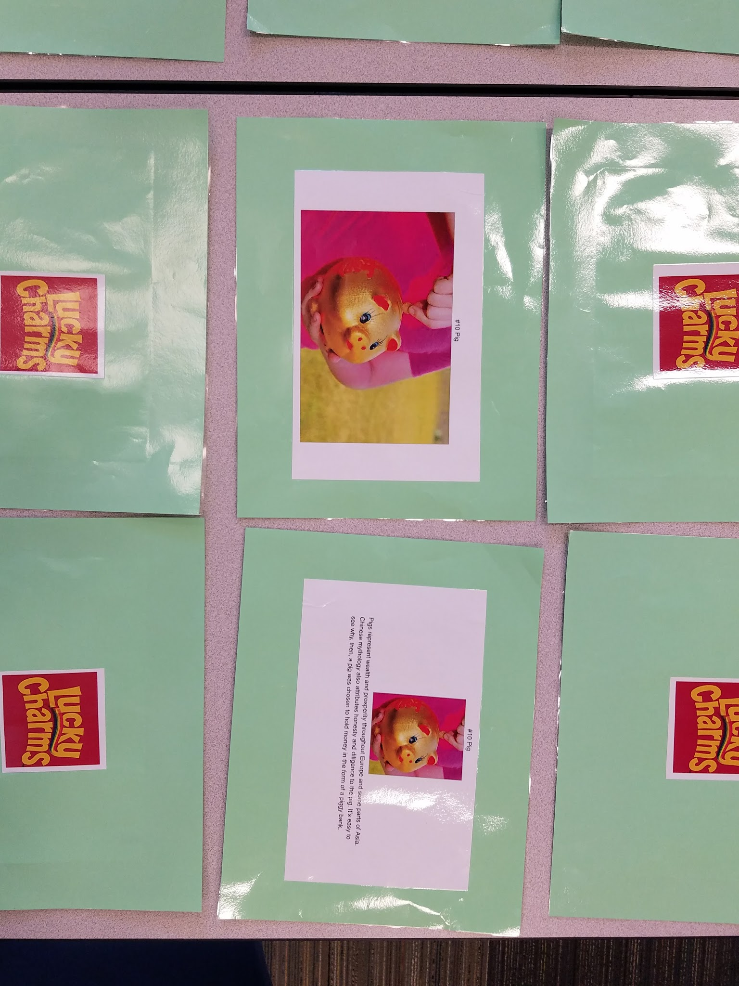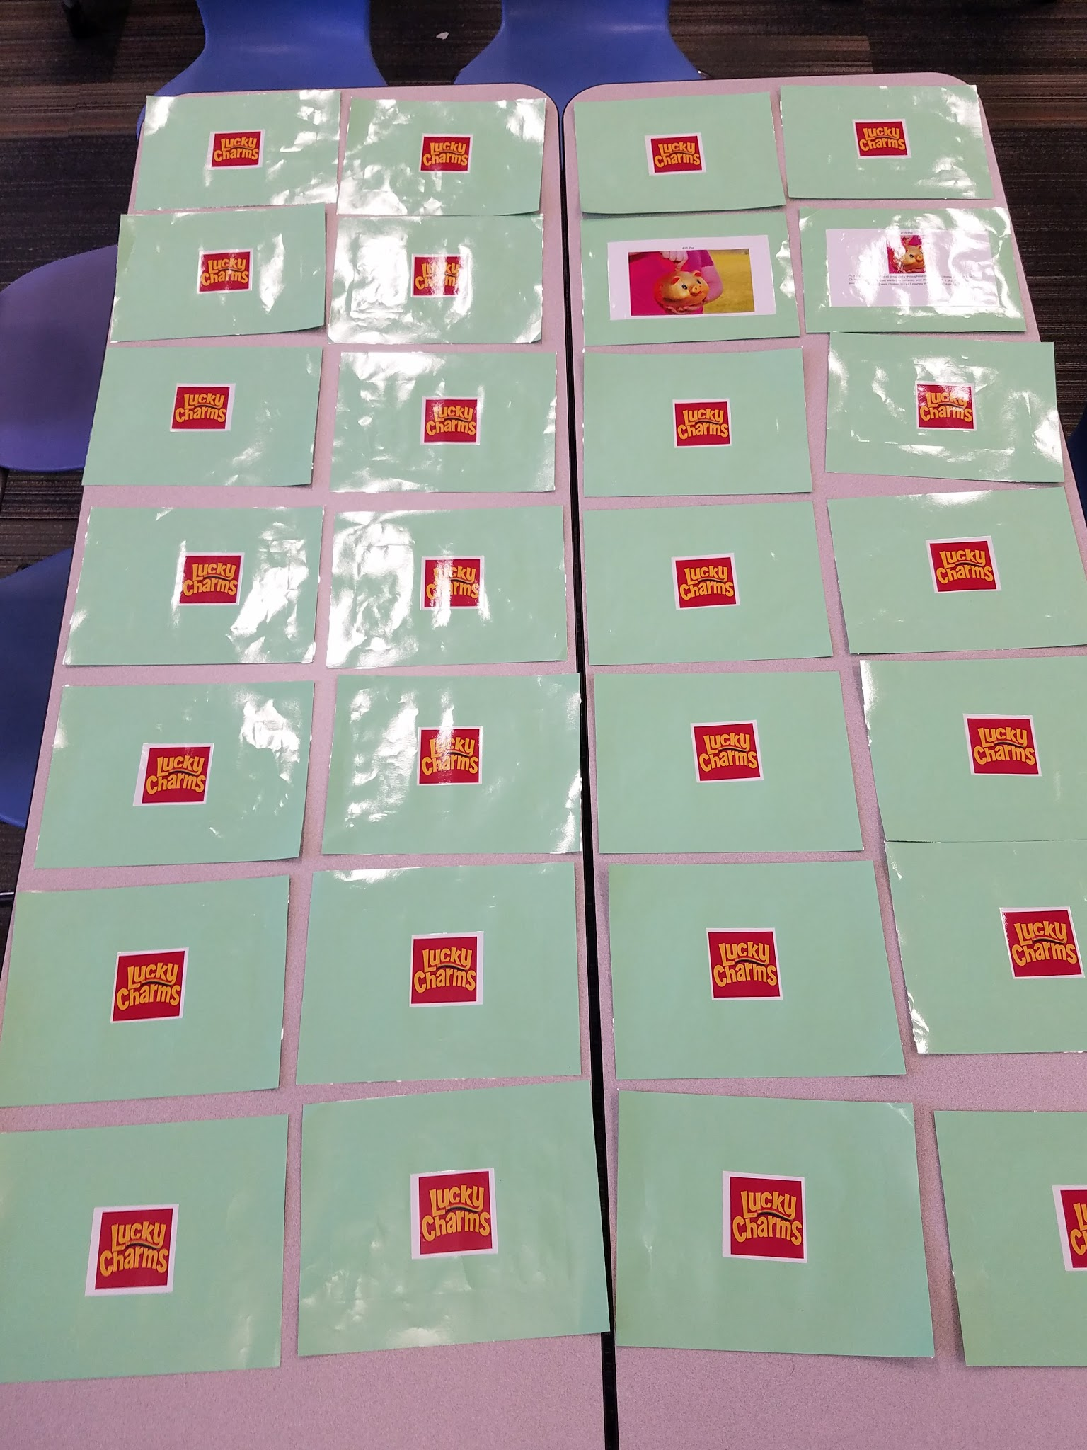
Targets
Students will…
- learn fun facts about St. Patrick’s Day, St. Patrick and lucky charms around the world.

Procedure
(Upper elementary)
Decorate and dress up for St. Patrick’s Day. You can use a Lucky Charms cereal box for decoration. In advance, copy a Lucky Charms cereal logo for one side of your Lucky Charm Memory Game cards.
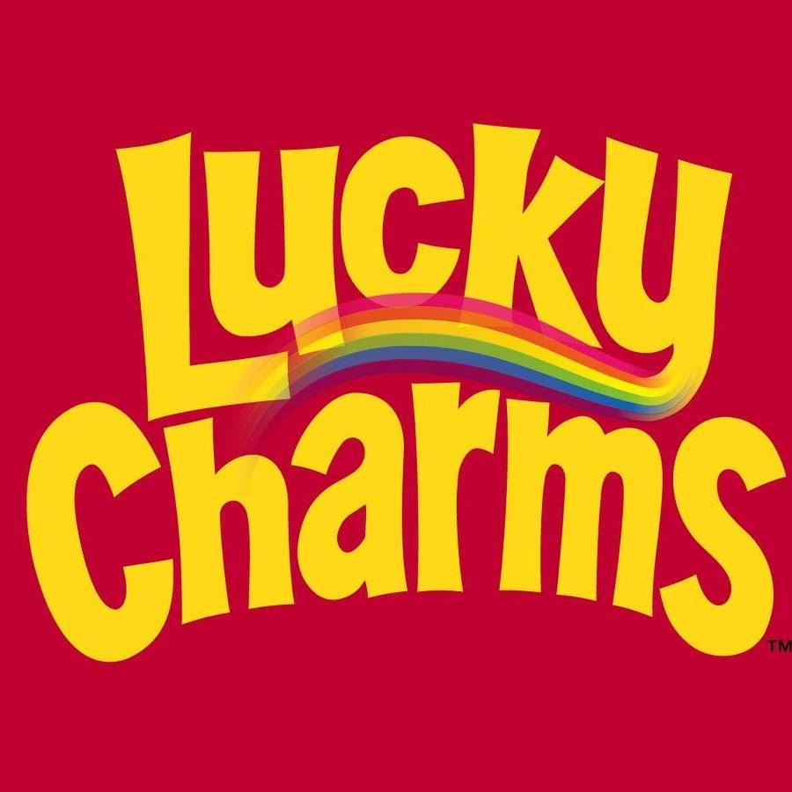

Copy two pictures of each lucky charm from around the world to complete your memory cards. One picture can be a little smaller and include a write up about what country and why it is considered lucky or unlucky. Here is a sample of possible items from my Google doc: https://docs.google.com/document/d/13cVQOgknvzvcmDvv93NaTrKEF9RE13XQN3bvkLlo62I/edit#heading=h.478htvpdpfe0 Laminate each card. Prior to class, push two tables together in two different areas of the library and place the cards upside down across them.
Put a St. Patrick’s Day image on the smartboard for when students arrive. Discuss some fun facts about St. Patrick’s Day, then show the students a video about lucky charms around the world. Divide the class in half, separated into girls and boys to play two separate memory games. Once both teams have completed their game, they will share each lucky charm by reading the information on its card.
Learning Standards

Resources
Salamanca, A. (2015, June 3). 25 good luck charms around the world. Retrieved from
http://list25.com/25-good-luck-charms-from-around-the-world/

TheAs57. (2013, March 30). 20 things that bring you good luck.
https://www.youtube.com/watch?v=FaKye9Jy-0k

#32 March Madness: History of Basketball & the Harlem Globetrotters
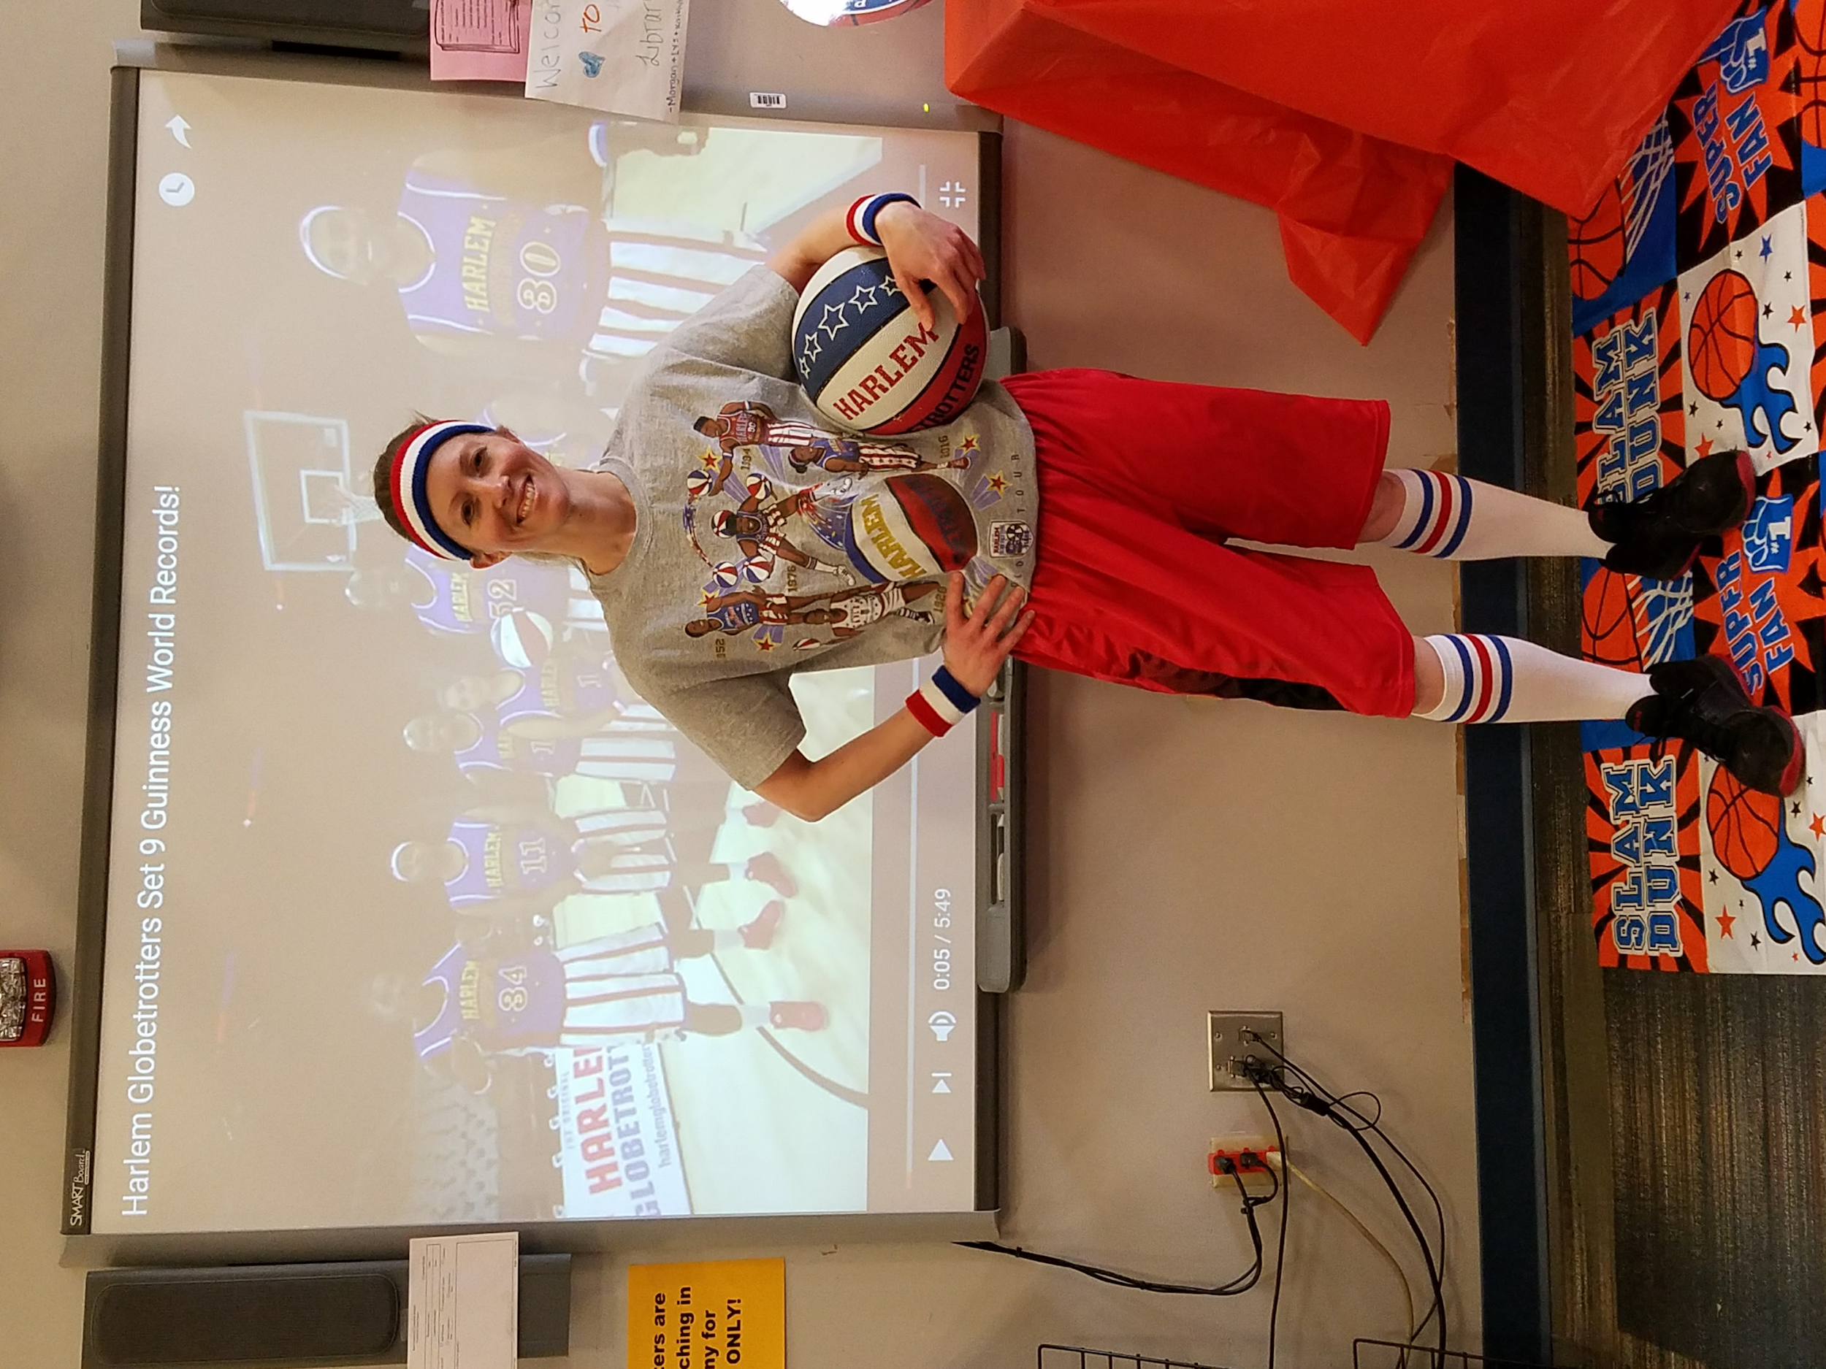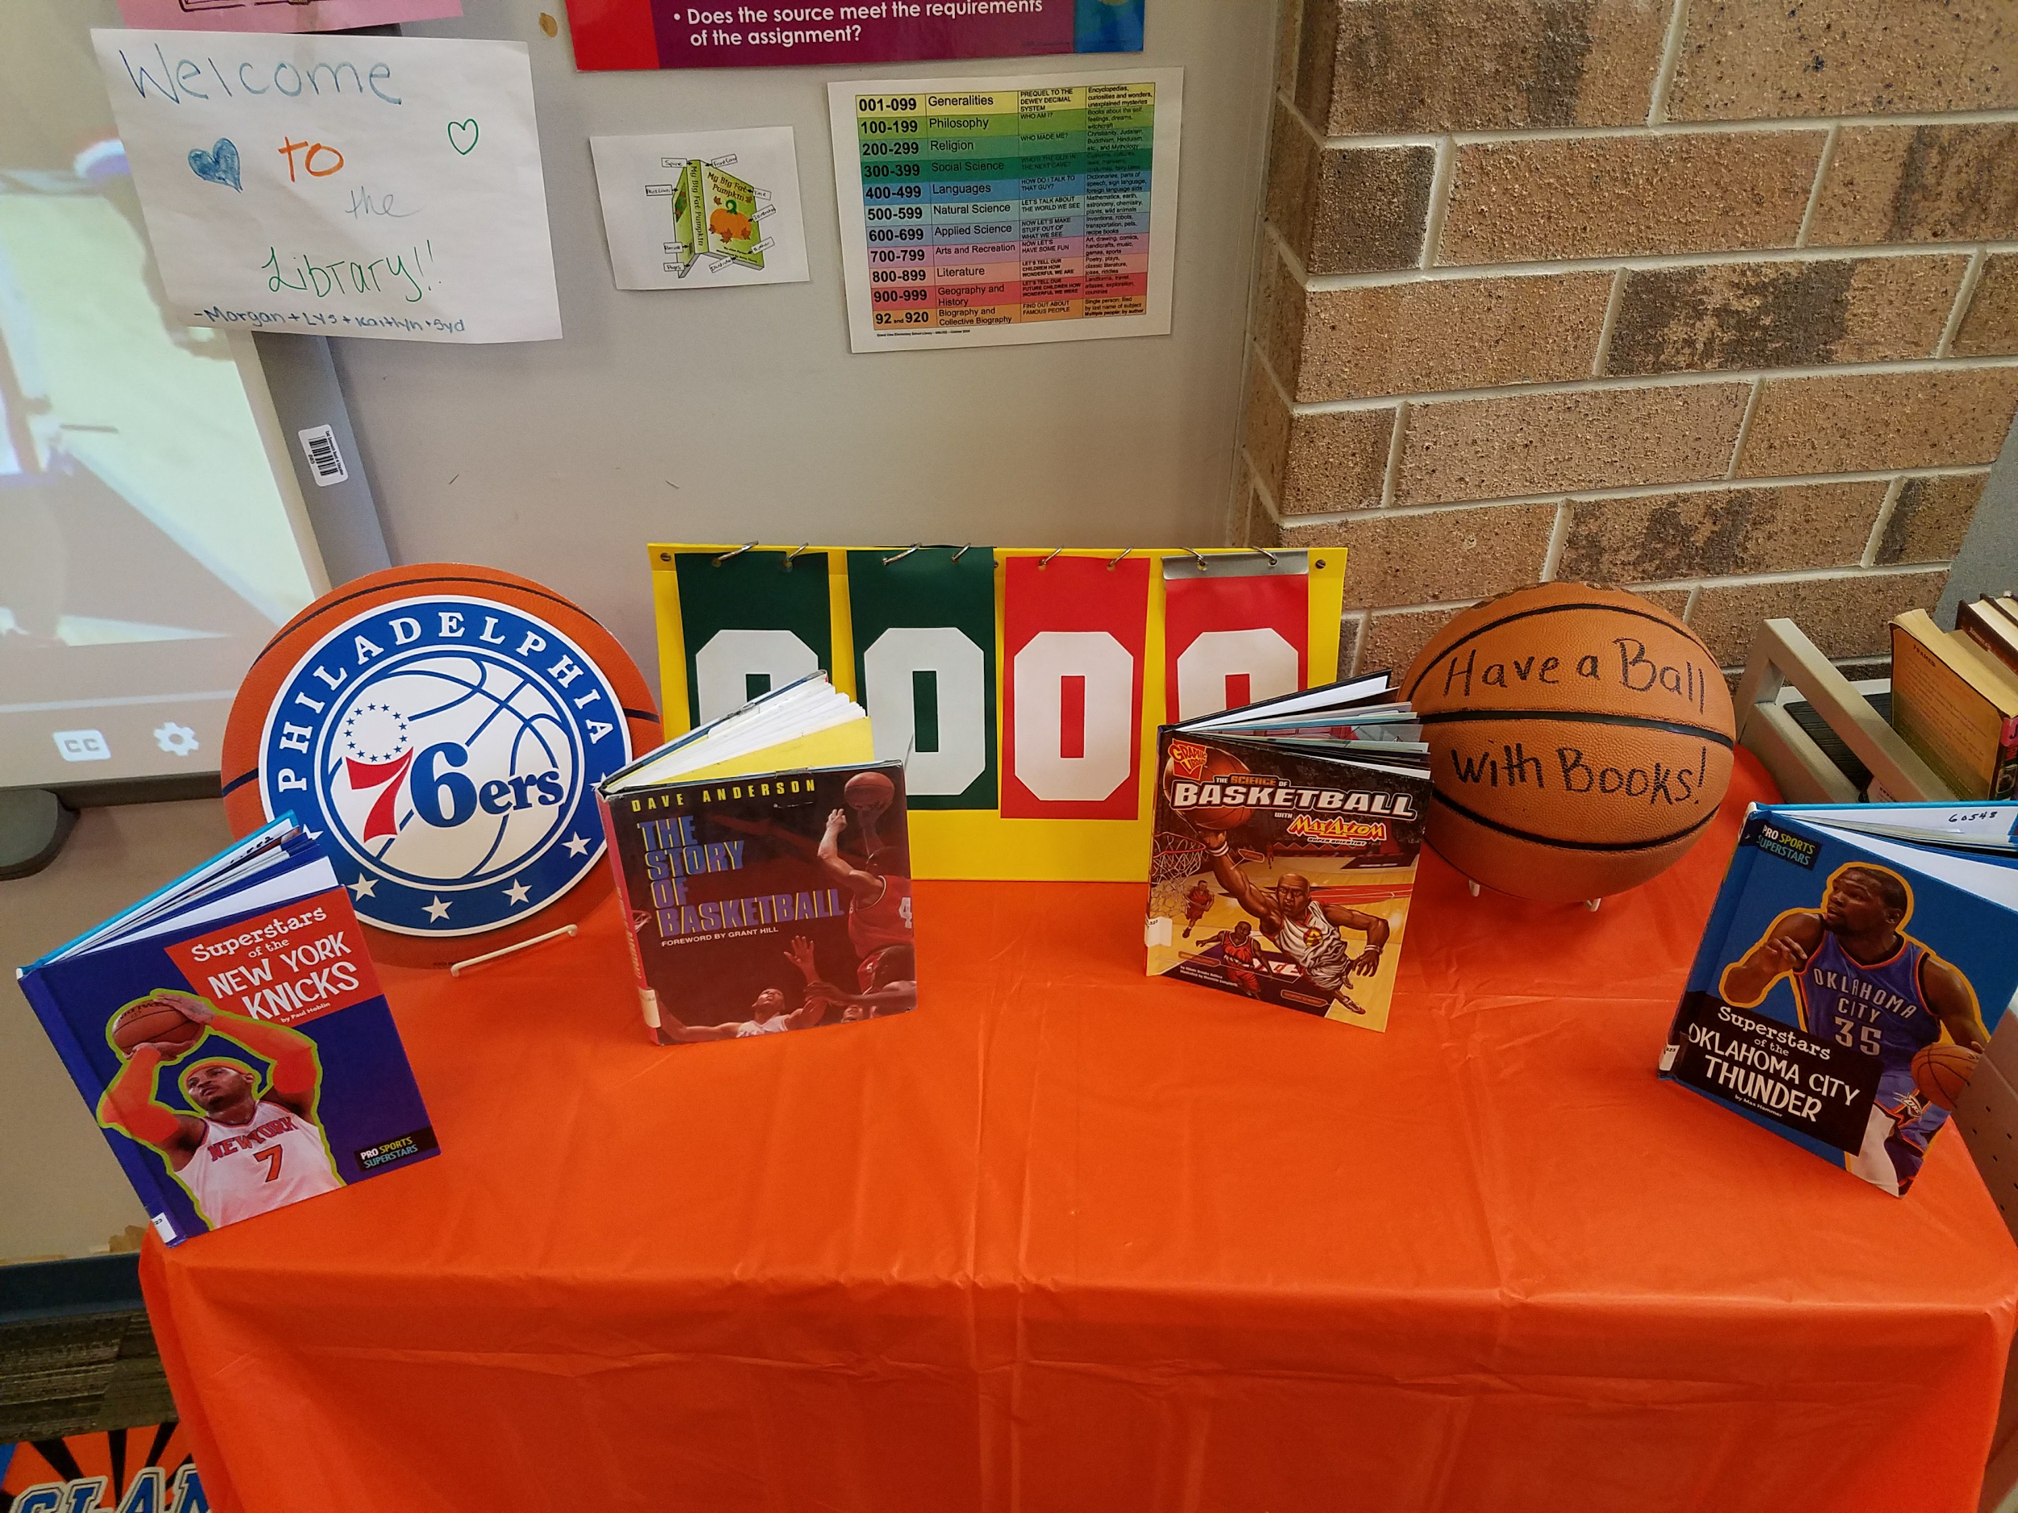
Targets
Students will…
- learn about the history of basketball and the Harlem Globetrotters.
- compete in a March Madness Class Reading Challenge.
Procedure
(Lower & upper elementary)
Dress in a basketball outfit, bring in a basketball and utilize any basketball decor available. Place multiple copies of basketball and globetrotter fact sheet on each table. Have the video of the Harlem Globetrotters playing to Sweet Georgia Brown playing for when the students enter. Open with a group discussion about the students’ prior knowledge for the sport of basketball. Share fun facts about how basketball got started and the Harlem Globetrotters through multiple videos. First play Dr James Naismith - Creator Of Basketball In Rare Interview 1939 WOR Radio https://www.youtube.com/watch?v=5yxk6pb64F8 . Then pause and have students take turns read facts from the basketball timeline. An example sheet is below:

Basketball Timeline

1891-The first game of basketball was played in Springfield, Massachusetts. It was created by James Naismith, a gym teacher, who wanted an indoor sport less injury-prone than football. The only items used were 2 peach “baskets” and an old soccer ball. After too much rough play during the first game, rules were instated.

1898-NBL (National Basketball League) was the first pro league formed, but it only lasted 5 years.
1906-NCAA (National Collegiate Athletic Association) was formed .
1909-Eastern Basket Ball League was formed.
1921-Metropolitan Basketball League was formed.
1925-American Basketball League was formed.

1926-Abe Saperstein created The Chicago Globetrotters.
1927-Coach Saperstein changed the team name to The New York Harlem Globetrotters team, knowing a big city name would draw more attention.
1929-Their name was revised for a final time to The Harlem Globetrotters.

1936-The first time basketball was played in the Olympics.

1940’s-The pre-game Magic Circle was created and set to Brother Bones’ version of Sweet Georgia Brown song.

1946-NBA (National Basketball Association) was formed.

1948-The Globetrotters played their first “serious game” against the championship Minneapolis Lakers team and won.

1949-NWBA (National Wheelchair Basketball Association) was formed.

1950-Nat “Sweetwater” Clifton was the first Globetrotter and African-American to join the NBA. He played for the New York Knicks.

1951-The Globetrotters starred in their first movie and began a world tour. They played anywhere...even in a bull ring, empty pool, on a floor raised by barrels and in St. Peter’s Square at the Vatican. During their world tour, the U.S. government ordained them “Ambassadors of Goodwill.”

1950’s-They became so popular 4 Globetrotter teams were created.

1967-ABA (American Basketball Association), a knock-off of the Globetrotters, was formed.

1970’s-The Globetrotters Saturday morning cartoon was created.

1997-WNBA (Women’s National Basketball Association) was formed.

Present Day-The Harlem Globetrotters have played over 26,000 games and traveled to 122 countries. They continue to play about 450 games a year. In addition, they have starred in over 25 movies and television shows. Today their average annual salary is $73,000 to 91,000.
*You can also share the movies and tv shows that the Globetrotters were in from wikipedia link https://en.wikipedia.org/wiki/Harlem_Globetrotters
Next show three videos, first Harlem Globetrotters Guinness World Records https://www.youtube.com/watch?v=S74Ohb2j0GA, Harlem Globetrotter Best Trick Shots ever compilation https://www.youtube.com/watch?v=frImW50n5Rk and last Amazing 583-Foot Basketball Shot Harlem Globetrotters https://www.youtube.com/watch?v=ijeR-JhB3rQ .
Allow students time to read through various basketball and world record books during book check out.
(Optional activity)
Inform each class that we will be running a “March Madness Reading Challenge.” With the support of the teachers, students will keep a log of minutes they have read each week. The classes in each grade level will be entered into a random head-to-head reading bracket. After the minutes are tallied, there will be a winner each week. Then the next classes will compete, until at the end of the month we can declare a the “March Madness Reading Champions” in each grade level and present them with a trophy or prize.
*Harlem Globetrotters Guinness World records and Trick shot record (for Guiness World Record Day 11/17 and National Trick Shot Day (12/6)
Materials
- Basketball decor, outfit and equipment
- Videos
- Informational fact worksheets
- World record and basketball books
- March Madness Reading Challenge letter and chart

Learning Standards
AASL - 1.1.6 Read, view, and listen for information presented in any format (e.g., textual, visual, media, digital) in order to make inferences and gather meaning.
AASL - 3.2.2 Show social responsibility by participating actively with others in learning situations and by contributing questions and ideas during group discussions.

Resources
Harlem Globetrotters. (2016, December 6). Amazing 583-Foot Basketball Shot Harlem Globetrotters. Retrieved from https://www.youtube.com/watch?v=ijeR-JhB3rQ
Harlem Globetrotters. (2016, November 16). Harlem Globetrotters Guinness World Records. Retrieved from https://www.youtube.com/watch?v=S74Ohb2j0GA
History.com. (2017, January 6). 10 Things You May Not Know About the Harlem Globetrotters. Retrieved from http://www.history.com/news/history-lists/10-things-you-may-not-know-about-the-harlem-globetrotters
History.com. (2017, January 7). Harlem Globetrotters play their first game (January 7, 1927). Retrieved from http://www.history.com/this-day-in-history/harlem-globetrotters-play-their-first-game
lilmikesf. (2016, January 15). Dr James Naismith - Creator Of Basketball In Rare Interview 1939 WOR Radio. Retrieved from https://www.youtube.com/watch?v=5yxk6pb64F8
Whistle Sports. (2016, November 9). Harlem Globetrotter Best Trick Shots ever compilation. Retrieved from https://www.youtube.com/watch?v=frImW50n5Rk

#33 April Fool’s!
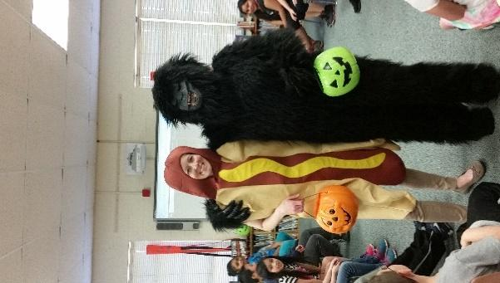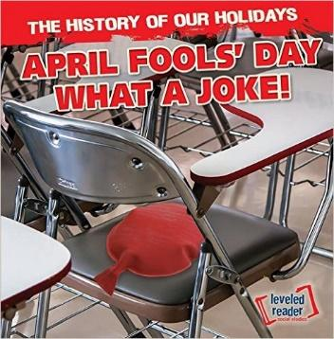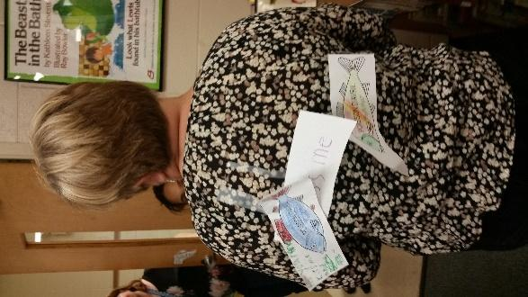

Targets:
Students will:
- have a BIG laugh and lots of fun while learning!
- learn about April Fool’s Day.

Procedure:
(Lower elementary)
You can create ANY April Fool’s trick, the following was mine...I wore a Halloween costume and have the library decorated with some Halloween items. The kids were ademit that it wasn’t Halloween and laughed at our holiday “mistake.” I was dressed as a hot dog and was holding a pumpkin trick or treat bucket. I passed out a sock to each student and then said “trick or treat, smell my feet! Seriously, go ahead those are dirty sock I wore on my feet!” I laughed and walked to my reading chair. Then “accidentally” sat on a hidden whoopee cushion and apologized as I said “it must have been the dog,” pointing to the dog stuffed animal next to the chair on the floor. Then I yelled, APRIL FOOL’s!.” After your April Fool’s trick, read the book, April Fool’s Day: What a Joke! by Theodore Jones. Explore the students’ knowledge of our lesson topics by asking additional questions throughout the story. Next show the video, https://www.youtube.com/watch?v=XmMMNyDbqcQ Afterward provide each student with a paper fish to color as a traditional prank in France, known as a poisson d'avril, which means “April Fish.” (We discuss that in the book.) The students can take it home to secretly tape on the back of a family member, then discuss what they learned about today in library.

Materials:
- A Sense of humor!
- Halloween Decor (if you go with the “trick” at the beginning of this lesson.)
- Tricks, gag items, stuffed dog
- Book, April Fool’s Day: What a Joke! By Theodore Jones
- Video
- Copies of poisson d'avril, which means “April Fish.”
- Scissors, crayons

Learning Standards:

AASL1.1.2 Use prior and background knowledge as context for new learning.
AASL 1.1.6 Read, view, and listen for information presented in any format (e.g., textual, visual, media, digital) in order to make inferences and gather meaning.
AASL 2.1.3 Use strategies to draw conclusions from information and apply knowledge to curricular areas, real world situations, and further investigations.
AASL 2.3.1 Connect understanding to the real world.
AASL 2.4.1 Determine how to act on information (accept, reject, modify).
AASL 3.2.2 Show social responsibility by participating actively with others in learning situations and by contributing questions and ideas during group discussions.

Resources:
Cool School. (2016, March 29). The History of April Fools & Pranks Nikki's Wiki Wiki for Kids at Cool School. Retrieved from https://www.youtube.com/watch?v=XmMMNyDbqcQ

April is National Poetry Month (3-week lesson)
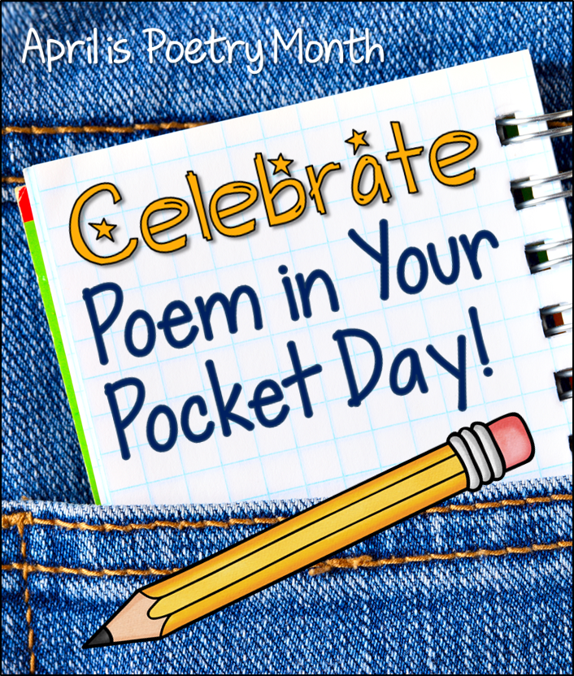
It is a good idea to have a multiple weeks of poetry activities. Since April is includes many special days such as April Fool’s Day, Earth Day, Easter (sometimes), etc., you could encourage students to pick a topic that is related to the month, or allow for their freedom of choice. Utilize great websites like, poetry games to get kids excited and started with writing their original pieces.
Targets
Students will…
- learn April is National Poetry Month.
- be introduced/reintroduced to poetry.
- create their own poems.
- Practicing listening and speaking skills.

#34 Poetry Lesson Introduction Week 1
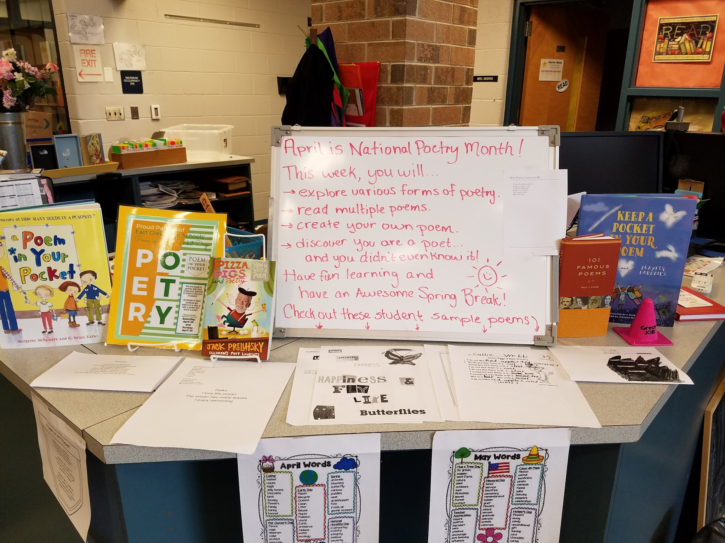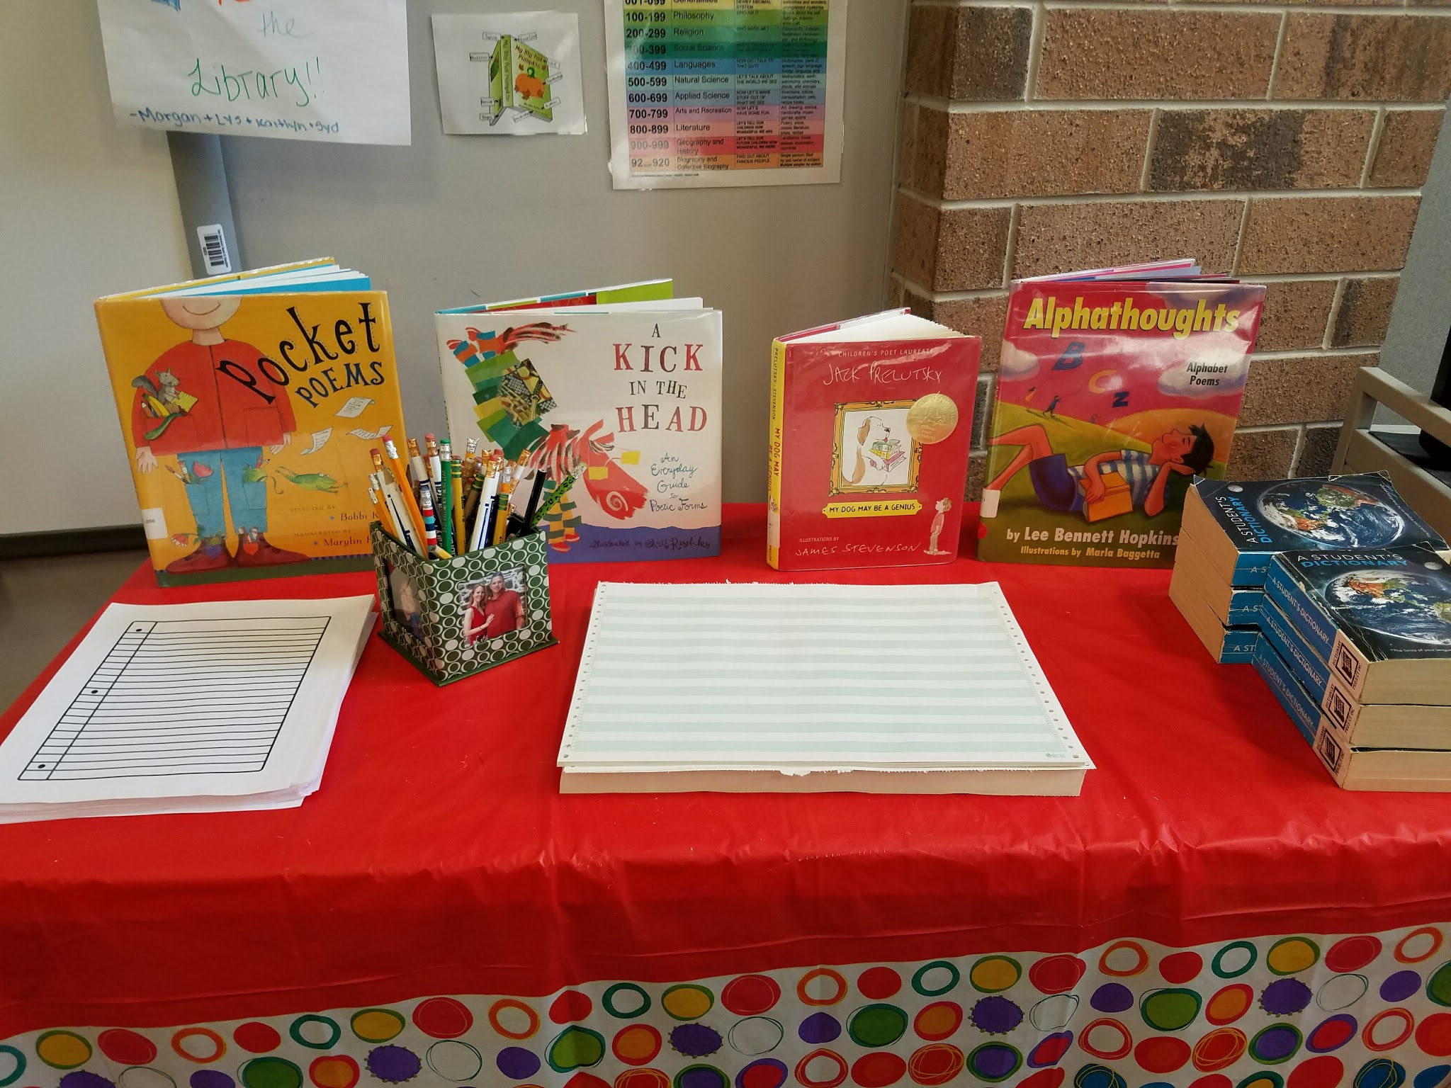

Procedure
Prior to class, set up three poetry tables. One with the necessary supplies, such as scrap paper, lined paper and pencils. A second table with magazines, scissors, glue sticks and colored paper for the for cut-up or collage poetry. A third table for black-out or found poetry where you provide them with weeded, damaged books to tear out a page, circle words on the page to create a new poem and markers to black-out the other words and create an illustration at the same time.
I wore a Poetry Month t-shirt the first week. I welcomed the students and announced that April was National Poetry Month and that we would spend a couple weeks learning about and creating poetry. For those students grumbling, I tell them to be patient there are dozens of types of poetry and I’m sure they will find a type that they will enjoy doing.
First, I showed them a Google slide presentation I created with various types of poetry. My sample presentation: https://docs.google.com/presentation/d/18efeMM7zpweZI2PB_D4psi6xxFrzB5mai2FDIU8Suxo/edit#slide=id.p
I also printed copies of all of the slides and attached them to a library wall to view at any time for a reference or inspiration. Next instruct students to spend some time flipping through and reading a variety of poems in the books on the tables and shelf tops. Then begin creating poems through an online poetry games website at http://www.poetrygames.org/poetry-machine/ or on their papers when they are ready.
#35 Poetry Lesson Keep Calm and Write Poetry Week 2
I wore a Keep Calm and Write Poetry shirt during week 2. Students will continue to work on their poem during week. It is important to walk around and see what the students are creating, how far they are along and if they need help. Once students complete their poem in an acceptable manner, give them a long piece of paper with a pocket printed on one side for them create and decorate a pocket for their poem. Encourage any students that are done quickly to create another poem or sit quietly and read some poetry books. At the end of this class students should have at least one poem and their pocket done. At the end of this week, hang all student pockets full of poems in the hallway by their classroom for others to begin reading.
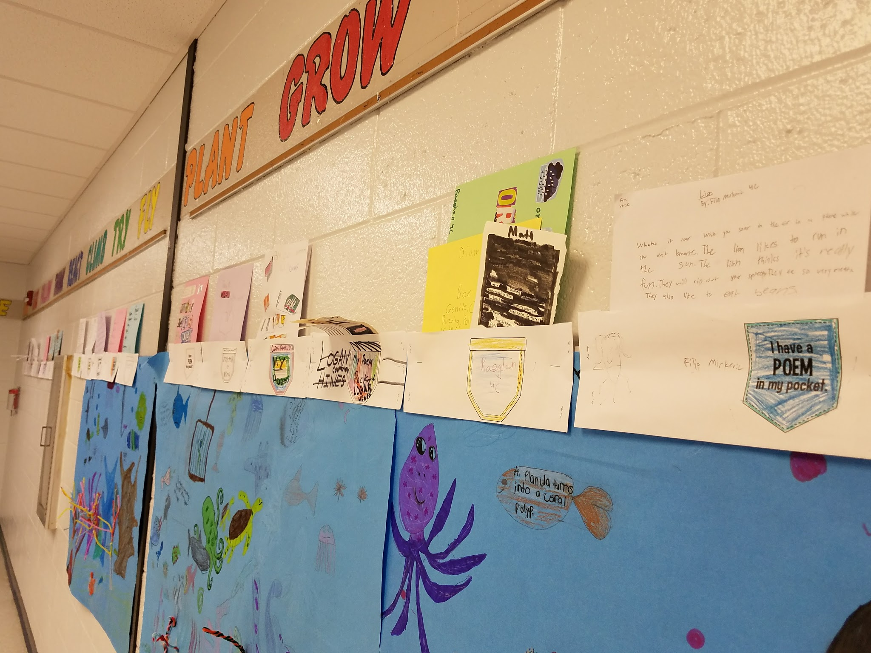

#36 Poetry Lesson Open Mic/Poetry Slam Week 3
I wore a vest full of pockets with poems sticking out of the pockets to celebrate and excite students about Poem in Your Pocket Day. You may want to invite parents or staff to join the class for their poem performance. Prior to class, hang curtains and set up a microphone for your open mic/poetry slam. Turn down the lights and use a spotlight to create the appearance of a performance stage. Students that weren’t here one of the weeks or work slowly can finalize their poems during the beginning of this week. Allow students a few minutes to practice reciting their poem before they begin performing or sharing their poem with the class. If any students are too nervous or uncomfortable sharing, ask if you can share for them. Encourage students to participate in Poem in Your Pocket Day event in school and outside of school.
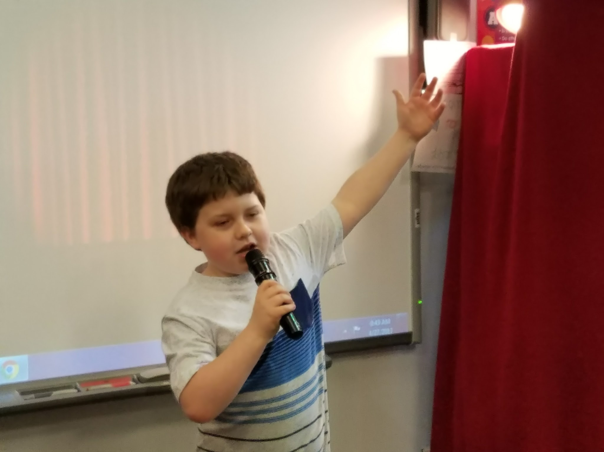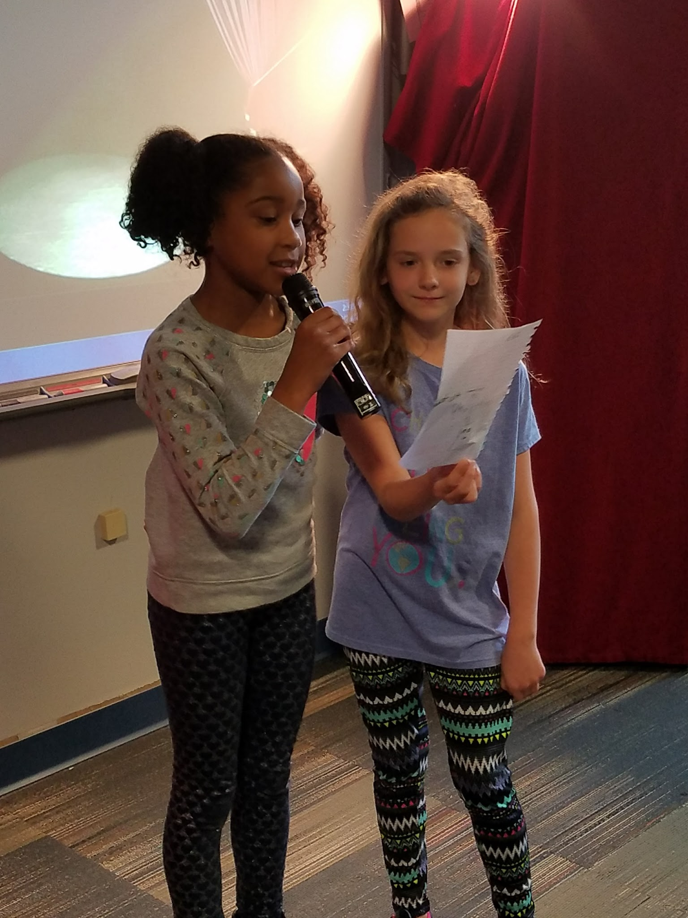
*Our district’s school librarians contacted local businesses to participate in a celebration of poetry the weekend after Poem in Your Pocket Day in which students could visit the business and recite a poem during their weekend business hours for a small gift, treat or coupon. This event is to promote poetry and connect with our local businesses during the process. I was one of the stops at The Little Red Schoolhouse yard sale.
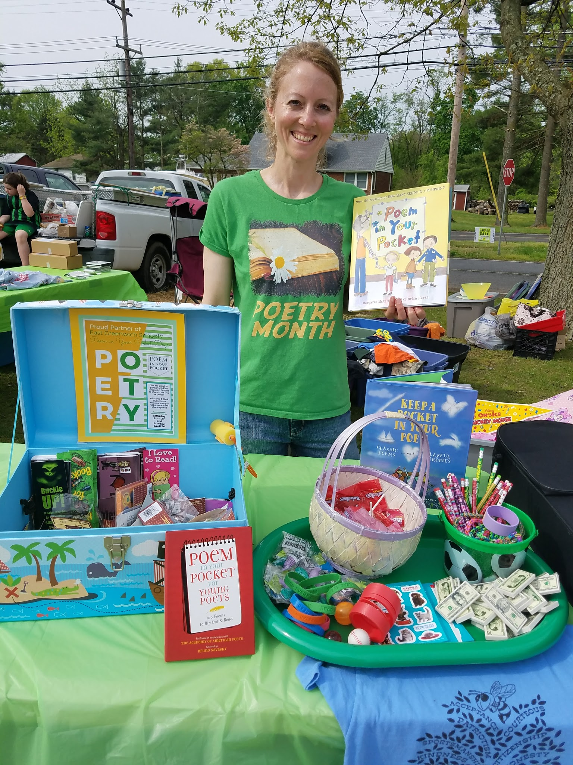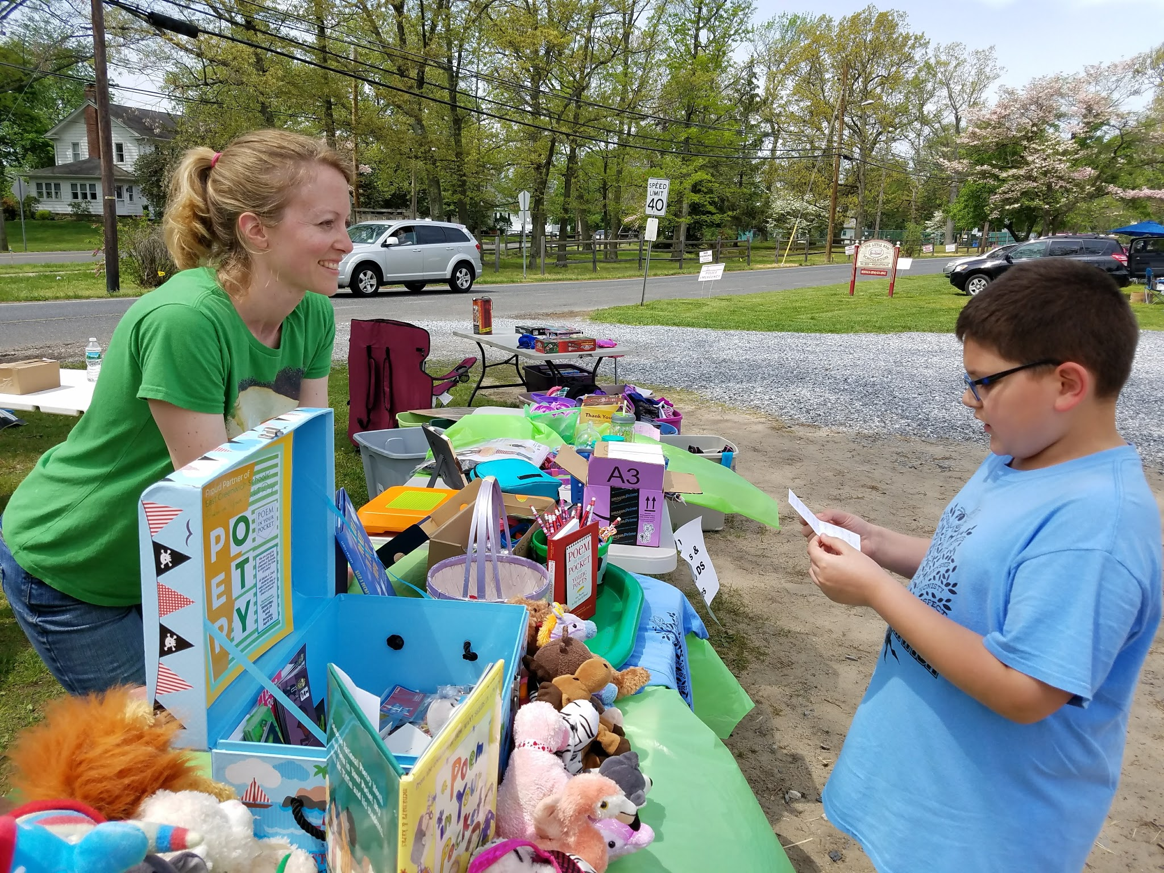

A sample flyer is below:
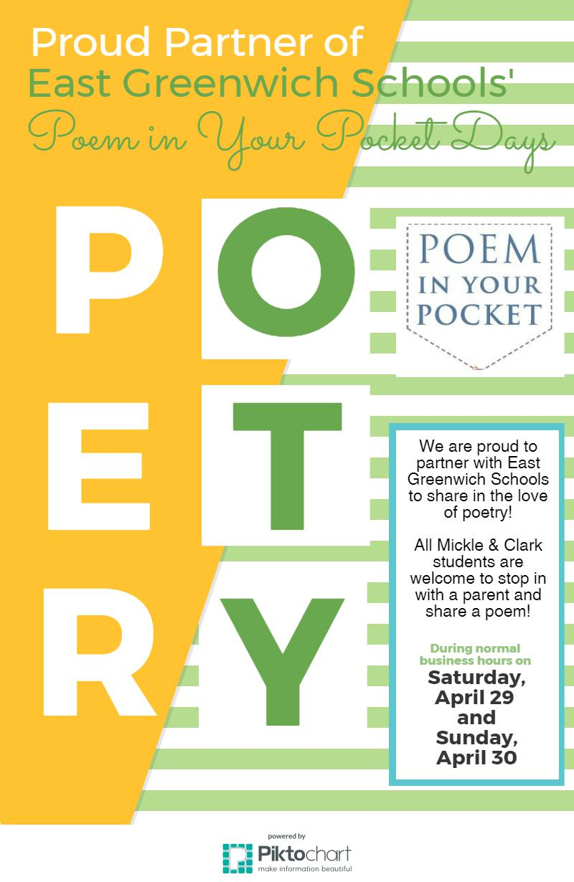

Learning Standards
English Language Arts (2016) RL.5.4. Determine the meaning of words and phrases as they are used in a text, including figurative language such as metaphors and similes.
English Language Arts (2016) RL.5.5. Explain how a series of chapters, scenes, or stanzas fits together to provide the overall structure of a particular story, drama, or poem.
English Language Arts (2016) RL.5.7. Analyze how visual and multimedia elements contribute to the meaning, tone, or beauty of a text (e.g., graphic novel, multimedia presentation of fiction, folktale, myth, poem).
AASL -1.2.2 Demonstrate confidence and self-direction by making independent choices in the selection of resources and information.
AASL-1.1.6 Read, view, and listen for information presented in any format (e.g., textual, visual, media, digital) in order to make inferences and gather meaning.
AASL -1.4.2 Use interaction with and feedback from teachers and peers to guide own inquiry process.
AASL -4.1.1 Read, view, and listen for pleasure and personal growth.
AASL - 2.1.6 Use the writing process, media and visual literacy, and technology skills to create products that express new understandings.
AASL -2.4.3 Recognize new knowledge and understanding.
AASL -3.1.3 Use writing and speaking skills to communicate new understandings effectively.
AASL -1.3.3 Follow ethical and legal guidelines in gathering and using information.
AASL -1.1.2 Use prior and background knowledge as context for new learning.

#37 The New Jersey Bunny
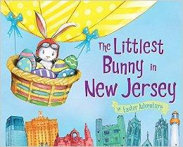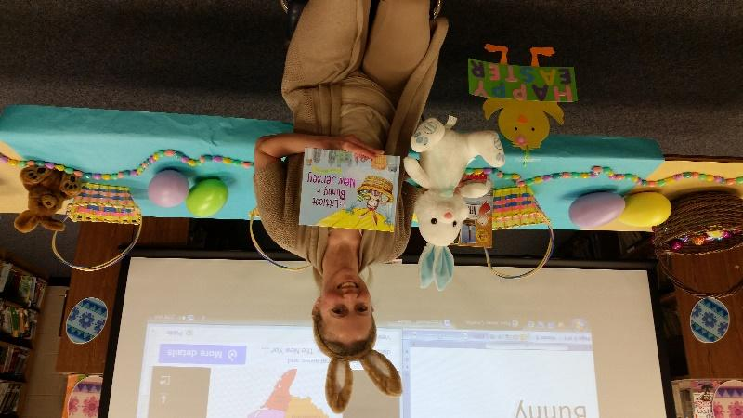

Targets
Students will:
- learn about Easter and New Jersey.
- listen for keywords and follow related instructions.

Procedures
(Lower elementary)
Pull Easter and New Jersey books for display and possible student check out. Pull Easter and New Jersey books for display and possible student check out. Wear bunny ears and welcome the students into the Easter/Spring decorated library. Put a graphic image of the counties in New Jersey and the words “bunny” and “New Jersey” on the smartboard in the background. Ask if anyone knows what state is pictured on the smartboard. Then discuss how there are counties within the states and towns within the counties. Point out which county and town the school is located.
Have the students sit in the chairs, that you have moved into a U-shape, while you read the book, The Littlest Bunny in New Jersey. Hand a small white bunny stuffed animal to the first student and instruct the class to pass the stuffed bunny to his or her neighbor every time they hear the words “bunny” and “New Jersey.” Ask questions throughout book such, info about Easter, bunnies, New Jersey, Garden State, gardens, magic, seek and finds, and any other subjects that touched upon. Continue to explore the students’ knowledge of our lesson topics by asking additional questions at the end of the story. Once the lesson is completed, inform the students they will each be able to find one Easter egg in the bookshelves to trade-in for a small prize. Remind students about our library rules and patience while searching for the egg and a library book. If there is additional time or students that cannot check out books have a bunny coloring page to color.

Materials
- Easter/Spring decor
- Easter ears
- Stuffed Easter Bunny
- Easter Eggs
- Small prize (stickers, bookmarks, pencils, etc.)
- Book, The Littlest Bunny in New Jersey by Lily Jacobs
- Coloring page, crayons

Learning Standards
AASL 3.2.2 Show social responsibility by participating actively with others in learning situations and by contributing questions and ideas during group discussions.
English Language Arts (2016) RL.3.1.: Ask and answer questions to demonstrate understanding of a text, referring English Language Arts (2016) RL.3.4.: Determine the meaning of words and phrases as they are used in a text, distinguishing literal from nonliteral language.
explicitly to the text as the basis for the answers.
English Language Arts (2016) RI.3.7.: Use information gained from illustrations (e.g., maps, photographs) and the words in a text to demonstrate understanding of the text (e.g., where, when, why, and how key events occur).

Resources
Map of the World. (n.d.). Map of New Jersey [Online image]. Retrieved from https://img.clipartfest.com/cca8244fed28d72e4531c629b2a11752_new-jersey-bergen-county-map-clipart-new-jersey_1583-3001.jpeg

#38 Six Flags Reading Roller Coaster
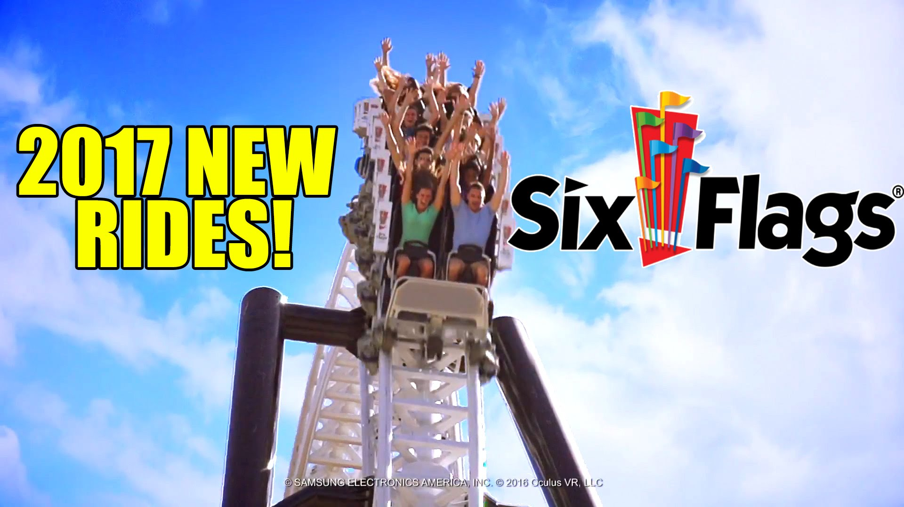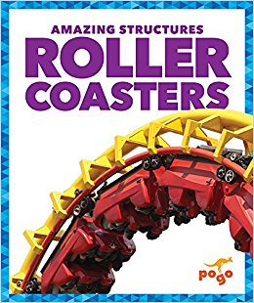
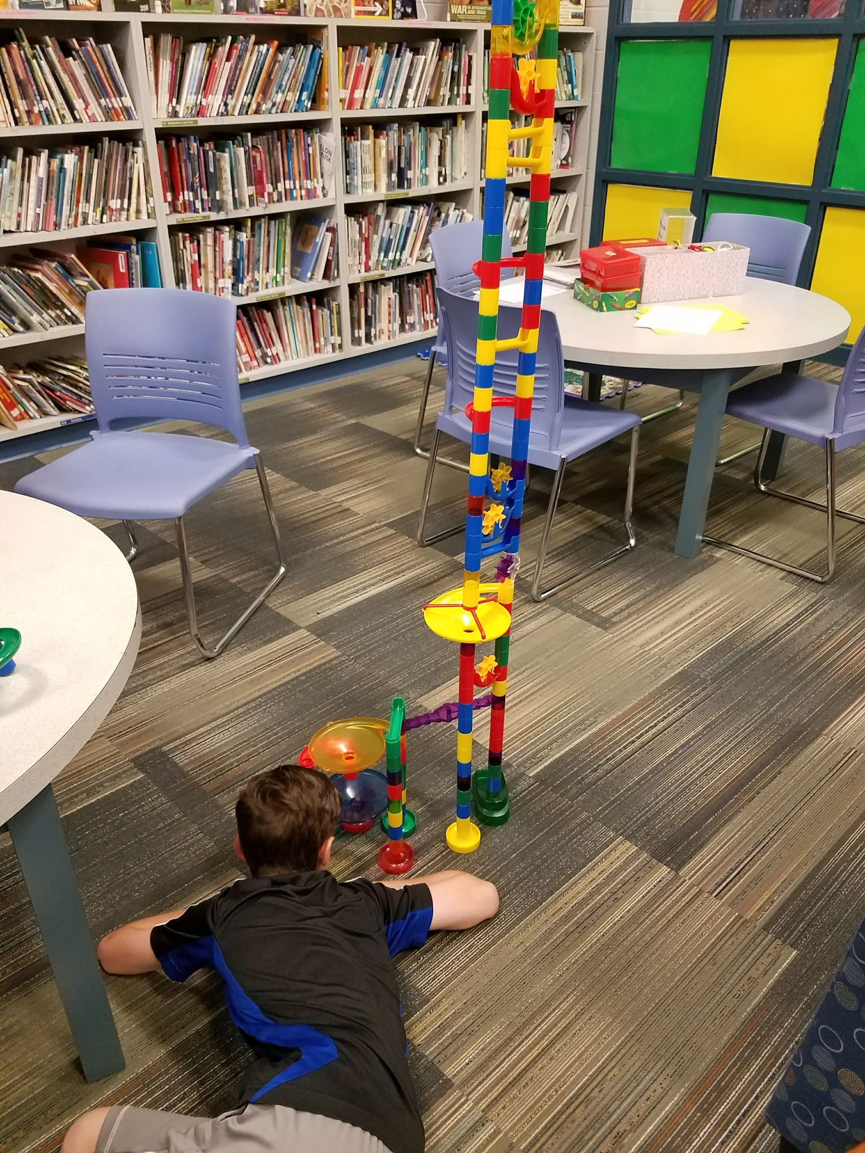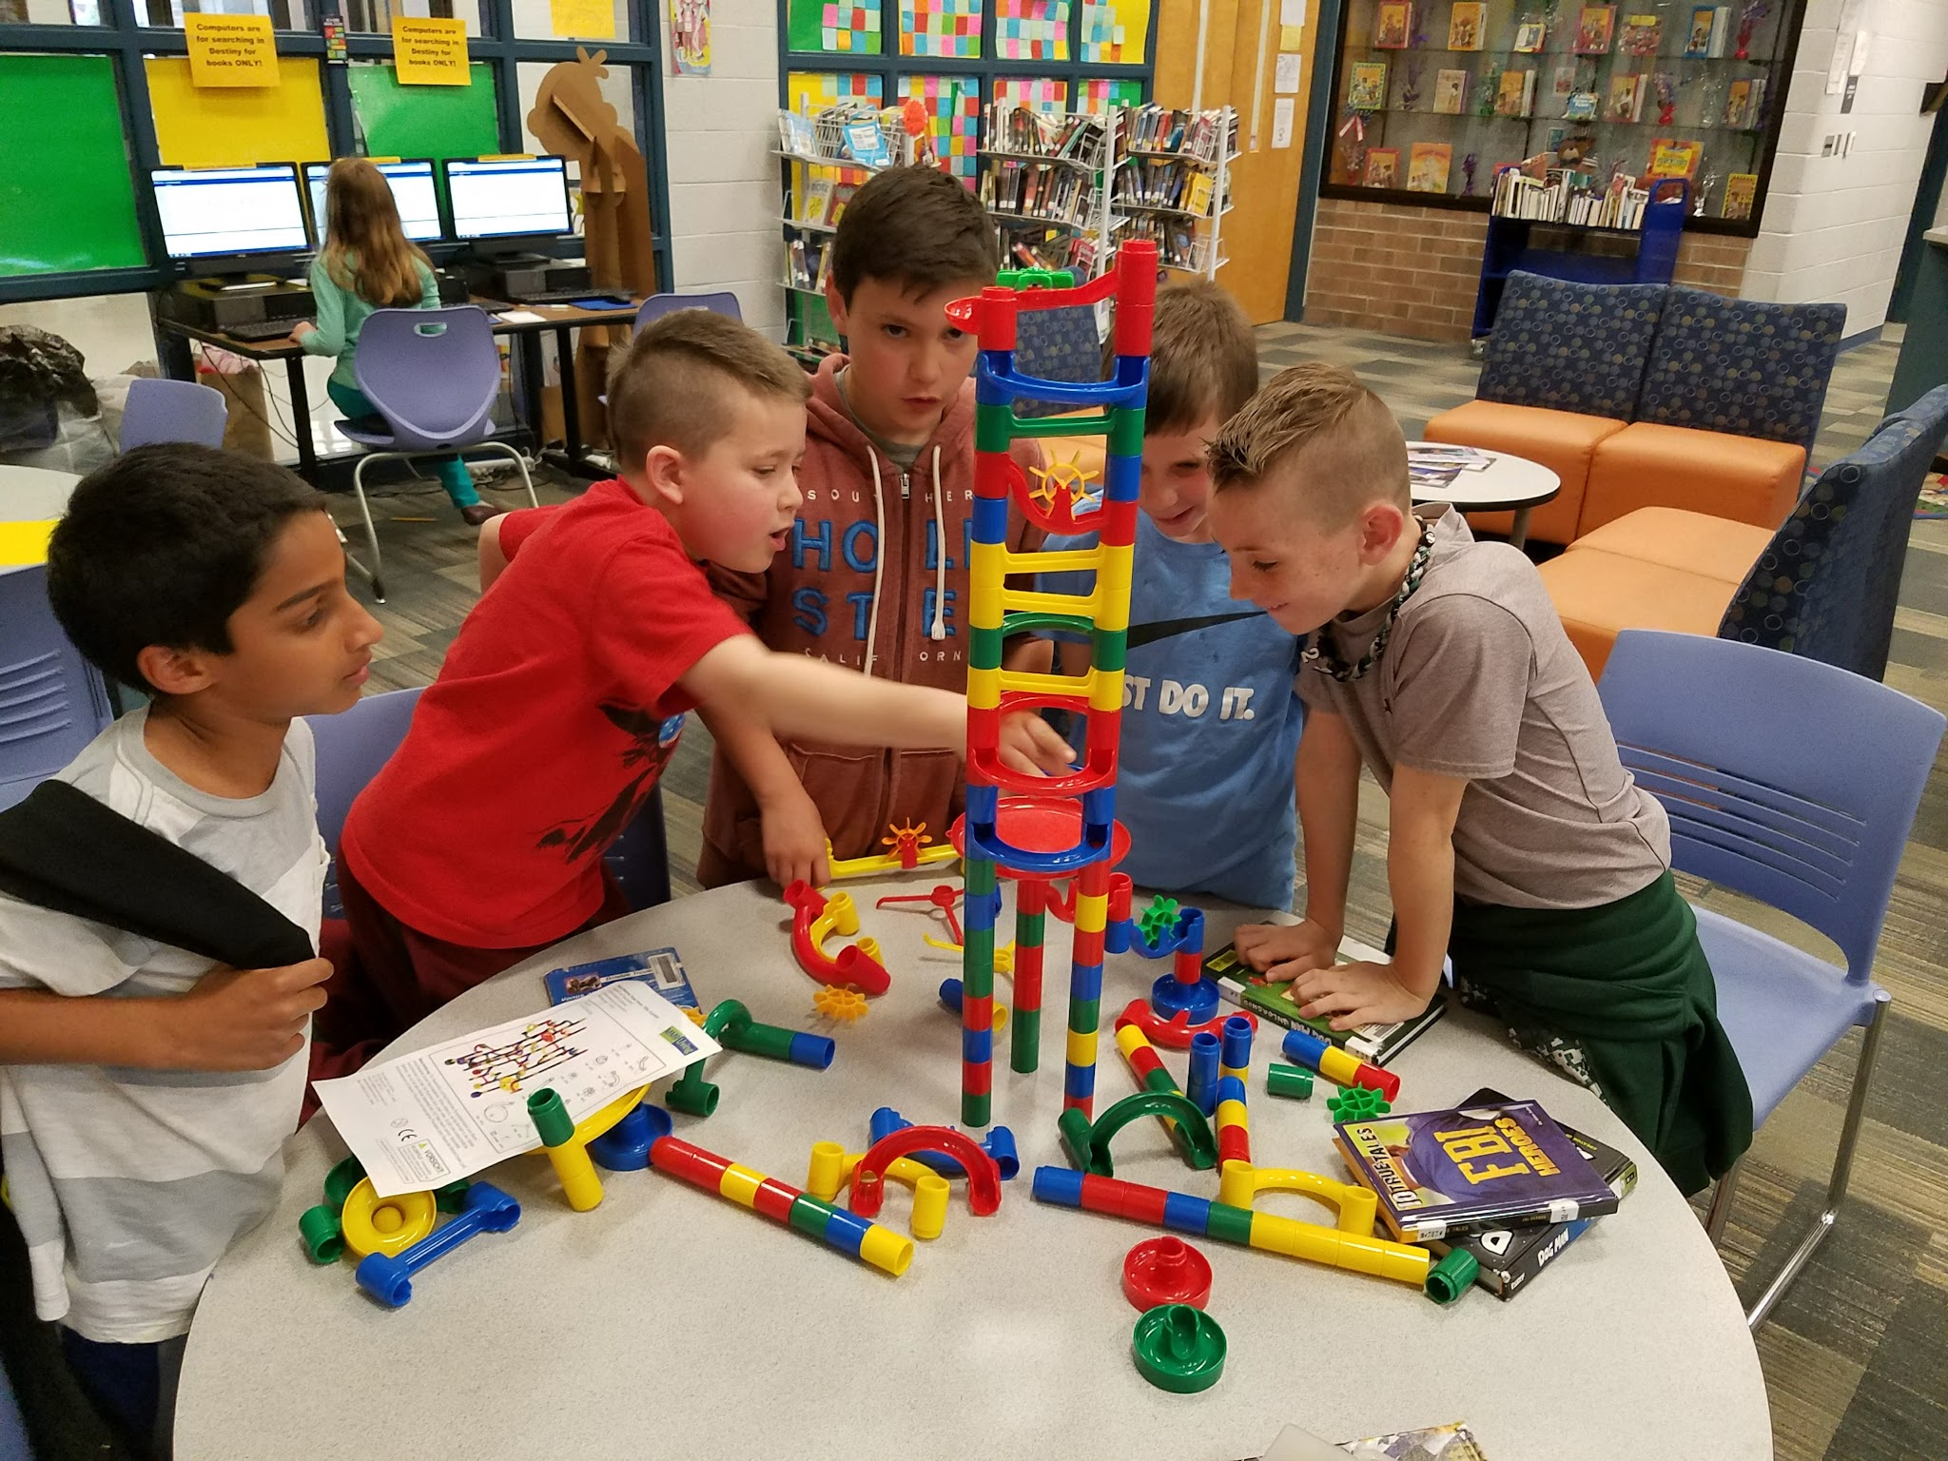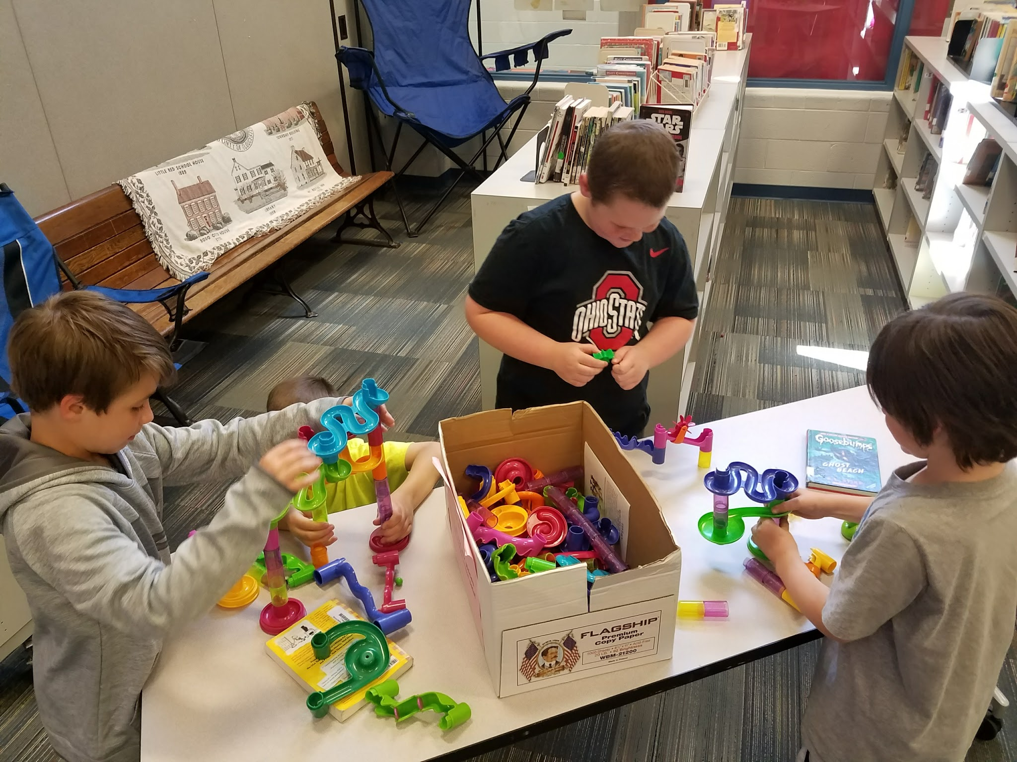

(Lower & Upper elementary)
Targets
Students will…
- learn about the science of roller coasters
- work together to design & construct their own marble “coasters.”

Procedures
Align this lesson with the schoolwide Six Flags Read to Succeed Reading Challenge. Information can be found at this link https://www.sixflags.com/greatamerica/community . The lesson can be when you announce the beginning of the reading challenge or during the week the forms are due (March 1st).
Purchase the book series, Amazing Structures series by Rebecca Pettiford which has 6 books, including the Roller Coasters book.
(For lower elementary) At this time read the book, Amazing Structures Roller Coasters by Rebecca Pettiford. For upper elementary just point out the book series.
Dress in a Six Flags (amusement park, roller coaster shirt, or any summer fun outfit with sunglasses, hat and hold a souvenir cup. Set the chairs up like a roller coaster two by two with slight curves. Welcome the students aboard the roller coaster, stating the safety/behavior rules prior to the ride.
Show a science video about the engineering of roller coasters http://www.sciencechannel.com/video-topics/engineering-construction/machines-rollercoaster/ .
Afterward, ask students how they feel about roller coaster and to share their personal experiences. Instruct students they are going to break into teams to construct their own marble roller coasters. Give each team a paper to write the team members’ names, name of their roller coaster, and time how long the marble takes to travel through it with an online timer displayed on the smartboard. Express the importance of teamwork! Show a second video while the students work together:
New Rides at Six Flags http://www.latimes.com/travel/themeparks/la-tr-six-flags-2017-20160831-snap-story.html
Best Roller Coasters Around the World http://www.travelchannel.com/interests/amusement-parks/video/best-roller-coasters-around-the-world
Top 10 Coolest Roller Coasters In The World https://www.youtube.com/watch?v=9dTcc_FqTms
Online Stopwatch http://www.online-stopwatch.com/large-stopwatch/
Have students break up into teams and allow them 10 minutes to construct their own roller coasters out of marble mazes. When time is up, have the teams demonstrate how their creation works.

Materials
- Six Flag or summer attire
- Videos
- (At least) 4 Marble maze sets
- Spare marbles

Learning Standards
AASL 1.1.6 Read, view, and listen for information presented in any format (e.g., textual, visual, media, digital) in order to make inferences and gather meaning.
AASL 1.3.4 Contribute to the exchange of ideas within the learning community.
AASL 2.1.5 Collaborate with others to exchange ideas, develop new understandings, make decisions, and solve problems.
AASL 2.2.4 Demonstrate personal productivity by completing products to express learning.
AASL 2.3.1 Connect understanding to the real world.
AASL 3.2.2 Show social responsibility by participating actively with others in learning situations and by contributing questions and ideas during group discussions.
AASL 3.2.3 Demonstrate teamwork by working productively with others.
Science (NJSLS-S 2014) 3-5-ETS1-3: Plan and carry out fair tests in which variables are controlled and failure points are considered to identify aspects of a model or prototype that can be improved.
Science (NJSLS-S 2014) 4-PS3-4: Apply scientific ideas to design, test, and refine a device that converts energy from one form to another.

Resources
MacDonald, B. (2016, September 1). Six Flags unveils new attractions for every park in 2017. Retrieved from http://www.latimes.com/travel/themeparks/la-tr-six-flags-2017-20160831-snap-story.html
Science Channel. (n.d.). Engineering & construction videos-rollercoaster. Rterieved from http://www.sciencechannel.com/video-topics/engineering-construction/machines-rollercoaster/
(Optional videos)
Best Roller Coasters Around the World (all grades) http://www.travelchannel.com/interests/amusement-parks/video/best-roller-coasters-around-the-world

Top 10 Coolest Roller Coasters In The World
(*Play on the Smartboard quietly or without sound while teams build their marble roller coasters) https://www.youtube.com/watch?v=9dTcc_FqTms
Online Stopwatch http://www.online-stopwatch.com/large-stopwatch/

#39 Baseball’s History & Inspiration
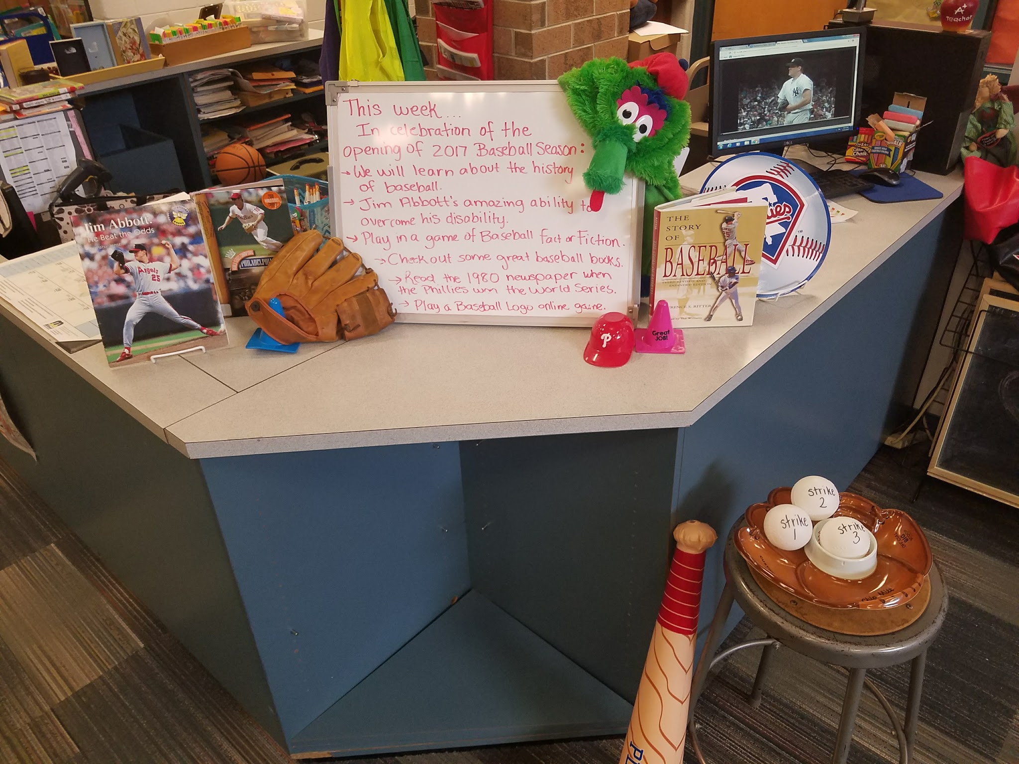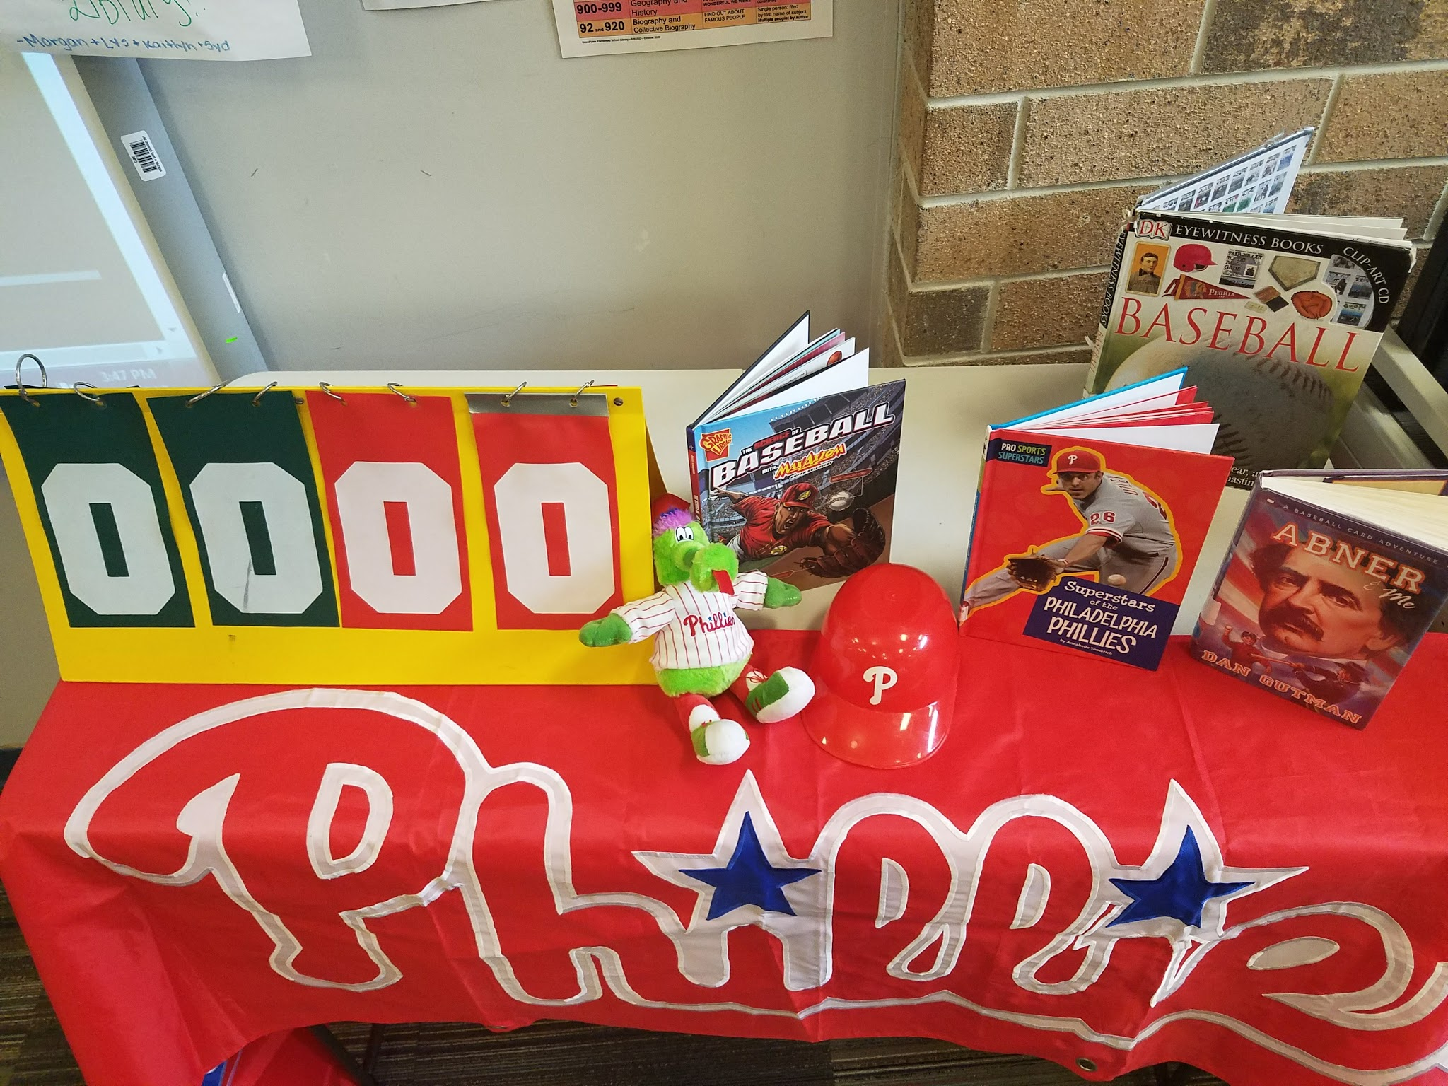
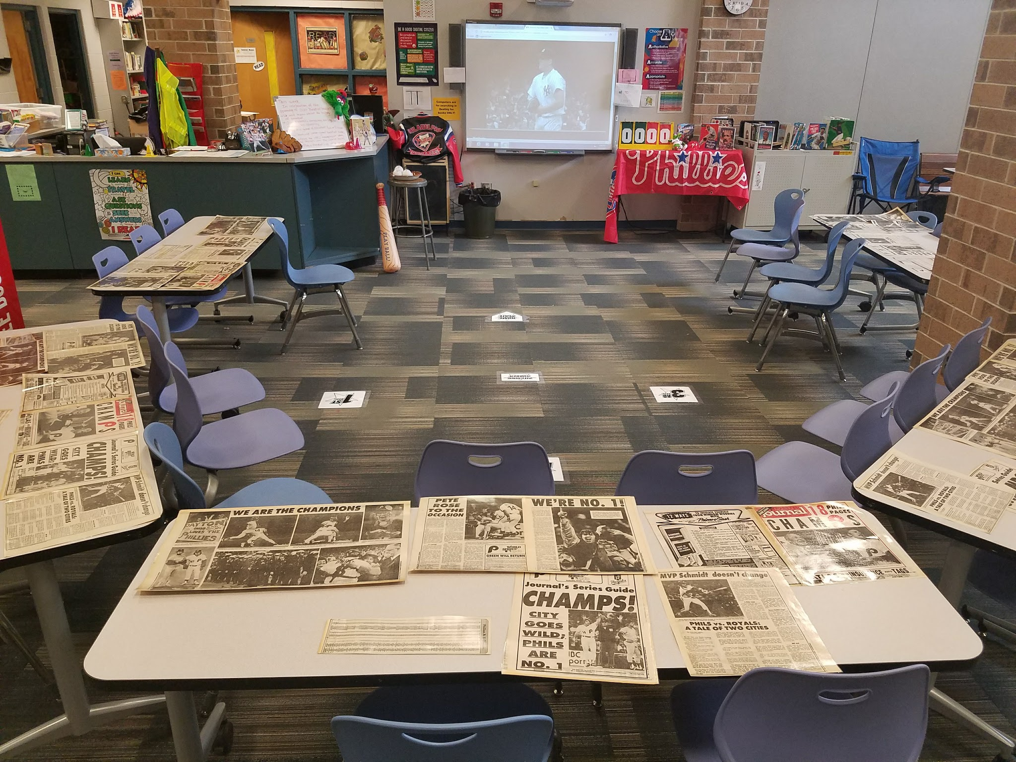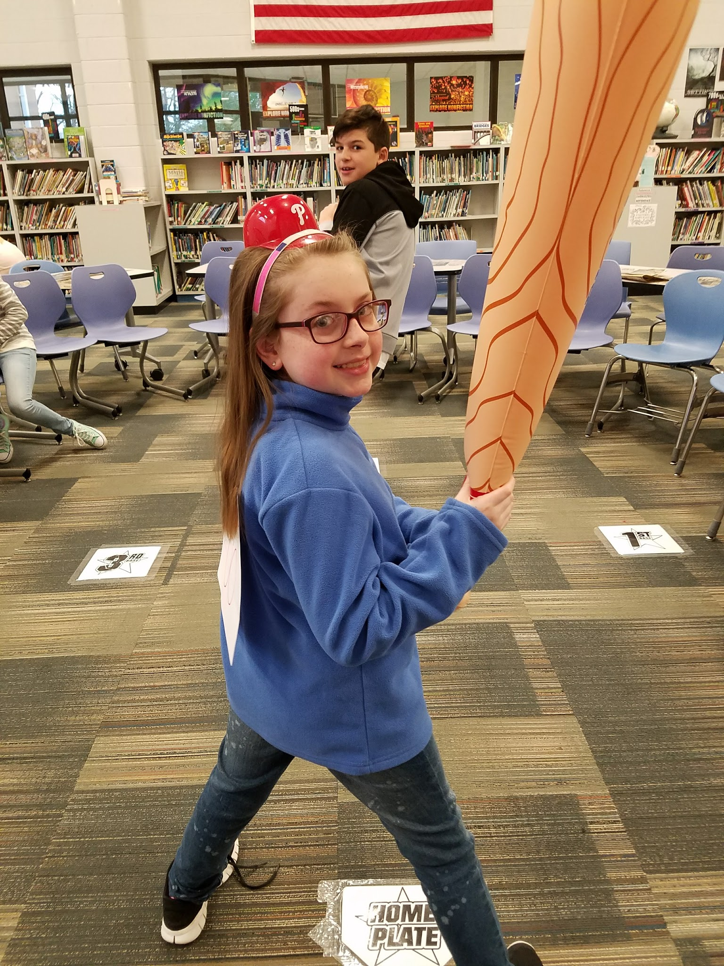
(Upper elementary)

Targets
Students will…
- learn about the history of baseball and the Philadelphia Phillies.
- analyze information from a newspaper about the Phillies.
- be inspired by baseball players that beat the odds.
(I purchased old newspapers at a yard sale, you can use a variety of other resources.)
Procedures
Pull nonfiction and fiction baseball books for display and possible student check out. Dress in your favorite baseball attire and decorate in a related theme. Move chairs around into a shape of a baseball diamond. Tape down bases (purchased from the dollar store) in the baseball diamond shape. Play Take Me Out to the Ballgame as students come in. Allow them tell to share what they know about baseball, if they play baseball/softball and have attended any professional baseball games. Share facts about how the game of baseball got started. (*For lower elementary, you can play this baseball video at this point https://www.youtube.com/watch?v=vjUHSgdzWJo )
Read or paraphrase (depending on grade level) a short book or section about Jim Abbott’s amazing ability to overcome his disability. Show first minute of the video of Jim Abbott pitching his last pitch for a no-hitter with the Yankees in 1993 http://m.mlb.com/video/topic/6479266/v2685734/9493-jim-abbotts-nohitter . Next show another inspirational player, Mo’ne Davis’s video when she was voted Sports Illustrated’s kid athlete of the year in 2014 https://www.youtube.com/watch?v=VIeBrcP38cw .
For our activity, separate the class into two teams. Have one player come to bat at a time and answer a baseball-related questions. (You can ask direct questions or true/false ones, alter by as needed by grade or if student states they don’t know much.) If they answer correctly, the player advances to first base. If not, it is strike one. Continue playing until the team gets 3 strikes or 5 runs “walk” in. Switch sides and follow the same rules. Adjust the game as needed for time to check out books. Also have assorted books on tables for students to read and help them become “Phanatics” of Books! Any student that is done early can also play a online baseball logo matching game.
*In addition, I purchased old newspapers from 1980 when the Phillies won the World Series to introduce some students to newspapers as another informational resource. You can also purchase current newspapers during the baseball season to laminate and use as an introduction to reading a newspaper and touch on the history of newspapers too.
Materials
- Baseball attire and decor
- Bases, inflatable bat, wiffle balls
- Scoreboard (borrowed from the gym) or use a chalkboard/smart notebook
- Videos
- Jim Abbott book
- Online game
- Old or new newspapers articles about baseball

Learning Standards
AASL -2.4.1 Determine how to act on information (accept, reject, modify).
AASL -1.1.4 Find, evaluate, and select appropriate sources to answer questions.
AASL -1.1.6 Read, view, and listen for information presented in any format (e.g., textual, visual, media, digital) in order to make inferences and gather meaning.
AASL -3.2.2 Show social responsibility by participating actively with others in learning situations and by contributing questions and ideas during group discussions.
AASL -4.1.1 Read, view, and listen for pleasure and personal growth.
AASL - 2.4.3 Recognize new knowledge and understanding.
AASL -1.1.2 Use prior and background knowledge as context for new learning.

Resources
Baseballsongs. (2011, May 18). Paul Richardson-Take me out to the ball game [Video file]. Retrieved from https://www.youtube.com/watch?v=WLlyMVBTZt0

Cool School. (2016, May 3). Baseball Facts - All About the Game of Baseball Nikki's Wiki -Wiki for Kids at Cool School [Video file]. Retrieved from https://www.youtube.com/watch?v=vjUHSgdzWJo

MLB.com. (2017). Jim Abbott pitches a no-hitter [Video file]. Retrieved from
http://m.mlb.com/video/topic/6479266/v2685734/9493-jim-abbotts-nohitter

Sideline. (2017). How Well Do You Know MLB Logos? [Video file]. Retrieved from
http://sideline.topix.com/quiz/17829/qidx1

Sports Illustrated Kids. (2014, December 2). Mone Davis: 2014 Sports Illustrated Kids SportsKid of the Year [Video file]. Retrieved from https://www.youtube.com/watch?v=VIeBrcP38cw

#40 ANTi-Bullying and Teamwork
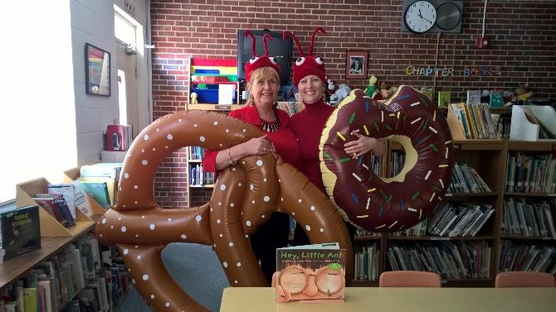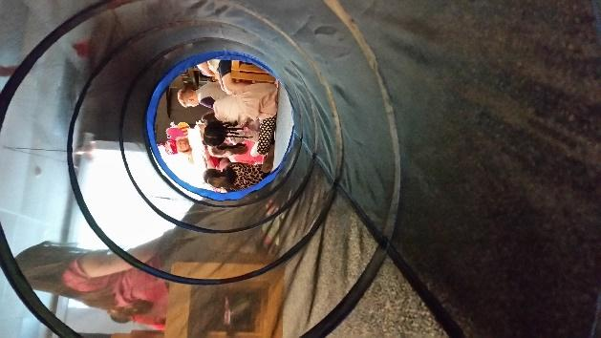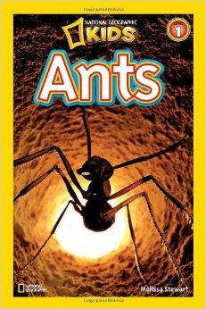
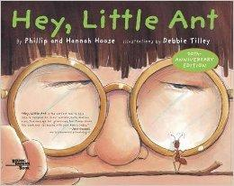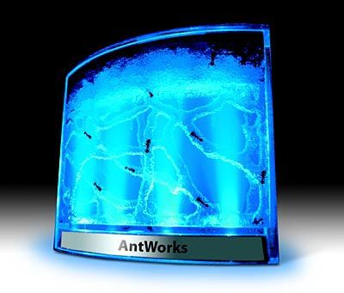
Targets
Students will...
- learn about ants.
- identify importance of not being a bully and teamwork.

Procedures
(Lower elementary)
Pull Earth Day, ant, and anti-bullying/being a friend books for display and possible student check out. Wear an ant hat and have the library decorated with picnic items. Meet the students in the hallway, holding large food-shaped pool floats, like a pretzel and donut. Tell the students and tell them we are gathering food for our ant colony. Welcomed them in as worker ants and to come through our “ant tunnel” into story time. The youtube video, The ants go marching one by one song, will be playing on the overhead projector. The lights will be out, with only a single light over my reading chair. After they crawl through the tunnel, they can take a quick look at our live ant farm on the table. Once everyone is seated, discuss the process of how the ants were obtained for our lesson. Next read Ants by Melissa Stewart. Throughout the book ask the students questions related to ants. Then read Hey, Little Ant by Phillip and Hannah Hoose. At the end, discuss the importance of all creatures, big and small; working together and not being a bully.
Allow students to crawl back through the tunnel to get their books, then fold it up. Place the ant farm on your desk, so students can watch them as they check out their books. Remind them not to touch it. Play an ant video on the smartboard as the search for their books https://www.youtube.com/watch?v=55tXhnlZoOg .
Materials
- Ant hat
- Food-shaped pool floats
- Crawl-through tunnel
- Hanging light/spotlight
- Picnic decor
- Books, Ants by Melissa Stewart and Hey, Little Ant by Phillip and Hannah Hoose
- Ants
- Ant farm (Best is Illuminated Ant Works on Amazon.com)

Learning Standards
AASL 3.2.2 Show social responsibility by participating actively with others in learning situations and by contributing questions and ideas during group discussions.
AASL 4.3.3 Seek opportunities for pursuing personal and aesthetic growth.
English Language Arts (2016) RL.3.1.: Ask and answer questions to demonstrate understanding of a text, referring
English Language Arts (2016) RL.3.4.: Determine the meaning of words and phrases as they are used in a text, distinguishing literal from nonliteral language.
explicitly to the text as the basis for the answers.

Resources
Segura, B. (2013, August 27) National Geographic Wild City of Ants [Video file]. Retrieved from https://www.youtube.com/watch?v=55tXhnlZoOg
Turtle Interactive. (2014, January 29). The ants go marching one by one song [Video file]. Retrieved from https://www.youtube.com/watch?v=Pjw2A3QU8Qg

