SWSD Media Center Curriculum Unit 1
“Tell me and I forget, teach me and I may remember, involve me and I learn.”
-Ben Franklin
#1 Welcome to “OUR” Library (Introduction)
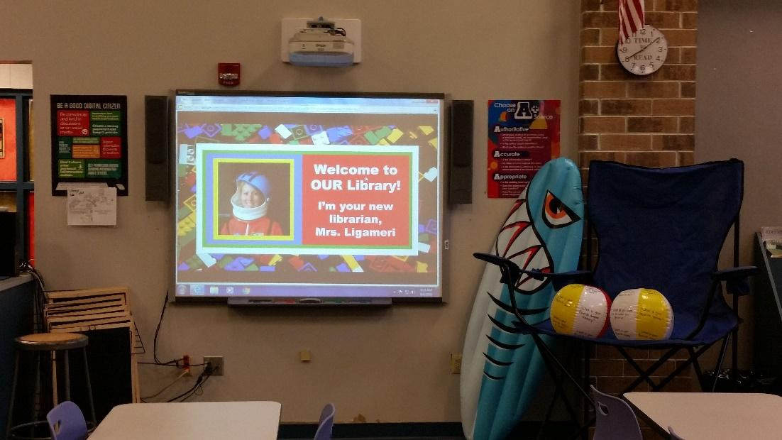
Targets
Students will…
- feel welcomed.
- be introduced to the librarian and library.
- learn the library rules and safety procedures.
- participate in an ice breaker activity.
Procedures
(Lower & Upper Elementary)
It is important to introduce yourself and welcome the students at the beginning of every year. Assure the students that the library is “ours,” meaning yours and theirs. You want them to feel at home, looking forward to coming each week, all while respecting and caring for the library’s books and resources. Discuss the rules and make sure they are also clearly posted. Clearly define the safety procedures and practice the various drills. Learning can and should be fun! Plan a fun activity to “break the ice.” A possible ice breaker activity to continue their summer fun can be to acquire two beach balls and write various questions on them for students to answer. Students lined up in 2 lines facing each other (approximately 3 feet away from each other) and gently tossed the ball. The students answer the questions that their hands landed on. Sample questions are “what is your favorite food, animal, color, book, movie, hobby, summer memory, etc.” Explain the book check-out and check-in procedures and allow the students time to ask questions and browse the bookshelves.
Materials
- Summer/fun attire and decor
- Library rules poster
- Posted safety procedures
- Ice Breaker activity supplies (ex. beach balls)
*I also created library cards on color index cards. Each grade level has a specific color. I printed address labels with the student’s patron number from our Destiny Library Manager Program and put a clear label over it for protection (they can be laminated at a future time if you want). The students can use these library cards throughout all grade levels). During the second library class, students should be permitted to personalize their library card with markers, colored pencils, stickers, etc.. This allowed them to show their creative talents and favorite things, while making it easier for them to locate their cards when laying out on the counter. Having these library cards available to scan for each class makes it easy to determine which students can check-out books (which only those cards are laid out on the counter) and also makes check out quicker.
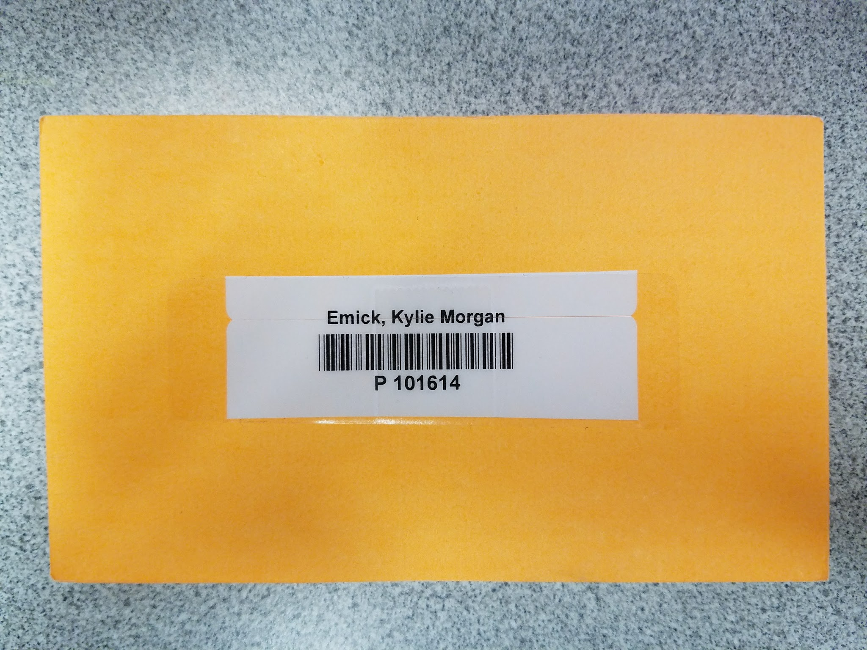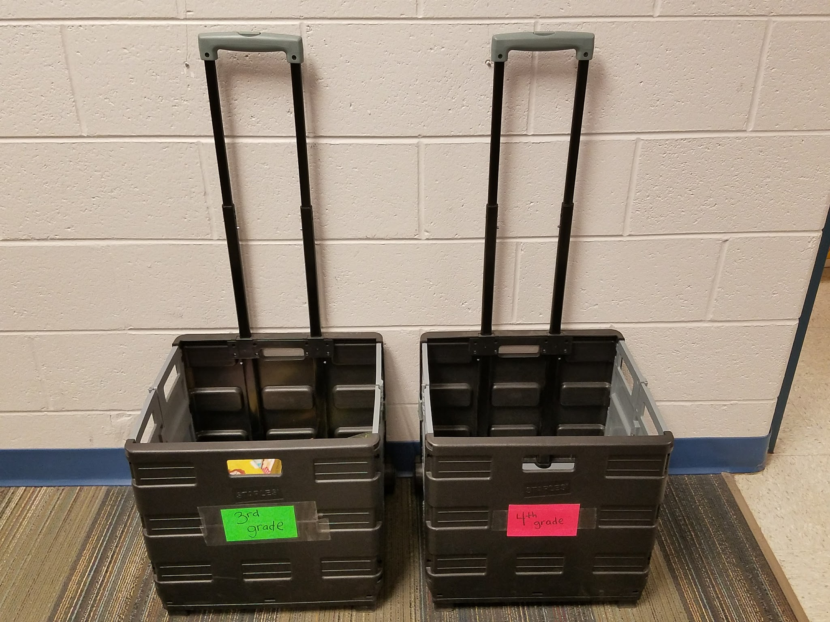
In addition, the school purchased 2 rolling carts for each grade’s hallway, so classes can gather and return their books the day before library to make book check-ins and check-outs smoother and assure books are better circulated.
In the following plans, I have included library lessons that I have already done or will be using in the future. I like to decorate for a particular theme, subject, holiday, etc. and just alter the lesson or activity to correlate to the grade/age of the students. Most lessons can be altered for lower and upper grade levels. Most students have responded positively to engaging, interactive lessons and their related activities. In addition, it makes the Library come alive and become the place where everyone wants to go and learn!

#2 The Book Doctor
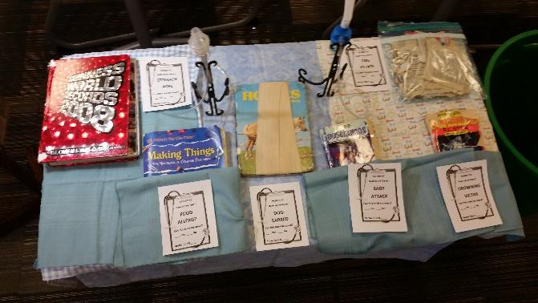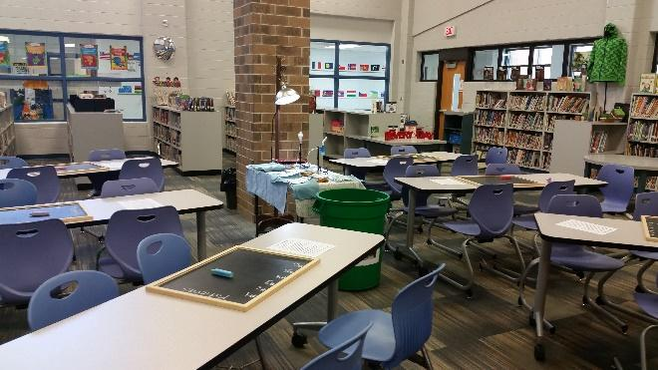
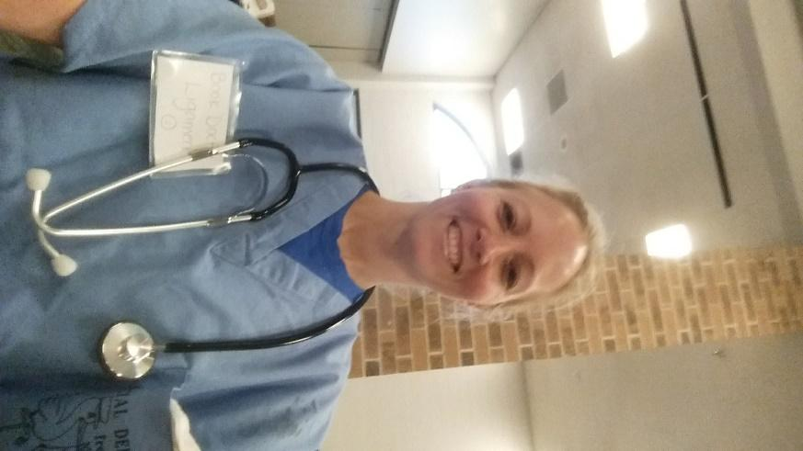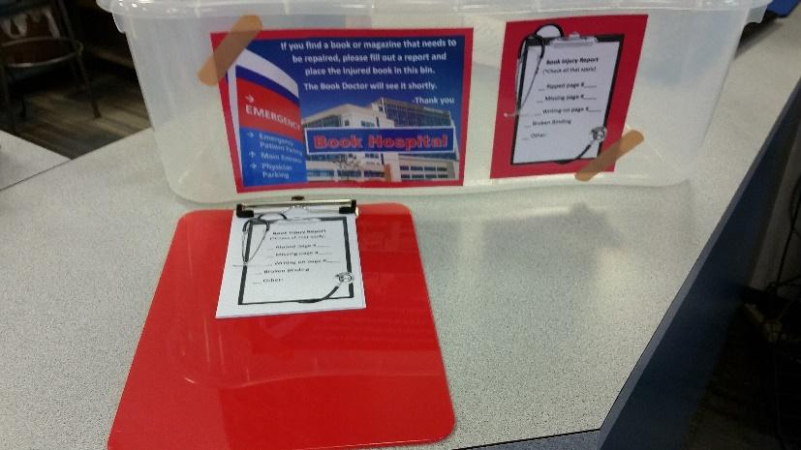
Targets
Students will:
- learn book care rules.
- identify various book damage.
- locate damaged books.

Procedures
(Lower Elementary)
Dress up like a doctor and set up a table like an emergency operating room. A youtube video of a siren will play on the Smartboard as the students enter. Welcome in the students and have them stand around the “operating” table. Sit at the table “performing a procedure” (fixing) a damaged book with scotch tape. Next talk to the book as if to calm it, let it know it can be repaired and will be okay. As the kids are engaged in this procedure, pause and grab the cart with a severely damaged book. Lift the book to the table. Try to “find a pulse,” “check if it’s breathing,” and do “chest compressions.” Then “charge the heart paddles” and “shock” the book back to life. After it doesn’t work, say, “We can’t save them all,” and cover the book with a blanket. Read the book, Manners with a Library Book by Amanda Doering Tourville. Discuss the importance of taking good care for our books, so that they don’t have to be thrown away. After the story, the boys and girls will sit down and do a worksheet about book care. At the end of the lesson, show the students our Book Hospital book bin and Book Injury Report forms. Allow them time to check out books and search for any damaged books among the shelves.
(Upper Elementary)
Dress as the "Book Doctor" and welcome the students into my Book Hospital's Emergency Room. A youtube video of a siren will play on the Smartboard as the students enter. Students will sit at tables in teams. Place a chalkboard, chalk and a copy of the book care rules on each table. As a group, discuss book care rules. Show the students six “injured” books that they will have to write down on the chalkboards which # book rule was broken and a “yes” or “no” as to whether the book can be saved. Injuries can include: “a stomach ache” in which an item in stuck inside the book that breaks the binding; “food allergy” with food stains; “drowning victim” with water damage; “baby attack” with torn pages; “dog attack” damage from pet; and “dog-eared” bent corners. Then discuss their answers. At the end of the lesson, show the students our Book Hospital book bin and Book Injury Report forms. Allow them time to check out books and search for any damaged books among the shelves to place in the book hospital.
Materials
- Doctor costume
- Book, Manners with a Library Book by Amanda Doering Tourville.
- Medical Equipment
- Chalkboard and Chalk
- Damaged books
- Google Slides presentation: "The Book Doctor is in"Book Hospital book bin and Book Injury report forms

Learning Standards
AASL - 1.1.2: Use prior and background knowledge as context for new learning.
English Language Arts (2010) 3.5.05.A.SL.5.1.b Follow agreed-upon rules for discussions and carry out assigned roles.
English Language Arts (2010) 3.5.05.A.SL.5.3 Summarize the points a speaker makes and explain how each claim is supported by reasons and evidence.

Resources:

UrbanSurvivalTactics. (2012, May 19). Ambulance-sound effect [Video file]. Retrieved from https://www.youtube.com/watch?v=m_JeMPXmn_E

My sample Google slides presentation: https://docs.google.com/presentation/d/1Stpze__nsJGxstP0PQnsYEcT-CROA9spt3FLy_28unA/edit#slide=id.g170c549d30_1_29

#3 The Groovy Dewey Book Party
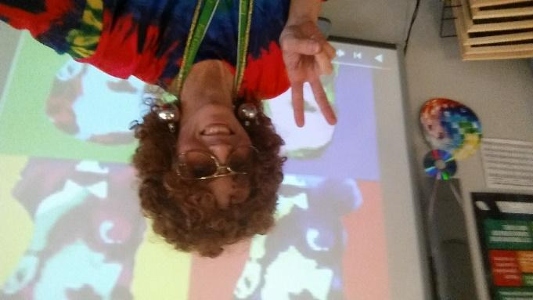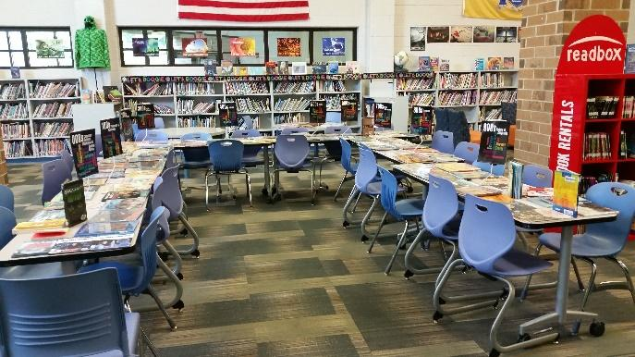
Targets
Students will...
- be introduced/reintroduced to the Dewey Decimal System.
- understand how and why books are classified in groups.
- explore the various genres in our library.
- listen and follow directions for the activity.

Procedures
(Lower & Upper Elementary)
Dress in tie-dye and decorate with 60’s décor. The tables will be connected in a U-shape and covered with books from every Dewey Decimal Classification with matching signs. Groovy music will be playing as students enter. Welcome the students and get them excited about grooving with Dewey. First show a Dewey Decimal youtube video, Introduction to the Dewey Decimal System
https://www.youtube.com/watch?v=9bV_sI8XQdI
After the video, point out the various genres on the tables and explain students will be playing musical chairs. However in this version, there will be additional chairs and no chairs will be taken away. Play a fun youTube videos created by students and teachers from popular songs altered to correlate to the library for approximately 30 seconds as students walk around the tables. When the music stops, the students will sit in a chair and spend 3 minutes exploring the books in their area. Perform this activity 3 or 4 times, as time allows. Encourage students to choose a book to check out from the tables at the completion of the activity. Allow time for students to check out books.
Materials
- Groovy décor and outfit
- Dewey Decimal Signs for all classifications
- Wire stands or sign holders
- Various books
- Videos and music videos

Learning Standards
AASL - 4.3.2 Recognize that resources are created for a variety of purposes.
AASL - 4.1.4 Seek information for personal learning in a variety of formats and genres.
AASL - 4.4.6 Evaluate own ability to select resources that are engaging and appropriate for personal interests and needs.
AASL - 1.1.2 Use prior and background knowledge as context for new learning.
AASL - 1.1.6 Read, view, and listen for information presented in any format (e.g., textual, visual, media, digital) in order to make inferences and gather meaning.
AASL - 4.4.1 Identify own areas of interest.
AASL - 4.1.1 Read, view, and listen for pleasure and personal growth.

Resources

Bentley Media Center. (2015, September 21). Introduction to the Dewey Decimal System
https://www.youtube.com/watch?v=9bV_sI8XQdI

Clark, A. (2014, March 2). Reading (Happy Song)
[Video file]. Retrieved from https://www.youtube.com/watch?v=h5F5Kdc1UVA

Examville. (2014, December 13). Dewey Decimal System Explained [Video file]. Retrieved from
https://www.youtube.com/watch?v=PkGEwtEbtg0&t=2s

Herbert, J. (2015, February 27). All About Them Books Video
("All About That Bass" parody) [Video file]. Retrieved from https://www.youtube.com/watch?v=zjf7H8K9r4U

Melvil Dewey. (2009, March 10). Melvil Dewey Rap [Video file. Retrieved from
https://www.youtube.com/watch?v=NHiUQb5xg7A

Smith, M. (2015, May 25). All About Them Books Video ("All About That
Bass" parody) [Video file].
Retrieved from https://www.youtube.com/watch?v=Zu27TqiEIDk

TopekaLibrary. (2015, April 13). CheckItOut - Taylor Swift Parody Video for National
Library Week [Video file]. Retrieved from https://www.youtube.com/watch?v=IfNfnL64rOQ

#4 Goldilocks and the Three Libearians-”Just Right” Book
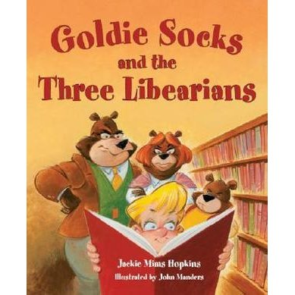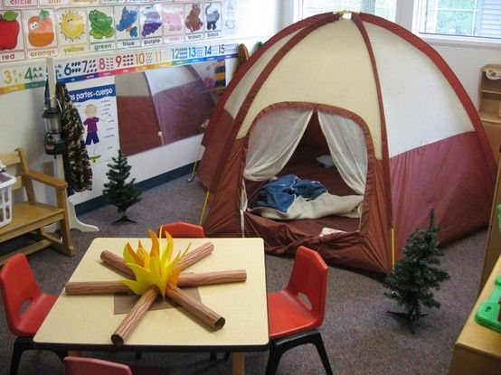
(Lower elementary)
Targets
Students will…
- make a connection between Goldilocks and the Three Bears and Goldisocks and the Three Libearians stories.
- recognize the importance of selecting a “just right” book.
Procedure
Set up a large tent in the library. Welcome students to sit inside the tent for story time. Read the book, Goldilocks and the Three Bears and Goldisocks and the Three Libearians. Next, have students sit at the tables. Give each student a piece of cardstock and a pencil. Instruct them to trace their hand and cut it out. Once they have their cut-out hand, they can go to the front table and use a piece of Scotch tape to attach a popsicle stick to the back to complete their “just right” bookmark. Then instruct the students as they finish their craft to select a “just right” book to check out.
*There are several other online activity options.
Materials
- Large tent
- Goldisocks and the Three Libearians by Jackie Mims Hopkins
- Peach, cream or tan cardstock paper
- Pencils
- Scissors
- Scotch tape
- Popsicle sticks

Learning Standards
AASL 4.1.1 Read, view, and listen for pleasure and personal growth.
AASL 4.3.3 Seek opportunities for pursuing personal and aesthetic growth.
AASL 4.4.2 Recognize the limits of own personal knowledge.
AASL 4.4.6 Evaluate own ability to select resources that are engaging and appropriate for personal interests and needs.
#5 Lego Man in Space
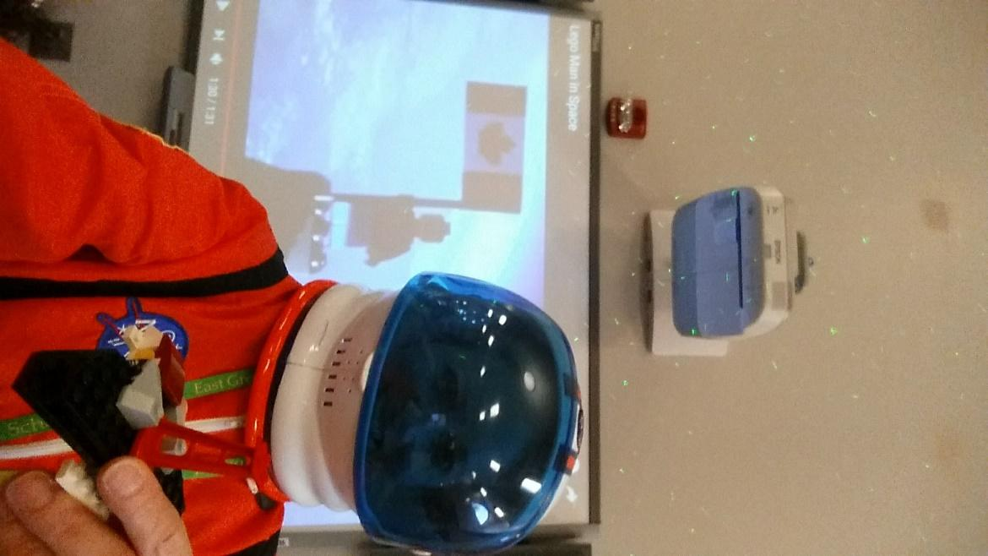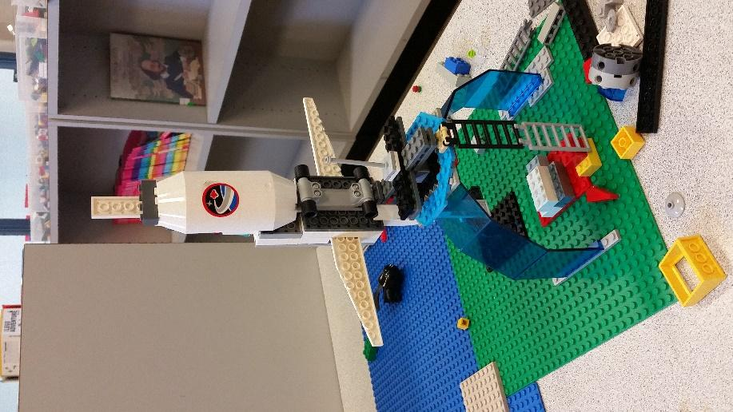
Targets
Students will:
- make a connection between the Lego Man in Space story book and the Lego Man in Space YouTube real videos.
- learn about the possibilities of launching objects into space.
- understand the importance of imagination, creating, working hard and not giving up.
- experience teamwork.

Procedures
(Lower & Upper Elementary)
Dress up like an astronaut and put the Star Wars theme song on the smartboard. (I also purchased a star showers light projector and had it aimed on the ceiling.) Read the book, Lego Man in Space by Mara Shaughnessy to the students. Afterward show them how to use Google search engine to access additional information about the Lego Man in Space. Show the real life video of Lego Man being launched into space at https://www.youtube.com/watch?v=MQwLmGR6bPA and then watch a second video of the news interview with the two teens at http://www.dailymotion.com/video/x2obekl_toronto-teens-send-lego-man-to-space_news. After the students watch the video, hold a group discussion and answer related questions. Have students get in teams for a lego building challenge. Put on the youtube video, 100 Amazing Lego Creations at https://www.youtube.com/watch?v=sYdYOyvr6wc, for them to see what other people have created and get even more excited about building their own creations. At the closure of class, the students can share their creations with the class and check out books.
Materials
- Astronaut suit
- Star shower indoor/outdoor light
- Space décor
- Book, Lego Man in Space by Mara Shaughnessy
- Videos
- Legos

Standards
AASL - 1.1.6 Read, view, and listen for information presented in any format (e.g., textual, visual, media, digital) in order to make inferences and gather meaning.
AASL - 2.2.4 Demonstrate personal productivity by completing products to express learning.
AASL - 2.1.5 Collaborate with others to exchange ideas, develop new understandings, make decisions, and solve problems.
AASL - 4.1.5 Connect ideas to own interests and previous knowledge and experience.
AASL - 4.4.6 Evaluate own ability to select resources that are engaging and appropriate for personal interests and needs.
AASL - 1.1.2 Use prior and background knowledge as context for new learning.
(YOu can include grade level science standards, if applicable)

Resources

Ho, M. (2012, January 25). Lego Man in Space [Video file]. Retrieved from https://www.youtube.com/watch?v=MQwLmGR6bPA

Bellamy, B. (2015, April 28). Toronto teens send LEGO man to space [Video file]. Retrieved from http://www.dailymotion.com/video/x2obekl_toronto-teens-send-lego-man-to-space_news

Coltsrock56. (2012, July 21). Star Wars theme (FULL) [Video file]. Retrieved from https://www.youtube.com/watch?v=_D0ZQPqeJkk

EpicDingoProductions’s channel. (2011, June 26). 100 Amazing Lego Creations [Video file]. Retrieved from https://www.youtube.com/watch?v=sYdYOyvr6wc,

#6 I Need My Monster
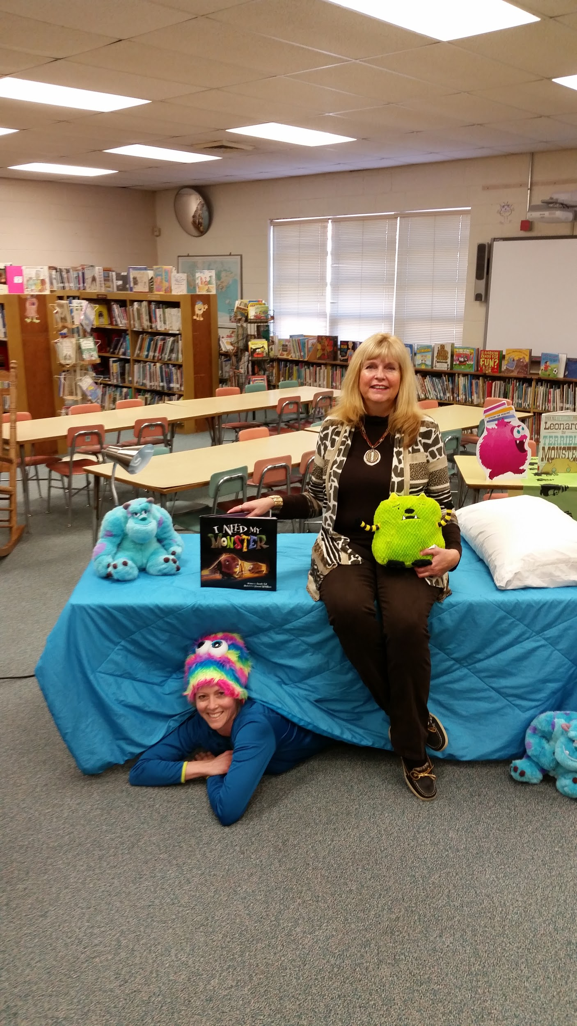
Targets
Students will…
- make a connection between the lesson to a bedtime story.
- acknowledge fears, like the dark or monsters.
- create their own “monster under the bed.”

Procedure
(Lower elementary)
Cover a table with a blanket and pillow. Place a few stuffed animals or monsters on and around it. (If you have an aide, student, or such that can hid under the table before the class comes in and until the monster comes out from under the bed to scare them, it will be fun, trust me. It may even be a good time to have a parent volunteer for each class do it as a surprise to their child.) Have the lights turned out and read by the light of a small table lamp, lantern or flashlight, with the students gathered around. If you don’t have a “monster” assisting you, when the right page comes, just make a quick jump and scary voice. After the story is over, you can have a group discussion about fears. Afterward, students can crawl under the bed to the other side to go pick out their books. If time allows, have blank paper available for students to draw their own “monsters under the bed.”
Materials
- Blanket, pillow, stuffed animals, etc.
- Lamp
- Furry monster hat
- I Need My Monster book by Amanda Noll
- Paper and crayons (for illustrating their own monster pictures)
Standards
AASL 1.1.6 Read, view, and listen for information presented in any format (e.g., textual, visual, media, digital) in order to make inferences and gather meaning.
AASL 2.3.1 Connect understanding to the real world.
AASL 3.3.2 Respect the differing interests and experiences of others, and seek a variety of viewpoints.
AASL 4.1.1 Read, view, and listen for pleasure and personal growth.

#7 Camping Out with the Jersey Devil (Halloween)
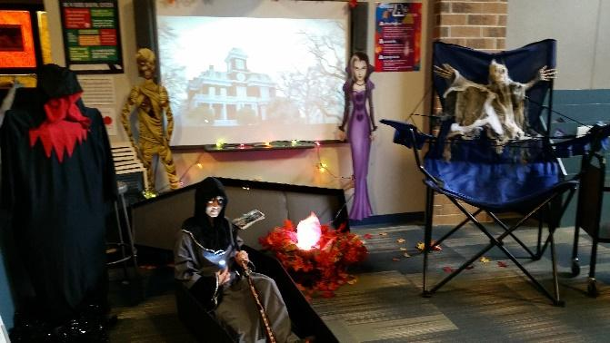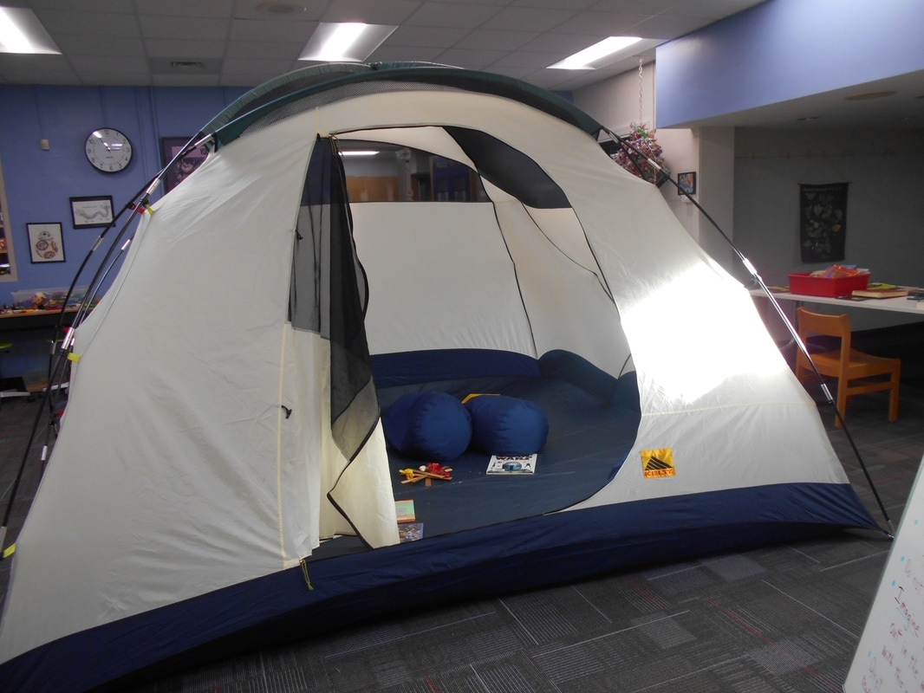
Targets
Students will...
- learn facts about Halloween and share past experiences.
- make a connection to a real camp out.

Procedures
(Lower & Upper Elementary)
Dress in a fun or scary costume to get kids excited about Halloween. If you can put up a tent for the week, allow students to sit in a tent or around the campfire for the lesson. Present Halloween fun facts through images and videos, like History.com’s Halloween Bet You Didn’t Know. Share ghost stories around the campfire, including The Legend of The Jersey Devil read by flashlight. (I copied the text in the book and created a long scroll out of it to read from.) Hide the bones of Mother Leeds, the Jersey Devil’s mom, in the bookshelves or other areas in the library. Tell the children if they can find all the bones and recreate Mother Leeds, the Jersey devil can finally be put to rest. Provide small flashlights for the students to search with. (You can alter this activity to instead locate various items or papers, utilizing a Dewey Decimal Hunt, etc.) During the bone hunt and book check out have a fun video playing such as, Dr. Seuss' movie Halloween Grinch's Night and select books to check out.

Materials
- Halloween decorations
- Tent and electric campfire
- Flashlights
- Plastic skeleton bones
- The Legend of The Jersey Devil by Trinka Hakes Noble
- YouTube Videos
Learning Standards
AASL - 3.2.3 Demonstrate teamwork by working productively with others.
AASL - 3.2.2 Show social responsibility by participating actively with others in learning situations and by contributing questions and ideas during group discussions.
AASL - 4.1.5 Connect ideas to own interests and previous knowledge and experience.
AASL- 3.3.2 Respect the differing interests and experiences of others, and seek a variety of viewpoints.
AASL - 1.1.2 Use prior and background knowledge as context for new learning.

Resources
Foster, G. (2012, May 14) The Grinch’s Halloween night [Video file]. https://www.youtube.com/watch?v=ygSEkwRCQPM
History.com. (2013, October, 30). Bet You Didn’t Know Halloween. [Video file]. Retrieved from http://www.history.com/topics/halloween/history-of-halloween/videos/bet-you-didnt-know-halloween

#8 The Little Old Lady who wasn’t Afraid of Anything
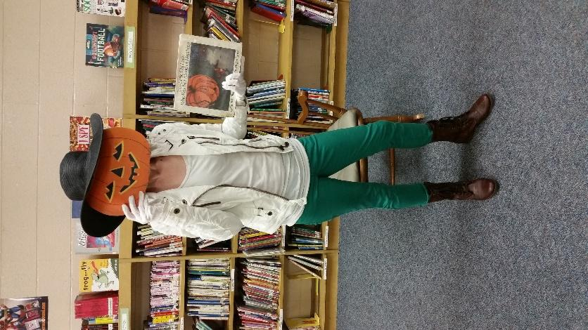
Targets
Students will…
- experience repetition.
- actively participate in storytime.
- draw conclusions from story elements.

Procedure
(Lower Elementary)
Dress up in similar clothing to the little old lady or the scarecrow in the story. (You can also have a special guest dress up as a scarecrow and surprise the students at the end of the story.) Turn the lights down and have students gather around the lantern for storytime. Read the Little Old Lady who wasn’t Afraid of Anything by Linda D. Williams, stopping after each page that has a clothing item following her. During the pause, hand two students mini flashlights and send them into the bookshelves to find the matching clothing item to the story. (Prior to class, you can attach velcro, magnets, or such to the back of each item and have a board to reassemble the pieces. You may also choose to just lay the found pieces on the floor in front of the students as they find them.) Encourage the students to repeat the chant throughout the storytelling...clomp, clomp, wiggle, wiggle, shake, shake, clap, clap. Before turning to the last page, ask for guesses of what they have assembled (Answer: A scarecrow). Allow the students to use the flashlights to search for their books to check-out.
Materials
- Halloween decor
- Old lady or scarecrow outfit
- Book, The Little Old Lady who wasn’t Afraid of Anything by Linda D. Williams
- Cut-outs of clothing items, pumpkin face, etc.
- Lantern, mini flashlights
Learning Standards
AASL1.1.2 Use prior and background knowledge as context for new learning.
AASL 1.1.6 Read, view, and listen for information presented in any format (e.g., textual, visual, media, digital) in order to make inferences and gather meaning.
AASL 2.2.3 Employ a critical stance in drawing conclusions by demonstrating that the pattern of evidence leads to a decision or conclusion.
AASL 2.3.1 Connect understanding to the real world.

#9 Who Would Win?
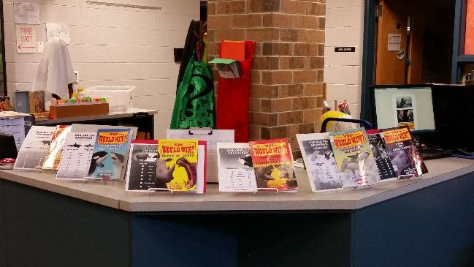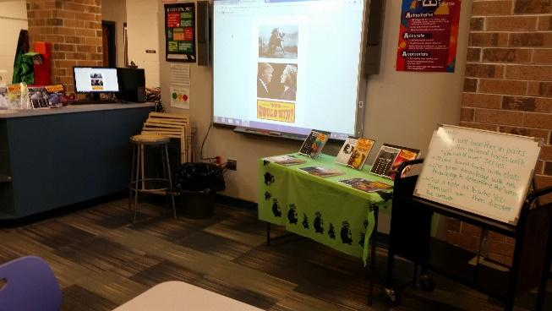
Targets
Students will:
- use prior knowledge.
- learn and compare animal facts/traits.
- participate in a partner share.

Procedures
(Lower & Upper Elementary)
Discuss the importance in having a voice, a right to freedom of opinions and to vote in preparation of the upcoming election. Have images of animals on the smartboard and discuss the battles that have gone on between animals since the beginning of time. Students will pair up to read a book from Jerry Pallotta Who Would Win? book series. Give each team a xerox copy of the checklist to their correlating book and a clipboard (if they are not working at the tables). They will use their handout to check off the winning animal in each category and also to write a few fun facts about their animal. Students will have a group discussion and share their assigned animal's facts/traits. All students will use their new knowledge to vote on which animal would win by a show of hands. After each pair's votes are complete, the partners will reveal which animal would win.
Materials
- Who Would Win? Books
- Copies of checklist in the back of each book
- Clipboards
- Pencils

Learning Standards

AASL - 1.1.6 Read, view, and listen for information presented in any format (e.g., textual, visual, media, digital) in order to make inferences and gather meaning.
AASL - 3.2.2 Show social responsibility by participating actively with others in learning situations and by contributing questions and ideas during group discussions.
AASL - 2.4.3 Recognize new knowledge and understanding.
AASL - 3.1.3 Use writing and speaking skills to communicate new understandings effectively.
AASL - 2.2.3 Employ a critical stance in drawing conclusions by demonstrating that the pattern of evidence leads to a decision or conclusion.
AASL - 1.1.2 Use prior and background knowledge as context for new learning.
AASL - 4.2.3 Maintain openness to new ideas by considering divergent opinions, changing opinions or conclusions when evidence supports the change, and seeking information about new ideas encountered through academic or personal experiences.
AASL - 2.1.3 Use strategies to draw conclusions from information and apply knowledge to curricular areas, real world situations, and further investigations

#10 One Vote, Two Vote, I Vote, You Vote
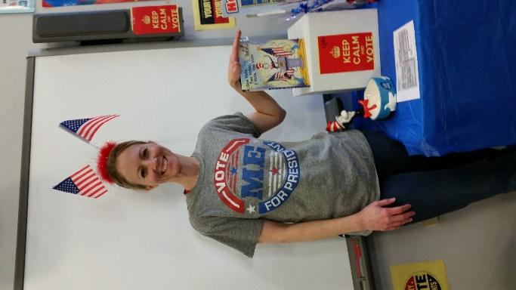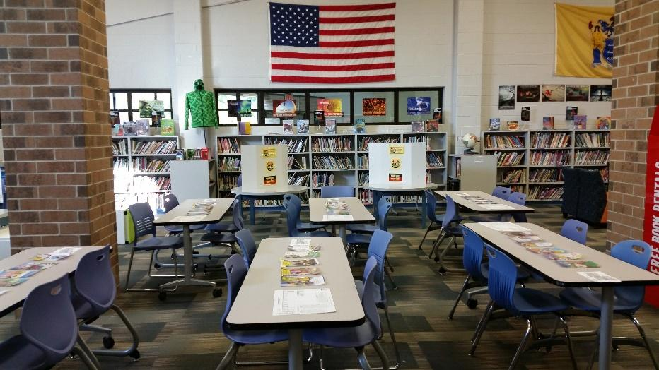
Targets
Students will...
- understand our freedoms, right to vote and the election process.
- define associated terms.
- cast an educated vote.
Procedures
Dress up in patriotic attire. Xerox the pages from Dr. Seuss's book, One Vote, Two Votes, I Vote, You Vote that have words, then number and laminate them. All students (unless a student is uncomfortable with reading aloud) will receive at least one numbered page to read aloud. After the story is read, ask follow-up questions and for definitions to various election-related words. Watch a video about electoral votes at https://www.youtube.com/watch?v=W9H3gvnN468. Show students a sample ballot and voter’s registration form. Have students take turns going into one of the voters’ booths to cast votes for President of the United States, President of the School, President of the Class, or whatever election categories you choose. Votes will be tallied by grade level and results will be posted at the completion of the week.
Materials
- Red, white & blue décor and outfit
- Dr. Seuss' book, One Vote, Two Votes, I Vote, You Vote by Bonnie Worth
- Laminated copies of the pages
- Does your vote count? The Electoral College explained video
- Tri-fold cardboard presentation boards
- Ballot boxes
- Ballots
Learning Standards:
AASL - 2.4.1 Determine how to act on information (accept, reject, modify).
AASL - 2.3.3 Use valid information and reasoned conclusions to make ethical decisions.
AASL - 3.3.3 Use knowledge and information skills and dispositions to engage in public conversation and debate around issues of common concern.
AASL - 3.1.5 Connect learning to community issues.
AASL - 1.1.6 Read, view, and listen for information presented in any format (e.g., textual, visual, media, digital) in order to make inferences and gather meaning.
AASL - 3.2.2 Show social responsibility by participating actively with others in learning situations and by contributing questions and ideas during group discussions.
AASL - 3.3.6 Use information and knowledge in the service of democratic values.
AASL - 3.3.1 Solicit and respect diverse perspectives while searching for information, collaborating with others, and participating as a member of the community.
AASL - 3.3.5 Contribute to the exchange of ideas within and beyond the learning community.
AASL - 3.3.2 Respect the differing interests and experiences of others, and seek a variety of viewpoints.
AASL - 2.2.3 Employ a critical stance in drawing conclusions by demonstrating that the pattern of evidence leads to a decision or conclusion.
AASL - 1.1.2 Use prior and background knowledge as context for new learning.
Social Studies (2009) 6.1.04.A.2 Explain how fundamental rights guaranteed by the United States Constitution and the Bill of Rights (i.e., freedom of expression, freedom of religion, the right to vote, and the right to due process) contribute to the continuation and improvement of American democracy.
Social Studies (2009) 6.1.04.A.7 Explain how the United States functions as a representative democracy, and describe the roles of elected representatives and how they interact with citizens at local, state, and national levels

Resources
Christina Greer. Does your vote count? The Electoral College explained [Video file]. Retrieved from https://www.youtube.com/watch?v=W9H3gvnN468

Sample Ballot:
Official Samuel Mickle Election Ballot

Democratic Party Hillary Clinton/Tim Kane

Republican Party Donald Trump/Mike Pence

Libertarian Party Gary Johnson/Bill Weld

Samuel Mickle Party Mrs. Ligameri/Mickey Mouse

Dr. Seuss’s Party Cat in the Hat/Thing 1

Write in _______________________________________

#11 Thank You, Sarah
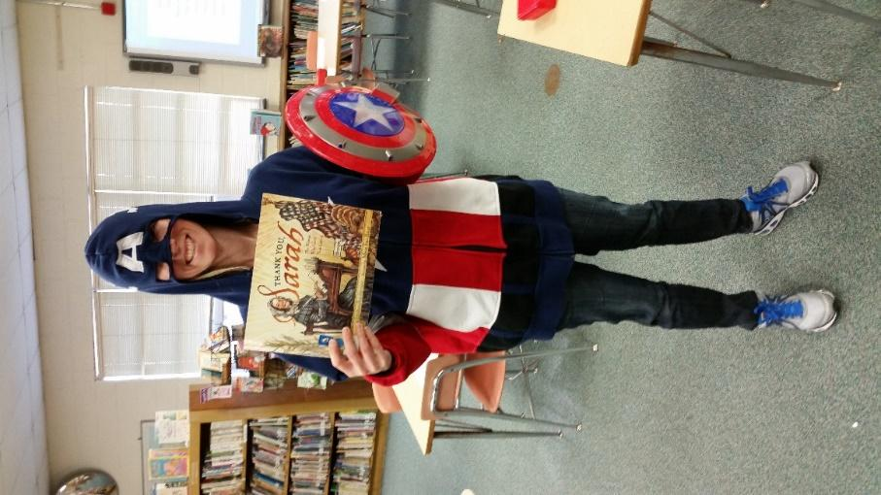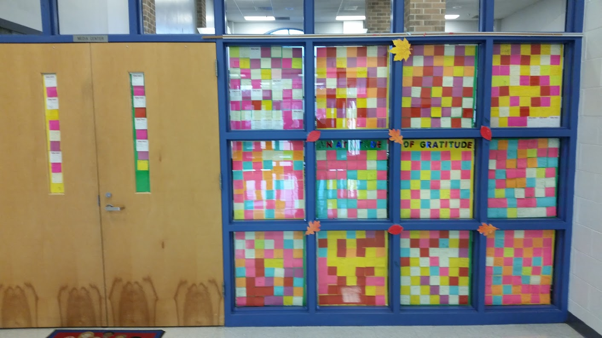
Targets
Students will:
- learn fun facts about Thanksgiving.
- be introduced to Sarah Hale.
- explore the events that took place during the Sarah’s journey.
- show gratitude.
- write a letter to request school improvements.
Procedure
(Lower elementary)
Dress up like a superhero. Discuss the First Thanksgiving and what Thanksgiving means to the students. Allow students to take turns reading from the book, Thank you, Sarah. During the reading, pause to discuss various historical events and people (civil war, presidents, etc.) Review Sarah Hale's accomplishments and perseverance (promoting women's education, being a writer, an activist, etc.). Students will write something they are thankful for on a post-it note to be posted in the front window's "Attitude of Gratitude Wall." Students will check out books, then pen a respectful letter to administration about changes/improvements they would like in school.

Materials
- Superhero costume
- Thank you, Sarah book by Laurie Halse
- Post-it notes
- Paper for student letters

Learning Standards
AASL 3.2.2 Show social responsibility by participating actively with others in learning situations and by contributing questions and ideas during group discussions.
AASL 4.4.1 Identify own areas of interest.
AASL 4.1.5 Connect ideas to own interests and previous knowledge and experience.
AASL 4.1.1 Read, view, and listen for pleasure and personal growth.
AASL 4.2.4 Show an appreciation for literature by electing to read for pleasure and expressing an interest in various literary genres.
AASL 4.1.4 Seek information for personal learning in a variety of formats and genres.
AASL 4.4.2 Recognize the limits of own personal knowledge.
AASL 1.3.4 Contribute to the exchange of ideas within the learning community.
AASL 1.1.2 Use prior and background knowledge as context for new learning.
Social Studies (2009) 6.1.04.A.1 Explain how rules and laws created by community, state, and national governments protect the rights of people, help resolve conflicts, and promote the common good.
Social Studies (2009) 6.1.04.D.15 Explain how various cultural groups have dealt with the conflict between maintaining traditional beliefs and practices and adopting new beliefs and practices.

#12 Balloons over Broadway, The Macy’s Thanksgiving Parade
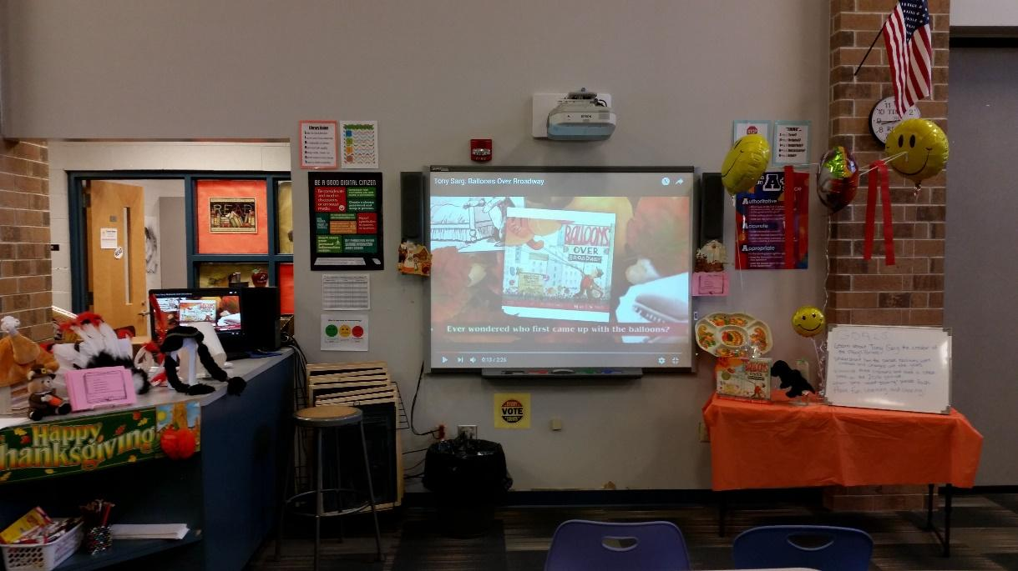
Targets
Students will...
- learn about the creator/designer of the Macy's Thanksgiving parade, Tony Sarg.
- understand the development and changes of the balloons/floats used in the parade over the past 90 years.

Procedure
(Lower & Upper elementary)
Discuss the traditions associated with Thanksgiving, include the Macy’s parade and the man who started it all, Tony Sarg. Watch the Tony Sarg's Balloons over Broadway book trailer (links are below). Then show the book reading of Tony Sarg's Balloons over Broadway from a youtube video. Next watch the preview of this year’s parade. Have a group discussion to answer any questions or allow students to share their related stories. Play last year’s parade video while students check out books. (See resources and links below)
* If there is extra time:
Lower elementary students can use blank paper to design their own balloons for the parade.
Upper elementary can work together to decorate mylar balloons with streamers, paper, foam shapes, etc. for balloon creations to display in the library.

Materials
- Thanksgiving decor
- Balloons
- Book, Tony Sarg's Balloons over Broadway by Melissa Sweet
- Blank paper
- Streamers, foam shapers, ribbon, etc.
Standards
AASL 2.1.4 Use technology and other information tools to analyze and organize information.
AASL 1.1.6 Read, view, and listen for information presented in any format (e.g., textual, visual, media, digital) in order to make inferences and gather meaning.
AASL 4.1.1 Read, view, and listen for pleasure and personal growth.
AASL 4.3.2 Recognize that resources are created for a variety of purposes.
AASL 4.2.1 Display curiosity by pursuing interests through multiple resources.
AASL 1.3.4 Contribute to the exchange of ideas within the learning community.
AASL - 1.1.2 Use prior and background knowledge as context for new learning.
Resources
Cyouel. (2014, November 15). Tony Sarg: Balloons over Broadway [Video file]. Retrieved from https://www.youtube.com/watch?v=DYQ1KPeBOzs

Fourcade, J. (2015, November 9). Balloons over Broadway by Melissa Sweet. [Video file]. Retrieved from https://www.youtube.com/watch?v=AMsYLtOVh2A

History. (2014, November 20). History of the Thanksgiving Day Parade [Video file]. Retrieved from https://www.youtube.com/watch?v=9kubRyY9b_w

Popsugar Girls’ Guide. (2016). 7 Mind-Blowing Facts about The Macy's Thanksgiving Day Parade | Find Your Happy [Video file]. Retrieved from https://www.youtube.com/watch?v=nZM4rl0SsXM

Cooper, P. and Carlin, K. (2016, November 24). Macy’s Thanksgiving Day Parade balloons are inflated [Video file]. Retrieved from
http://www.salon.com/2016/11/24/watch-macys-thanksgiving-day-parade-floats-come-to-life/
Marr, J. (2016, November 24). Entire 2016 Macy’s Thanksgiving Day Parade [Video file]. Retrieved from https://www.youtube.com/watch?v=RkCbUZR7Tpk

#13 Finding Winnie
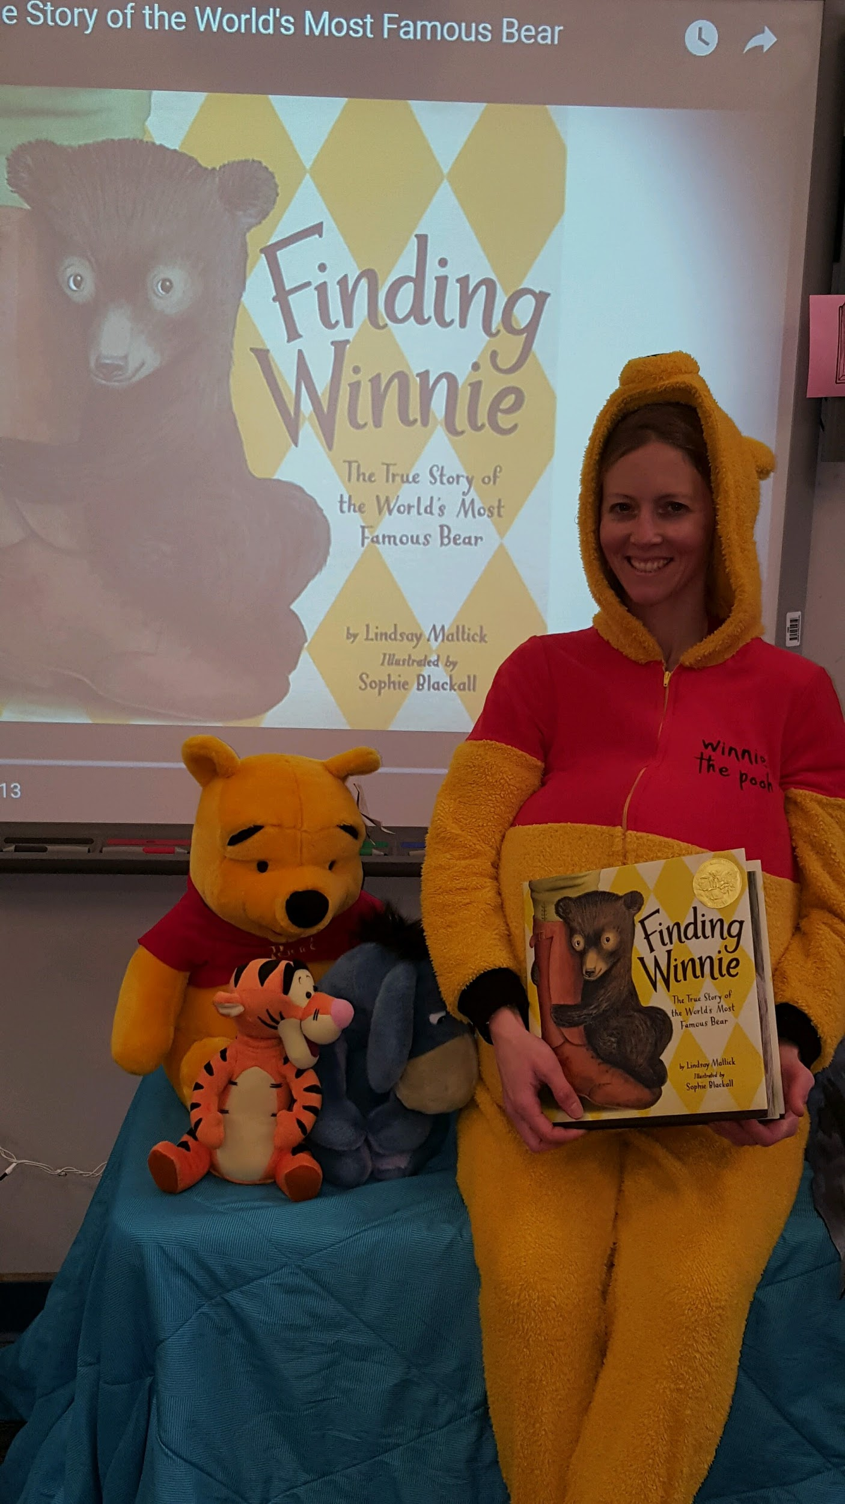

Targets:
Students will...
- understand that Winnie-the-Pooh was a real bear.
- discover the life-lines and timelines of Winnie the bear and his owner, Captain Harry Colebourn.
- explain the events that took place in the time period, including war.

Procedures
(Lower & Upper elementary)
Dress up like Winnie-the-Pooh (or wear Winnie ears). Cover a table with a blanket, pillow and stuffed Winnie and friends. Play a Winnie-the-Pooh music video https://www.youtube.com/watch?v=C7JvP-iL0tE as students enter the library. Read Finding Winnie book https://www.youtube.com/watch?v=8uGejnaFSRw (for lower grades) or play the video of it being read on the Smartboard (for upper grades). Show a youtube video of an interview with Lindsay Mattick (great-great granddaughter and author) Finding Winnie: The true story behind Canada's famous bear https://www.youtube.com/watch?v=UQEqu9p7qvA
*(Option to expand the lesson to include developing family trees, World War I topics, etc.)
Materials
- Winnie-the-Pooh costume
- Pillow pets, Winnie decor, pillow and a blanket
- Book, Finding Winnie Book by Lindsay Mattick
- Youtube videos

Standards
AASL 1.1.6 Read, view, and listen for information presented in any format (e.g., textual, visual, media, digital) in order to make inferences and gather meaning.
AASL 3.1.2 Participate and collaborate as members of a social and intellectual network of learners.
AASL 4.1.1 Read, view, and listen for pleasure and personal growth.
AASL 4.1.4 Seek information for personal learning in a variety of formats and genres.
AASL 1.3.4 Contribute to the exchange of ideas within the learning community.
AASL 1.1.2 Use prior and background knowledge as context for new learning.
AASL 1.2.2 Demonstrate confidence and self-direction by making independent choices in the selection of resources and information.

Resources
CTV News. (2015, October 20). Finding Winnie: The true story behind Canada's famous bear [Video file]. Retrieved from https://www.youtube.com/watch?v=UQEqu9p7qvA

Galbread, D. (2014, September 13). Winnie the Pooh theme song [Video file]. Retrieved from https://www.youtube.com/watch?v=C7JvP-iL0tE

StoryTeller. (2016, March 21). Finding Winnie [Video file]. Retrieved from https://www.youtube.com/watch?v=8uGejnaFSRw

#14 Ivan the Remarkable True Story of the Shopping Mall Gorilla
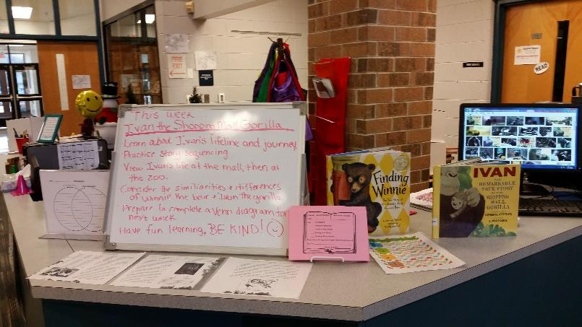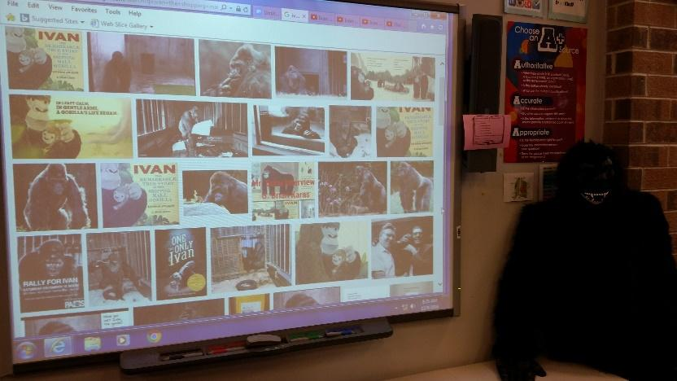
Targets
Students will...
- understand Ivan was a real gorilla that was kept in a shopping mall.
- discover the life-lines and timeline of Ivan.
- gather new and recall past information.
Procedures
(Lower & Upper elementary)
Wear a gorilla costume, or just use it as a prop. Discuss Ivan the shopping mall gorilla’s five main life events to assist students with their activity.
- Ivan was born in a jungle.
- Ivan and another gorilla were captured and taken from the jungle.
- The gorillas were shipped across the world, shortly after arriving the little girl gorilla died.
- Ivan was raised like a real child for a few years, then put in a shopping mall when he was getting too big.
- After many years, Ivan was sent to a zoo.
Have the pages of the story book that you copied spread across three tables, not in order. Put an online timer on, and time students working together as they resequence the story. Keep a record of times to post the winning classes. Once they have reconstructed the story in order, each student can stand behind a page and read the story aloud to the class. (Any students not wanting to read are asked to stand quietly nearby and listen.) Then show two Youtube videos, one while Ivan is still living in the shopping mall https://www.youtube.com/watch?v=fCuFU2RdUGc and one when he is living at the Atlanta Zoo https://www.youtube.com/watch?v=FF1oWHL-lSs. Students will work in small groups to complete a Venn diagram comparing Winnie the Pooh and Ivan the shopping mall gorilla.

Materials
- Gorilla costume
- Ivan the Shopping Mall Gorilla and Ivan the One and Only book
- Laminated copies of the story pages
- 2 Youtube videos: 1 real-life footage of Ivan in the shopping mall, 1 real-life footage of Ivan in the Atlanta Zoo.
- Venn diagram worksheets

Standards
AASL 1.1.6 Read, view, and listen for information presented in any format (e.g., textual, visual, media, digital) in order to make inferences and gather meaning.
AASL 2.1.5 Collaborate with others to exchange ideas, develop new understandings, make decisions, and solve problems.
AASL 1.1.9 Collaborate with others to broaden and deepen understanding.
AASL 1.1.2 Use prior and background knowledge as context for new learning.
AASL 2.1.2 Organize knowledge so that it is useful.
Resources
Applegate, K. (2011, December 30). Ivan the One and Only Book Trailer [Video file]. Retrieved from https://www.youtube.com/watch?v=UtPdqV2crQ0

argofilms. (2014, March 28). Ivan the gorilla lived alone in a shopping mall for over 20 years (The Urban Gorilla) [Video file]. Retrieved from https://www.youtube.com/watch?v=OYYL2LxotA8

Google images. (2016) Ivan the Gorilla. Retrieved from
https://www.google.com/search?q=ivan+the+shopping+mall+gorilla&safe=strict&biw=1328&bih=819&source=lnms&tbm=isch&sa=X&sqi=2&pjf=1&ved=0ahUKEwj64PzymefQAhWIOCYKHQ3YDIYQ_AUIBygC&dpr=0.75

Online-Stopwatch.com Stop watch. Retrieved from http://www.online-stopwatch.com/large-stopwatch/

Tacoma News Tribune. (2016, February 5). Ivan the beloved gorilla [Video file]. Retrieved from https://www.youtube.com/watch?v=fCuFU2RdUGc
Zoo Atlanta. (2012, August 20). Ivan the Gorilla in the zoo [Video file]. Retrieved from https://www.youtube.com/watch?v=FF1oWHL-lSs

#15 The Carpenter’s Gift—The Rockefeller Tree
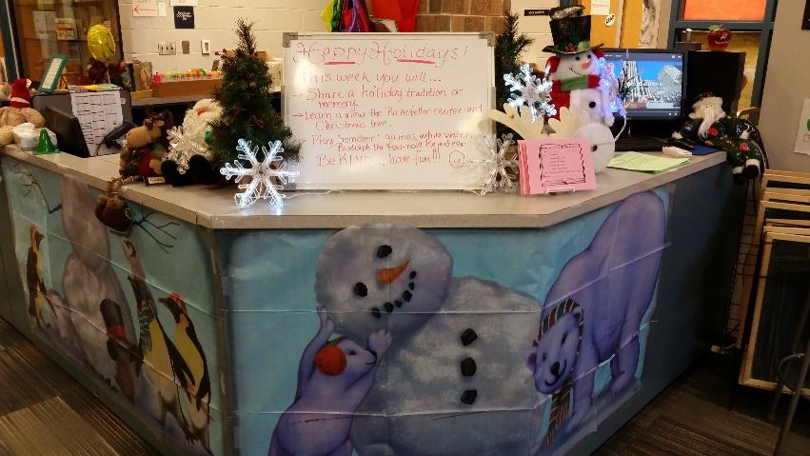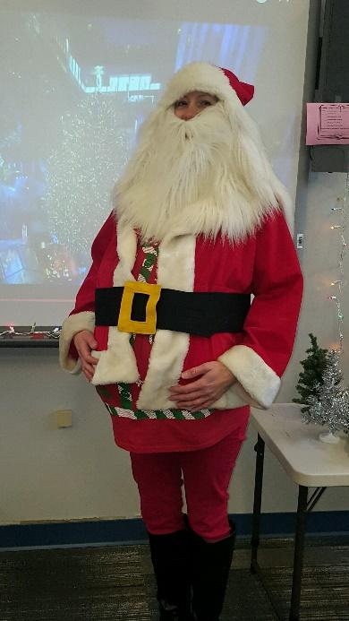
(Lower elementary)
Targets
Students will...
- understand gratitude and making a difference through the reading of The Carpenter's Gift story book.
- learn the history of the Rockefeller Center tree.
- work well together in building challenges.Procedure
Dress up like Santa or any holiday attire. Discuss the history of the Rockefeller Center Christmas tree. Read The Carpenter's Gift book. Afterward watch a few videos that show the selection, transportation, decorating and lighting of the annual Rockefeller Christmas Tree https://www.youtube.com/watch?v=4OgEKbGo00Q and https://www.youtube.com/watch?v=bDH4KbyuxfM. Have students write down a list of books they would like as presents for the upcoming holidays. Direct students to read the various fun facts about the Rockefeller tree posted around the room as they select books to check out. Allow students to play various “reindeer” games together. Put a yule log fireplace video on during activities and check out.
Materials
- Santa suit or holiday attire
- The Carpenter's Gift book
- Rockefeller Center tree videos
- Printed tree facts pages
- Christmas "book" wish lists worksheet
- Assorted games and activities.
Learning Standards
AASL 3.2.3 Demonstrate teamwork by working productively with others.
AASL 1.1.6 Read, view, and listen for information presented in any format (e.g., textual, visual, media, digital) in order to make inferences and gather meaning.
AASL 3.2.2 Show social responsibility by participating actively with others in learning situations and by contributing questions and ideas during group discussions.
AASL 4.4.1 Identify own areas of interest.
AASL 4.1.1 Read, view, and listen for pleasure and personal growth.
AASL 2.4.3 Recognize new knowledge and understanding.
AASL 3.1.3 Use writing and speaking skills to communicate new understandings effectively.
AASL 1.1.2 Use prior and background knowledge as context for new learning.
Resources
The Entertainment Channel. (2016, November 30). The Christmas Tree Lighting | Christmas in Rockefeller Center 2016 [Video file]. Retrieved from https://www.youtube.com/watch?v=4OgEKbGo00Q

The Museum of War. (2012, December 11). Rudolph the Red Nosed Reindeer song [Video file]. Retrieved from https://www.youtube.com/watch?v=mfWH2AVSrww

Today. (2016, November 10). First Look At The 94-Foot Rockefeller Center Christmas Tree [Video file]. Retrieved from https://www.youtube.com/watch?v=bDH4KbyuxfM

#16 Rockefeller Christmas Tree
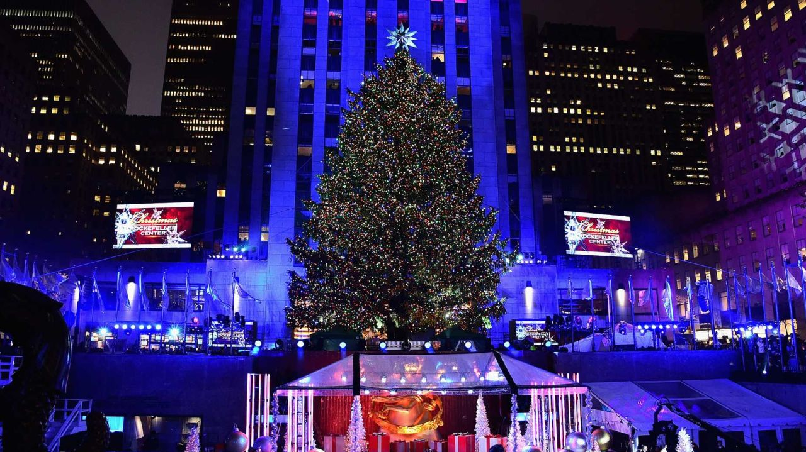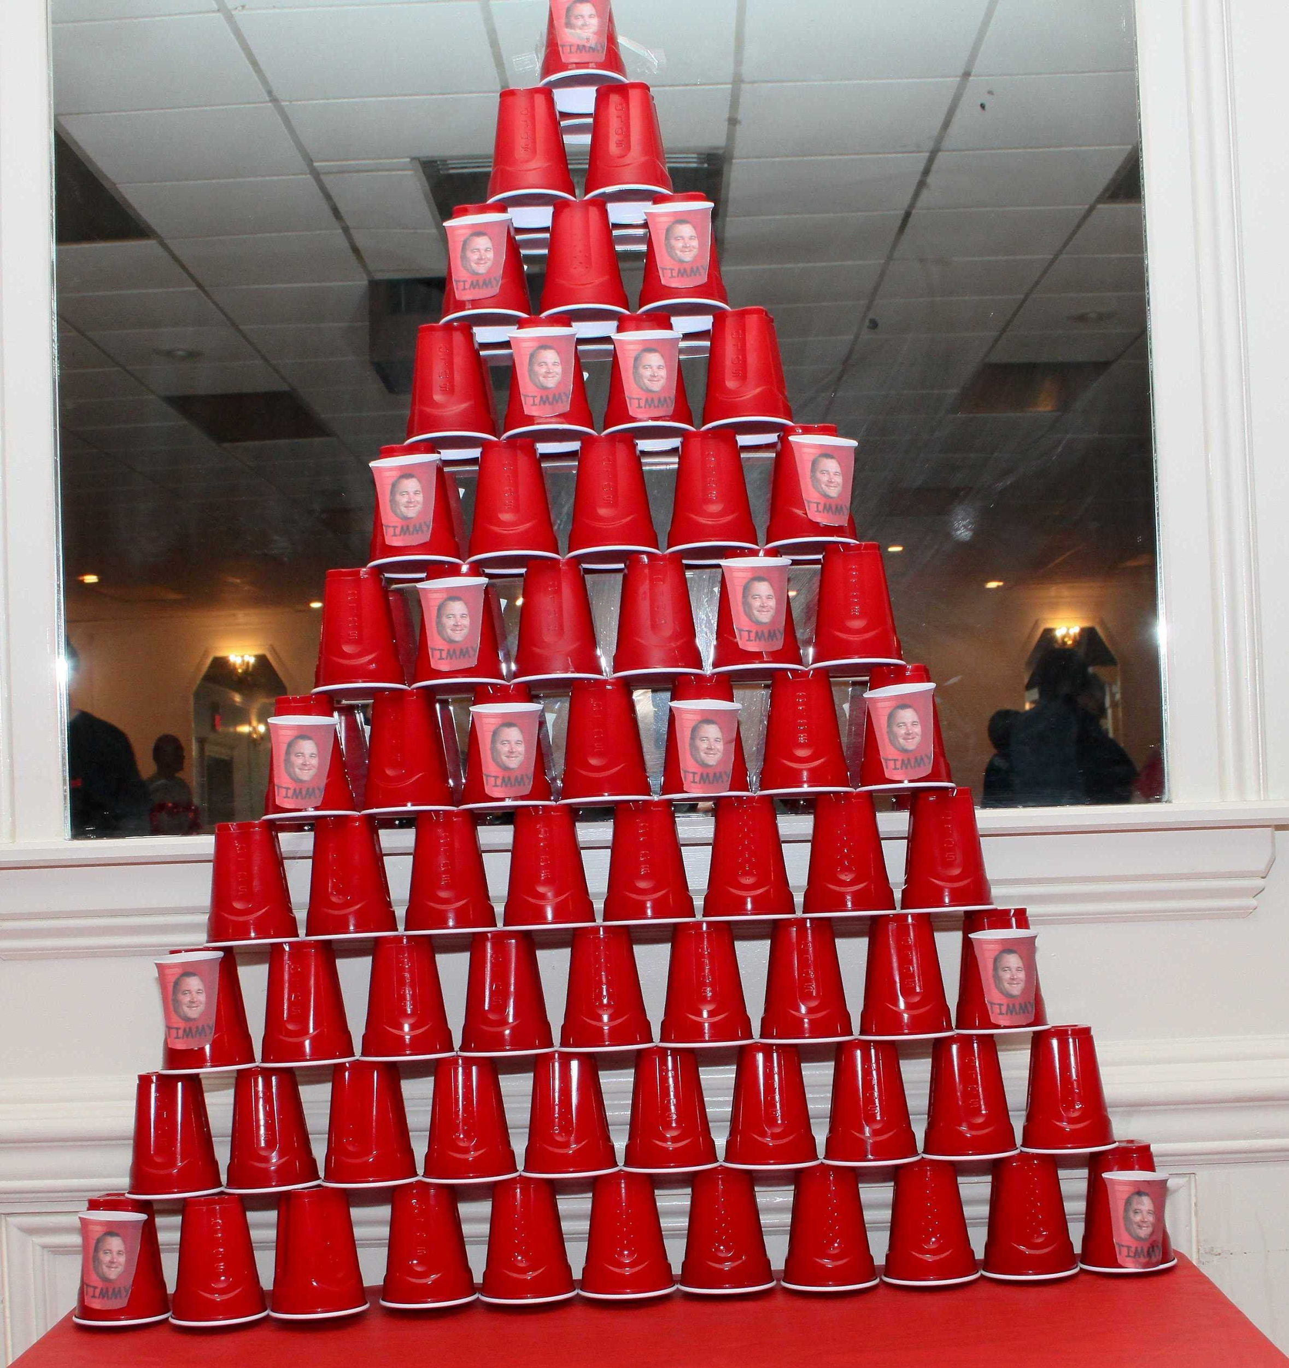

(Upper elementary)
Targets
Students will...
- recall their favorite holiday traditions.
- understand the history of the Rockefeller Center tree.
- work well together in a red cup tree building competition.
Procedure.
Dress up like Santa or in any holiday attire. Allow time for the students to each share their holiday traditions. Watch a video about the history of the Rockefeller Center and another about Christmas tree. Have each student stand by a fun facts about the Rockefeller tree posted around the room. Then instruct students to write down a list of books they would like as presents for the upcoming holidays as they select books to check out. Allow students to get into groups for a tree building contest that uses red plastic cups. Allow time for students to check-out books. Put a yule log fireplace video on during activities and check out.
- Santa suit or holiday attire
- Rockefeller Center tree videos
- Printed tree facts pages
- Christmas "book" wish lists worksheet
- Red plastic cups, assorted games and activities.

Learning Standards
AASL 3.2.3 Demonstrate teamwork by working productively with others.
AASL 1.1.6 Read, view, and listen for information presented in any format (e.g., textual, visual, media, digital) in order to make inferences and gather meaning.
AASL 3.2.2 Show social responsibility by participating actively with others in learning situations and by contributing questions and ideas during group discussions.
AASL 4.4.1 Identify own areas of interest.
AASL 4.1.1 Read, view, and listen for pleasure and personal growth.
AASL 2.4.3 Recognize new knowledge and understanding.
AASL 3.1.3 Use writing and speaking skills to communicate new understandings effectively.
AASL 1.1.2 Use prior and background knowledge as context for new learning.
Resources
Hallmark Movies & Mysteries. (2015, December 23). A Very Happy Yule Log [Video file]. Retrieved from https://www.youtube.com/watch?v=Ye2gMvRa-iE

McKechnie, N. (2014, May 18). History of NYC Rockefeller center [Video file]. Retrieved from
https://www.youtube.com/watch?v=aDi4WaQYyaw

Stoller-Lindsey, N. (2014, December 15). 18 facts about Rockefeller tree [Video file]. Retrieved from
https://www.thrillist.com/entertainment/new-york/midtown-west/nyc-rockefeller-center-christmas-tree-history

The Entertainment Channel. (2016, November 30). The Christmas Tree Lighting | Christmas in Rockefeller Center 2016 [Video file]. Retrieved from https://www.youtube.com/watch?v=4OgEKbGo00Q

The Museum of War. (2012, December 11). Rudolph the Red Nosed Reindeer song [Video file]. Retrieved from https://www.youtube.com/watch?v=mfWH2AVSrww

Today. (2016, November 10). First Look At The 94-Foot Rockefeller Center Christmas Tree [Video file]. Retrieved from https://www.youtube.com/watch?v=bDH4KbyuxfM

#17 Happy New Year’s!!!

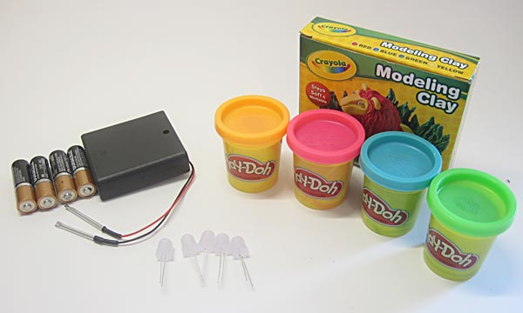
Targets
Students will...
- learn the history of New Year's.
- explore facts about the Annual Ball Drop.
- understand conducting electricity.
Procedures
Decorate the library with New Year’s decor and lights. Adorn yourself with a New Year’s hat, headband, noisemaker or such. Show the students a video about the history of New Year’s. Discuss New Year’s traditions the students have. Share fun facts about the Ball Drop and show an accompanying video. Discuss electricity and the components that make it possible, then show Squishy Circuits with Play-doh video. Roll a ball of dough and allow students to take turns sticking squishy circuits into the play doh. Connect the battery pack wires and light up the New Year’s conductive dough Ball the class created together. Allow time to discuss what New Year’s resolutions are and possible resolutions students want to make after book check-out.
Materials
- New Year's Decor
- New Year’s hats, lights, etc.
- YouTube videos
- Squishy circuits
- Batteries
- Play doh

Standards
AASL 1.1.6 Read, view, and listen for information presented in any format (e.g., textual, visual, media, digital) in order to make inferences and gather meaning.
AASL 3.2.2 Show social responsibility by participating actively with others in learning situations and by contributing questions and ideas during group discussions.
AASL 1.1.9 Collaborate with others to broaden and deepen understanding.
AASL 1.1.2 Use prior and background knowledge as context for new learning.
Science*
Resources
AP Archive. (2015, July 31). Practice for New Year’s Eve ball drop [Video file]. Retrieved from
https://www.youtube.com/watch?v=VhFBZN_s6F0

Business Insider. (2016, December 30). Why do we drop a ball on New Year’s Eve? [Video file]. Retrieved from https://www.youtube.com/watch?v=5OMQCSvVgmc

christmaspoems. (2011, December 6). Auld Lang Syne New Year’s song [Video file]. Retrieved from https://www.youtube.com/watch?v=Eb6d0-Fr1gI

History.com (2013, January 2). Bet you didn’t know New Year’s Eve [Video file]. Retrieved from
http://www.history.com/topics/holidays/new-years

Imagination Station OH. (2013, March 2). Squishy Circuits with Play-doh. Retrieved from https://www.youtube.com/watch?v=L8bvNHhlK30

University of St. Thomas. (n.d.) Squishy circuits. Retrieved from http://courseweb.stthomas.edu/apthomas/SquishyCircuits/conductiveDough.htm

#18 Our Years through Space and Time

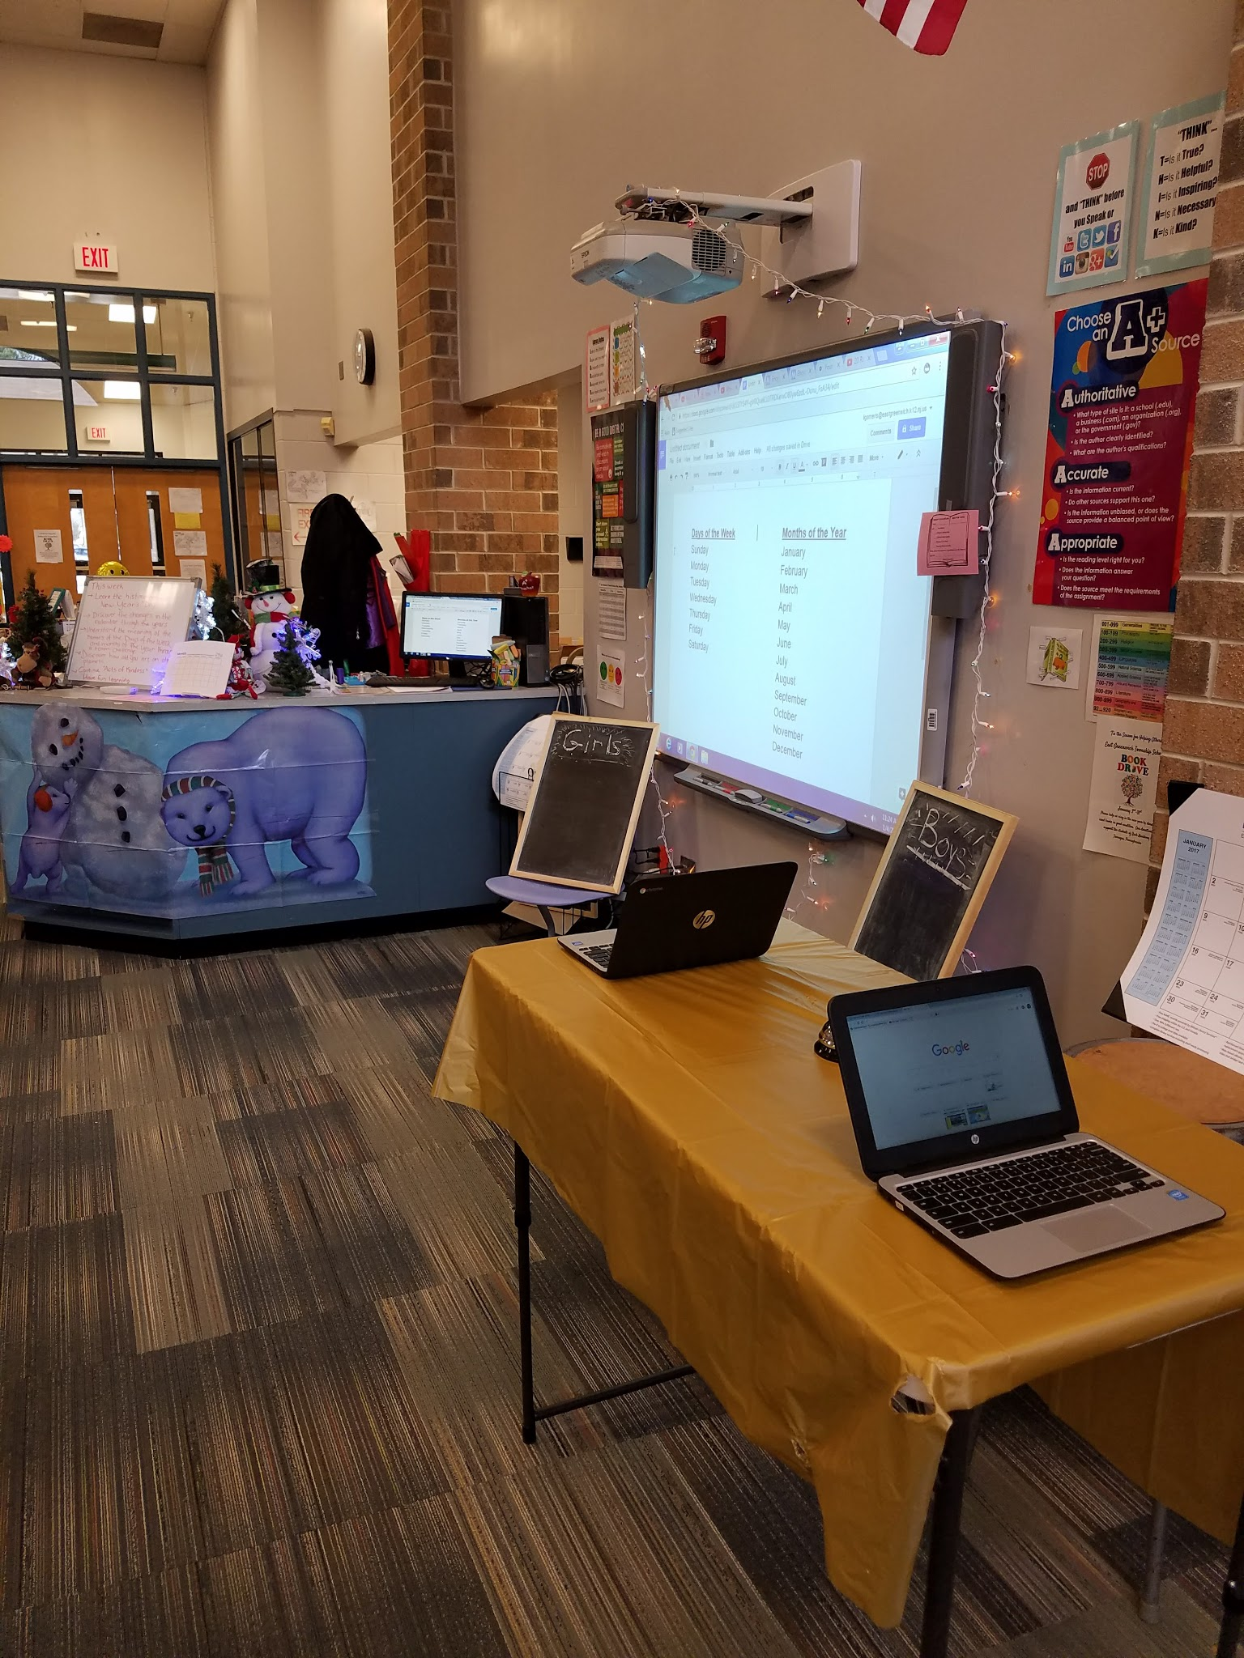
Targets

Students will…

- analyze the calendars from the past.
- understand the meaning of the days' and months' names.
- compare Earth years to those on the other planets.
- propose their own calendar.

Procedures
(Upper elementary)
Have various calendars visible and available for students to look at later. Show the students a video about why we have so many calendars. Discuss various calendars (Julian, Gregorian, Jewish, Islamic, Chinese, etc.) before the group activity. Tell student they are going to have a challenge, boys against the girls. Have two laptops, back to back with a bell next to each. Ask the contestants one question at a time, such as the meaning of the days' and months' names; their origin; what Roman god they were named after, etc. The player that rings the bell and gives the correct answer gets a point for their team. The scorekeeper can put a tally mark on the corresponding chalkboard.
After the competition, show the students a website that will tell your your age of the other planets in days and years, that they can input their own information during book selection time. If there is additional time, students may take a blank printable calendar or draw their own with the days, weeks or year they choose.

Materials
- New Year's Decor
- Globe
- YouTube video
- Chalkboards and chalk
- Calendars
- Blank Calendar worksheet

Standards
AASL 1.1.6 Read, view, and listen for information presented in any format (e.g., textual, visual, media, digital) in order to make inferences and gather meaning.
AASL 3.2.2 Show social responsibility by participating actively with others in learning situations and by contributing questions and ideas during group discussions.
AASL 1.1.9 Collaborate with others to broaden and deepen understanding.
AASL 1.1.2 Use prior and background knowledge as context for new learning.
Resources

Blank Printable Calendar [image] Retrieved on December 15, 2016 from
http://www.printablee.com/postpic/2009/07/kindergarten-blank-calendar-template_256573.jpg

Encyclopedia Mythica. (2007). Origins of the Names of the months
http://www.pantheon.org/miscellaneous/origin_months.html

Encyclopedia Mythica. (2007). Origins of the Names of the week
http://www.pantheon.org/miscellaneous/origin_days.html

Hipschman, R.(2000). Your age on other planets. Retrieved from
https://www.exploratorium.edu/ronh/age/

Newquist, C. (2014, December 9). Happy New Year! Calendar based lesson ideas. Retrieved from http://www.educationworld.com/a_lesson/lesson045.shtml

Seeker Daily. (2016, January 1), Why are there so many calendars [Video file]. Retrieved from
https://www.youtube.com/watch?v=DaLsuZRj9wg

#19 Happy Birthday, Ben Franklin...Celebrating Inventions by Mistake!
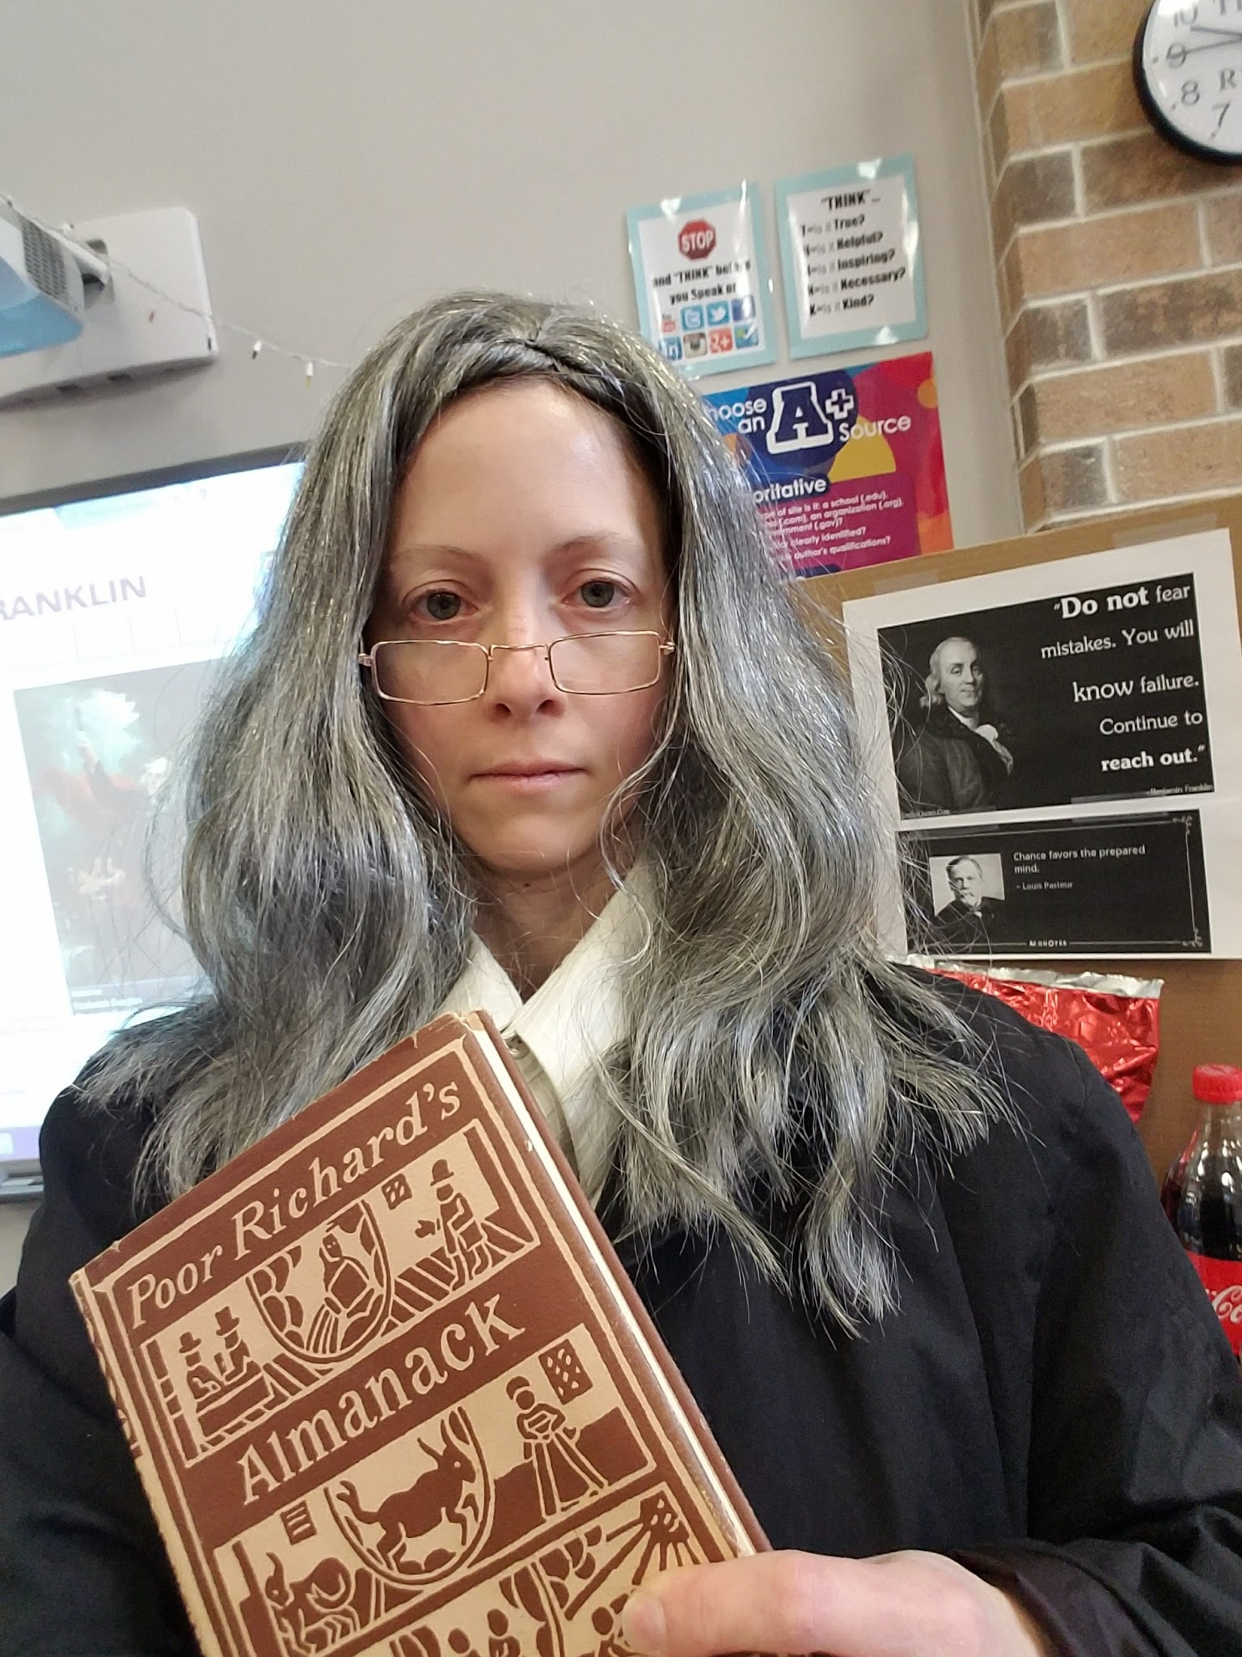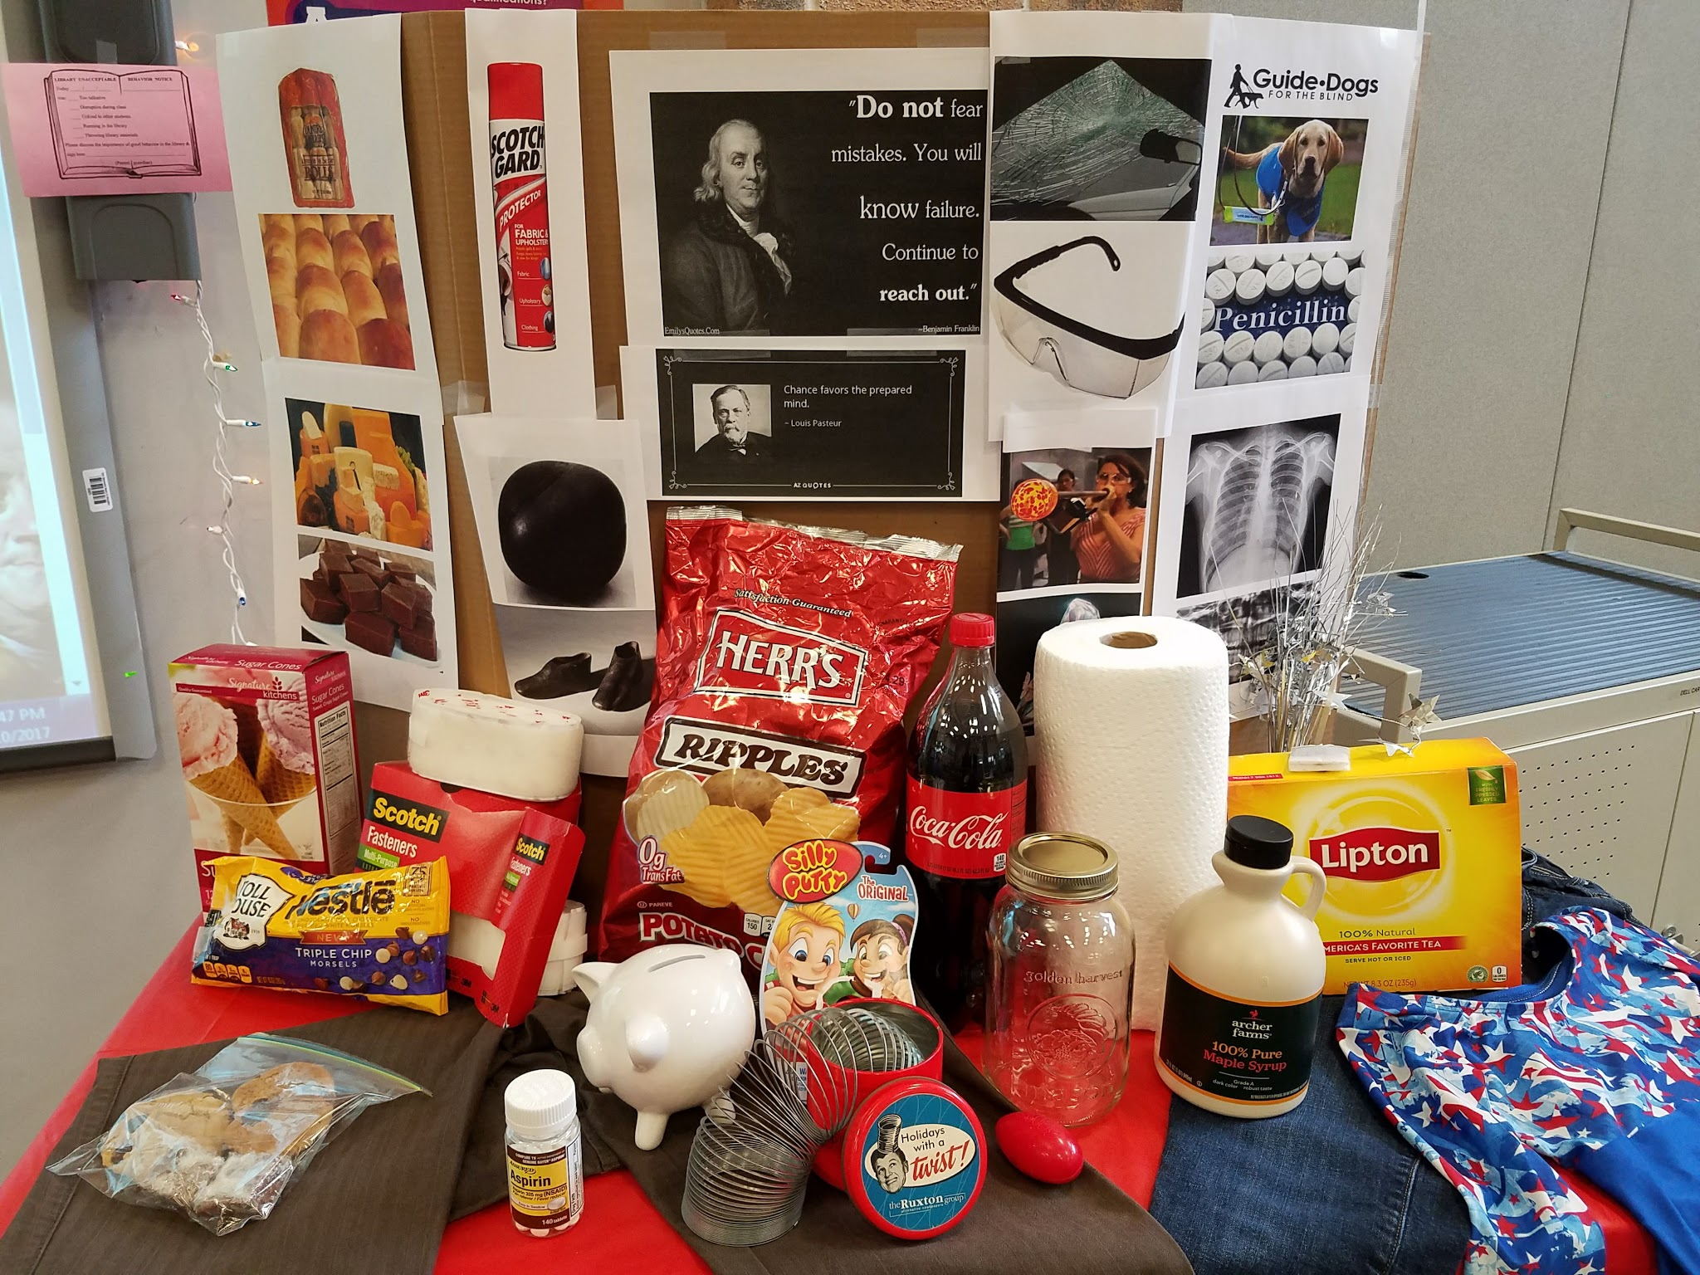
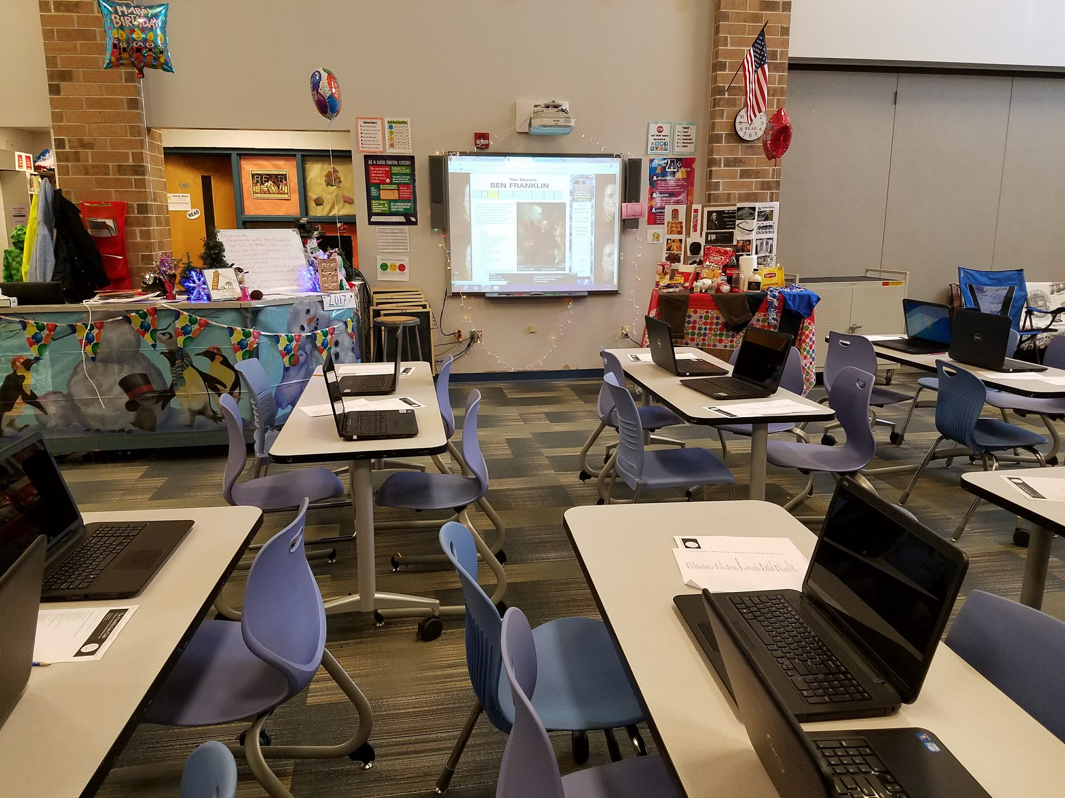
Targets
Students will....
- celebrate Ben Franklin’s birthday and his many accomplishments
- understand some inventions were by mistake.
- learn through partner research facts about mistaken inventions.
Procedures
(upper elementary)
Dress up like Ben Franklin and have the library set up as a birthday party for him. (His birthday is January 12th). Discuss Ben Franklin’s birthday and many accomplishments. Direct the students’ attention to the various products on the front table and ask then what do all the items have in common. After a multiple guesses, discuss how everyone one makes mistakes, famous people and ordinary people alike. Tell them that every wonderful, useful item on the table is here by mistake! Allow student to pair up, then come select one index card. Allow ten minutes for students to research their "invention by mistake," then write important facts about it. Hold a group discussion to share the found information. Allow time for students to check-out books.
Materials
- Ben Franklin costume (or at least glasses)
- Various food items and supplies
- Mistakes that Worked book by Charlotte Foltz Jones
- Index cards with one of the Inventions by Mistake
- Laptops
- Worksheet for research information

Standards
AASL 1.1.4: Find, evaluate, and select appropriate sources to answer questions.
AASL 1.1.6: Read, view, and listen for information presented in any format (e.g., textual, visual, media, digital) in order to make inferences and gather meaning.
AASL1.1.8: Demonstrate mastery of technology tools for accessing information and pursuing inquiry.
AASL 1.1.9: Collaborate with others to broaden and deepen understanding.
AASL 1.3.5: Use information technology responsibly.
AASL 2.2.1: Demonstrate flexibility in the use of resources by adapting information strategies to each specific resource and by seeking additional resources when clear conclusions cannot be drawn.
AASL 3.1.1: Conclude an inquiry-based research process by sharing new understandings and reflecting on the learning.
AASL 3.1.3: Use writing and speaking skills to communicate new understandings effectively.
AASL 3.2.3: Demonstrate teamwork by working productively with others.
Resources
U.S. History.org. (2017). The Electric Ben Franklin. Retrieved from http://www.ushistory.org/franklin/science/

The Franklin Inn. (n.d.) Benjamin Franklin: Achievements & Contributions. Retrieved from
http://thefranklininn.com/history/benjamin-franklin-achievements-contributions/

#20 Now Boarding Air Force One
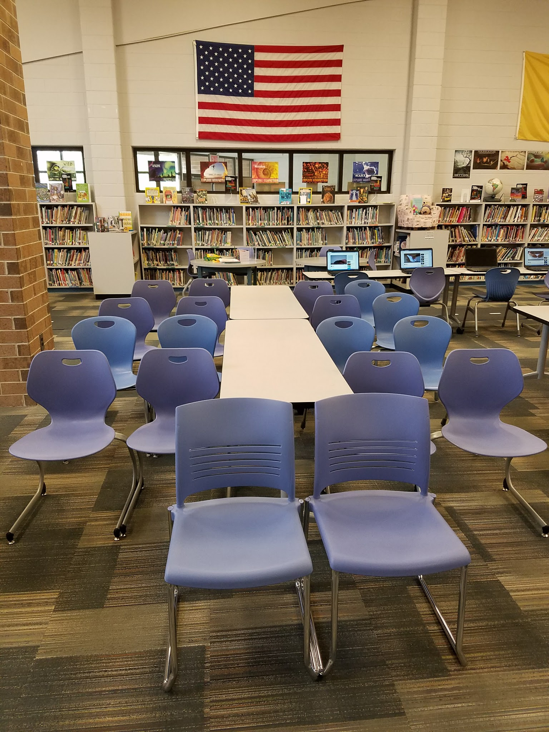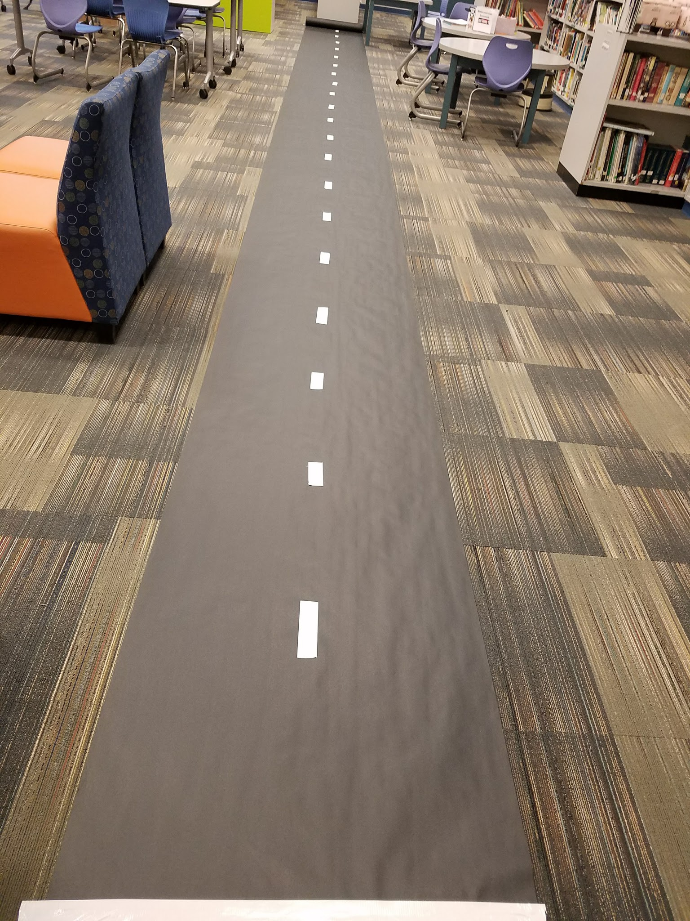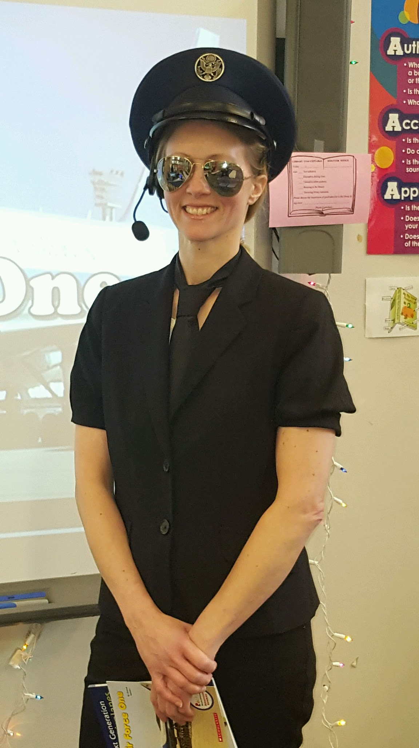
Targets
Students will…
- view and learn about Air Force One.
- be introduced to Nato’s phonetic alphabet.
- discuss aerodynamics.
- create and fly their own paper airplanes.
Procedure
(Lower & Upper elementary)
Set up the chairs in rows together with an empty aisle or tables down the center, as if they were seats on an airplane. Dress up like a pilot (important items are a hat, jacket, sunglasses and heatset). Place all supplies for the lesson or books on a wheeled cart to mimic a stewardess’s cart. Ask the student’s who knows what Air Force One is by a show of hands. Have fun by instructing students on the airplane rules, then tell the students it is time for an onboard movie presentation. Show the students three videos. The first video is on the history of the first president’s planes (I only showed the first 1 minute and 38 seconds). The second video is ABC news channel’s interview and tour of Air Force One. The last video is 5 fun facts to know about Air Force One.
Then show a short video on a world record paper airplane flight. Afterward allow the students some time to individually or in pairs construct their own paper airplanes. Have a few paper airplane how-to books available or allow students to search how-to videos. Prior to class, roll out a long piece of black bulletin board paper as the runway and add strips of white or yellow tape for lines. Let each student have one flight attempt. Whoever flies their plane the furthest gets to write his or her name on the Captain’s Top Flight List posted on the wall.
(Optional-Lower elementary)
Read the book, Air Force One by Joanne Mattern. You may want to have them draw their own design for the next Air Force One and tell them they can turn it into a paper airplane at home and fly it instead.
(Optional-Upper elementary)
If time allows, you can have copies of the Nato phonetic alphabet and aerodynamics definitions to discuss with the students. Encourage them to make their own call name (like Air Force One) or develop secret codes.
Materials
- Air Force, airplane and/or pilot decor
- Videos
- Nato phonetic alphabet, aerodynamics and Top Captain worksheets
- Plain paper
- How-to make paper airplanes books
- Black bulletin board paper
- Yellow or white tape
- Air Force One by Joanne Mattern

Standards
AASL - 1.1.6 Read, view, and listen for information presented in any format (e.g., textual, visual, media, digital) in order to make inferences and gather meaning.
AASL - 2.1.5 Collaborate with others to exchange ideas, develop new understandings, make decisions, and solve problems.
AASL - 4.1.4 Seek information for personal learning in a variety of formats and genres.
AASL - 1.1.2 Use prior and background knowledge as context for new learning.
Science (2009) 5.2.04.E.2 Identify the force that starts something moving or changes its speed or direction of motion.

Resources
*watch until 1:38 minutes
Reading through History. (2016, November 10). What is Air Force One? Retrieved from https://www.youtube.com/watch?v=enPBld3Agm4

abcNEWS. (2015, May 5). Inside Air Force One: Secrets to Presidential Travel. Retrieved from
http://abcnews.go.com/Nightline/video/inside-air-force-secrets-presidential-travel-30806835

The Paper Airplane Guy. (2012, February 27). World Record Paper Airplane Distance.mov. Retrieved from https://www.youtube.com/watch?v=wedcZp07raE

Top5s. (2014, September 13). 5 things to know about Air Force One. Retrieved from
https://www.youtube.com/watch?v=yX3tZCFPbUk

Nato code phonetic alphabet
https://en.wikipedia.org/wiki/NATO_phonetic_alphabet

*Utilize “how-to-make paper airplanes” videos for students to view.

