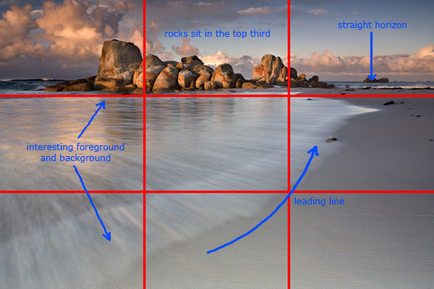
Composition Challenge!

Project: Students will be able to understand how composition is the secret ingredient to making great art. It can make the most boring subject and make it fascinating.

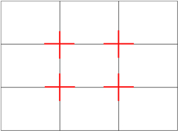
The Rule of Thirds: The basic principle behind the rule of thirds is to imagine breaking an image down into thirds (both horizontally and vertically) so that you have 9 parts. As follows.

As you’re taking an image you would have done this in your mind through your viewfinder or in the LCD display that you use to frame your shot.
With this grid in mind the ‘rule of thirds’ now identifies four important parts of the image that you should consider placing points of interest in as you frame your image.
Not only this – but it also gives you four ‘lines’ that are also useful positions for elements in your photo.
The theory is that if you place points of interest in the intersections or along the lines that your photo becomes more balanced and will enable a viewer of the image to interact with it more naturally.
Studies have shown that when viewing images that people’s eyes usually go to one of the intersection points most naturally rather than the center of the shot – using the rule of thirds works with this natural way of viewing an image rather than working against it.
Now Start your project:

- SET THE STAGE –
Look at various photographers and make a list of compositional strategies to try as you view and discuss the work. Think about filling the picture plane by establishing a focal point, the Rule of Thirds and creating variety.
- TIME TO CREATE! Experiment with placing ordinary objects (paper clips, rubber bands..etc.) in various interesting arrangements and filling the frame of your camera so the COMPOSITION is unique and intriguing. Please take many shots because it takes multiple tries to get a winning shot!
- COLLABORATE To SHARE and REFLECT – After uploading your work form a group of 3 or 4 students to review the work and share what composition they find is the strongest and why.

Standards
TECH.8.1.8.D.CS2, TECH.8.1.8.B.CS2, TECH.8.1.8.C.CS1, TECH.8.1.8.B.CS1, SCI.MS-ETS1-4, TECH.8.1.8.D.CS1, , SCI.MS-ETS1-3, TECH.8.1.8.A.CS2, TECH.8.1.8.A.1, VPA.1.1.8.D.CS1, VPA.1.2.8.A.CS1, VPA.1.2.8.A.3, VPA.1.3.8.D.CS1, VPA.1.3.8.D.1, VPA.1.3.8.D.CS2, VPA.1.3.8.D.2, VPA.1.3.8.D.CS4, VPA.1.3.8.D.CS6, VPA.1.3.8.D.6, VPA.1.4.8.A.CS2, VPA.1.4.8.A.CS6, VPA.1.4.8.A.6, VPA.1.4.8.A.7, VPA.1.4.8.B.CS1, VPA.1.4.8.B.1, VPA.1.4.8.B.2, TECH.8.1.8.D.CS3, , SCI.MS-ETS1-2, TECH.8.1.8.A.CS1
ESSENTIAL QUESTION: How does the operator of the camera arrange their subject to make the composition interesting?
OBJECTIVES: Students will be able to examine various arrangements and experiment takeing photos with the rule of thirds in mind.
MATERIALS: Canon Rebel Student Kits, everyday object
ADAPTATIONS: Redirectives, verbal prompts, one on one instructions, repeated practice, peer instruction, small group instruction, self-paced, repeated demonstrations, adjust difficulties of lessons, Google Speak,
ASSESSMENT: Observation during student discussions, observation of individual progress during project creation, final project rubric, Google Classroom submission

