Beginner Focus Point Project rev 7-12-16 (full auto mode)
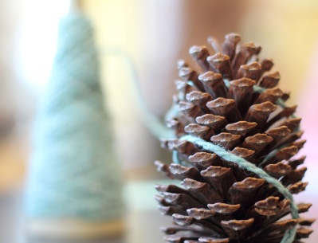

Project: Learning to Select a Specific Focus in Your Photo!

Students will take photographs using a variety of focus points. Objects, such as insects, yarn spools, crayons, pencils, etc, will be photographed. Focusing requires very precise manual focus technique. Choice of focus point can dramatically alter the final photograph, especially with a wide aperture (i.e. 3.2 or lower).

SET Your Camera to the following | When set make a
Lens: 50 MM
Lens: MF (manual focus switch on lens)
Mode Dial: (Full Auto Mode)

Notice how both objects can be seen in both photographs and that the camera doesn’t move.
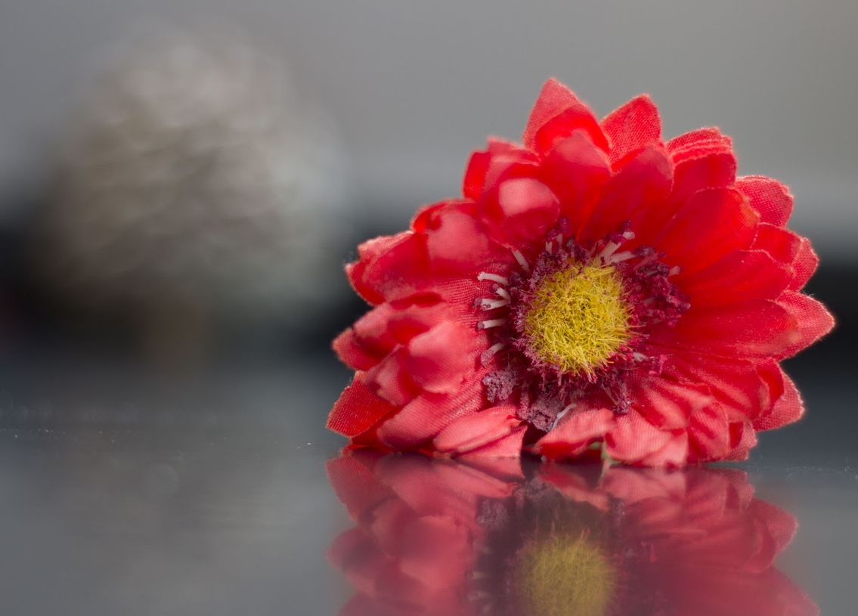
Now it’s time to Photograph!

- Set up two objects in a diagonal pattern. Make sure you can see both objects in the camera’s viewfinder without moving the camera. See diagram and take note of where you and the camera are in relation to the objects:

- Check all camera settings.

- Securely attach your camera to the tripod and leave the strap around your neck. (You can also place the camera on the table top instead of using a tripod)

4. Manually Focus on the object in front. After several shots, (Without
moving the Camera!!) Focus on the object in back. Try to focus on
different points to create different compositions!

5. Please submit two of the best photos (one with front object in focus
and one with back object in focus) using the proper procedure for
submitting your assignments.

Setting Exposure
Setting Shutter Speed: Use the Main Dial to change the Fraction in the upper LHC of the screen.
Setting Aperture: Hold down the AV button while turning the Main Dial (F Value).
Setting ISO: Press the ISO button and use the arrows to select the proper ISO, then press “Set”.
Notice the White Bar is at “0”

Standards
TECH.8.1.8.D.CS2, TECH.8.1.8.B.CS2, TECH.8.1.8.C.CS1, TECH.8.1.8.B.CS1, SCI.MS-ETS1-4, TECH.8.1.8.D.CS1, , SCI.MS-ETS1-3, TECH.8.1.8.A.CS2, TECH.8.1.8.A.1, VPA.1.1.8.D.CS1, VPA.1.2.8.A.CS1, VPA.1.2.8.A.3, VPA.1.3.8.D.CS1, VPA.1.3.8.D.1, VPA.1.3.8.D.CS2, VPA.1.3.8.D.2, VPA.1.3.8.D.CS4, VPA.1.3.8.D.CS6, VPA.1.3.8.D.6, VPA.1.4.8.A.CS2, VPA.1.4.8.A.CS6, VPA.1.4.8.A.6, VPA.1.4.8.A.7, VPA.1.4.8.B.CS1, VPA.1.4.8.B.1, VPA.1.4.8.B.2, TECH.8.1.8.D.CS3, , SCI.MS-ETS1-2, TECH.8.1.8.A.CS1
ESSENTIAL QUESTION: How does the operator of the camera choose and control her focus points?
OBJECTIVES: Students will review basic camera functions learned in past classes, and focus points
MATERIALS: Canon Rebel Student Kits, Tripods
ADAPTATIONS: Redirectives, verbal prompts, one on one instructions, repeated practice, peer instruction, small group instruction, self-paced, repeated demonstrations, adjust difficulties of lessons, Google Speak,
ASSESSMENT: Observation during student discussions, observation of individual progress during project creation, final project rubric, Google Classroom submission

