Where in the World – Unit 7

Title of Unit | Where in the World Are We? | Grade Level | 1st Grade
Subject | Social Studies and ELA | Time Frame | 3rd Term (2-3 weeks)
Developed By | Dina Ciccone and Tracy Dirkes
Stage 1 - Identify Desired Results
Established Goals: CCSS / CCCS / Big Ideas / Big Themes
Concept: Dependence, Independence and Interdependence

Big Ideas: We are all citizens in our world and we all need knowledge of geography and application of geographic skills to ensure we understand relationships between people, their behavior, places and the environment for problem solving and historical understanding.

Topics: Geography, Maps/Globe, Water and landforms, Sacajawea, Lewis and Clark

Books: Where do I live by Neil Chesanow, My Father’s Dragon by Ruth Stiles Gannett

Reconceived Standards:

- Students will explain how different maps represent different places and how people use different types of maps for different purposes. (Comprehension)
- Describe how landforms, climate and weather, and availability of resources have impacted where and how people (Comprehension)
- Students will compare and contrast information that can be found on different types of maps, and determine when the information may be useful. (Synthesis)

- Students will identify the main idea and retell key details from both literary and informational texts in their own words. (Comprehension). Students will compare and contrast individuals, events, ideas or pieces of information and decided how these are linked together. (Analysis)
Received Standards:

- New Jersey Social Studies Standards:
  - 6.3 Active Citizenship in the 21st Century All students will acquire the skills needed to be active, informed citizens who value diversity and promote cultural understanding by working collaboratively to address the challenges that are inherent in living in an interconnected world. (Comprehension)
  - 6.1 U.S. History: America in the World All students will acquire the knowledge and skills to think analytically about how past and present interactions of people, cultures, and the environment shape the American heritage. Such knowledge and skills enable students to make informed decisions that reflect fundamental rights and core democratic values as productive citizens in local, national, and global communities.
    - 6.1.4.B.1 Compare and contrast information that can be found on different types of maps and determine how the information may be useful. (Analysis)
    - 6.1.4.B.2 Use physical and political maps to explain how the location and spatial relationship of places in New Jersey, the United States, and other areas, worldwide, have contributed to cultural diffusion and economic interdependence. (Apply)
    - 6.1.4.B.3 Explain how and when it is important to use digital geographic tools, political maps, and globes to measure distances and to determine time zones and locations using latitude and longitude. (Comprehension)
    - 6.1.4.B.4 Describe how landforms, climate and weather, and availability of resources have impacted where and how people (Comprehension)

- New Jersey Social Studies Skills:
  - Spatial Thinking (K-4)
~ Determine locations of places and interpret information available on maps and globes (Comprehension)
~ Use thematic maps and other geographic representations to obtain, describe, and compare spatial patterns and information about people, places, regions and environments. (Apply)

- Common Core – ELA Standards:
  - CCSS.ELA-Literacy.RL.1.1
Ask and answer questions about key details in a text. (Knowledge)
  - CCSS.ELA-Literacy.RL.1.2
Retell stories, including key details, and demonstrate understanding of their central message or lesson. (Comprehension)
  - CCSS.ELA-Literacy.RL.1.3
Describe characters, settings, and major events in a story, using key details. (Comprehension)
  - CCSS.ELA-Literacy.RI.1.1
Ask and answer questions about key details in a text. (Knowledge)
  - CCSS.ELA-Literacy.RI.1.2
Identify the main topic and retell key details of a text. (Knowledge)

  - CCSS.ELA-Literacy.RI.1.3
Describe the connection between two individuals, events, ideas, or pieces of information in a text. (Comprehension)
  - CCSS.ELA-Literacy.RI.1.5
Know and use various text features (e.g., headings, tables of contents, glossaries, electronic menus, icons) to locate key facts or information in a text. (Application)
  - CCSS.ELA-Literacy.RI.1.6
Distinguish between information provided by pictures or other illustrations and information provided by the words in a text. (Analysis)
  - CCSS.ELA-Literacy.SL.1.4
Describe people, places, things, and events with relevant details, expressing ideas and feelings clearly. (Knowledge)

Cross-curricular Integration (Interdisciplinary Teaching and Learning)
Will you integrate this unit with other curricular areas? If so, what areas? In what ways will you connect the curricular areas?
Social Studies and Literacy (ELA):
Literacy strategies and skills will be applied as students acquire information and communicate their learning and understanding in Social Studies. Integration of Literacy and Social Studies is critical for student success. It is essential that literacy strategy and skill instruction be purposefully and appropriately planned and embedded within Social Studies instruction; i.e. planning for the literacy and social studies outcomes, differentiating, matching instruction to the learners, and in consideration of resources.

This unit connects to Character Education and Citizenship as students will build awareness of how to care for our world.

This unit will transition into a Science unit that integrates Science and Literacy (ELA). The big idea of the next unit will be energy.

Enduring Understandings  If a student spends time with you during this unit, what is  absolutely essential that the student understand and be able to transfer as a result of the experience (Rigor: Quadrant “D”)? |  | Essential Questions  What provocative questions will foster inquiry, understanding, and transfer of learning (Relevance)? (Often, open-ended questions that stimulate reflective thought and inquiry and connect the knowledge and skills to the enduring understanding are used.)

Students will understand that...  - Geography helps us learn about where we live.  - Students will understand that they are a small part of a large world.  - People live in communities such as a city, farm, or neighborhood. Communities are in a bigger place called a state. Fifty states make up our country, the United States of America. A country is part of a continent. There are seven continents and five oceans on Earth.  - Maps can be used to illustrate the parts of the world.  - Different maps represent different places.  - People use different types of maps for different purposes.  - Historical leaders, such as Lewis and Clark and Sacajawea, helped discover our world. | Content specific…  Big Idea:  - What is geography?  - Where do we live?  - Why is “where” important?  - Where am I?  - How do literary and informational texts (books) teach us about geography?  Topical:  - What are maps and globes?  - Why do we need directions on a map and globe?
Knowledge:  What knowledge (topics and facts) will student acquire as a result of this unit? This content knowledge may come from the indicators, or might also address pre-requisite knowledge that students will need for this unit. | Skills  What skills will students acquire as a result of this unit? List the skills and/or behaviors that students will be able to exhibit as a result of their work in this unit. These will come from the indicators.
Students will know...  - Geography tells you where places are and what they are like. A map is a drawing of a place or part of a place.  - A globe is a model of the Earth.  - You can look at pictures, maps, globes and places around you to learn about geography  - Common physical features of a community are lakes, rivers, hills, mountains, forests.  - Sacagawea’s knowledge of nature, people, and land helped Lewis & Clark on their journey | Students will be able to…  - Identify a map and globe.  - Explain why we use different maps  - Identity common physical features on a map  - Find New Jersey (our state) on a map  - Find the United States on a map (or globe)  - Find continents and oceans on a map  - Show location and direction by using left/right and near/far on a map  - Use symbols to locate places/ features on maps and globes.  - Use symbols to make a simple map

Stage 2 – Assessment Evidence
Performance Task
Through what authentic performance task will students demonstrate the desired understandings, knowledge, and skills? (Typically, the P.T. describes the learning activity in narrative form. The P.T. usually includes a scenario or situation that requires students to apply knowledge and skills to demonstrate their understanding in an authentic, real life situation {Relevance}. Describe your performance task scenario below)
By what criteria will performances of understanding be judged?
GRASPS Elements of the Performance Task
G – Goal  What should students accomplish by completing this task? | Goals:  - Act as a tour guide for a simple map; students can work in groups to articulate directions (Formative)  - Determine where you are in the world by creating a foldable project that layers the individuals and groups of the world (Summative)  - Create a foldable that identifies the different types of landforms (Summative)  - With guided support, research Sacajawea, Meriweather Lewis and/or William Clark, their expedition west, and how their exploration, contributions and teamwork have  impacted the American way of life, both past and present (Formative and Summative)
R – Role  What role (perspective) will your students be taking? | Roles:  - Tour Guide  - Researchers  - Historian
A – Audience  Who is the relevant audience? | Audiences:  - Teacher and/or peers
S – Situation  The context or challenge provided to the student. | Situations:  - Students will act as a tour guide and describe a simple map; students will also give directions.  - Students will present their knowledge to the teacher by creating a foldable, providing key details about a historical leader, and taking a written test.
P – Product, Performance  What product/performance will the student create? | Products:  - Maps, foldable of landforms, foldable of where we are in the world, and portfolio page for booklet
S – Standards & Criteria for Success  Create the rubric for the Performance Task | Standards:  - Project grades  - Grading key for test  - Teacher observation for discussions  If it is developed as part of the plan, attach the rubric to the Unit Plan.
Performance Evidence  Through what evidence (work samples, projects, surveys, observations, quizzes, tests, journals or other means) will students demonstrate achievement of the desired results? What formative and summative assessments will be used throughout the unit to arrive at the outcomes? |  | Student Self-Assessment  In what ways will students reflect upon or self-assess their learning?
- Pre-assessment, if applicable (Formative)  - Checks for Understanding (Formative)  - Discussion (Formative)  - Tour guide presentation (Formative)  - Student questions/comments (Formative)  - Teacher questions and prompts (Formative)  - Observation/Anecdotal records (Formative)  - Foldables (Summative)  - Cooperative Learning/Public Speaking project (Formative)  - Test (Summative) |  | - Use reflective questions, prompts and responses  - What do I know? What did I learn? How do I know where I am? How can I describe my world?

Stage 3 – Learning Plan
What teaching and learning experiences (WHERETO) will you use to:
- achieve the desired results identified in Stage 1?
- equip students to complete (with understanding) the assessment tasks identified in Stage 2?
Where are your students headed? Where have they been? How will you make sure the students know where they are going?
What experiences do the learners bring to the unit? How have the interests of the learners been ascertained? Have the learners been part of the pre-planning in any way? What individual needs do you anticipate will need to be addressed? Learning environment: Where can this learning best occur? How can the physical environment be arranged to enhance learning?
W  H  E  R  E  T  O | Where – We will start the unit with students making connections back to the Parts of Our World Unit delivered in September and October. Students will use their knowledge about communities and the world to understand Geography. Students will also recognize other famous Americans who explored our country.  We will use KWL charts for topics to determine student readiness.
 | Hook – The unit will launch with a 1st Grade Treasure Hunt. Students in both 1st Grades will use a map and clues to find a puzzle piece in the N, S, E, W locations of the playground. After the puzzle pieces are discovered, students will come together to make the puzzle. Students will discuss what they discovered and learned. This will set the stage on using maps to find places.
Equip -
- Class discussion about maps
- Turn and share with a neighbor your ideas about using maps, globes, and landforms
- Develop vocabulary – map, globe, compass rose, symbol, map key, continent, ocean, lake river, mountain, valley, hill, volcano, plains, island, canyon, desert
- Reviewing and adding to the KWL charts to help students retain information and ask new questions.
- Practice identifying the main idea and key details in stories
- Present directions like a tour guide to class; practice oral presentation skills
- Use age-appropriate resources to learn about explorers (Sacajawea and Lewis/Clark) and use graphic organizers to record information about the famous American
- Create a foldable about the landforms and/or where we are in the world
 | Rethink – Provide opportunities for students to discuss what they know and think. Ask students lots of questions to help them articulate their ideas.
 | Evaluate – Students will consider if they know where they live, can use a map, and identify how places look using landform vocabulary.
 | Tailor – If needed, students will receive extra support in creating their projects, reading about their influential leader and/or recording facts about them.
Organization –
- Plan launch activity – Treasure Hunt
- Plan Centers – vocabulary cards
- Prepare projects
- Create end of the unit assessment with modifications

In what ways will you engage students at the beginning of the unit?
Students will use a map and/or clues to understand more about the importance of using maps to find places. Students will enjoy this discovery-based activity.
What activities / events will help students experience and explore the enduring understandings and essential questions in the unit? How will you equip them with needed skills and knowledge?
# | Lesson Title | Lesson Activities | Cross-curricular | Resources
1 | X Marks the Spot  (1 day –  1 hour) | Students in both 1st Grades will experience what can be discovered when they use a map and the compass rose. Students will work together to find vocabulary words for their team. Each team will go to a zone area. Once the pieces are discovered, students will come together to find their match and then visit the treasure chest.  Students will discuss what they learn about their areas and try to discuss it using landform vocabulary.  Return to classroom. Ask: where do we live? How would we describe it? Is it similar to other places in our country? What is geography? Make a KWL chart (This will serve as the pre-assessment.) | Yes | People and Places Student Text by Macmillan/  McGraw Hill  Paper  Worksheets  Famous American of the Month Flip Chart  Very First Biographies by Scholastic  Possible resources:  Scholastic News  Reading A to Z books
2 | What is Geography?  What is a map?  What is a globe?  (1-2 days) | Use Social Studies Unit 2 launch to introduce Geography, pg 62-63. Emphasize key words on this page: mountain, city, river, farm, weather. Ask: How can you learn about Geography. Geography tells you where places are and what they are like. Use observations, maps, globes, and pictures to describe them.  Using Maps and Globes. Using page H9-H12, students can identify the purpose of maps and globes. Read pages together and discuss. Ask: How do maps help us get from place to place? Where have you seen maps? How do labels help you understand a map? How do globes help you see what Earth is like? How are globes and maps alike?  Reading Maps  Watch https://jr.brainpop.com/socialstudies/geography/readingmaps/  Reading AtoZ: Reading A Map  http://www.readinga-z.com/projectable/book.php?id=1866&lang=1&type=book  Play a vocabulary match game (cards from MapsContinentandCommunityUnit.pdf). Divide the room in half - one half will be definitions and the other vocabulary words. All words will be related to the unit.  After reading and discussing maps, complete Big Idea Questions worksheet.  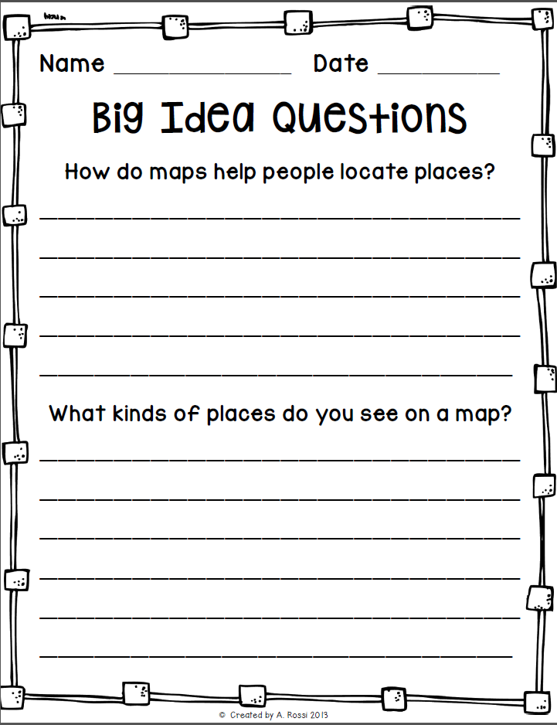 | Yes

3 |  | What are map keys?  What is a compass rose?  (1 day) | Using Pictures and Maps. Pg 72  Explain that a map is a drawing of a place and that it is flat. Pictures are real and a map is a drawing.  Using Map keys. Pg 90  For maps, explain that symbols are drawings that stand for real things. Why do we use symbols? Why do we have a map key?  Review Compass Rose – NESW (Never Eat Soggy Waffles)  Use worksheet packet (from MapsContinentandCommunityUnit.pdf) to show what students know about map keys and compass rose, pgs 32-34.  If time allows, watch https://jr.brainpop.com/socialstudies/geography/readingmaps |  | Yes
4 |  | Landforms and Bodies of Water  (2 – 3 days) | What are landforms? What are bodies of water?  Landforms are different kinds of land on the Earth such as hill, mountain, valley and plain. Bodies of water are different types of water forms such as oceans, lakes and rivers.  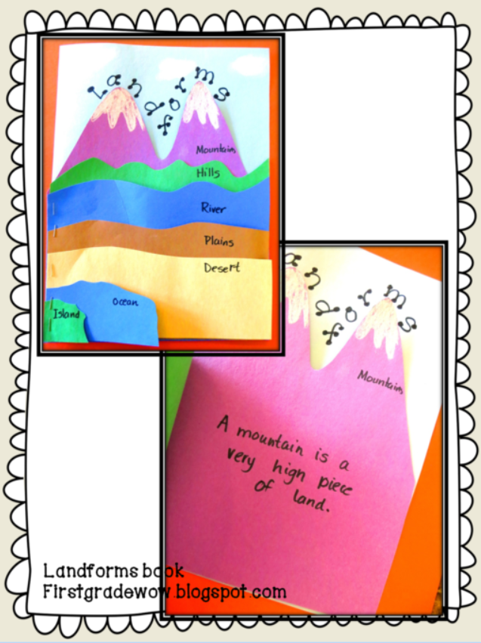  Read *Water and Land p 86-89; What are the physical characteristics of landforms and bodies of water? Compare and contrast their characteristics. Use the venn diagram (from MapsContinentandCommunityUnit.pdf pg 62-64) to describe landforms.  Watch https://jr.brainpop.com/socialstudies/geography/landforms/  Select several worksheets in folder to practice identifying and describing.  Make landforms booklet. |  | Yes
5 |  | Tour Guide  (1-2 days) | Talk to students about how to be a tour guide. You need to share directional information, visual information, and details. Watch examples - https://www.youtube.com/watch?v=uG20wQ94yd0 or https://www.youtube.com/watch?v=dp8VOG8Cgag or discovery education – Using Maps (2:22)  Have students work in teams to practice being a tour guide, using a classroom or neighborhood map. One student is the guide and another student move game pieces based on directions. Change roles.  - Tina’s Neighborhood (WhereintheWorldAfreeminigeographyunitforfirstgrade).  - Classroom Map (Classroom Map Game)  - All Around Town  - Neighborhood map image  - Maps available in the Really Good Stuff book set  When students are ready, record their descriptions using the iPads. (optional) |  | Yes
6 |  | Continents & Oceans | The earth is composed of 7 continents and 4/5 oceans. They are North America, South America, Europe, Asia, Africa, Antartica and Australia. They oceans are Atlantic, Pacific, Indian, Artic and the Southern. Use map from LandformsContinentsOceansAScienceWritingLiteracyUnit  Watch - https://jr.brainpop.com/socialstudies/geography/continentsandoceans/  Complete the directed coloring map activity (MapsContinentandCommunityUnit.pdf) |  | Yes
7 |  | Americans Long Ago: Sacagawea and/or Merriweather Lewis and William Clark  (Complete over 2 days) | Read *Sacagawea, p 244-245; Read parts of story from Reading A to Z (Level Y); How did Sacajawea help Lewis and Clark?  Activities:  - Watch either Sacagawea video  - https://www.youtube.com/watch?v=PnT0k9wdDZo (Start video 30 seconds in)  - http://www.teachertube.com/video/sacagawea-118532  Students will read more in depth about Sacagawea and/or Merriweather Lewis and William Clark. They will add this famous American to their Famous American booklet. Students will need to write independently in their booklet. |  | Yes
8 |  | Centers | The centers can be planned for a class period or two, or can be incorporated into Daily 3 centers.  - Matching game for landforms  - Landform Riddles  - US Puzzle  - Directions Folder Game |  | Yes
9 |  | Culminating Activities | Take end of the unit assessment (landform quiz and map assessment)  Play Landforms around the World.  Complete the “Me in the World” project. |  | Yes
Special Considerations:
- Each teacher has a library of books that may describe various landforms and parts of our country. These can be used to enrich any lesson.
- Each lesson will begin and end with an essential question
- Several of the above lessons will be 2 to 3 periods long
- Some of the instruction will occur during morning meeting, a Shared Reading block and/or during another Social Studies literacy block
- Some of the teaching and work will be completed in small group during centers
- Additional resources will be added

 | Assess and Reflect (Stage 4)
 | Reflections / Considerations (Self-assessment) |  |  | Comments
Unit and Areas of Study:
Did I maintain alignment and integrity between and among Stage 1, Stage 2, and Stage 3?
 | Adaptive Dimension:  Did I make purposeful adjustments to the curriculum content (not outcomes), instructional practices, and/or the learning environment to meet the learning needs and diversities of all my students? |  |  | For struggling students:  For students who need a challenge:
Instructional Approaches:
Did I use a variety of teacher directed and student centered instructional approaches?
Resource-based Learning:
Did the students have access to various resources on an ongoing basis?
Content and Perspectives/Gender Equity/Multicultural Education:
Have I nurtured and promoted diversity while honoring each child’s identity?

Adapted from: Wiggins, Grant and J. McTighe. (1998). Understanding by Design, Association for Supervision and Curriculum Development.

