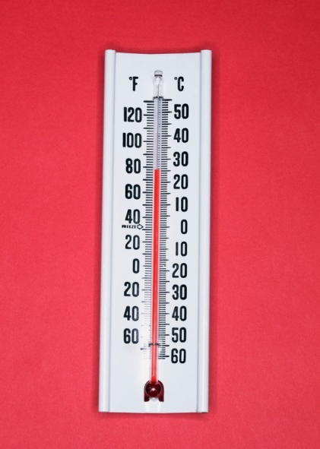
Name ___________________ Date ___________
thermometer

This weather tool
measures how much
rain has fallen.

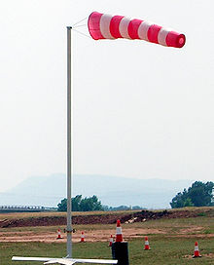
wind sock

This weather tool
measures the strength
and direction of the wind.

This weather tool
measures the
temperature.
rain gauge

Name ___________________ Date ___________

This weather tool
measures how much
rain has fallen.

This weather tool
measures the strength
and direction of the wind.

This weather tool
measures the
temperature.

