Circle the best answer.

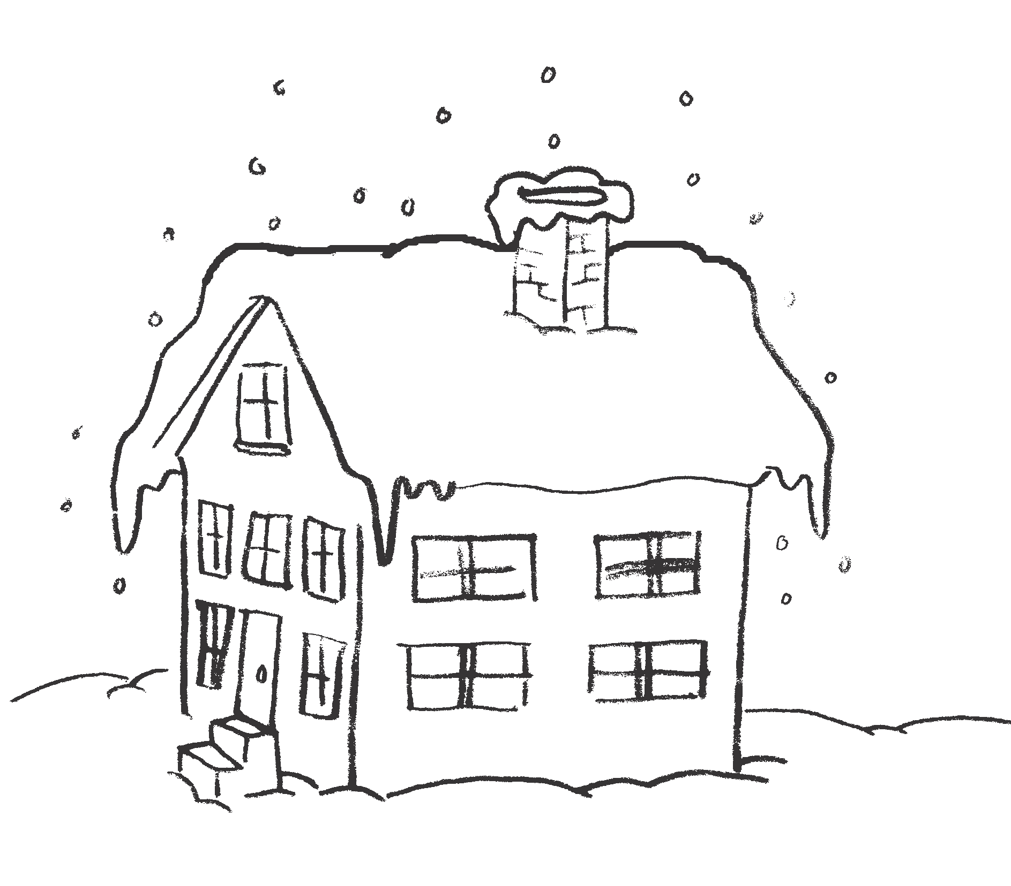
1. Look at the picture. What season is it?

A. spring
B. summer
C. fall
D. winter

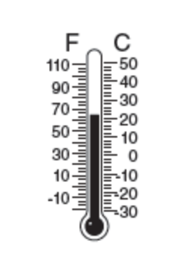
2. Look at the picture. How could you use this
tool to measure weather?

A. to measure the amount of sunshine
B. to measure how hot or cold it is outside
C. to measure the direction of the wind
D. to measure the amount of rain

3. We are picking pumpkins and apples. Tree leaves are orange and yellow. What season is it?
A. spring
B. summer
C. fall
D. winter

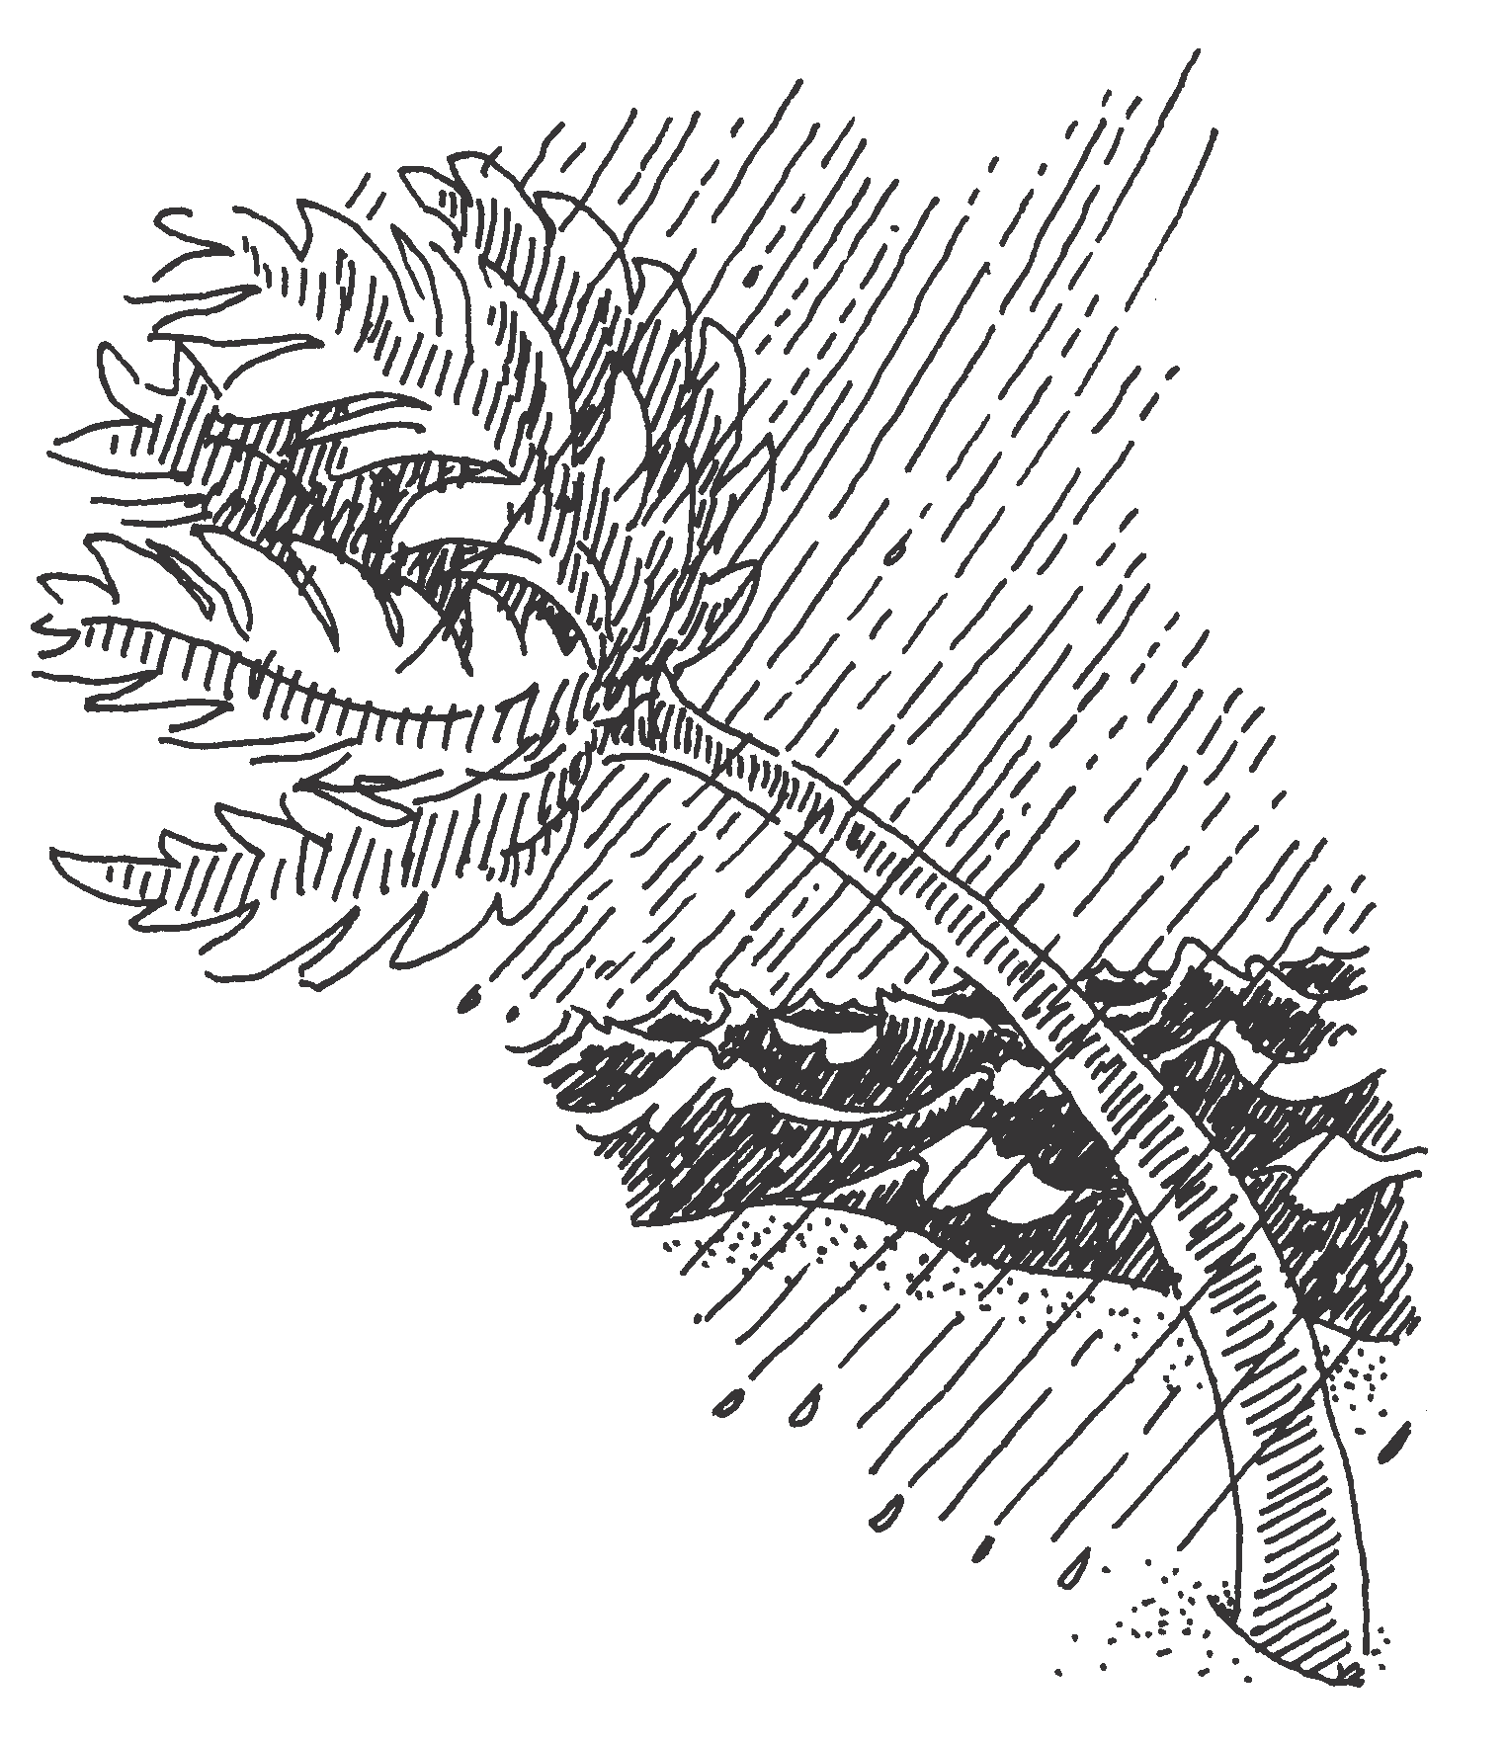
4. Look at the picture. How could you describe
the weather in this picture?

A. sunny and windy
B. rainy and windy
C. sunny and dry
D. rainy and still

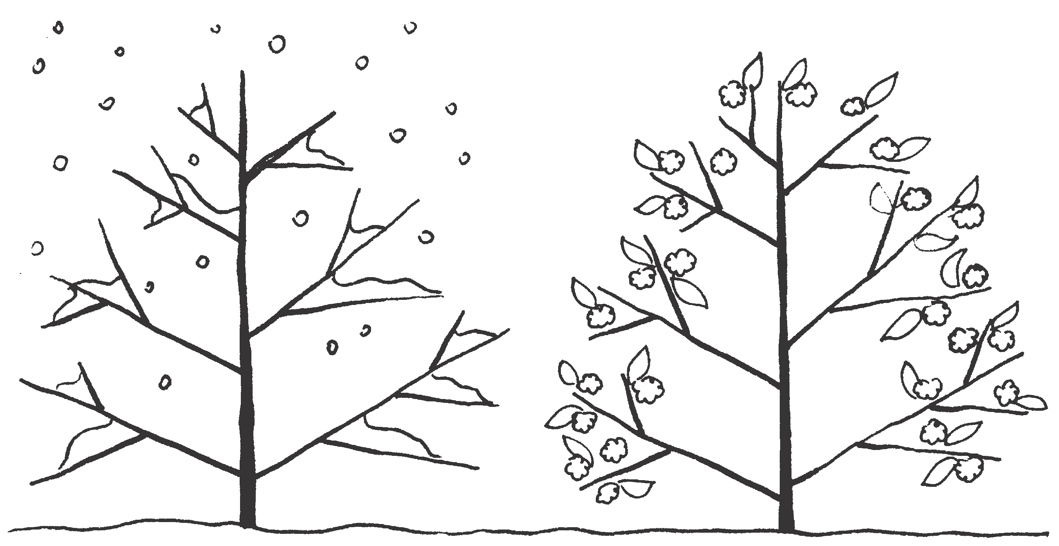
5. Look at the tree in two different seasons in the picture.
Which seasonal changes are shown here?
A. from spring to summer
B. from winter to spring
C. from summer to fall
D. from fall to winter

6. Which season comes AFTER spring?

A. spring
B. summer
C. fall
D. winter

7. Which tool can measure the amount of rain that falls?

- a wind sock
- a ruler
- a rain gauge
- a thermometer

8. _________________ is what it is like outside.

- Seasons
- Weather
- Temperature
- Hurricane

9. Write a sentence about how you can stay safe in a type of bad weather.

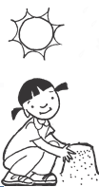
10. Use the clues to figure out which season each child shows.
Draw a line from each season to the correct child.

- Winter

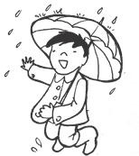

- Spring

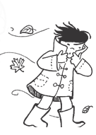

- Summer

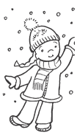
- Fall/Autumn

11. What does a meteorologist do?

12. Look at the picture. Use two words to describe the weather.


 

 

