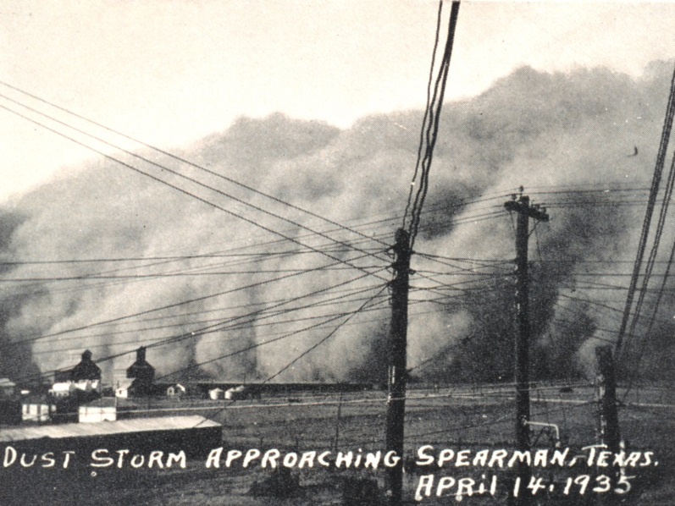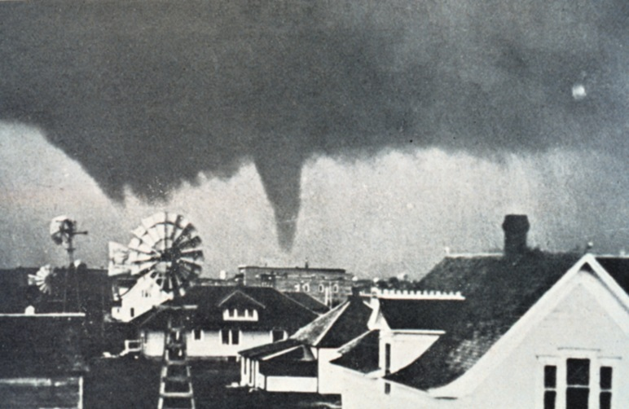

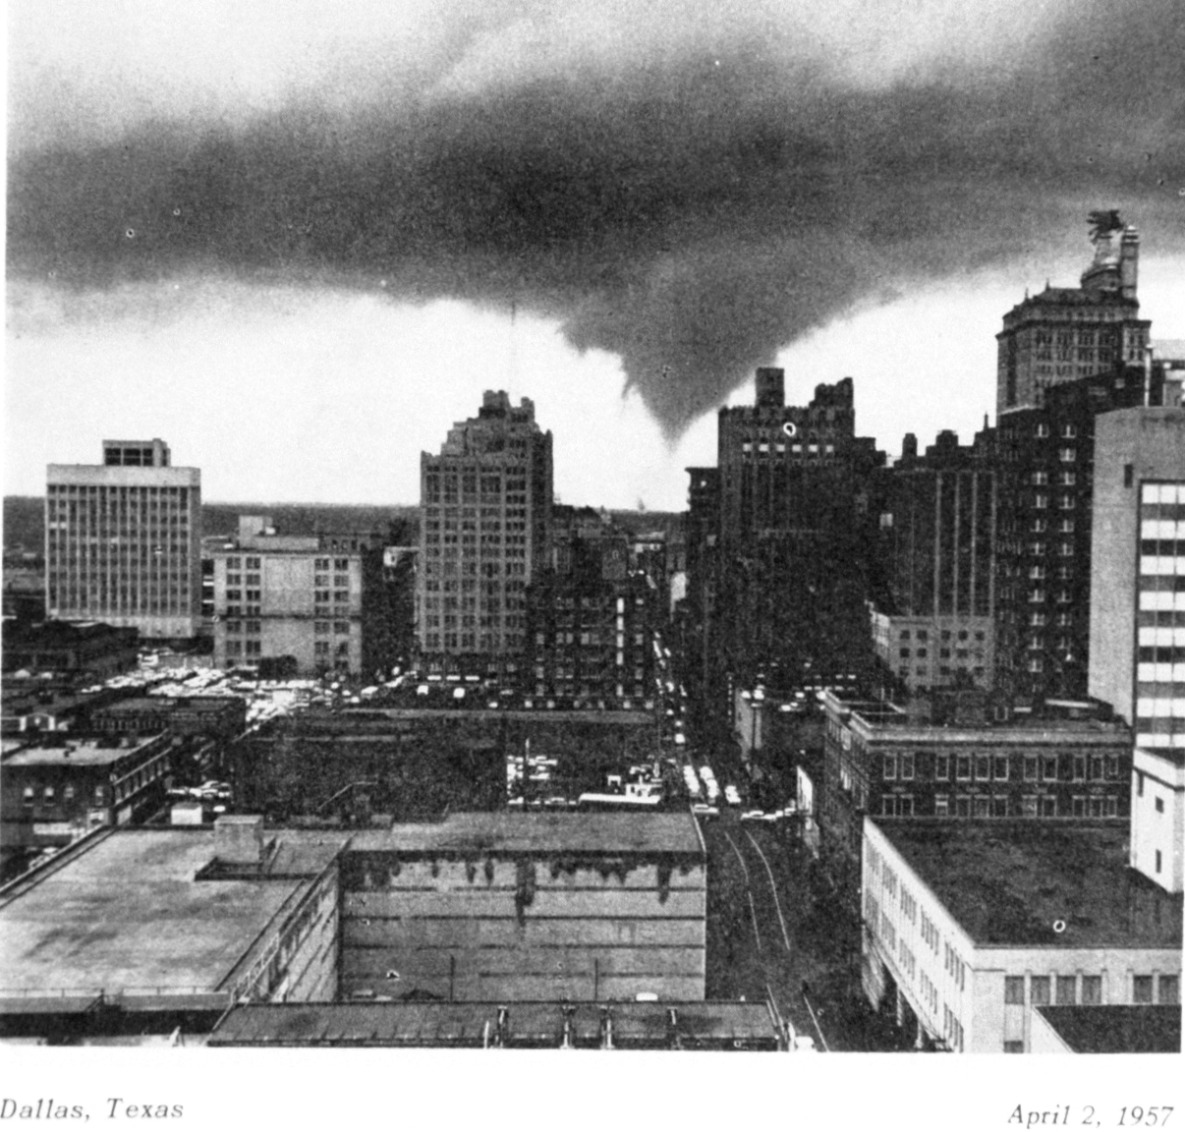

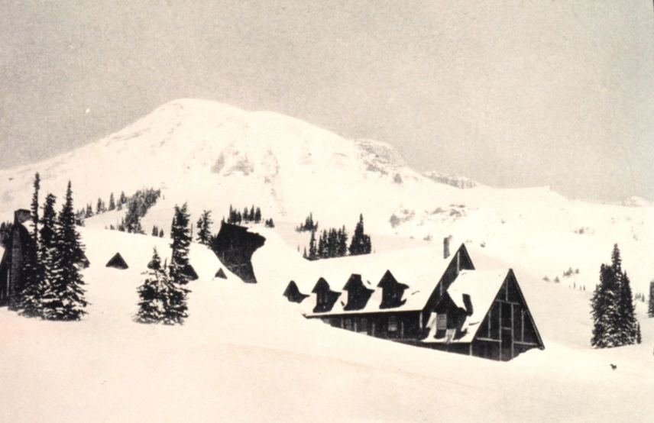

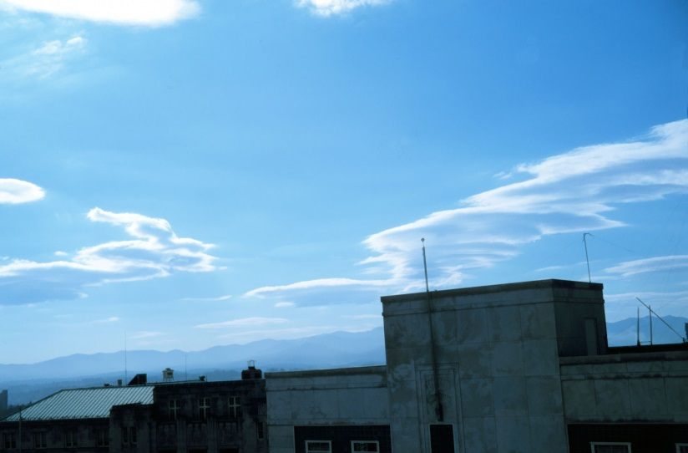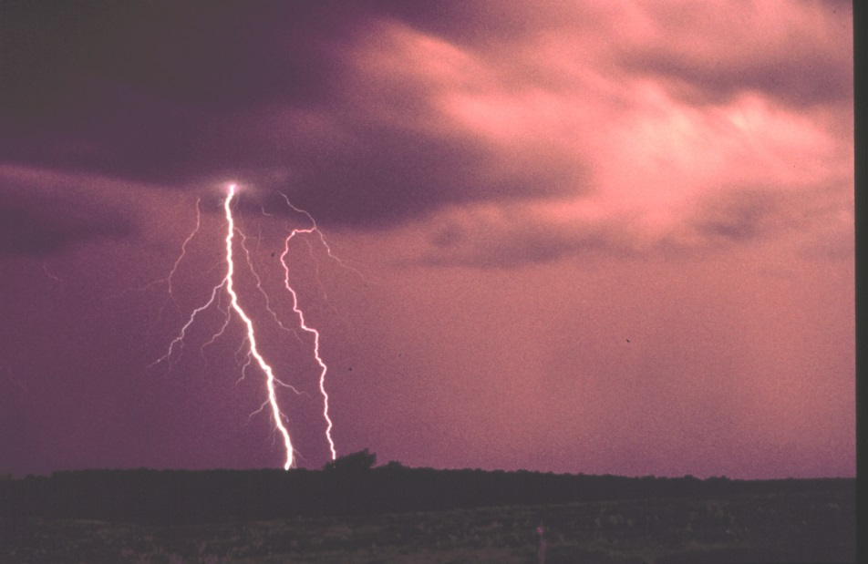

[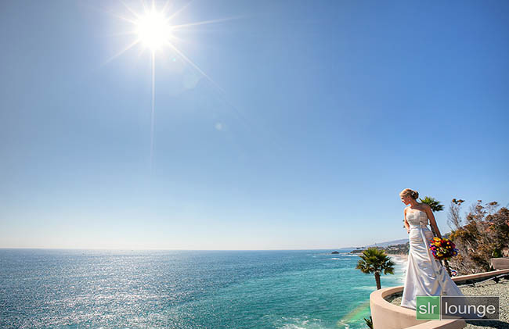](http://www.google.com/url?sa=i&rct=j&q=sunny+photograph&source=images&cd=&cad=rja&uact=8&docid=DX7_qsZUE5EmEM&tbnid=KnsGwSIwnyOQqM:&ved=0CAYQjRw&url=http%3A%2F%2Fwww.slrlounge.com%2Fphotography-essentials-the-sunny-16-rule&ei=qokwU8r-Js3MkAews4HIBQ&psig=AFQjCNHdKdQNLs2mCJCpdLCyHmc8vqLfzQ&ust=1395776169707381)

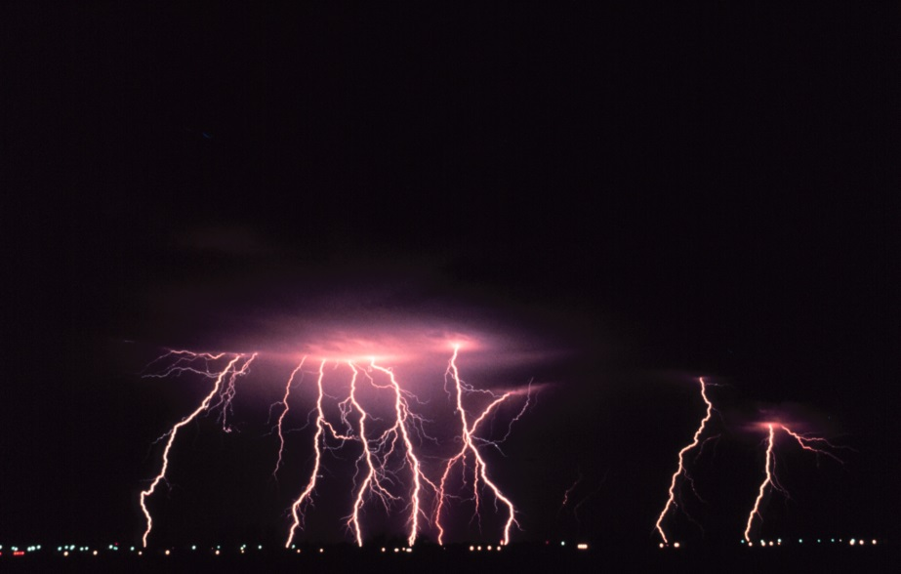

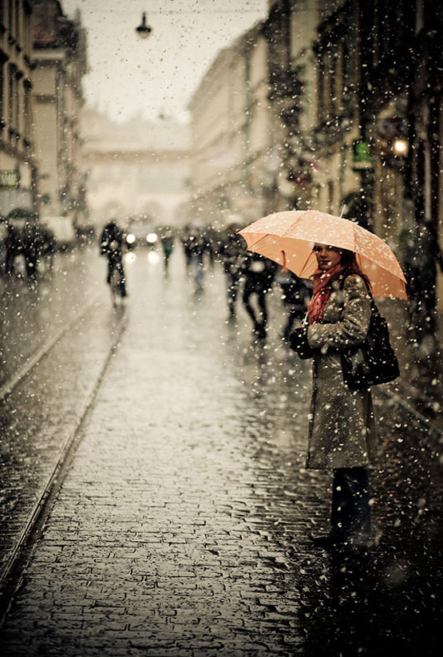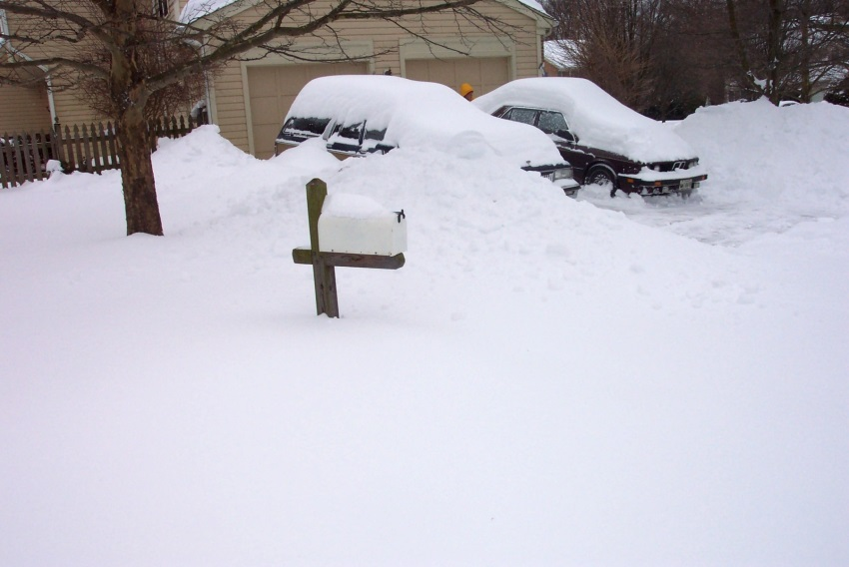

[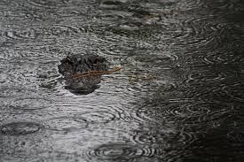](http://www.google.com/imgres?q=rain%20photograph&um=1&safe=active&sa=N&biw=1301&bih=592&hl=en&tbm=isch&tbnid=7skNgCydn7xRaM%3A&imgrefurl=http%3A%2F%2Fwodumedia.com%2Fnational-geographic-traveler-magazine-2013-photo-contest%2Foutdoor-scenes-in-the-rain-this-photograph-was-taken-while-i-was-on-vacation-in-south-carolina-it-was-a-rainy-miserable-day-until-i-happened-upon-this-alligator-hanging-out-in-a-local-pond-sout%2F&docid=CawwgOT3-XkloM&imgurl=http%3A%2F%2Fwodumedia.com%2Fwp-content%2Fuploads%2F2013%2F05%2FOUTDOOR-SCENES-In-the-Rain-This-photograph-was-taken-while-I-was-on-vacation-in-South-Carolina.-It-was-a-rainy-miserable-day-until-I-happened-upon-this-alligator-hanging-out-in-a-local-pond.-South-Carolina-USA.-Kandace-Stro-960x640.jpg&w=960&h=640&ei=kYcwU8a3EdKMkAfU4IHIBQ&zoom=1&ved=0CKQBEIQcMBc&iact=rc&dur=363&page=2&start=11&ndsp=16)

[](http://www.google.com/url?sa=i&rct=j&q=rainbow+photograph&source=images&cd=&cad=rja&uact=8&docid=T2NDNnFZZQgZBM&tbnid=cgpgtBtr_tn2DM:&ved=0CAYQjRw&url=http%3A%2F%2Fwww.designzzz.com%2Fbeautiful-rainbow-photography%2F&ei=N4gwU96UO8OqkAfL8oGYBg&psig=AFQjCNGNPXY3G3YFHif8Qy7OWbQH6Re3dQ&ust=1395775918658514)

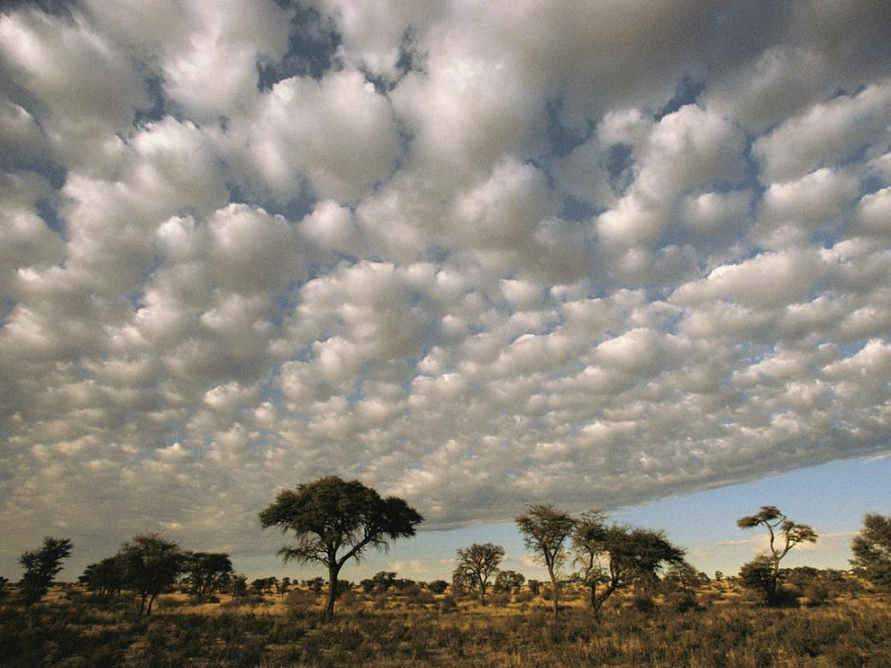

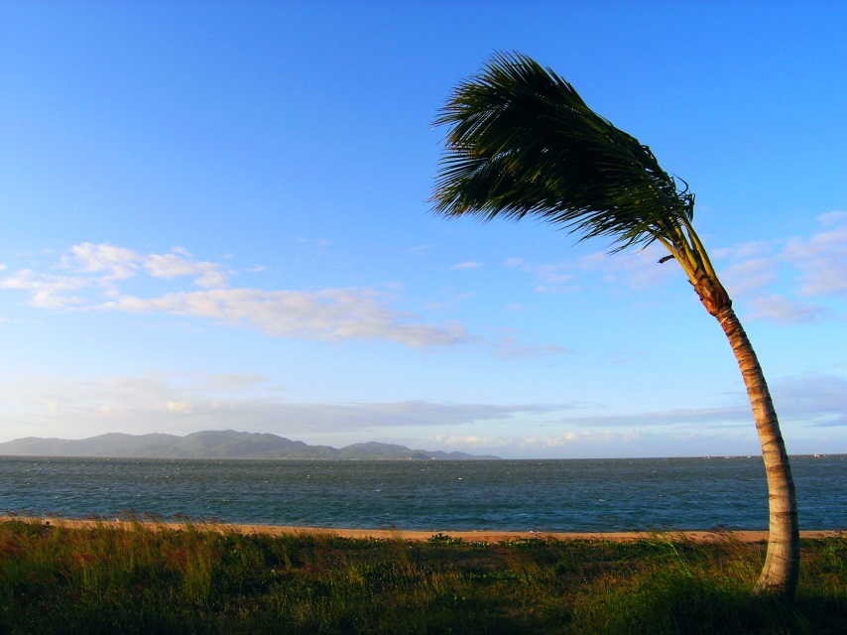

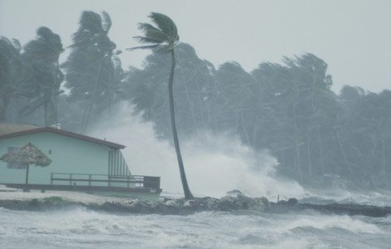

Kansas Tornado 1915

Texas Dust storm 1935

Texas Tornado 1957

27 ft. deep snow in Washington 1916

Ice Crystals

