Unit Design Template

Title of Unit | The Parts of Our World | Grade Level | 1st Grade
Subject | Social Studies and ELA | Time Frame | 1st Term (4 weeks)
Developed By | Dina Ciccone
Stage 1 - Identify Desired Results
Established Goals: CCSS / CCCS / Big Ideas / Big Themes
Concept: Individuals and Groups

Big Ideas: Families and communities of long ago and today are influenced by the values and traditions of both individuals and groups.

Topics: Family, Community, Historical leaders

Reconceived Standards:

- Students will examine the diverse values and traditions that individuals and groups bring to historical events and to the present. (Synthesis)

- Students will develop their personal identities in the context of the culture of their families, schools, and communities. (Analysis)

- Students will identify the main idea and retell key details from both literary and informational texts in their own words. (Comprehension). Students will compare and contrast individuals, events, ideas or pieces of information and decided how these are linked together. (Analysis)

- Students will acknowledge that individual parts make up a whole and/or group.

Received Standards:

- New Jersey Social Studies Standards:
  - 6.3 Active Citizenship in the 21st Century All students will acquire the skills needed to be active, informed citizens who value diversity and promote cultural understanding by working collaboratively to address the challenges that are inherent in living in an interconnected world. (Comprehension)
  - 6.1 U.S. History: America in the World All students will acquire the knowledge and skills to think analytically about how past and present interactions of people, cultures, and the environment shape the American heritage. Such knowledge and skills enable students to make informed decisions that reflect fundamental rights and core democratic values as productive citizens in local, national, and global communities.
    - 6.1.4.A.15 Explain how and why it is important that people from diverse cultures collaborate to find solutions to community, state, national, and global challenges. (Comprehension)
    - 6.1.4.D.13 Describe how culture is expressed through and influenced by the behavior of people. (Comprehension)
    - 6.1.4.D.18 Explain how an individual’s beliefs, values, and traditions may reflect more than one culture. (Comprehension)

- New Jersey Social Studies Skills:
  - Chronological Thinking (K-4)
~ Place key historical events and people in historical eras using timelines. (Knowledge)
~ Explain how the present is connected to the past. (Comprehension)

- Common Core – ELA Standards:
  - CCSS.ELA-Literacy.RL.1.1
Ask and answer questions about key details in a text. (Knowledge)
  - CCSS.ELA-Literacy.RL.1.2
Retell stories, including key details, and demonstrate understanding of their central message or lesson. (Comprehension)
  - CCSS.ELA-Literacy.RL.1.3
Describe characters, settings, and major events in a story, using key details. (Comprehension)
  - CCSS.ELA-Literacy.RI.1.1
Ask and answer questions about key details in a text. (Knowledge)
  - CCSS.ELA-Literacy.RI.1.2
Identify the main topic and retell key details of a text. (Knowledge)
  - CCSS.ELA-Literacy.RI.1.3
Describe the connection between two individuals, events, ideas, or pieces of information in a text. (Comprehension)
  - CCSS.ELA-Literacy.RI.1.5
Know and use various text features (e.g., headings, tables of contents, glossaries, electronic menus, icons) to locate key facts or information in a text. (Application)
  - CCSS.ELA-Literacy.RI.1.6
Distinguish between information provided by pictures or other illustrations and information provided by the words in a text. (Analysis)
  - CCSS.ELA-Literacy.SL.1.4
Describe people, places, things, and events with relevant details, expressing ideas and feelings clearly. (Knowledge)

Cross-curricular Integration (Interdisciplinary Teaching and Learning)
Will you integrate this unit with other curricular areas? If so, what areas? In what ways will you connect the curricular areas?
Social Studies and Literacy (ELA):
Literacy strategies and skills will be applied as students acquire information and communicate their learning and understanding in Social Studies. Integration of Literacy and Social Studies is critical for student success. It is essential that literacy strategy and skill instruction be purposefully and appropriately planned and embedded within Social Studies instruction; i.e. planning for the literacy and social studies outcomes, differentiating, matching instruction to the learners, and in consideration of resources.

This unit also connects to Health and Character Education topics.

This unit will transition into a Science unit that integrates Science and Literacy (ELA). The big idea of the next unit will be constancy and change.

Enduring Understandings  If a student spends time with you during this unit, what is  absolutely essential that the student understand and  be able to transfer as a result of the experience (Rigor: Quadrant “D”)? |  | Essential Questions  What provocative questions will foster inquiry, understanding, and transfer of learning (Relevance)? (Often, open-ended questions that stimulate reflective thought and inquiry and connect the knowledge and skills to the enduring understanding are used.)

Students will understand that...  - Families come in all different shapes and sizes, and should be appreciated for their differences and similarities.  - Individuals have different perspectives based on their beliefs, values, traditions, culture, and experiences.  - Individuals belong to groups such as a family, school and community.  - Building relationships to people, places, and resources in the local community and beyond influences our daily lives.  - Groups and individuals made changes in history and can make changes in our daily lives.  - Individual parts can often make a whole/group complete and/or better. | Content specific…  Big Idea:  - Why do we study individuals?  - How do groups change our world?  - How do individuals become team players?  - How do literary and informational texts (books) teach us about the world?  Topical:  - What values are important to your family?  - Why is being part of a community important?  - How can I learn about my family and community from the past?
Knowledge:  What knowledge (topics and facts) will student acquire as a result of this unit? This content knowledge may come from the indicators, or might also address pre-requisite knowledge that students will need for this unit. | Skills  What skills will students acquire as a result of this unit? List the skills and/or behaviors that students will be able to exhibit as a result of their work in this unit. These will come from the indicators.
Students will know...  - A family is a group of people who care for one another. A neighborhood is a place where people live, work and play. People live in communities such as a city, farm, or neighborhood.  - Communities are in a bigger place called a state. Fifty states make up our country, the United States of America. A country is part of a continent. There are seven continents on Earth.  - Historical leaders, such as Albert Einstein, Benjamin Franklin, Clara Barton and our current president, change our world.  - Geography tells you where places are and what they are like.  - Our whole world, community and family are made of individual parts. | Students will be able to…  - Describe different families.  - Compare and contrast similarities and differences in the ways families meet basic needs  - Identify and describe how people live, work, and play in communities  - Use pictures and maps to locate places, such as our state, country, and continent.  - Describe physical characteristics of continents and oceans.  - Consider how leaders have influenced the past and today  - Categorize information  - Explain how the present is connected to the past.

Stage 2 – Assessment Evidence
Performance Task
Through what authentic performance task will students demonstrate the desired understandings, knowledge, and skills? (Typically, the P.T. describes the learning activity in narrative form. The P.T. usually includes a scenario or situation that requires students to apply knowledge and skills to demonstrate their understanding in an authentic, real life situation {Relevance}. Describe your performance task scenario below)
By what criteria will performances of understanding be judged?
GRASPS Elements of the Performance Task
G – Goal  What should students accomplish by completing this task? | Goals:  - Compare and contrast their family and community to others in classroom groups (Formative)  - Compare and contrast the past with today and debate the benefits of the changes (Formative)  - Determine where you are in the world by creating a foldable project that layers the individuals and groups of the world (Summative)  - Research with guided support how specific individuals and groups influence the world and present key details about each historical leader (Formative and Summative)
R – Role  What role (perspective) will your students be taking? | Roles:  - Researchers and/or eyewitnesses
A – Audience  Who is the relevant audience? | Audiences:  - Teacher and/or peers
S – Situation  The context or challenge provided to the student. | Situations:  - Students will debate and discuss with peers their understanding of family and community.  - Students will present their knowledge to the teacher by creating a foldable, providing key details about a historical leader in video format, and taking a written test.
P – Product, Performance  What product/performance will the student create? | Products:  - Foldable project, key details interview, test
S – Standards & Criteria for Success  Create the rubric for the Performance Task | Standards:  - Rubric for “Me in the World” project  - Grading key for test  - Teacher observation for verbal presentation  If it is developed as part of the plan, attach the rubric to the Unit Plan. (See end of unit for the “Me in the World” rubric.)
Performance Evidence  Through what evidence (work samples, projects, surveys, observations, quizzes, tests, journals or other means) will students demonstrate achievement of the desired results? What formative and summative assessments will be used throughout the unit to arrive at the outcomes? |  | Student Self-Assessment  In what ways will students reflect upon or self-assess their learning?
- Pre-assessments (Formative)  - Checks for Understanding (Formative)  - Discussion (Formative)  - Debate (Formative)  - Student questions/comments (Formative)  - Teacher questions and prompts (Formative)  - Observation/Anecdotal records (Formative)  - Interview (Formative)  - Me in the World project (Summative)  - Test (Summative) |  | - Use reflective questions, prompts and responses  - What do I know? What did I learn? How am I an individual and part of a group?

Stage 3 – Learning Plan
What teaching and learning experiences (WHERETO) will you use to:
- achieve the desired results identified in Stage 1?
- equip students to complete (with understanding) the assessment tasks identified in Stage 2?
Where are your students headed? Where have they been? How will you make sure the students know where they are going?
What experiences do the learners bring to the unit? How have the interests of the learners been ascertained? Have the learners been part of the pre-planning in any way? What individual needs do you anticipate will need to be addressed?
Learning environment: Where can this learning best occur? How can the physical environment be arranged to enhance learning?
W  H  E  R  E  T  O | Where – We will start the unit with students understanding more about themselves and their families. Then they will learn about other families and how they are the same and different. Next they will situate this knowledge in the context of local communities and the world around them. Throughout the unit, students will learn about individuals of today and the past that had an impact on the world. We will use KWL charts for each topic to determine student readiness.
 | Hook – Students will bring in “All About Me in a Bag” to share at morning meeting time. Each student will have the opportunity to share about themselves through objects and photos. Students will identify similarities and differences. This will set the stage for the unit and will help build classroom community.
Equip -
- Class discussion about themselves, families, communities, parts of the world.
- Turn and share with a neighbor your ideas about individuals and groups
- Develop vocabulary – family, community, neighborhood, state, country
- Reviewing and adding to the KWLH chart will help students retain information and ask new questions.
- Practice oral presentations in other content areas to lead to the timeline presentation.
- Model oral interview expectations
- Practice identifying the main idea and key details in stories
- Model how to create a Me in the World map
- Use VENN diagram to compare and contrast family and communities with others
- Use VENN diagram to compare and contrast the benefits of the past and present
- Use age-appropriate resources to learn about influential leaders and use graphic organizers to record information about the leader.

 | Rethink – Provide opportunities for students to discuss what they know and think. Ask students lots of questions to help them articulate their ideas.
 | Evaluate – Students will consider where they are in this world. They should see that they are a small part of a big idea after completing the project.
 | Tailor – If needed, students will receive extra support in creating their project, reading about their influential leader and/or recording facts about them.
Organization –
- Plan Family and Community Centers
- Prepare colored circles and labels for number of students in class
- Prepare a rubric for the project
- Interview students at end of unit using iPad video

In what ways will you engage students at the beginning of the unit?
Invite students to create an “All About Me” in a bag for homework. When they bring this in, 1 student a day will be selected to share about themselves. Students will recognize how they are the same and different. Students are excited for this activity.

What activities / events will help students experience and explore the enduring understandings and essential questions in the unit? How will you equip them with needed skills and knowledge?
# | Lesson Title | Lesson Activities | Cross-curricular | Resources
1 | Families | Read Families Are Different by Nina Pellegrini in Shared Reading. Explore how there all types of family arrangements and that families come in different shapes and sizes. Begin to understand the main idea and key details of a story. Discuss how the photographs support the information of a text. Turn and talk to a neighbor. Describe your family. Now draw and label your family.  Read Social Studies text - Many Families pp 14-17 and discuss information.  Link to benchmark writing activity in Writer’s Workshop.  Read Social Studies text – Families Celebrate pp 18-21; Make list of holidays; p. 4  Read Social Studies text – Family Rules pp 30-33. Compare and contrast rules at home and at school. | Yes | People and Places Student Text by Macmillan/McGraw Hill  Families Are Different by Nina Pellegrini  Seven Blind Mice by Ed Young  This is My House by Arthur Dorros  From Head to Toe by Eric Carle  Paper  Worksheets  Famous American of the Month Flip Chart  Very First Biographies by Scholastic  Possible resources: Did It Take Creativity to Find Relativity, Albert Einstein?  I Am Albert Einstein by Grace Norwich and Ute Simon  Clara Barton By Wil Mara and W. P. Mara  The Modern Inventions of Benjamin Franklin Now & Ben by Gene Barretta, Gene Barretta  What Does the President Do? BY: Amanda Miller  16 Amazing People All Young Learners Should Know About Very First  Biographies BY: Ruth Culham  Young Christopher Columbus by Eric Carpenter
2 | Parts Help the Whole | Read Seven Blind Mice by Ed Young in Shared Reading. Explore themes of parts of a week, colors, ordinal numbers and how each individual can’t see the big picture, but the whole group can. | Yes
3 | My World | Read It’s My World by Scholastic. Explore the parts of the world. Relate to your own world. Discuss with a neighbor. Identify the main idea and key details of a story. Discuss how the photographs support the information of a text. Turn and talk to a neighbor. Describe your world. Now draw and label your world. | Yes
4 | Communities | Brainstorm – What is a community? Complete KWL.  Learn about the different communities – town (suburban), farm (rural), city (urban). Describe the differences and similarities. Look through photographs and identify the type of each.  Read Social Studies text – Where Families Live pp 24-27; Draw where you live and a place in your neighborhood. P. 5; Practice using addresses (pp 28-29); Assign homework activity writing address. P 6 | Yes
5 | Global Community | Read Social Studies text - Where we Live; Discuss what are some things you know about where you live. What is your neighborhood like? Draw a picture of where you live p 66-73. WR: p2-5  Read Social Studies text - Our Country; Explore how big communities make states and countries.  Sort and categorize information. p 74-77  Read Social Studies text - Our World; Compare and contrast continents and oceans; Sing songs; Play “Our World Guessing Game” | Yes
6 | World Leaders | Working in small groups, learn about several world leaders (individuals) that have influenced the world we live in. Discuss how they did this. Some of this study may occur with a small group during centers. Students will share 1 or 2 facts about why the leader is important. This will be presented on video. | Yes
7 | My Body | Read From Head to Toe by Eric Carle in Shared Reading. Explore theme of parts of a body make a whole person. Make connections to “All About Me.” What can you do? Take a photograph of what you can do and then write about the picture….I can…These pictures will be displayed in the classroom. | Yes
8 | History | Introduce the idea that history is the story of the past. We can learn from the past. Learn how famous Americans influence our country. Read p. 220-224. Discuss what history is and what we have learned from our families. Chart Past vs. Present. Compare and contrast things from today and things from long ago – clothes, toys, school, transportation. Complete assessment.  Throughout this unit and the next science unit, study key people: Albert Einstein, Ben Franklin, Clara Barton, Christopher Columbus, and our current president | Yes
9 | Centers | 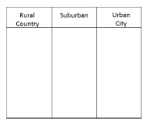  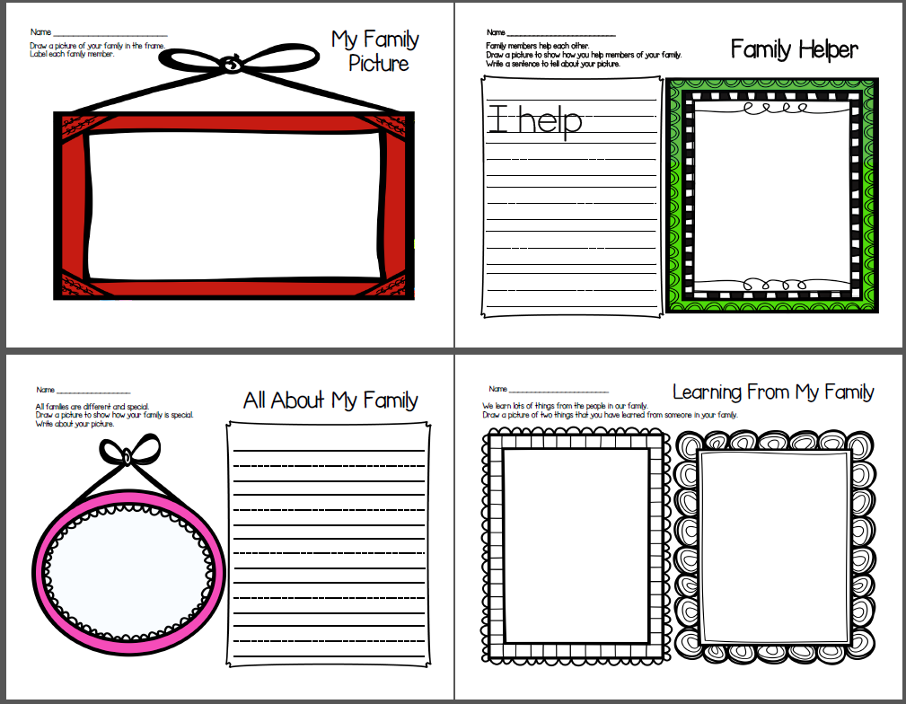  Throughout the week, provide opportunities to explore centers that allow students to explore more about their family and community. Use writing materials from Family Matters packet and the community sort from the Communities Around Us packet. The Writing activities will be supported by teachers. | Yes
10 | Culminating Project | 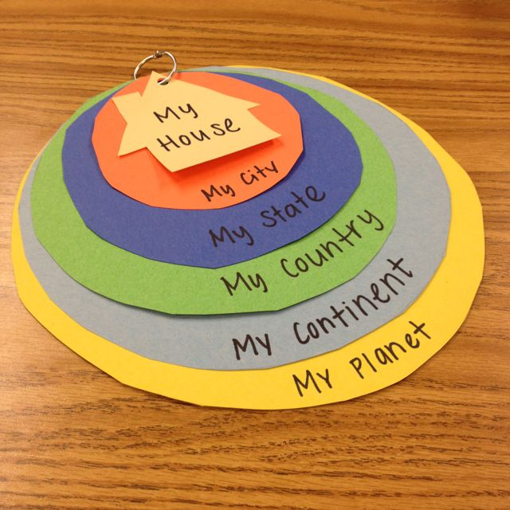  Create a Me in the World project. Use the correct circle and label and put in order. | Yes
Special Considerations:
- Each lesson will begin and end with an essential question
- Several of the above lessons will be 2 to 3 periods long
- Some of the instruction will occur during morning meeting, a Shared Reading block and/or during another Social Studies literacy block
- Some of the teaching and work will be completed in small group during centers
- Additional resources will be added

Assess and Reflect (Stage 4)
Reflections / Considerations (Self-assessment) | Comments
Unit and Areas of Study:
Did I maintain alignment and integrity between and among Stage 1, Stage 2, and Stage 3?
Adaptive Dimension:  Did I make purposeful adjustments to the curriculum content (not outcomes), instructional practices, and/or the learning environment to meet the learning needs and diversities of all my students? | For struggling students:  For students who need a challenge:
Instructional Approaches:
Did I use a variety of teacher directed and student centered instructional approaches?
Resource-based Learning:
Did the students have access to various resources on an ongoing basis?
Content and Perspectives/Gender Equity/Multicultural Education:
Have I nurtured and promoted diversity while honoring each child’s identity?

Adapted from: Wiggins, Grant and J. McTighe. (1998). Understanding by Design, Association for Supervision and Curriculum Development.

Formative Assessment 1

Making A Map: Me in the World

Student Name: ________________________________________

CATEGORY | 4 | 3 | 2 | 1
Knowledge Gained | When shown Me in the World map, the student can accurately explain the sequence. | When shown Me in the World map, the student can 80% of the time accurately explain the sequence. | When shown Me in the World map, the student can 70% of the time accurately explain the sequence. | When shown Me in the World map, the student can not accurately explain the sequence.
Labels - Accuracy | At least 90% of the items are labeled correctly. | 80-89% of the items are labeled correctly. | 79-70% of the items are labeled correctly. | Less than 70% of the items are located correctly.
Labels & Features - Neatness | 90-100% of the labels/features can be read easily. | 89-80% of the labels/features can be read easily. | 79-70% of the labels/features can be read easily. | Less than 70% of the labels/features can be read easily.
Knowledge Gained | When shown Me in the World map, the student can accurately explain the sequence. | When shown Me in the World map, the student can 80% of the time accurately explain the sequence. | When shown Me in the World map, the student can 70% of the time accurately explain the sequence. | When shown Me in the World map, the student can not accurately explain the sequence.
SCORE
Total:

Formative Assessment 2

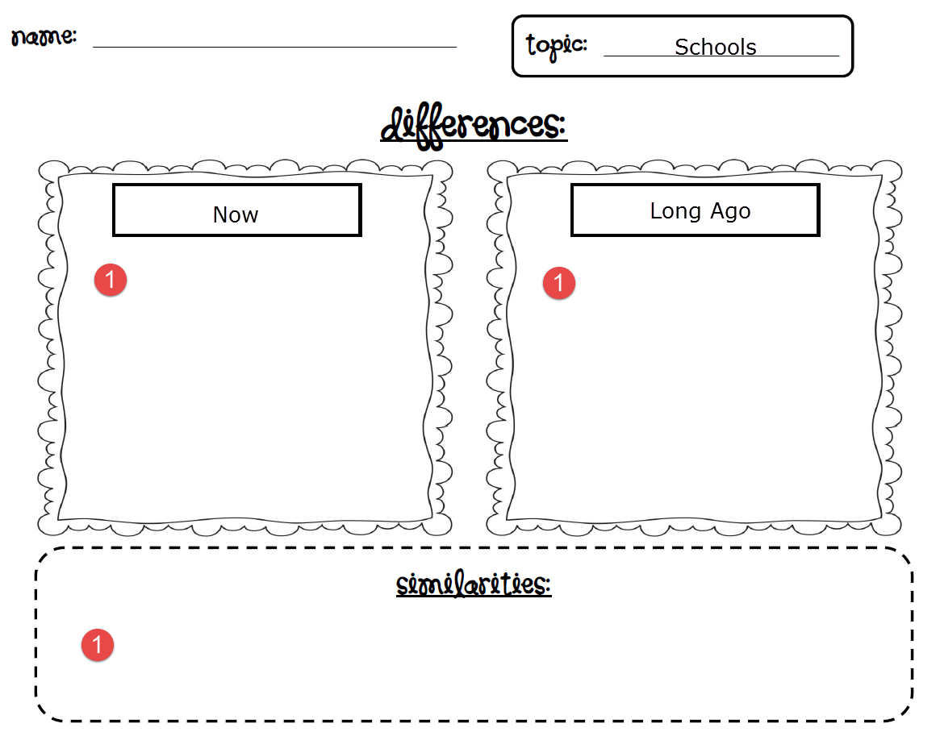
Summative Assessment 1

Parts of Our World Test
Draw how your family is special. Please label picture and add details.
Draw a community and show how it is important. Please label picture and add details.

