**Name: ________________________ Date: __________________**

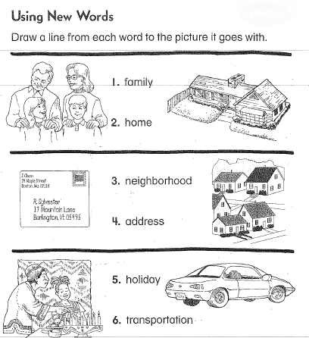**Parts of Our World Test**

**C:\Users\hrodio\AppData\Local\Microsoft\Windows\Temporary Internet Files\Content.IE5\1XAN8W3C\MC900390858[1].wmf**

Dr. Browne

1357 Mays Landing Rd.

Folsom, NJ 08037

|  |  |
| --- | --- |
| 7. What would help you find where a city is located?  Circle the best answer. | A) A dictionary  B) A map  C) A calendar |
| 8. A ____________ is a flat drawing of a real place.  Circle the best answer. | 1. A map B) A globe |

|  |  |
| --- | --- |
| 9. Name a type of community and  draw a picture to match. |  |
| 10. Draw your family celebrating a holiday. Please label the holiday and family members. Show details. |  |

|  |  |
| --- | --- |
| Bonus Question:  Name a cardinal direction.  (**HINT**: *Never eat soggy waffles*)  : | ___________________________ |