Cape May Field Trip Project 7-12-16

Examples of photos and photo settings below. Yours may be a little different.
Shutter Speed: 1/400th
Aperture: F 7.1
ISO: 200 (Photo Brandon Warrington)

Shutter Speed: 1/20th
Aperture: F 10
ISO: 100

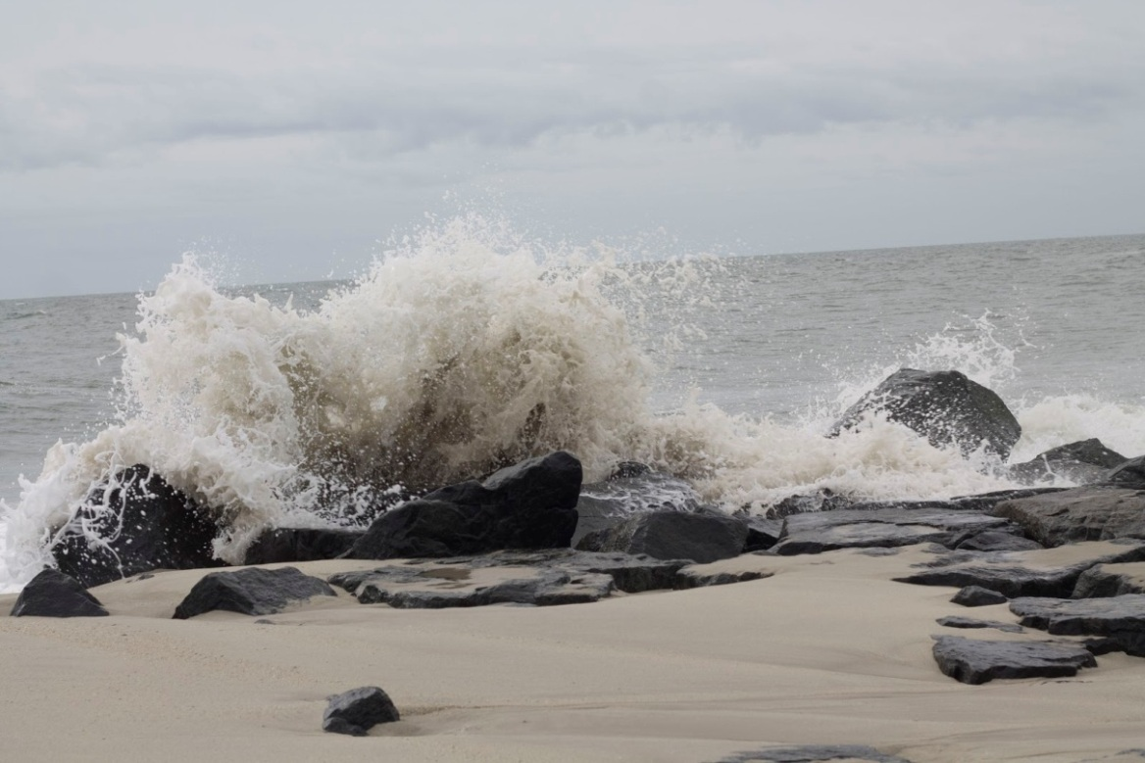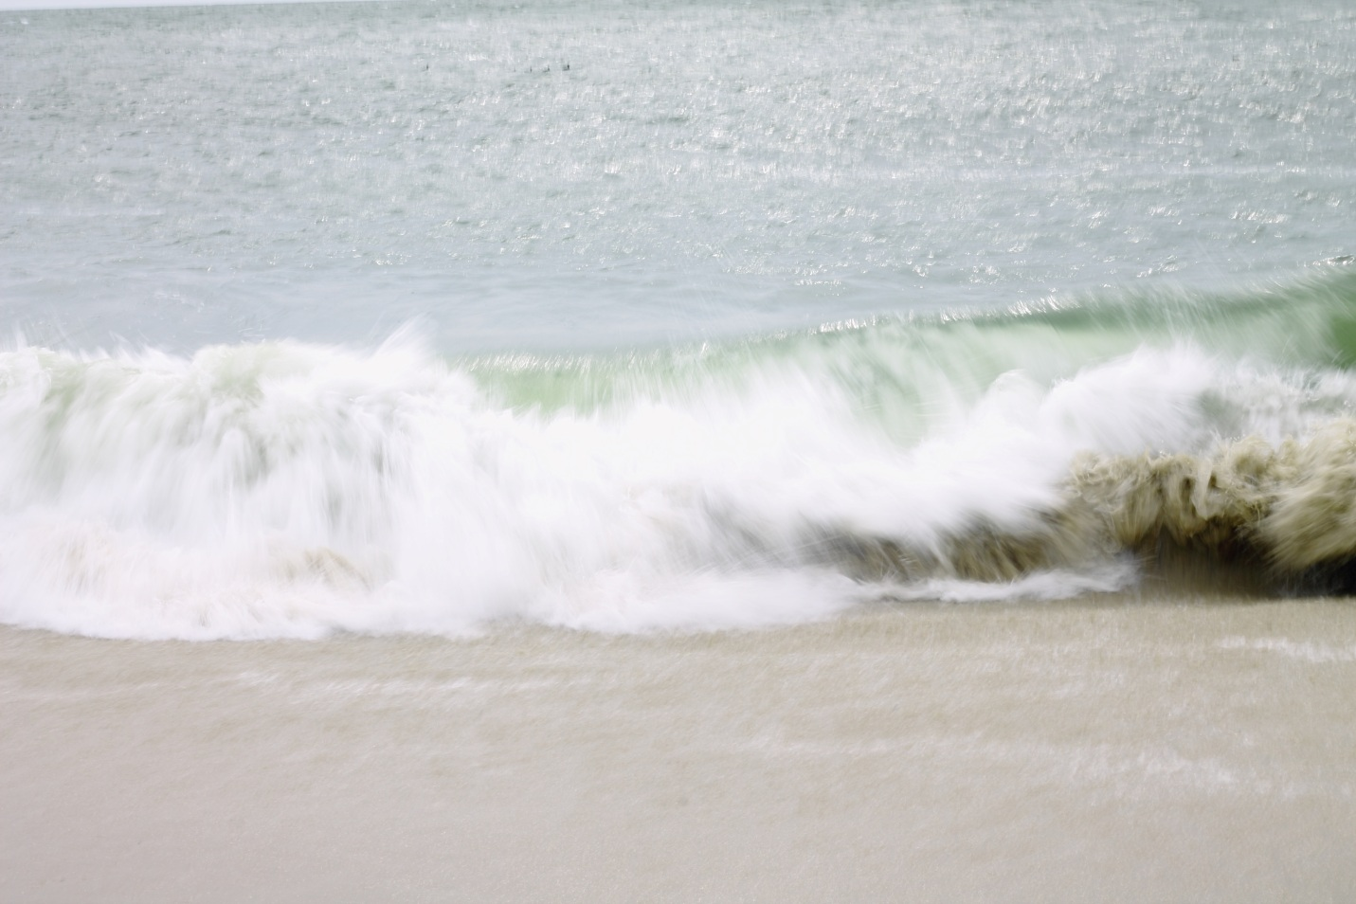

Setting Exposure
Setting Shutter Speed: Use the Main Dial to change the Fraction in the upper LHC of the screen.
Setting Aperture: Hold down the AV button while turning the Main Dial (F Value).
Setting ISO: Press the ISO button and use the arrows to select the proper ISO, then press “Set”.
Notice the White Bar is at “0”

Project:

A. You will be experimenting with slow and fast shutter speeds while photographing ocean waves. Fast shutter speeds of 1/250th of a second and faster will freeze the motion of the individual water droplets. Slow shutter speeds of 1/40th of a second and slower will create a smooth, velvety affect. Please remember that slow shutter speeds of less than 1/60th of a second will be blurry if a tripod is not used. Please take at least 10 slow shutter photos and 10 fast shutter photos. When you have 10 photos of each, check in with your teacher to make sure you’re on the right track. You can then go back and shoot more if you need to.

B. You will also experiment with wide and narrow aperture photography in the town center and along the town streets. Wide apertures of 4.0 or less with produce a nice blurry background (if you are close enough to your object). Apertures of 7.1 and higher will make the background sharply in focus. Please take at least 10 wide aperture photos and 10 narrow aperture photos. When you have 10 photos of each, check in with your teacher to make sure you’re on the right track. You can then go back and shoot more if you need to.

REMEMBER!
- Don’t walk away from your camera on your tripod, EVER EVER EVER!
- Light is very important as it changes so often in an outdoor environment, so you may need to change your settings before you shoot!
- Clean your lens often to avoid salt spray!
- Especially with slow shutter wave shots, if you can’t get a perfect exposure, try dropping your ISO as low as it can go to avoid overexposure.

SET Your Camera to the following | When set make a
Lens: 50mm, and/or 18-55mm, and/or 10-17mm
Lens: MF (manual focus)
Mode Dial: M (Manual Mode)
Clean your lens. Tripod???

Standards
TECH.8.1.8.D.CS2, TECH.8.1.8.B.CS2, TECH.8.1.8.C.CS1, TECH.8.1.8.B.CS1, SCI.MS-ETS1-4, TECH.8.1.8.D.CS1, , SCI.MS-ETS1-3, TECH.8.1.8.A.CS2, TECH.8.1.8.A.1, VPA.1.1.8.D.CS1, VPA.1.2.8.A.CS1, VPA.1.2.8.A.3, VPA.1.3.8.D.CS1, VPA.1.3.8.D.1, VPA.1.3.8.D.CS2, VPA.1.3.8.D.2, VPA.1.3.8.D.CS4, VPA.1.3.8.D.CS6, VPA.1.3.8.D.6, VPA.1.4.8.A.CS2, VPA.1.4.8.A.CS6, VPA.1.4.8.A.6, VPA.1.4.8.A.7, VPA.1.4.8.B.CS1, VPA.1.4.8.B.1, VPA.1.4.8.B.2, TECH.8.1.8.D.CS3, , SCI.MS-ETS1-2, TECH.8.1.8.A.CS1

ESSENTIAL QUESTION: How does shutter speed affect the quality of moving ocean water? How does aperture affect the quality and personality of town and architectural photographs?
OBJECTIVES: Students will experiment with shutter speed while taking photographs of ocean waves and will experiment with aperture while taking town and architecture photographs.
MATERIALS: Canon Rebel Student Kits, Tripods

ADAPTATIONS: Redirectives, verbal prompts, one on one instructions, repeated practice, peer instruction, small group instruction, self-paced, repeated demonstrations, adjust difficulties of lessons, Google Speak,

ASSESSMENT: Observation during student discussions, observation of individual progress during project creation, final project rubric, Google Classroom submission

