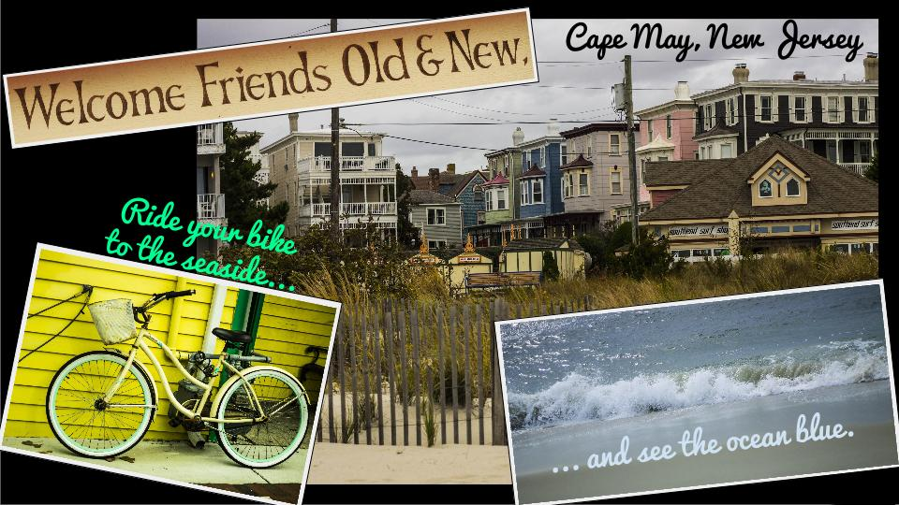
Field Trip Postcard ! rev 2-12-16

Objective:
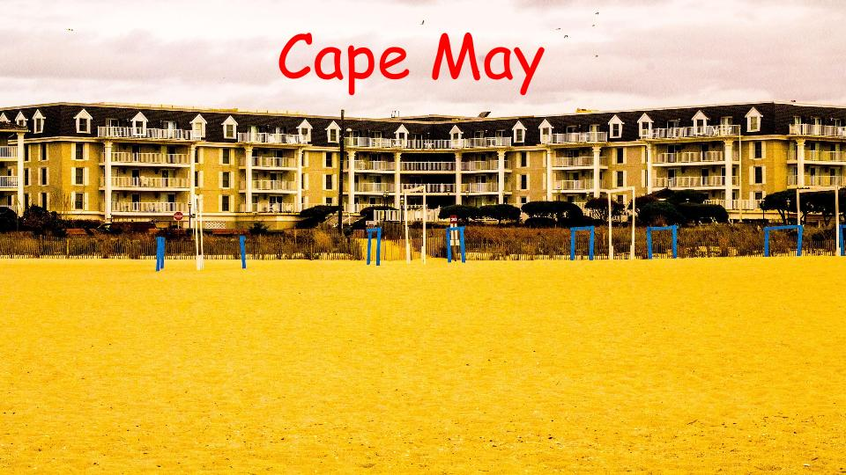
Use Photoshop to enhance a select photo
to make it look like an advertisement. This projects purpose is to experiment with the tools that are available on Photoshop. Please do not limit your edits to simple additions but instead research ways to create the effects that you want.

What is Graphic Design: What can be added to a photograph to make it an effective advertisement? In your digital classes what have you learned that might add to this assignment?

Here are some tips:
- What’s a catchy slogan?
- What photograph captures the essence of the area?
- What effects would enhance this photo to make it unique…color, layers, fonts, composition (arrangement of objects and subject)
Standards
TECH.8.1.8.D.CS2, TECH.8.1.8.B.CS2, TECH.8.1.8.C.CS1, TECH.8.1.8.B.CS1, SCI.MS-ETS1-4, TECH.8.1.8.D.CS1, , SCI.MS-ETS1-3, TECH.8.1.8.A.CS2, TECH.8.1.8.A.1, VPA.1.1.8.D.CS1, VPA.1.2.8.A.CS1, VPA.1.2.8.A.3, VPA.1.3.8.D.CS1, VPA.1.3.8.D.1, VPA.1.3.8.D.CS2, VPA.1.3.8.D.2, VPA.1.3.8.D.CS4, VPA.1.3.8.D.CS6, VPA.1.3.8.D.6, VPA.1.4.8.A.CS2, VPA.1.4.8.A.CS6, VPA.1.4.8.A.6, VPA.1.4.8.A.7, VPA.1.4.8.B.CS1, VPA.1.4.8.B.1, VPA.1.4.8.B.2, TECH.8.1.8.D.CS3, , SCI.MS-ETS1-2, TECH.8.1.8.A.CS1

ESSENTIAL QUESTION: How can photos be used to create an advertisement for a vacation destination?
OBJECTIVES: Students will be able to, experiment with photoshop tools to create an unique postcard of a specific location.

MATERIALS: Student photographs and photoshop

ADAPTATIONS: Redirectives, verbal prompts, one on one instructions, repeated practice, peer instruction, small group instruction, self-paced, repeated demonstrations, adjust difficulties of lessons, Google Speak,

ASSESSMENT: Observation during student discussions, observation of individual progress during project creation, final project rubric, Google Classroom submission

