Shutter Speed Project: Water Droplet 7-12-16

Examples of photos and photo settings below. Yours may be a little different.
Shutter Speed: 1/125^{h}
Aperture: F 10
ISO: 100 (Photo Madison Moffa)

Shutter Speed: 1/2000th
Aperture: F 5.6
ISO: 400 (Photo Jordyn Brown)

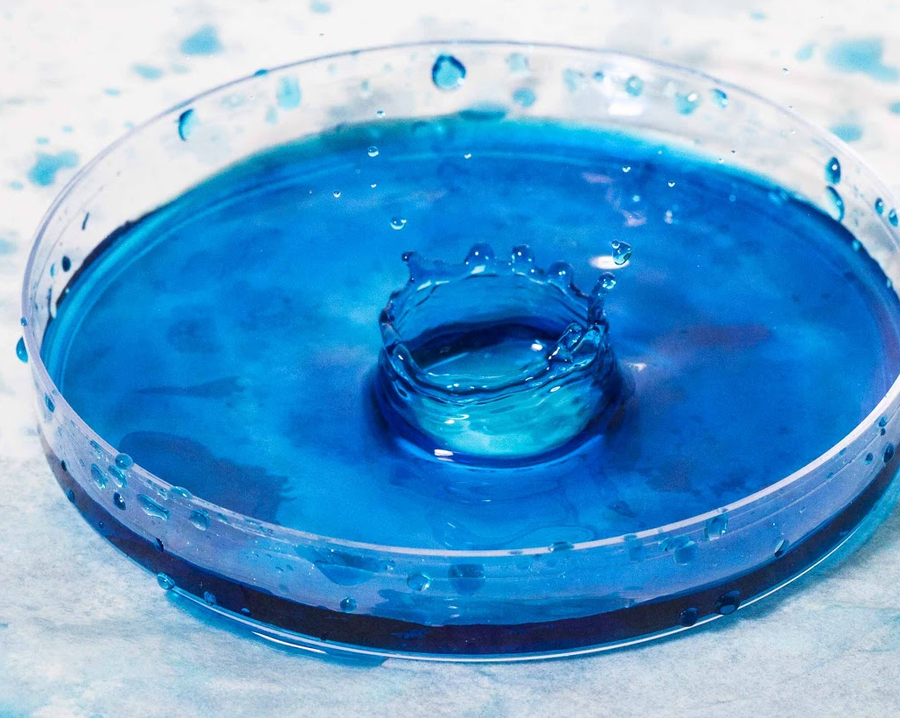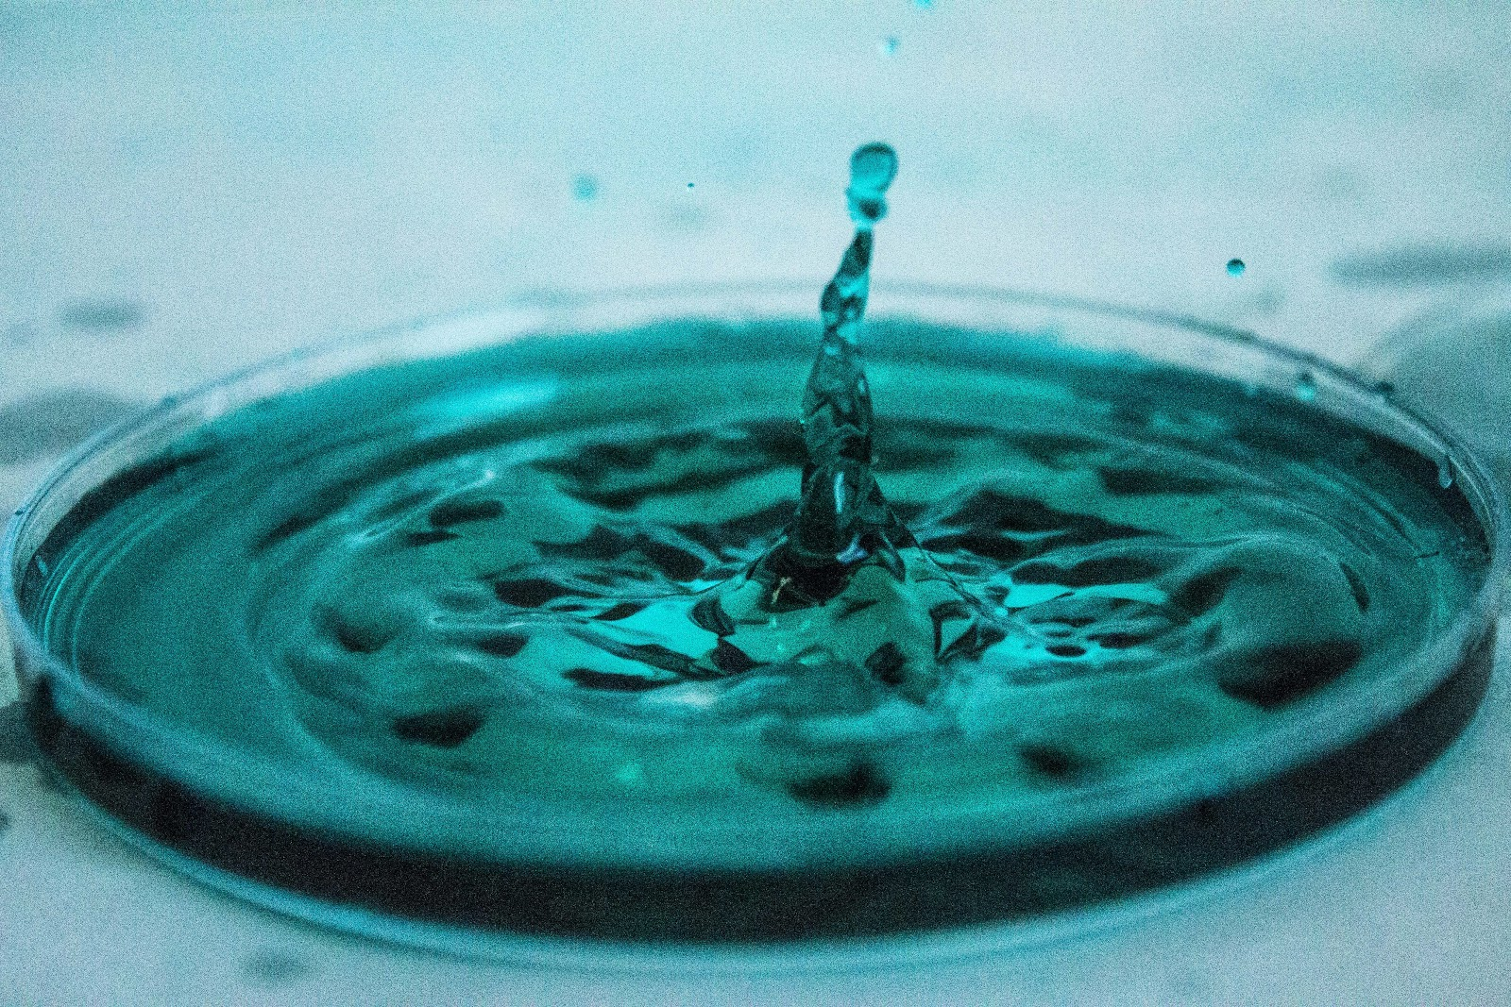

Project:
- Five (or more) photographs of water droplets splashing into colored water using two different lenses..
- Five (or more) photographs of water droplets splashing onto a hard surface, using two different lenses.

SET Your Camera to the following | When set make a
Lens: 50mm (for first shoot)
18-55mm with macro filter (for second shoot)
Lens: MF (manual focus)
Mode Dial: M (Manual Mode)
Clean your lens
External Flash Settings (Optional… See External Flash
Instructions is you are using this)
- Transmitter (check with teacher for channel
setting)
- Receiver
- Flash and stand
- Batteries (4 AA for Flash and 2AAA for
transmitter and receiver)
- Mode: TTL (Through the Lens), or Manual ½, ¼, or less
- Set Zoom on flash to closest focal length of lens

Now its time to Photograph!

- Check all camera settings.
- Set up tri-fold board with white or gray paper on table.
- Set up Petri Dish on gray paper.
- Fill petri dish with colored water and obtain a dropper.

(Only use steps 5-7 if you’re using External Flash) See External Flash Instructions for more detail)
- Attach Receiver to bottom of External Flash and turn on (then press channel to select).
- Attach Transmitter to Hot Shoe of camera and turn on.
- Flash Head positioned on side of Petri Dish, pointed at your Petri Dish.

- Securely attach your camera to the tripod and leave the strap around your neck. Set camera a little higher than water level.
- When using about 8 cm – 10 cm from the drop.50mm lens- Camera should be about 30 cm from the drop.
10. When using 18-55mm lens with the macro filter- Camera should be
within a few inches of the drop.
11. Set your Shutter Speed and Aperture and use an appropriate ISO.
12. Focus- Manually focus on a pencil or pen tip placed EXACTLY where
you will place the water droplet. (you can use live view and zoom in on
your dropper, then turn live view off and shoot as normal.)
13. Drop the water and shoot! Take
14. Repeat with other lens.
15. Repeat entire project, but with water droplet falling on a hard
Surface, such as glass or the table top.

Setting Exposure
Setting Shutter Speed: Use the Main Dial to change the Fraction in the upper LHC of the screen.
Setting Aperture: Hold down the AV button while turning the Main Dial (F Value).
Setting ISO: Press the ISO button and use the arrows to select the proper ISO, then press “Set”.
Notice the White Bar is at “0”

Standards
TECH.8.1.8.D.CS2, TECH.8.1.8.B.CS2, TECH.8.1.8.C.CS1, TECH.8.1.8.B.CS1, SCI.MS-ETS1-4, TECH.8.1.8.D.CS1, , SCI.MS-ETS1-3, TECH.8.1.8.A.CS2, TECH.8.1.8.A.1, VPA.1.1.8.D.CS1, VPA.1.2.8.A.CS1, VPA.1.2.8.A.3, VPA.1.3.8.D.CS1, VPA.1.3.8.D.1, VPA.1.3.8.D.CS2, VPA.1.3.8.D.2, VPA.1.3.8.D.CS4, VPA.1.3.8.D.CS6, VPA.1.3.8.D.6, VPA.1.4.8.A.CS2, VPA.1.4.8.A.CS6, VPA.1.4.8.A.6, VPA.1.4.8.A.7, VPA.1.4.8.B.CS1, VPA.1.4.8.B.1, VPA.1.4.8.B.2, TECH.8.1.8.D.CS3, , SCI.MS-ETS1-2, TECH.8.1.8.A.CS1

ESSENTIAL QUESTION: How does shutter speed affect the quality of a photograph of a moving water droplet?
OBJECTIVES: Students will experiment with shutter speed while taking photographs of water droplets.
MATERIALS: Canon Rebel Student Kits, Tripods

ADAPTATIONS: Redirectives, verbal prompts, one on one instructions, repeated practice, peer instruction, small group instruction, self-paced, repeated demonstrations, adjust difficulties of lessons, Google Speak,

ASSESSMENT: Observation during student discussions, observation of individual progress during project creation, final project rubric, Google Classroom submission

