Macro Focus Point Project Revised 7-12-16
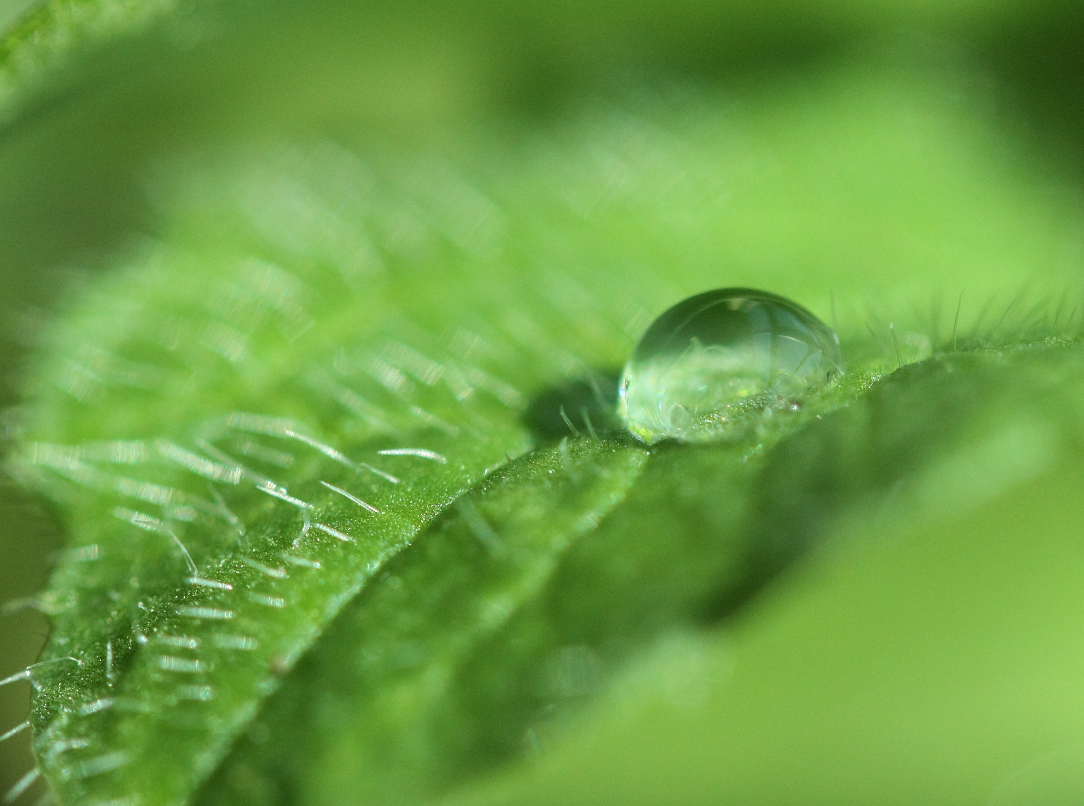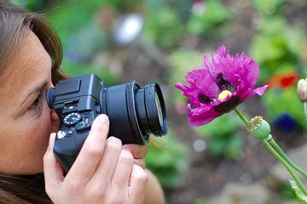
Notice How Close the Camera is to the subject!
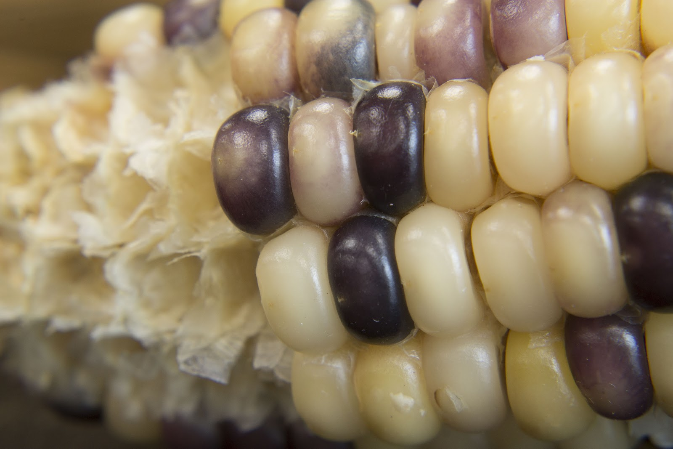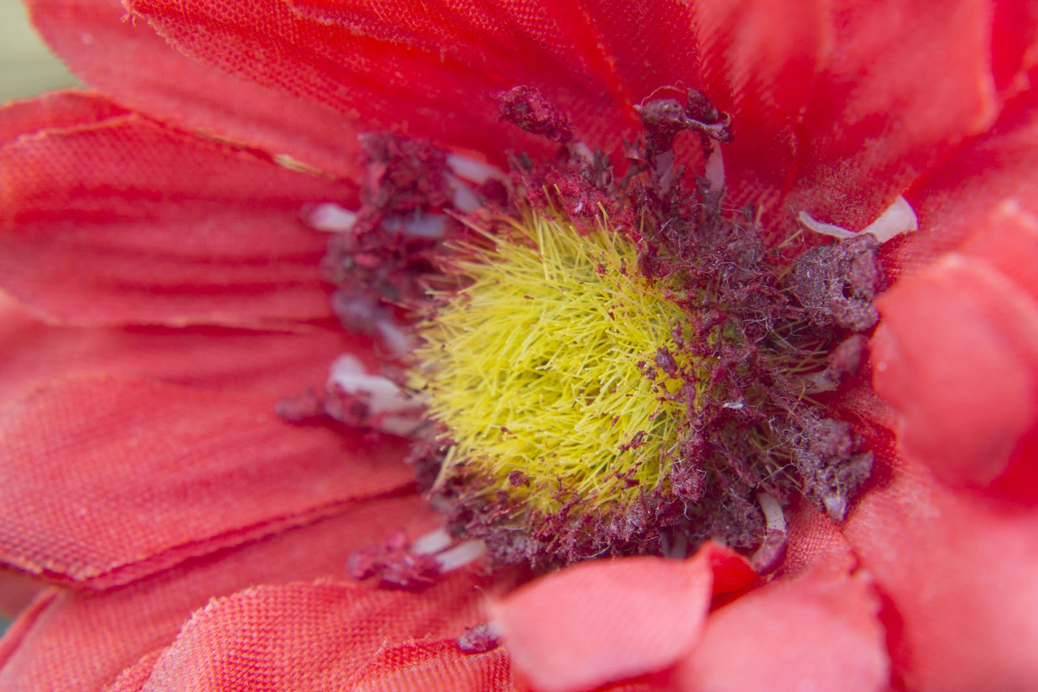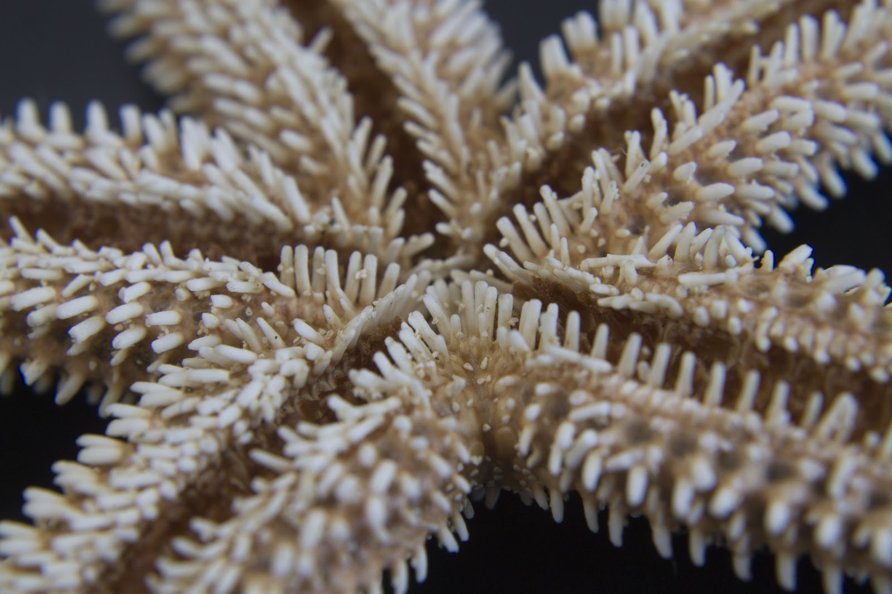
Photo by Anna Rivera Photo by Anna Rivera Photo by Anna Rivera

Project: Using a Macro Filter for extreme close-ups!

Students will take CloseUp photographs using a variety of focus points. Objects, such as insects, yarn spools, crayons, pencils, etc. will be photographed using macro filters installed on lens. Focusing using macro filters/lenses requires very precise focus technique since depth of field is so shallow. Choice of focus point can dramatically alter the final photograph. You will be choosing two or three objects to photograph.

Setting Exposure
Setting Shutter Speed: Use the Main Dial to change the Fraction in the upper LHC of the screen.
Setting Aperture: Hold down the AV button while turning the Main Dial (F Value).
Setting ISO: Press the ISO button and use the arrows to select the proper ISO, then press “Set”.
Notice the White Bar is at “0”

SET Your Camera to the following | When set make a
Lens: 18 -55 MM
Lens: MF (manual focus)
Mode Dial: M (Manual Mode)
ISO: 400 (Adjust for correct exposure if needed)
Attach macro filter to lens (screws on gently!)
Aperture: F13 or higher
Now it’s time to Photograph!

- Check all camera settings.

- Grab a black box. Open it up and place your object inside to be photographed against a white background.

- Attach a Macro filter (in the black fold-out pouches) to your camera lens by screwing it directly onto the UV lens (gold)- VERY GENTLY, DON’T OVERTIGHTEN! There are numbers on the side of the macro filters. 1+, 2+, 4+, and 10+. The higher the number, the closer you can get to your subject.

- Securely attach your camera to the tripod (small or large) and leave the strap around your neck. You may also place your camera on the table without a tripod.

- Set camera to Live View. You will use the LCD display to view your object while focusing. Fill the display with your object! Get real up close and personal! The little white rectangle is your focus box. This can be moved by using the arrows. Once the white focus box is on the part of object you want, you can zoom in, using the checkerboard button, and continue your fine focusing. Also, set your camera to the 2-second timer to avoid shake.

- Set your aperture. Hint: for beginners, setting a narrow aperture, (high F-Value i.e. F13), will make it a little easier to focus on your desired portion of the object.

- Set your shutter speed to create a proper exposure. (See diagram below)

- Focus. Manually focus on your chosen point of the object. Try different
points to create different compositions!

9. Please submit a total of 5-10 photographs of 2-3 different objects.

Does something look wrong??
Too dark or too light?? It could be your exposure!
Standards
TECH.8.1.8.D.CS2, TECH.8.1.8.B.CS2, TECH.8.1.8.C.CS1, TECH.8.1.8.B.CS1, SCI.MS-ETS1-4, TECH.8.1.8.D.CS1, , SCI.MS-ETS1-3, TECH.8.1.8.A.CS2, TECH.8.1.8.A.1, VPA.1.1.8.D.CS1, VPA.1.2.8.A.CS1, VPA.1.2.8.A.3, VPA.1.3.8.D.CS1, VPA.1.3.8.D.1, VPA.1.3.8.D.CS2, VPA.1.3.8.D.2, VPA.1.3.8.D.CS4, VPA.1.3.8.D.CS6, VPA.1.3.8.D.6, VPA.1.4.8.A.CS2, VPA.1.4.8.A.CS6, VPA.1.4.8.A.6, VPA.1.4.8.A.7, VPA.1.4.8.B.CS1, VPA.1.4.8.B.1, VPA.1.4.8.B.2, TECH.8.1.8.D.CS3, , SCI.MS-ETS1-2, TECH.8.1.8.A.CS1
ESSENTIAL QUESTION: How does the operator of the camera choose and control her macro (close-up) focus points?
OBJECTIVES: Students will review basic camera functions learned in past classes, and focus points. Students will then photograph close-up details of insects, flowers, or any items of student choice which show texture.
MATERIALS: Canon Rebel Student Kits, Tripods
ADAPTATIONS: Redirectives, verbal prompts, one on one instructions, repeated practice, peer instruction, small group instruction, self-paced, repeated demonstrations, adjust difficulties of lessons, Google Speak,
ASSESSMENT: Observation during student discussions, observation of individual progress during project creation, final project rubric, Google Classroom submission

