Each of the following sentences contains subordinate clause. Write the first and last word of each clause and identify what we would call the clause if it were in Latin. A list of clauses provided below.
Ablative Absolute | Cum Causal clause | Cum Circumstantial clause
Cum Concessive clause | Indirect Command | Indirect Question
Indirect Statement | Purpose clause | Relative Clause
Result Clause

- When the Optimate dictator, Sulla, was in power, he ordered Caesar to divorce Cornelia, who was the daughter of a prominent member of the Popular faction.
________________________________________________ _____________________________
________________________________________________ _____________________________
________________________________________________ _____________________________
- Since Caesar was awarded the civic crown (oak leaves) for saving the life of a citizen in battle, Caesar’s general sent him on an embassy to Nicomedes to obtain a fleet of ships; with Nicomedes being a homosexual, many in Rome sarcastically asked how Caesar had obtained the fleet.
________________________________________________ _____________________________
________________________________________________ _____________________________
________________________________________________ _____________________________
________________________________________________ _____________________________

- When sailing to Greece for further study, Caesar was kidnapped by Cilician pirates and held for ransom. With 20 talents being asked for as ransom, Caesar said that he was worth at least 50.
________________________________________________ _____________________________
________________________________________________ _____________________________

- Caesar spent so heavily in a successful effort to get elected pontifex maximus (chief priest) that he nearly bankrupt. He divorced Pompeia because of her involvement in a scandal with another man, although the man had been acquitted in the law courts; Caesar is reported to have said that the wife of Caesar had to be above suspicion.
________________________________________________ _____________________________
________________________________________________ _____________________________
________________________________________________ _____________________________

Write the first and last word of each clause and identify the clause from the list provided below.
Ablative Absolute | Cum Causal clause | Cum Circumstantial clause
Cum Concessive clause | Indirect Command | Indirect Question
Indirect Statement | Purpose clause | Relative Clause
Result Clause

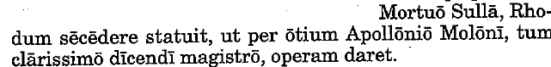

________________________________________________ _____________________________
________________________________________________ _____________________________

________________________________________________ _____________________________

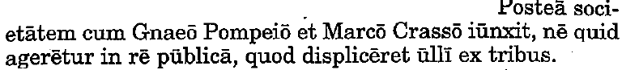

________________________________________________ _____________________________
________________________________________________ _____________________________

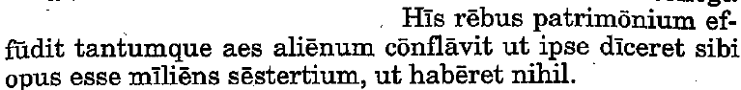

________________________________________________ _____________________________
________________________________________________ _____________________________
________________________________________________ _____________________________

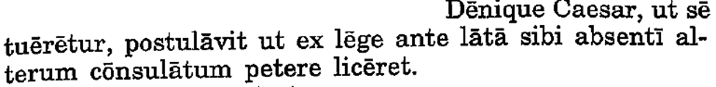

________________________________________________ _____________________________
________________________________________________ _____________________________

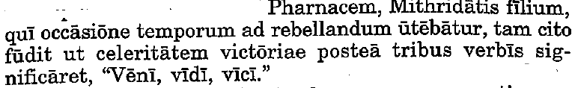

________________________________________________ _____________________________
________________________________________________ _____________________________

Translate any four of the passages above.

