

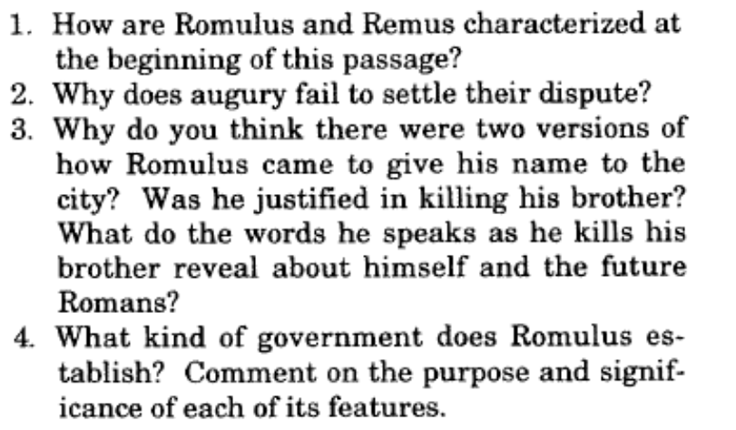

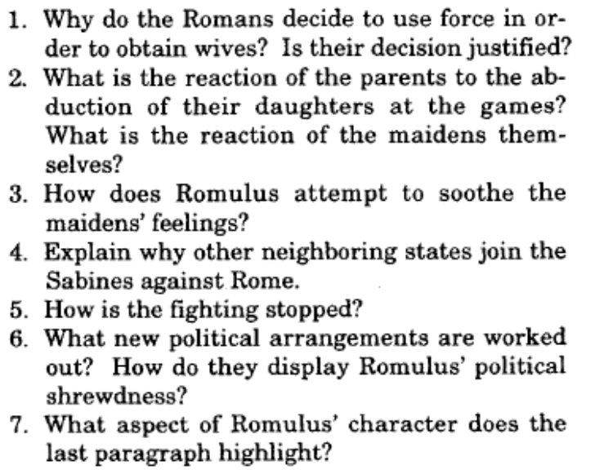

|  |
| --- |
| Chapter 4 |
| Chapter 5 |
|  |