Nanjiecun: A village that still lives and works as Mao laid down
By Peter Day
Presenter, Global Business
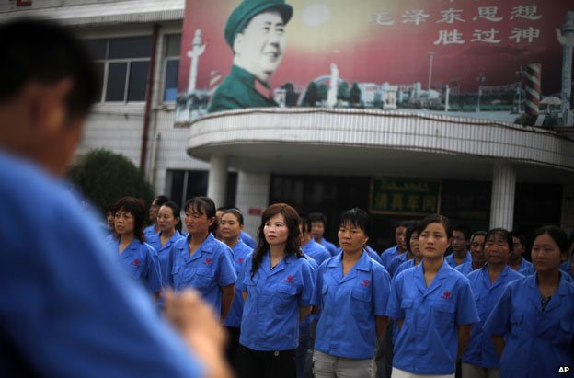
A morning session of revolutionary songs
Mao Zedong was a founding father of the People's Republic of China. He died in 1976, but his presence is still firmly felt in the small village of Nanjiecun, where one of the country's last Maoist communes shows no sign of giving up the ghost.
Dawn is often murky in central China - grey skies, thin smog everywhere.
But rain or shine, in Nanjiecun village, at 06:15 every morning, the air is suddenly full of songs of praise for China's mighty former leader, Mao Zedong. The anthems blare forth up and down the empty streets, from loudspeakers on every lamp post.
Nanjiecun is a place where time seems to have stood still, or even gone backwards. It is one of China's very few remaining Maoist communes, a showcase for a vanished regime.
On and on chants the song that many Chinese recognise from their childhood, or their parents' childhoods: "The East turns red, the sun is rising, China has Mao Zedong, he's seeking people's happiness, he's seeking the way forward..." The choruses are sunny, driving, uplifting.
Sixty years ago, they would have been everywhere, in every town and village. Now they are just here, in Henan province in the middle of China.
They are pleased to welcome visitors. The village's propaganda chief shows me round.
The archive hall tells the story. After Mao Zedong's successors handed state-owned land back to the farmers in the 1980s, the people here were persuaded to give the land back to the village. It is run as a commune - everyone shares in the enterprise.
The historic displays show photographs of decrepit cottages. There is a drawing of the way the land used to be tilled - two men pulling a plough instead of oxen, guided by a third. A hard life, not quite within living memory.
When the village returned to Maoist communal principles in the 1980s, it appears to have flourished, perhaps rather more than it did in the 1960s when Mao's rigorous rule was the way the whole country was run, and millions perished in strife and famine.
Nanjiecun's rural slums were replaced with apartment blocks - a traditional Chinese arch was erected at the entrance to the village.
There is a big square with a big statue of Mao, and posters of other communist heroes - Karl Marx, Lenin, Stalin. Lots of red banners everywhere.
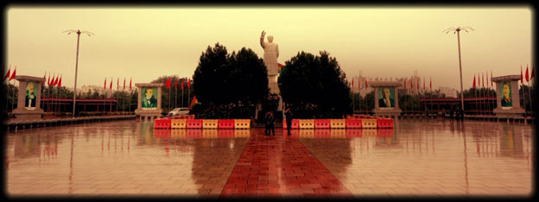
New factories on old farmland attracted outside investment, making noodles, beer, medicines.
There is a newspaper and a radio station which wakes the village up every morning with those Chairman Mao songs. The village television station has tapes of many more celebratory performances.
The noodle factory was set up 15 years ago with Japanese investment. It was swarming with hygienically clad workers when I was there.
The noodles fresh off the production line tasted good too, at the end of the run, served up to us by an engaging young woman who had joined the village community when she married a local boy.
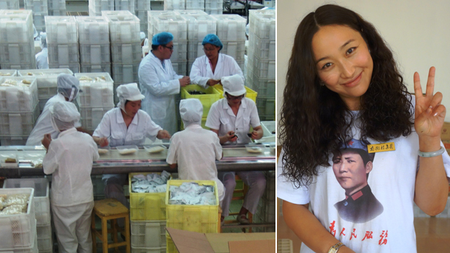
The noodle factory's production line, and server Li Juanjuan - who has married into the village community
She said she enjoyed the quiet life set slightly apart from the rush and jabber of modern urban China just a few streets away.
Here in Nanjiecun, there are almost no cars, just a few of the electric scooters that have blissfully replaced the two-stroke engine in China, and some sedate three-wheeler trucks.
The place is plain, clean, devoid of commercial advertising, austere - although there are lots of Maoist banners and slogans, of course.
Basic pay is low - the equivalent of £20 ($32) a month. But commune members also get rent-free apartments, with utilities and basic foodstuffs provided, plus education.
Modern-day China is only a few streets away. But family ties are very strong.
It is poignant to experience such a nostalgic place in a China which is still undergoing ferocious modernisation and frantically growing urbanization.
The great Chinese export machine - fuelled by cheap labour, which has been the main engine of growth for 30 years - is now being officially replaced by a more balanced economy.
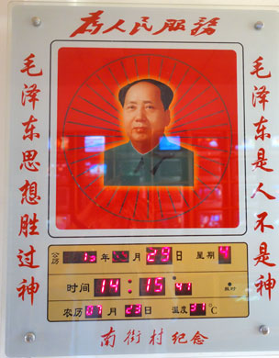
The calendar...

The Chinese authorities are now seemingly concentrating on constructing a consuming society owning homes and cars and smartphones and the other paraphernalia of 21st Century living.
Detached though the commune at Nanjiecun may be from the swirling consumerist China all around it, you only have to step into one of the village's apartments to find an array of creature comforts that are somewhat in advance of the austerity of the Cultural Revolution.
The elderly occupant talked to us in her living room, clean, high-ceilinged and spacious, dominated by a landscape painting of a lake and a pagoda taking up most of one wall.
There a nice flat-screen television beaming out a repeat of one of those endless historical epics from Central China TV.
There was a shiny microwave oven, and shelves arrayed with the trophies of a lifetime of family presents and community awards.
And in proud position above the television on the wall, a big electronic calendar with the digital dates arranged around a portrait of Chairman Mao in his prime.
When you pressed a button, his face was suddenly embellished by a rainbow array of coloured lights, beaming.
The calendar was made in the village, of course.

