Name ___________________________

**Chapter 4: Life in the Colonies**

6.1.8.C.2.a, 6.1.8.C.2.b, 6.1.8.C.2.c, 6.1.8.B.3.a, 6.1.8.D.2.a, 6.1.8.D.2.b, 6.1.8.D.3.a

**Use the following words to complete the sentences below: (2 points each)**

|  |
| --- |
| **climate class export proprietor treaty** |

**1. A society or group is called _______________________.**

**2. A formal agreement between countries is a __________________________.**

**3. The new colonies would need products for them to _____________________.**

**4. A ________________ was someone who owns land.**

**5. The ______________ was important when choosing a region because it allowed them to determine how long the growing season would be.**

**6. What is mercantilism? (2 points) __________________________________________________________________________**

**__________________________________________________________________________**

**__________________________________________________________________________.**

**7. Describe why the meetinghouse was the center of town life? (2 points)**

**___________________________________________________________________________**

**___________________________________________________________________________**

**___________________________________________________________________________**

**___________________________________________________________________________**

**__________________________________________________________________________.**

|  |
| --- |
| **8.** |
| **Interpreting a Map (2 points each)**  Using the map, answer the following questions:  Which two crops were grown mostly in the Southern Colonies?  _____________________________________________  Which region’s colonies depended most on fishing?    _____________________________________________    Explain how the map shows that climate had an impact on farming?  __________________________________________________________________________________________________________________________________________ |

**9. What was the significance of triangular trade? (5 points)**

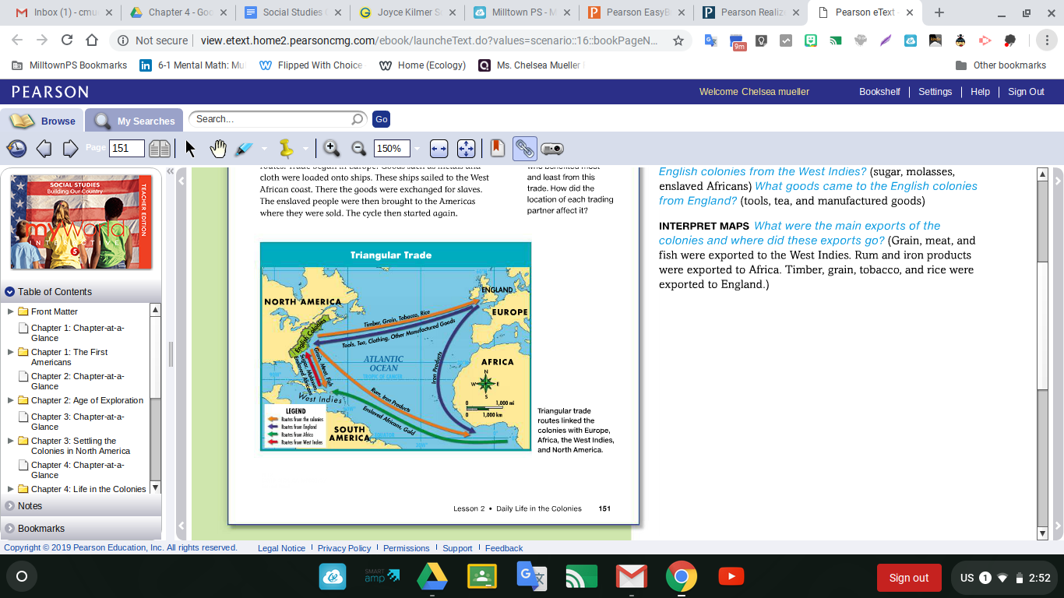

**____________________________________________________________________________________________________________________________________________________________________________________________________________________________________________________________________________________________________________________**

**10. Explain what it take to build a society. (5 points)  
_______________________________________________________________________________________________________________________________________________________________________________________________________________________________________**

**__________________________________________________________________________________________________________________________________________________________**

**11. How and why did slavery grow in the colonies? (5 points)**

**__________________________________________________________________________________________________________________________________________________________**

**__________________________________________________________________________________________________________________________________________________________**

**12. Pick two of the following colonies New England, Middle, and Southern Colonies’ and describe how their climates are alike and how they differ. (5 points)**

