Name ___________________________

Chapter 3: Settling the Colonies in North America
6.1.8.A.2.a, 6.1.8.A.2.b, 6.1.8.A.2.c, 6.1.8.B.2.a,6.1.8.B.2.b, 6.2.8.B.4.a, 6.2.8.B.4.b, 6.2.8.B.4c, 6.2.8.B.4.d, 6.1.8.C.2.a, 6.2.8.C.3.a, 6.2.8.C.3.b, 6.2.8.C.4.a, 6.2.8.C.4.b

Use the following words to complete the sentences below: (2 points each)

missionaries Puritan monopoly encomienda system royal province

1. The Company of New France had a ________________, so no one else could buy and sell furs.
2. The ________________________________ meant that Spanish settlers could take Indians’ lands and make them work for free.
3. __________________________ governed and tried to convert American Indians to Catholicism in New Spain.
4. John Winthrop was a ______________________ because he wanted to change the Church of England.
5. New France is a __________________________ because it is an area controlled by the commands of a king or queen.
6. What is an indentured servant? (2 points) __________________________________________________________________________
__________________________________________________________________________
__________________________________________________________________________.

7. Why did people leave their homelands? (5 points)
___________________________________________________________________________
___________________________________________________________________________
__________________________________________________________________________.
8.
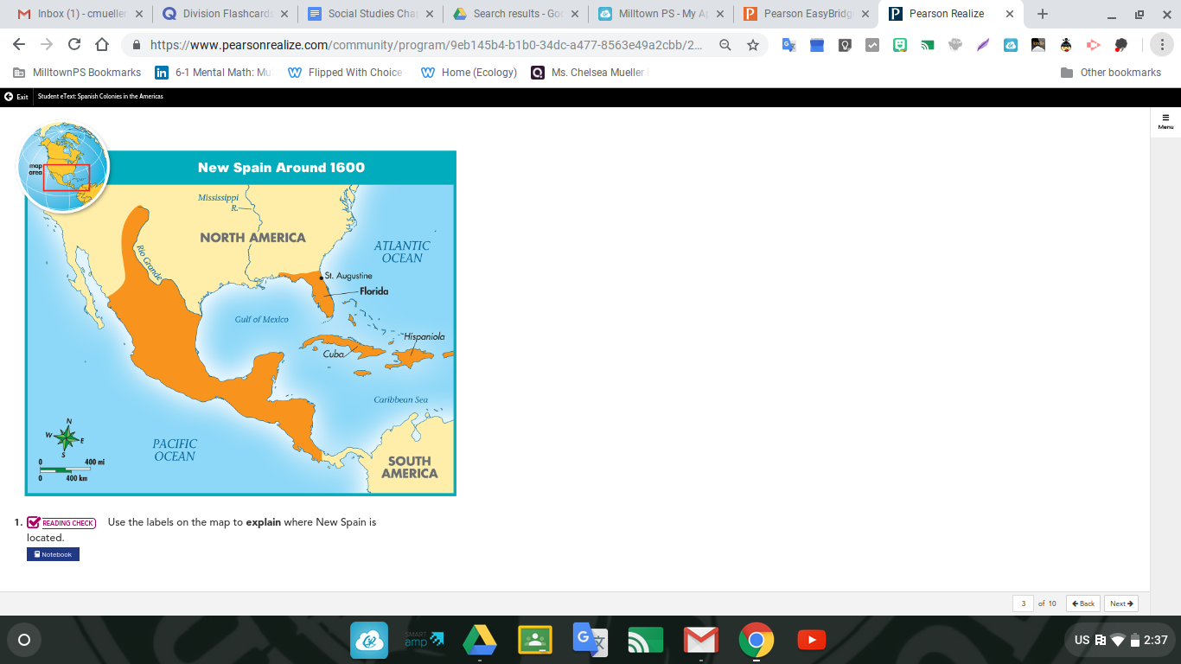
Interpreting a Map (2 points each)
Using the map, explain where New Spain is located.

__________________________________________________________________________________________________________________________________________

9. How did competition among European countries affect the settlements of North America? (2 points)
____________________________________________________________________________________________________________________________________________________________________________________________________________________________________________________________________________________________________________________

10. Why was the formation of the House of Burgesses important? How does its formation affect American life today? (5 points)
_______________________________________________________________________________________________________________________________________________________________________________________________________________________________________
__________________________________________________________________________________________________________________________________________________________
11. How were the Roanoke colony and the Jamestown colony alike and how did they differ? Compare and contrast. (5 points)

_________________________________________________________________________________________________________________________________________________________________________________________________________________________________________________________________________________________________________________________________________________________________________________________________

